AFAR REGIONAL PORTAL
Software System Analysis & Modernization Report
Based on source code review of the "Afar-backup" Laravel 8 application

Prepared by: Claude (Anthropic) — Technical Code Review
Date: July 17, 2026

Table of Contents

1. System Overview

1.1 What this system is
The reviewed codebase (“Afar-backup”) is a bilingual content-management and public information portal for the Afar Regional State, built on Laravel 8 (PHP 7.3/8.0). It is a single monolithic application that serves two audiences from one codebase: a public-facing website (news, tenders, vacancies, events, directorates, city administration profiles, galleries) and a password-protected administrative dashboard used to author that content. Every field of substance — titles, descriptions, positions — is stored twice: once in English and once in Amharic (columns such as title/titleamh, description/descriptionamh), and a SetLanguage middleware switches the active locale based on a {language} URL segment (e.g. /en/..., /am/...).

1.2 Purpose inferred from the code
The routes, controllers and database schema point to a government-style communications and e-service portal used to:
- Publish official news, announcements and event notices to the public.
- Publish and manage procurement tenders and job vacancies, including downloadable PDF/Word attachments.
- Present the region's organizational structure (directorates and city/woreda administration profiles) with photos and downloadable documents.
- Host a media gallery (images and video) and an image slider/portfolio for the homepage.
- Let citizens submit a contact message that an administrator can review.
- Give administrative staff a role/permission-gated back office to create, edit and delete all of the above.

1.3 Technology stack (as found in the repository)
Layer | Technology / Package | Notes
Language / runtime | PHP ^7.3 | ^8.0 | composer.json allows either — the app was not written against a single target.
Framework | Laravel 8 (laravel/framework ^8.75) | Released Sept 2020; out of official security support (see §6).
Auth & sessions | Laravel built-in Auth (Auth::routes()) + laravel/sanctum ^2.11 | Sanctum is installed but only wired to a single /api/user route — not used for the content API.
Authorization | spatie/laravel-permission ^5.5 | Full role/permission tables exist; only one role (“Admin”) is actually seeded.
Auditing | spatie/laravel-activitylog ^4.5 | Wired into almost every model via the LogsActivity trait.
Front-end | Blade templates + laravel-frontend-presets/material-dashboard ^1.1 | Server-rendered HTML/CSS/JS admin theme (Now UI / Material Dashboard style), no SPA framework.
Images | intervention/image ^2.7 | Referenced in controllers for image handling.
Social sharing | jorenvanhocht/laravel-share ^4.2 | Generates share links on public detail pages.
Database | MySQL/MariaDB (afar.sql, afar(3).sql dumps included) | InnoDB, utf8mb4.
File storage | Local disk (public/, storage/app) | Uploaded files are moved directly into public/image/* and documents/ via $file->move().

1.4 Functional modules
Fifteen Eloquent models drive the system. Each corresponds to one content type and, in almost every case, to one admin controller, one public “Front” controller/page, and one database table:
Module | Public-facing? | Admin-managed? | Bilingual fields?
News (+ NewsImage gallery) | Yes — list & detail | Yes | Yes
Events | Yes — calendar/list | Yes | Title only
Tenders | Yes — list, detail, file download | Yes | Yes
Vacancies | Yes — list, detail, file download | Yes | Yes
Publications | Yes — list, detail, file download | Yes | Yes
Announcements | Yes — list & detail | Yes | Yes
About | Yes — static page | Yes | Yes
Directorates | Yes — category listing + detail + file | Yes | Yes
City Admins | Yes — category listing + detail + file | Yes | Yes
Gallery (photo/video) | Yes | Yes | No
Sliders (homepage banner) | Yes (rendered on homepage) | Yes (create/delete only) | No
Portfolio | Not routed on the public site | Yes | No
Contact messages | Public submits ("/message") | Admin reviews (read-only list) | No
Users / Roles / Permissions | — | Yes (Super Admin) | —

1.5 What is conspicuously missing
- A real public API: routes/api.php contains a single Sanctum-protected /user endpoint. There is no JSON API for news, tenders, vacancies, etc. — everything is server-rendered HTML.
- Automated tests: tests/Feature and tests/Unit only contain Laravel's default placeholder ExampleTest — there is no test coverage of any business logic.
- A finished multi-image feature: a MultiImages model and migration exist, but MultiImagesController is an empty, unimplemented stub.
- Environment-driven secrets: a plaintext file named “file” at the project root appears to contain a hosting/database username and password committed directly to the repository (see §6.5 and §8 for the security implication and recommended remediation).

2. Actors
The permission seed data (spatie/laravel-permission tables) defines granular, per-module CRUD permissions (e.g. news-list, news-create, news-edit, news-delete, tender-*, vacancy-*, event-*, contact-*, role-*, user-*), but the shipped database only seeds a single role, “Admin,” holding every permission. This is an important finding: the system was designed for multiple distinct back-office roles but currently operates as if only one exists. The table below documents the actors implied by the code and permission model — not just the one role that happens to be seeded today.

2.1 Actor inventory
Actor | Type | Access route | Primary goals
Public Visitor | Unauthenticated, external | Public site (/{language}/...) | Read news/tenders/vacancies/events, view directorate & city admin info, download documents, contact the region, switch language.
Content Administrator | Authenticated, internal staff | /home dashboard (session auth) | Create/edit/delete news, events, tenders, vacancies, publications, announcements, gallery, sliders, portfolio, about, directorates, city admin pages; triage contact messages.
Super Administrator / System Owner | Authenticated, elevated | /users, /roles | Manage user accounts and define roles & permissions; implied owner of the whole permission matrix (role-* and user-* permissions exist specifically for this actor).
(Latent) API Consumer | Authenticated via Sanctum token | /api/user only, today | Not yet a real actor — the Sanctum scaffolding exists for a future mobile app or external integration, but no content endpoints are exposed to it yet.

2.2 Reasoning behind the actor split
- Public Visitor vs. Administrator: enforced structurally — every admin route in routes/web.php sits inside Route::group(['middleware' => 'auth'], ...), while every public route sits inside the {language}-prefixed group with no auth middleware.
- Content Administrator vs. Super Administrator: inferred from the permission seed list itself. Module permissions (news-*, tender-*, event-*, contact-*, vacancy-*) are logically “editorial,” while role-* and user-* permissions are logically “system administration.” Spatie's middleware (permission:role-list|role-create|... in RoleController and permission:user-*... in UserController) already gates those two permission families separately — the code is ready for the split even though only one combined role exists in the data today.
- API Consumer: laravel/sanctum is a full dependency and a personal_access_tokens table is migrated, but it is used for exactly one route. This is best read as a placeholder for a future actor (a mobile app or partner integration) rather than a currently active one — see §7, API Migration Strategy.

3. Use Cases
The diagram below groups use cases by actor, derived directly from routes/web.php and the corresponding controllers. Dotted lines indicate a use case a Super Admin can also perform (because that role holds every permission), not a separate implementation.
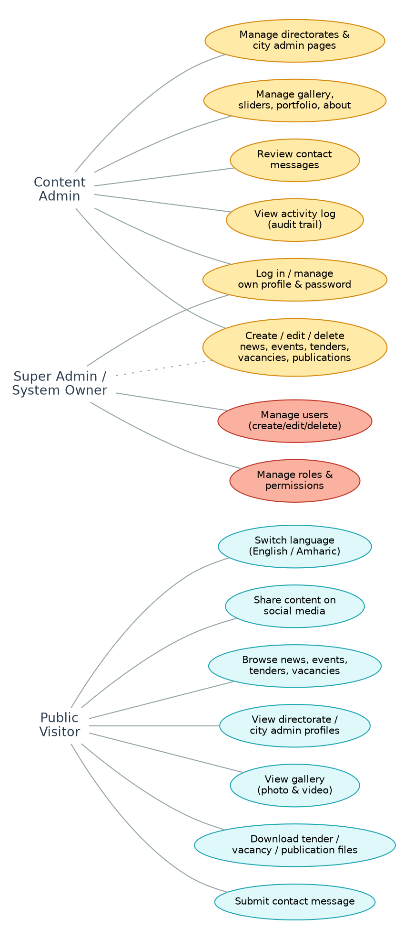
Figure 1. Use-case diagram: Public Visitor, Content Administrator and Super Administrator.

3.1 Public Visitor use cases (detailed)
Use case | Route(s) | Notes
Browse home / featured content | GET /{language}/ (IndexController) | Shows sliders, latest news, front blocks.
Browse & read news | GET /{language}/front-news, GET /{language}/detail/{id}/news | News detail loads related NewsImages gallery.
Browse events | GET /{language}/front-event | Calendar-style listing driven by events.start/end.
Browse & download tenders | GET /{language}/front-tender, /detail/{id}/tender, GET /tenders/{id}/download | File download is a separate named route outside the {language} group.
Browse & download vacancies | GET /{language}/front-vacancy, /front-vacancy/{id} | Vacancy detail is a dedicated show() rather than the generic DetailPageController.
Browse & download publications | GET /{language}/front-publication, GET /publication/{id}/download
Read announcements | GET /{language}/front-announcment, /detail/{id}/announcment
Explore directorates by category & download attached file | GET /{language}/directorate/{type}, /directorateDetail/{id}, GET /director/{id}/download | “type” filters on the free-text directorates.model column.
Explore city administration by category & download attached file | GET /{language}/cityAdmin/{type}, /cityAdminDetail/{id}, GET /cityAdmin/{id}/download | Mirrors the directorate pattern exactly.
View photo/video gallery | GET /{language}/front-gallery, /front-video
Read the About page | GET /{language}/front-about
View contact information & submit a message | GET /{language}/front-contact, POST /message | MessageController persists to contacts.
Share a page on social media | Rendered on detail pages via laravel-share | Facebook, Twitter, LinkedIn, WhatsApp, Telegram links.
Switch language | URL {language} segment (en / am) | No cookie/session persistence found — every internal link must re-embed the segment.

3.2 Administrator use cases (detailed)
All routes below are inside the auth-protected group and, module by module, are additionally gated by a matching Spatie permission (e.g. news-list|news-create|news-edit|news-delete).
- Full CRUD (index/create/store/edit/update/destroy) on: News, Gallery, Tenders, Vacancies, About, Publications, Announcements, Portfolio, Directorates, City Admins — via Route::resource().
- User management: create, edit, delete staff accounts (excluding “show”) — Route::resource('users', ...).
- Role & permission management: create roles, assign permission sets, edit and delete roles — RoleController.
- Event management: list and create only (no dedicated edit/destroy routes were found — see §8 for the recommendation to complete this resource).
- Contact triage: view submitted messages (ContactController@index) — no reply, status-change, or delete route exists.
- Homepage slider management: add and delete slides; the “front” content blocks (About-style teaser) are edited via a dedicated Front edit/update pair.
- Own-profile management: edit profile and change password (ProfileController).
- Image sub-management on News: a separate images/* route set (create, edit, update, delete) manages the one-to-many NewsImage gallery per article.

4. Entity–Relationship Diagram
The diagram reflects the schema exactly as defined in database/migrations, not an idealized version. Solid arrows are relationships Eloquent models declare in PHP (hasMany/belongsTo). Dashed lines are the standard Spatie permission pivot tables. Dotted lines are relationships that exist only by convention (a shared string/int pair) with no enforced foreign key — explained in §6.2.
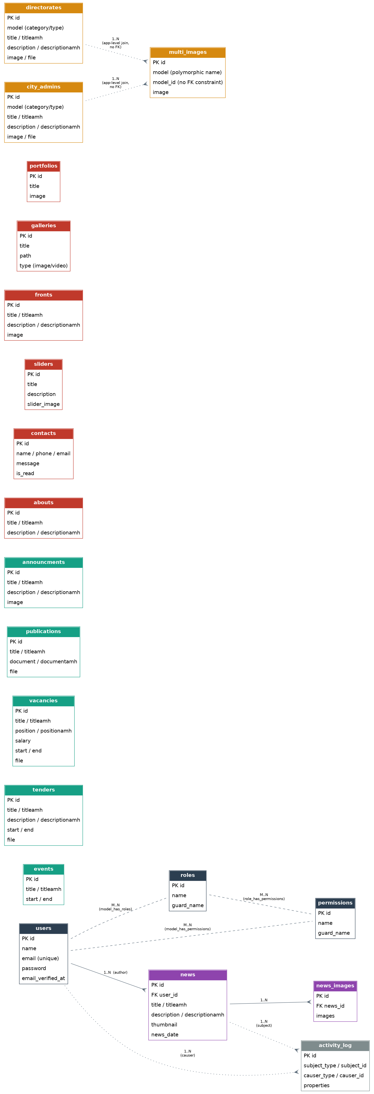
Figure 2. Entity-relationship diagram of the Afar portal schema.

4.1 Table-by-table summary
Table | Purpose | Key columns | Declared relationships
users | Staff / admin accounts | id (INT), name, email (unique), password | hasMany About, hasMany News; roles via model_has_roles
news | News articles | id (BIGINT), user_id (INT), title(amh), description(amh), thumbnail, news_date | belongsTo User; hasMany NewsImage
news_images | Extra images per article | id, news_id, images | belongsTo News
events | Calendar events | id, title(amh), start, end | None declared
tenders | Procurement notices | id, title(amh), description(amh), start, end, file | None declared
vacancies | Job postings | id, title(amh), position(amh), salary, start, end, file | None declared
publications | Downloadable reports/docs | id, title(amh), document(amh), file | None declared
announcments | Short public notices | id, title(amh), description(amh), image | None declared
abouts | About-page content | id, title(amh), description(amh) | belongsTo User (declared, but abouts has no user_id column — see §6.2)
contacts | Citizen contact messages | id, name, phone, email, message, is_read | None declared
sliders | Homepage banner images | id, title, description, slider_image | None declared
fronts | Homepage teaser block(s) | id, title(amh), description(amh), image | None declared
galleries | Photo/video gallery items | id, title, path, type | None declared
portfolios | Portfolio images | id, title, image | None declared
directorates | Org-structure profiles | id, model (category), title(amh), description(amh), image, file | None declared (model used as an informal category key)
city_admins | City/woreda admin profiles | id, model (category), title(amh), description(amh), image, file | None declared (mirrors directorates)
multi_images | Generic image attachments | id, model, model_id, image | None declared; controller unimplemented
roles / permissions / model_has_roles / model_has_permissions / role_has_permissions | Spatie RBAC pivot set | standard package schema | Many-to-many, package-managed
activity_log | Audit trail (spatie/laravel-activitylog) | subject_type/id, causer_type/id, properties | Polymorphic, package-managed
personal_access_tokens | Sanctum API tokens | tokenable_type/id, token, abilities | Polymorphic, package-managed, effectively unused

5. Architecture

5.1 Current architecture
The application is a classic Laravel monolith with no service boundaries: one PHP process type serves the public site, the admin dashboard, file downloads and (minimally) the API, all reading and writing one MySQL database and one local disk.
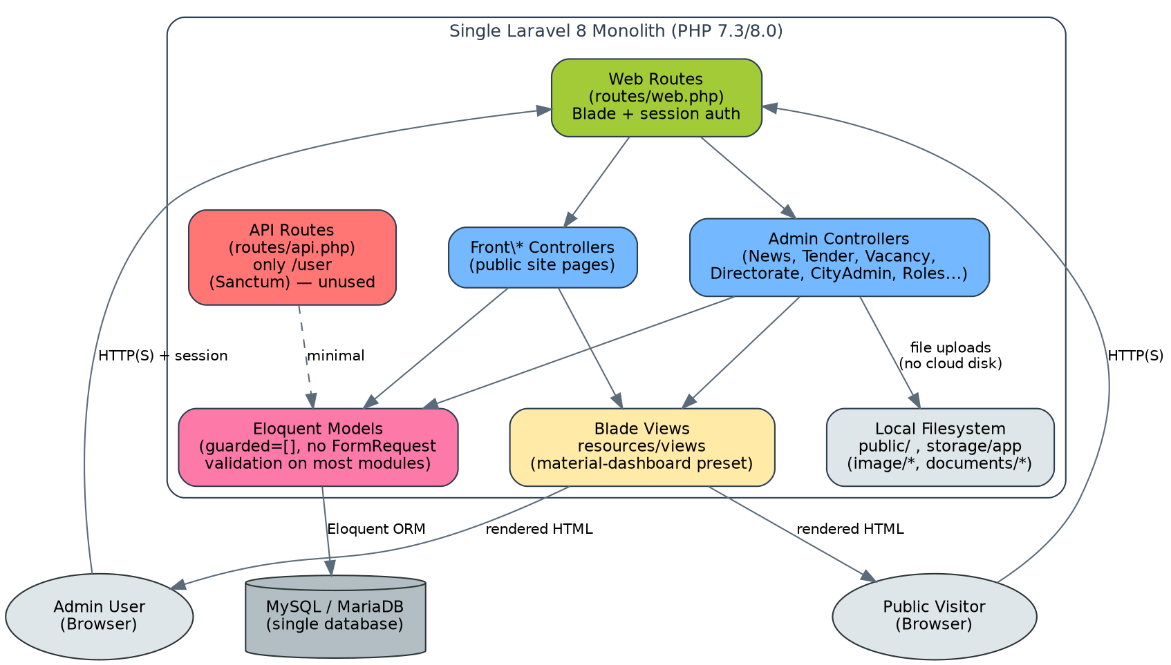
Figure 3. Current-state architecture — single Laravel monolith.

Key architectural observations
- No separation between read (public) and write (admin) paths. Both are handled by the same controllers/models with the same request lifecycle, so a spike in public traffic (e.g. a viral tender announcement) shares resources with the admin editing experience.
- Session-based, server-rendered UI throughout. Both the public site and the admin dashboard are Blade views returned as full HTML pages; there is no client-side app and no JSON contract between front end and back end, which is why routes/api.php is effectively empty.
- File storage is local disk. Uploaded images and documents are written straight into the public/ webroot and a documents/ folder via $file->move(), with no storage disk abstraction (Laravel's Storage facade / S3 driver is not used). This ties the application to a single server instance and its local filesystem.
- No queueing, caching, or background processing in use. QUEUE_CONNECTION defaults to sync and no Job classes were found, so any slow operation (e.g. resizing an uploaded image) blocks the HTTP request that triggered it.
- Language is a URL segment, not a first-class setting. SetLanguage middleware reads {language} from the URL and calls App::setLocale() per-request; there is no user preference, cookie, or Accept-Language negotiation.

5.2 Recommended target architecture
The proposed target keeps Laravel (protecting the team's existing PHP investment) but reshapes it into a versioned API behind a gateway, with the public site and admin dashboard as API consumers, object storage for media, and a queue/cache layer for background work — all introduced incrementally (see §7 for the migration sequencing).
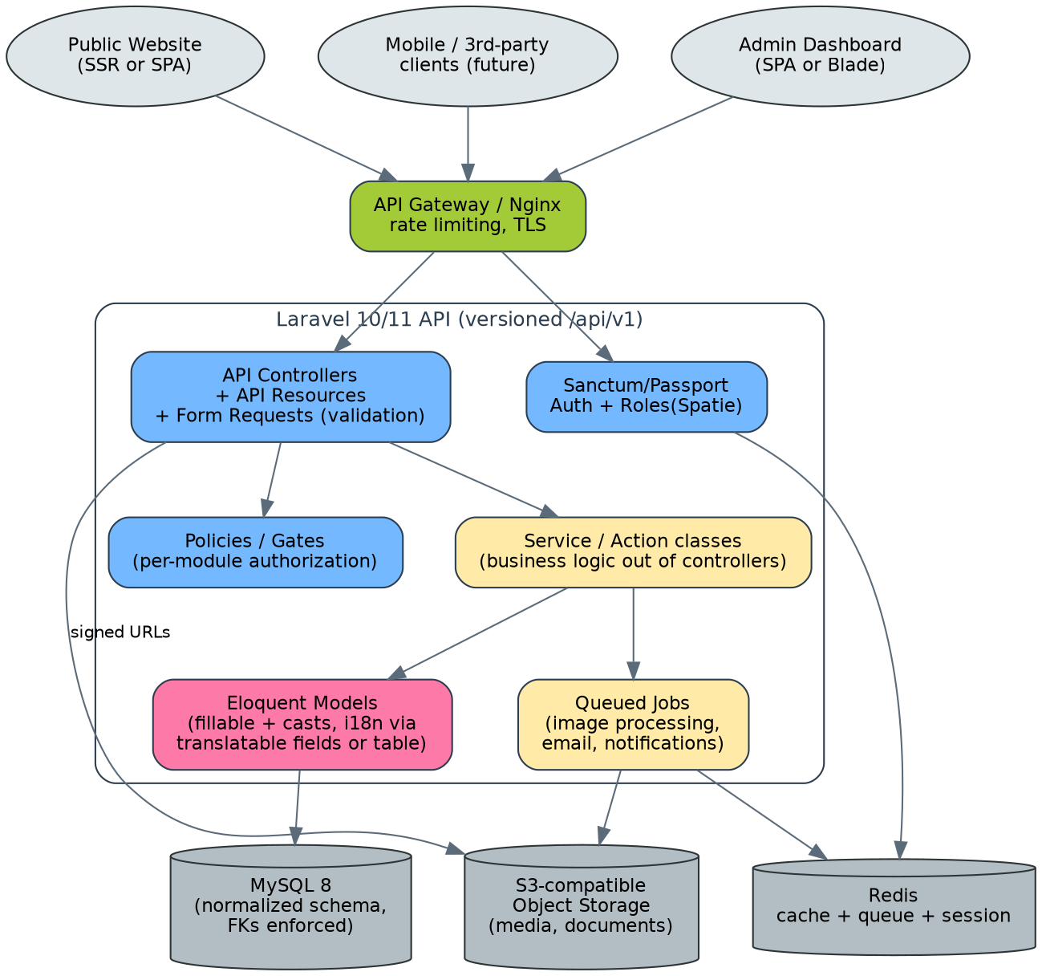
Figure 4. Proposed target architecture — API-first Laravel with object storage and a queue.

Why each change is recommended
- API Gateway / Nginx in front: centralizes TLS termination and rate limiting so the same protections apply whether a request comes from the public website, the admin app, or a future mobile client, instead of being reimplemented per controller.
- Form Requests + API Resources + Policies: replaces ad-hoc validation currently embedded in controllers with reusable, testable classes, and gives every module the same authorization pattern the RoleController already demonstrates is possible.
- Service/Action classes: moves file-handling and business logic out of controllers (several current controllers, e.g. DirectorateController::store, contain 40+ lines of inline image/document handling) so it can be unit-tested and reused between the web and API entry points.
- Object storage (S3-compatible): removes the coupling between the app server and uploaded files, which is required if the application is ever load-balanced across more than one server, and enables CDN delivery of images/documents.
- Redis for cache/queue/session: lets slow operations (image resizing, outgoing email/notifications for new tenders or vacancies) move off the request thread, and lets session/cache state be shared across multiple app instances.

6. Database Analysis
This section is based on a direct read of every file in database/migrations, the models in app/Models, and the two SQL dumps included in the backup (afar.sql, afar(3).sql). Findings are ordered from most to least structurally significant.

6.1 No mass-assignment protection on almost any model
Thirteen of the fifteen models declare protected $guarded = []; (About, Announcment, CityAdmin, Contact, Directorate, Event, Front, Gallery, News, NewsImage, Portfolio, Publication, Slider, Tender, Vacancy). This disables Eloquent's mass-assignment guard entirely, meaning every column on the underlying table — including ones added by a future migration — becomes writable from any array passed to create()/update(), including, in principle, a raw request()->all() call.
Why this matters
This is the classic Laravel mass-assignment vulnerability class: if a controller ever calls Model::create($request->all()) without a preceding FormRequest whitelist, a malicious or malformed request could set columns the form was never meant to expose. It also means validation is the only thing standing between a request and the database, and validation was not found to be systematic (see §6.6).

6.2 Declared relationships that the schema does not actually enforce
Two migrations attempt to declare a foreign key inline using a pattern that does not work in Laravel's schema builder:
- news_images.news_id: $table->unsignedInteger('news_id')->constrained('news')->onDelete('cascade');
- news.user_id: $table->unsignedInteger('user_id')->constrained('users');
The ->constrained() helper only creates a real foreign key when it is called on a column built with foreignId() (which returns a special ForeignIdColumnDefinition). Called on a plain unsignedInteger() column as it is here, Laravel's underlying Fluent attribute bag silently accepts and discards the call — no ALTER TABLE ... ADD CONSTRAINT is ever emitted. In addition, news.id is created with $table->id('id', 20) (a BIGINT auto-increment primary key), while news_images.news_id is an unsignedInteger (a plain INT) — a column-type mismatch that would prevent MySQL from accepting a real foreign key between them even if one were attempted correctly.
Why this matters
In practice this means referential integrity for these two relationships is enforced only by application code (Eloquent's belongsTo/hasMany), never by the database itself. Deleting a user row will not cascade or block on their news articles at the DB layer, and orphaned news_images rows can accumulate if application code ever deletes a news row directly (e.g. via a raw query or Eloquent::delete() bypassing model events). Every other table in the schema (tenders, vacancies, publications, directorates, city_admins, multi_images, etc.) has no foreign key at all — relationships that exist (e.g. directorates ↔ multi_images via a shared model/model_id string pair) are conventions enforced only by controller code.

6.3 Bilingual content is duplicated per-column, not modeled as translation data
Every bilingual module repeats the same pattern: title / titleamh, description / descriptionamh (and, for vacancies, position / positionamh). This works for exactly two languages but has real costs:
- Adding a third language (e.g. Afar-Saho, Oromo) requires a schema migration and a controller/view change in every single module — not a configuration change.
- Every text search, sort, or full-text index has to be duplicated per language column.
- Large text limits are set per-column as VARCHAR(N) (e.g. description VARCHAR(7500), documentamh TEXT(20000)) rather than a language-agnostic TEXT/LONGTEXT type, doubling the risk of MySQL's ~65,535-byte row-size ceiling being hit as more VARCHAR columns are added to a row.
Why this matters
A conventional Laravel pattern — either a JSON-cast translatable column (title => {"en":..,"am":..}) or a dedicated *_translations child table — would let the number of supported languages grow without further schema changes, and would let each field use a single language-agnostic TEXT column instead of a hard-coded VARCHAR length per language.

6.4 Inconsistent primary key strategy
Migrations mix $table->increments('id') (unsigned INT, used by abouts, events, contacts, tenders, vacancies, galleries, announcments, portfolios in one migration file's original form, directorates, city_admins) with $table->id(...) (BIGINT, used by news, sliders, portfolios' later definition, multi_images, and all Sanctum/permission package tables). There is no technical reason for the split — it reflects different points in time the modules were added rather than a deliberate sizing decision.
Why this matters
Inconsistent PK types make any future foreign key relationship between an INT-keyed table and a BIGINT-keyed table awkward (the child FK column type must match the parent exactly), and it is the root cause of the news / news_images mismatch described in §6.2.

6.5 A plaintext credential file is committed to the repository
A file named simply “file” sits at the project root (outside any .env mechanism) and contains what reads as a hosting/database password and two account identifiers in plain text.
Why this matters — treat as urgent
Any credential that has been committed to a repository (even a private one, and even inside a backup zip) should be treated as compromised, because it is very difficult to guarantee no copy of the repository history was ever cloned, mirrored, or backed up elsewhere. The immediate recommendation is to (1) rotate the exposed database/hosting password now, (2) delete the file from the working tree and purge it from git history, and (3) move all secrets exclusively into .env, which is already correctly listed in .gitignore for this project.

6.6 Validation is inconsistent across modules
app/Http/Requests exists, but only RoleController and a couple of others were found to call $this->validate() inline; several store()/update() methods (e.g. in DirectorateController, CityAdminController) move an uploaded file to disk before any validation of file type, size, or required fields is visible in the reviewed code path.
Why this matters
Combined with $guarded = [] (§6.1), the lack of a systematic FormRequest per module means file-upload endpoints are the weakest input-validation point in the system — exactly where malicious file uploads (web shells disguised as images/documents) are most damaging.

6.7 No soft deletes despite an audit-log package being installed
spatie/laravel-activitylog is wired into most models via the LogsActivity trait and logs name/text/email changes, but none of the migrations include a deleted_at column, so every delete() call is a hard, unrecoverable delete.
Why this matters
The activity log records that a news article was deleted, but not the article's content at the time of deletion in a form that can be restored with a single call — recovering deleted content requires manually reconstructing it from the activity_log's JSON properties. Adding Laravel's SoftDeletes trait alongside the existing activity log would give the system a genuine “undo” capability at very low implementation cost.

6.8 No indexes beyond primary/unique keys
None of the content tables (news, tenders, vacancies, publications, events, directorates, city_admins) declare a secondary index, even though the public site filters/sorts on created_at, news_date, start/end, and the free-text model/type category column.
Why this matters
At current content volumes this is invisible; as the archive of news/tenders/vacancies grows over years of operation, every “latest 3” and “filter by category” query (both patterns appear repeatedly in the Front controllers) will degrade to a full table scan. Adding indexes on created_at/news_date/start and on directorates.model / city_admins.model is a low-risk, high-value fix.

7. API Migration Strategy
Today, routes/api.php contains exactly one route (GET /api/user, protected by Sanctum). Every other piece of functionality — all public content, all admin CRUD — is delivered as server-rendered Blade HTML through routes/web.php. “API migration” here therefore means introducing a real API layer where essentially none exists, not modernizing an old one. The recommended approach is the strangler-fig pattern: build the new API alongside the existing site, prove it out module by module, then retire Blade routes only once each API equivalent is confirmed at parity.

7.1 Phased plan
Phase | Goal | Key actions
0 — Safety net | Make it safe to change anything | Write feature tests around current Blade behavior for each module (there is currently no coverage beyond Laravel's default stub); snapshot the two SQL dumps as a fixture for regression testing; freeze schema changes until phase 1 lands.
1 — Read-only public API | Expose existing public content as JSON without touching the admin side | Add routes/api.php v1 GET endpoints for news, events, tenders, vacancies, publications, announcements, directorates, city_admins, gallery, about, contact-info, each behind an ApiResource class that flattens title/titleamh into a single {"en":..,"am":..} shape (§6.3); add response caching (Redis) since these are read-heavy and change infrequently.
2 — Authenticated admin API | Let the admin dashboard (and, later, any SPA rewrite) talk to the same backend as the public API | Add POST/PUT/DELETE v1 endpoints per module, secured with Sanctum tokens and the existing Spatie permission middleware (permission:news-create, etc. — already proven in the Blade controllers, just re-applied to API controllers); introduce FormRequest classes per module to close the validation gap in §6.6.
3 — Consolidate the ad-hoc “type” routing | Replace hand-written if/else type switches with a single contract | DetailPageController and the directorate/cityAdmin “type” routes currently branch on a raw string per content type. Replace with one polymorphic /api/v1/content/{type}/{id} contract backed by a small type-to-model map, so adding a new content type in the future means one array entry, not a new if-block copy-pasted across controllers.
4 — Front-end cut-over | Point the actual public website and admin dashboard at the new API | Either keep Blade views but have them call the internal API (fastest, lowest-risk) or replace the public site / admin UI with a client-side app (Vue/React) consuming the API (higher effort, needed if a future mobile app or partner integration is planned). Run both the legacy Blade path and the new API-backed path side by side per module, gated by a feature flag, and cut over module by module.
5 — Decommission legacy routes | Remove duplication once parity is proven | Once every module's API-backed path has run in production without regressions for an agreed soak period, delete the corresponding Blade-only controller/view code and collapse routes/web.php down to session bootstrapping (login/logout) plus, if kept, server-rendered SEO-critical pages.

7.2 Supporting decisions
- Versioning: prefix every new route with /api/v1/ from day one, even though there is no v0 to migrate from — it costs nothing now and avoids a painful unversioned-to-versioned migration later.
- Auth strategy: Sanctum is already a dependency and is well suited to both token-based access (a future mobile app) and SPA cookie-based auth (an admin dashboard rewrite) — no new auth package is needed, it simply needs to be used beyond the single /user route.
- Rate limiting: apply Laravel's throttle middleware per route group (looser for public read endpoints, stricter for the contact-message POST endpoint, which is a public write path and therefore a spam target).
- Documentation: generate an OpenAPI/Swagger spec from the new FormRequest + Resource classes as they are written (e.g. via a package such as scramble or a manually maintained spec), so the API is discoverable by future front-end or mobile teams from day one rather than reverse-engineered later.
- File downloads: the existing named download routes (tenders/{id}/download, publication/{id}/download, director/{id}/download, cityAdmin/{id}/download) should move behind the object-storage layer recommended in §5.2, returning a signed, time-limited URL from the API rather than streaming the file through the PHP process.

8. Redesign Recommendations
Recommendations are grouped by urgency. Each includes the specific evidence from the codebase that motivates it, so priorities can be re-weighed against real operational constraints rather than taken on faith.

8.1 Do immediately (security-critical, low effort)
Rotate & remove the committed credential file
A plaintext file named “file” at the repo root contains what reads as a hosting/DB password (§6.5). Treat as compromised: rotate now, delete from the working tree and git history, keep secrets only in .env.
Re-enable mass-assignment protection
13 of 15 models use $guarded = []; (§6.1). Replace with explicit $fillable lists so a stray or malicious request field can never silently write to a column the form didn't intend to expose.
Add file-upload validation before any move() call
Several store()/update() methods move uploaded files to disk with no visible size/MIME/type validation (§6.6). Add FormRequest rules (mimes:, max:) as a first line of defense against malicious uploads.
Upgrade PHP and Laravel off end-of-support versions
Laravel 8 (released Sept 2020) and PHP 7.3 have both been outside their official security-support windows for an extended period; unpatched CVEs in the framework or language itself are a standing risk for a publicly reachable government site.

8.2 Do next (structural, moderate effort)
Add real foreign key constraints
->constrained() on plain unsignedInteger() columns does not create an enforced FK (§6.2). Rebuild the affected columns with foreignId()->constrained() (or an explicit foreign() call with matching column types) so the database, not just application code, guarantees referential integrity.
Introduce FormRequest classes for every module
Consolidates validation currently scattered or missing across controllers (§6.6) into one reusable, testable place per module, and is a prerequisite for the API controllers in §7 Phase 2.
Move uploaded files to object storage
Direct $file->move() calls into public/ and documents/ (§5.1) tie the app to one server's local disk. Switching to Laravel's Storage facade with an S3-compatible driver decouples files from any single app server and enables a CDN.
Add SoftDeletes to content models
spatie/laravel-activitylog is already installed and used, but deletes are hard/unrecoverable (§6.7). Adding deleted_at columns gives the system real undo capability essentially for free.
Add indexes on frequently filtered/sorted columns
created_at, news_date, start/end and the directorates.model / city_admins.model category columns are queried repeatedly with no supporting index (§6.8) — cheap to add now, expensive to retrofit under load later.
Finish or remove the multi-image feature
MultiImagesController is an empty stub despite a migrated table and model (§1.5). Either implement it properly as a polymorphic morphMany relationship (replacing the informal model/model_id string convention used elsewhere) or remove the dead code to reduce maintenance confusion.
Complete the Event admin resource
Only index and store routes exist for events (no edit/update/destroy) — every other module is a full Route::resource(); Events should be brought to parity for a consistent editorial experience.

8.3 Plan for the medium term (larger effort, high payoff)
Normalize bilingual content out of duplicated columns
The title/titleamh pattern repeated across nine tables (§6.3) doesn't scale past two languages and duplicates every text-length limit. Moving to a JSON-cast translatable column or a *_translations child table is a bigger migration but pays for itself the first time a third language is requested.
Build the versioned public + admin API described in §7
Unlocks a future mobile app, decouples the front end from Blade, and forces the validation/authorization cleanup in 8.1–8.2 to be applied consistently rather than module-by-module as time allows.
Populate the role system the permission model already anticipates
Permissions are already namespaced per module (news-*, tender-*, event-*, contact-*, etc.) exactly as a multi-role system would need, but only one “Admin” role is seeded (§2.2). Introducing an “Editor” role limited to content permissions (without user-*/role-*) would let the region add junior content staff without granting full system control — with zero new permission-modeling work, since the permissions already exist.
Introduce automated test coverage
tests/ currently contains only Laravel's default placeholder tests (§1.5). Every recommendation above becomes materially safer to execute once feature tests exist for the current behavior of each module — this should run in parallel with, not after, the other medium-term work.

8.4 Summary priority matrix
Recommendation | Urgency | Effort | Risk if deferred
Rotate/remove committed credentials | Immediate | Very low | Unauthorized database/hosting access
Re-enable $fillable on models | Immediate | Low | Mass-assignment exploitation
Validate file uploads | Immediate | Low | Malicious file upload / web shell
Upgrade PHP / Laravel version | Immediate | Medium | Unpatched framework/language CVEs
Real foreign key constraints | Next | Medium | Silent data corruption / orphaned rows
FormRequest validation everywhere | Next | Medium | Inconsistent, unsafe data entry
Object storage for uploads | Next | Medium | Cannot scale beyond one server
Soft deletes | Next | Low | Unrecoverable accidental content loss
Indexing | Next | Low | Slow queries as content grows
Finish/remove multi-image feature | Next | Low | Ongoing maintenance confusion
Translation normalization | Medium-term | High | Costly to add a 3rd language later
Versioned public/admin API | Medium-term | High | No path to mobile/partner integrations
Populate Editor role | Medium-term | Very low | Over-privileged staff accounts
Automated test coverage | Medium-term | Medium (ongoing) | Every future change carries regression risk

Notes on this report
Every finding above was verified against the actual files in the uploaded Afar-backup.zip archive: composer.json, the full app/Models and app/Http/Controllers trees, all files in database/migrations, routes/web.php, routes/api.php, the Spatie permission seed data inside afar.sql, and relevant middleware/config files. No functionality was assumed from the module names alone — the routes, controller bodies and migration definitions were read directly.

