Evan Bonsignori

Project 4 Results

Electric Circuit Analysis, ENGR 3100

April 11, 2017

# Objective

Analyze the circuit from Figure 1 and determine the voltage of $V_{C1}$ over time where $v_{1}\left(t\right)=1.5u\left(t\right)-3u\left(t-0.01\right)+1.5u\left(t-0.02\right) V$. Simulate results in PSCPICE and use an oscilloscope to measure the voltages.

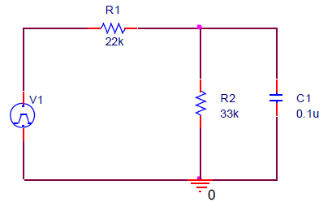

Figure 1, First Order Circuit

# Circuit Analysis to Find Total Response of The System

The circuit of Figure 1 was analyzed using node voltage analysis and resulted in the following equation:

$$\frac{V1-V_{C1}}{R1}+\frac{0-V_{C1}}{R2}+\frac{0-V_{C1}}{\frac{1}{sC_{1}}}=0$$

Which results in the following differential equation in the time-domain:

$\frac{dV_{c1}}{dt}+757.67V_{c1}=454.54V_{c1}$

The following work was performed to determine the piecewise total response of the circuit to V1:

Natural Response: $V_{c1}\left(t\right)= A_{1}e^{-757.6t }$

Forced Response: $0<t<0.1$ $V_{c1}\left(0<t<0.1\right)=1.5$ $V_{c1}\left(t\right)=A_{2}$

$0+757.6\left(A_{2}\right)=454.54\left(1.5\right)$ => $A_{2}=.899$

$V_{c1}\left(0\right)=0=>A_{1}+ 0.899=>A_{1}= -0.899$

Total Response: $0<t<0.1$ => $V_{c1}\left(t\right)= -0.899e^{-757.6t}+0.899$

Forced Response: $0.01<t<0.02$ $V_{c1}\left(0.01<t<0.02\right)= -1.5$ $V_{c1}\left(t\right)=A_{2}$

$0+757.6\left(A_{2}\right)=454.54\left(-1.5\right)$ => $A_{2}= -0.899$ $V_{c1}\left(0.01\right)=0.899=>$

$$0.899=A_{1}e^{-757.67(0.1)}-0.899$$

Total Response: $V_{c1}\left(t\right)=3507.6e^{-756.6(t-0.1)}-0.899$

Forced Response: $0.02<t< ∞$ $V_{c1}\left(0.02<t<∞ \right)$ = 0 $V_{c1}\left(t\right)=A_{2}$

$0+757.67\left(A_{2}\right)=0=>A_{2}=0=>A_{2}=0$ $V_{c1}\left(0.02\right)= -0.897=>$

$$-0.897=A_{1}e^{-757.6t}$$

Total Response: $V_{c1}\left(t\right)= -3.421*{10}^{6}e^{-757.6(t-0.2)}$

$$V_{c1}\left(t\right)=\left\{\left.\begin{aligned}-0.899e^{-757.6t}+0.899, 0<t<0.1 \\ 3507.6e^{-756.6(t-0.1)}-0.899 0.01<t<0.02 \\ -3.421*{10}^{6}e^{-757.6\left(t-0.2\right)} 0.02<t< ∞ \end{aligned}\right\}\right.$$

**MATLAB Graph of Total Response**

Figure 2 contains the code used to generate the MATLAB plot in Figure 3 of the circuits total response using the piecewise total response equations.

clc;

clear;

close all;

% piecewise time intervals

t1 = 0 : .005 : .01;

t2 = .01 : .005 : .02;

t3 = .02 : .005 : .03;

t = [t1 t2 t3];

% piecewise total responses

VC1_1 = -.898*exp(-757.6.*t1) + .899;

VC1_2 = 1.79*exp(-757.6.*t2) - .899;

VC1_3 = -.899*exp(-757.6*(t3-.02));

% plot total response over time

VC1 = [VC1_1 VC1_2 VC1_3];

plot(t,VC1);

Figure 2, MATLAB Program to Graph Response

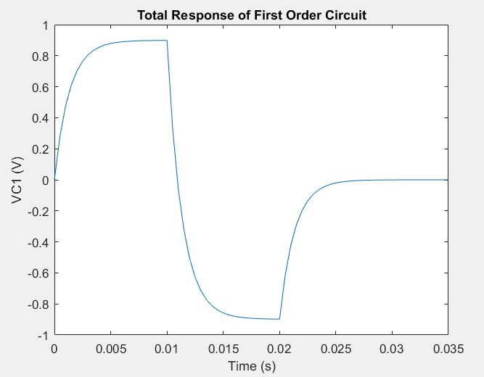

Figure 3, Total Response Plot



# Verification Using PSpice

The circuit in Figure 1 was entered in OrCAD Capture and simulated to verify the analytically determined total response as graphed in Figure 3. Figure 4 contains the circuit schematic and Figure 5 contains the time-domain graph of V1, the input, as the blue square waves and the response of $V_{C1}$ as the red trace.

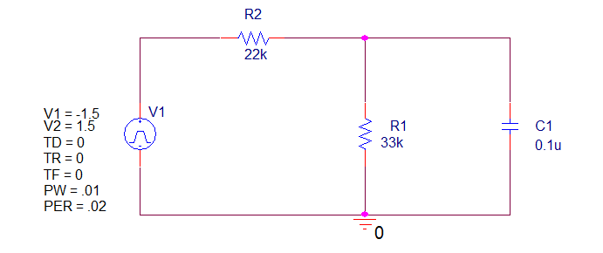

Figure 4, OrCAD Capture Schematic

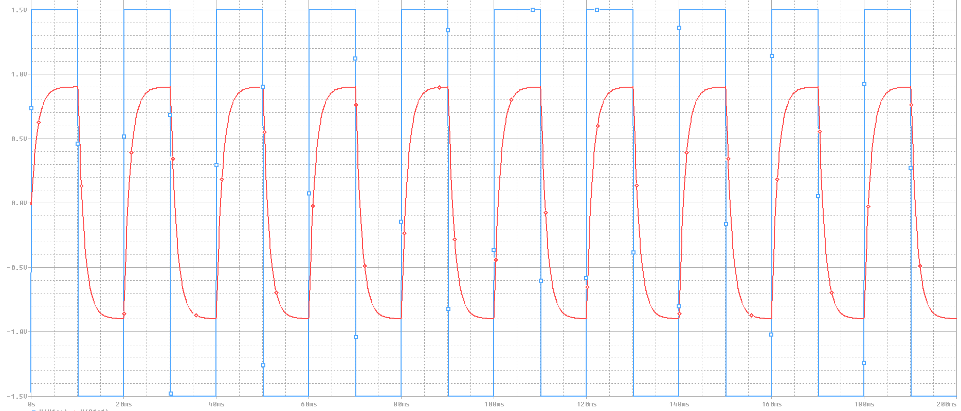

Figure 5, OrCAD Capture Simulation

**Oscilloscope Verification**

Figure 6 contains the simulation screenshots from an oscilloscope attached to the circuit set up on a CADET protoboard. The oscilloscope was attached to the input and the output, $V_{C1}$. The orange trace is the input and the blue trace is the output.

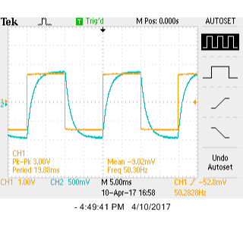

Figure 6, Oscilloscope