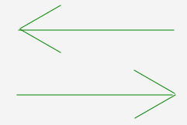
Rolling Codes Authentication System

Final report

Evan Bonsignori, Tyler Norris, Tosha Schmid, Darryl Brown

Department of Computer Science and Information Technology
Armstrong State University

9/29 – 12/5, 2017
Table of Contents

1 Executive Summary (1-2 pages; 5 points - Complete) 3
2 Project Background (2-4 pages; 5 points – Complete) 5
2.1 Needs Statement 5
2.2 Goal and Objectives 5
2.3 Design Constraints and Feasibility 5
2.4 Evaluation of Alternative Solutions 6
3 Final Design (3-6 pages; 20 points – Complete) 7
3.1 System Description 7
3.2 System Diagrams 8
3.3 Approach for Design Validation 9
4 Implementation Notes (3-6 pages; 30 points – Complete) 10
5 Experimental Results (3-7 pages; 20 points – Needs Proofread and Updated Images) 25
5.1 Authentication Protocol Testing 25
5.2 Modularized XTEA Testing 31
6 User’s Manuals (2-4 pages; 20 points – upload pictures and needs polishing (GUI)) 32
7 Appendices 33

Executive Summary (1-2 pages; 5 points - Complete)
Given two separated entities, a transmitter and a reader, one needs to be able to correctly identify another when communicating across a medium. These entities may be two pieces of hardware, and the medium wireless communication. They may be two separated software constructs communicating over the World Wide Web. For instance, a car key fob is a transmitter, and the reader that needs to identify it is the car it intends to open. Another example is a light in a building (reader), that can be activated over WIFI from a cell phone (transmitter). In each of these cases, the reader should only do something if the transmitter sending the signal is the one that the reader is linked to. The process by which a reader receives a request from a transmitter and verifies it is called the authentication process.
Evaluating the need for this type of authentication process is trivial. There are multiple communications between two systems that need to verify a sender’s identity before carrying out some operation. The more important question is why our project is implemented in software rather than hardware. The need to represent the authentication process in software is useful for many reasons. Not only can the authentication process be implemented to authentication between two separate software entities, but the software representation can be useful for testing the authentication process before implementing it in hardware.
However, the purpose of our Rolling Codes Authentication System (RCAS) is not to securely communicate between two entities; rather it is to demonstrate this very communication. Thus, our project is education in its scope and purpose, and is not intended to be used in any commercial product. The educational benefit of our project is to understand and correctly demonstrate a concrete implementation of symmetric key cryptography between a reader and any number of linked transmitters.
The description of the system is as follows: A reader has multiple linked transmitters. Each transmitter has a 64-bit initialization vector called an IV. Each reader has a matching IV stored in its record corresponding to the IV of a linked transmitter’s ID. Having the transmitter IV in the reader’s record before communication is established is what puts this problem in the domain of symmetric key cryptography. In addition to shared IVs, there is a shared 128-bit key used in encryption and decryption. The authentication process begins when the transmitter sends a packet to the reader.
The initial packet sent is called the request packet and consists of three elements: the ID of the transmitter sending the packet (64-bits), the ID of the reader the packet is being sent to (16-bits), and the unpredictable sequence (64-bits). The unpredictable sequence is the most important part of securing the authentication process. It is one of 256 encrypted transmitter IVs, selected at (pseudo) random.
The encryption method used is called XTEA (eXtended Tiny Encryption Algorithm) with CTR mode (Counter Mode). XTEA requires a 128-bit key, which both the transmitter and reader have stored in their records. The transmitter generates 256 XTEA encrypted IVs where each IV is summed with the current iteration (i = 0 to 256) before being encrypted. After encrypting each IV+i using the XTEA, we pseudo-randomly select one of the 256 results. The final step is the CTR mode step, where we XOR the chosen encrypted result with the transmitter’s ID to get our unpredictable sequence.
When the reader receives the request packet containing the unpredictable sequence, it uses the transmitter ID provided by the packet to fetch its corresponding IV and repeats the process described in the previous paragraph. It encrypts IV+i for i = 0 to 256 and XOR’s each result with the transmitter’s ID. At each step the reader compares the results of XOR’ing the encrypted IV+i and if it matches the unpredictable sequence, then the authentication process is verified.
Now we have a system that requires a reader to know both a transmitter’s ID and its IV, and we only provide the ID in the response packet for interception. The unpredictable sequence has been encrypted using XTEA with CTR mode and thus leaks little information. However, if a skilled interceptor manages to find the IV and recreate the process used to generate the unpredictable sequence, then they can resend the request packet and verify the authentication protocol.
To prevent interceptors who have figured out both the ID and IV of a transmitter from authenticating a reader, we implement our final method of security: rolling codes. The rolling codes method requires that a response packet be returned to the transmitter after each request. If the request is verified, then the response packet will let the transmitter know it is time to update their IV with a new value that they provide in the final 64-bits of the response packet. This value is the XTEA with CTR encrypted value of IV+256. Before sending the value, the reader updates its record with a new IV corresponding to the transmitter, IV+256. After receiving the value, the transmitter decrypts the last 64-bits of the response packet and if it is not the current IV of the transmitter, the transmitter updates its own IV value as the value decrypted (IV+256).
In software, we represent the reader and transmitter as classes with their appropriate attributes. A reader has its ID, an array of linked transmitter ID and IV pairs, and a key. A transmitter has its ID, IV, and a key that is the same as the reader it is linked to. A packet class is used to concatenate an inputted transmitter ID, reader ID, and 64-bits into a single construct that can be read by methods in both the transmitter and reader classes. The initial values of every attribute in the reader and transmitter classes are pseudo-randomly generated at runtime by a RandomBits class. The XTEA algorithm is represented as a class that can be initialized with a 128-bit key with methods for encryption and decryption that take 64-bits as argument (plaintext for encryption, ciphertext for decryption).
Attributes that need to be in bits are represented using the following Java primitives: 16 bits are as a short primitive, 32 bits as an int primitive, 64 bits as a long primitive, and the 128-bit key as an array of four 32-bit int primitives. Initialization and communication between the models are done with a controller class, FXMLDocumentController. This controller class communicates with the FXML GUI named FXMLDocument.fxml. The GUI allows for users to create up to 5 readers each linked with 1 to 10 transmitters. The controller class initializes each object as they are created, and when a user chooses to begin the authentication protocol between them, the controller class initiates the authentication by generating a request packet from the transmitter and sending it to the reader. The response packet is then also sent through the controller and the results of the authentication are outputted to the GUI.
The project began with five members and shrunk to four within the first month. Requirements for the entire project were outlined at the first meeting by Evan Bonsignori and breakdowns of who and how to solve them were assigned. Further meetings were bi-weekly and were used to discussed progress and communicate results.
By October 21st, the entirety of the project was complete and functional, save the documentation. In that phase the authentication process was clearly demonstrated between reader and transmitter with verified rolling code and CTR mode methods. However, the XTEA method was implemented in a way that worked, but was not entirely correct per requirements. By October 30th, the XTEA method was modified and test methods were added to the GUI. At the time of this document, everything in the program has been functional since October 30th.

Project Background (2-4 pages; 5 points – Complete)
Implemented in Java with a GUI, the Rolling Codes Authentication System (RCAS) needs to demonstrate the authentication protocol between a reader and its linked transmitters emulated in software for educational and testing purposes. An authentication protocol that involves 144-bit request and response packets must be implemented between a reader and transmitter. The cryptographic XTEA algorithms with CTR mode need to be used, and authentication is only established when all conditions of the authentication protocol are satisfied.

Needs Statement
If a user desires to send a signal from a transmitter to a reader that is only accepted if the transmitter is linked to that reader, then they wish to prevent the reader from accepting signals from others who are using different transmitters. A hacker can spoof a signal that makes the reader think that it is coming from a linked transmitter. This is frequently achieved by intercepting a previously sent signal (packet) from a transmitter and resending it to a reader.

Goal and Objectives
The goal of our RCAS is to provide an authentication protocol that prevents hackers from spoofing a secure connection to a reader from a fake transmitter. Our system prevents a spoofed signal from being confirmed by “rolling” the signal required by the reader after each transmission. After each successful transmission between a reader and transmitter, the initialization vector (IV) is updated in both the reader and transmitters’ records. This way, if a hacker intercepts a previously sent packet and attempts to resend the IV used in the intercepted transmission, the transmitter’s request will be rejected.
In the scenario that a hacker intercepts a packet, it will not be easy for them to derive the IV from the intercepted packet, or the shape of the packet itself without further knowledge of the system. An intercepted packet will contain an unpredictable sequence which is one of 256 possibilities of the IV XOR’d with a transmitter’s ID. Eventually the user may discover that the transmitter ID is included in the packet and retrieve one of the 256 IV’s; however, this IV will be encrypted using an XTEA algorithm. The hacker would not be able to decrypt the IV without the 128-bit key shared between a linked reader and transmitter. This layer of security adds to the rolling codes approach, making the system more secure from hackers seeking to spoof the signals of linked transmitters.
The first objective is in the implementation of the RCAS, and it is to prevent any hacker from faking a transmitter’s request packet. The primary objective of the design was to create a GUI that demonstrates a system that achieves the first objective. This GUI can be used for educational purposes to understand and demonstrate how the authentication protocol works.

Design Constraints and Feasibility
The project was assigned on September 29th 2017 and had to be completed and delivered by December 5th 2017. A team member dropped from the team, leaving only one member with GUI coding experience. The specifications of the design were constrained to a document provided by our team’s professor. Additional specifications included an option of either C++ or Java as implementation language, and the exclusion of external libraries or dependencies such as the XXTEA library for Java, which would have provided XTEA functionality without need for implementation. We were allowed and chose to use JavaFX for GUI development.
The final specification as listed in the project description is that, “All algorithms must be coded by the developers,” which prevented us from using a premade XTEA algorithm. We would have adapted the algorithm to fit our language, Java, as the initial implantation was in C. However, this specification implied that we could not use the premade XTEA algorithm which led to us needing to create it on our own. This led to a feasibility questioning our abilities.
The problem statement requires knowledge of somewhat advanced cryptography algorithms. Since this project was assigned when our team only had knowledge of shift ciphers, the feasibility of solving the algorithms seemed incomprehensible. However, as the semester progressed we learned TEA and CTR mode which made implementing XTEA more feasible. By using Java’s built in primitives, rather than having to implement our own binary representation, the implementation of the XTEA algorithm was relatively simple and only involved following a detailed procedure. As the reader will see in the next section, our method of implementing binary representations with a custom class added unnecessary complexity to the XTEA algorithm implementations.

Evaluation of Alternative Solutions
Initially the project didn’t appear too complex and everything could be hard coded in one or two classes. However, as the need for a GUI was considered, a MVC design paradigm was considered. We used JavaFX’s FXML interface to create a drag and drop GUI and a controller class to interact with it. The logic behind the models is stored in separate classes. There is a reader class, a transmitter class, a packet class, and other helped classes for the XTEA algorithm, random bits generation, and XTEA testing.
- Binary Representation
We chose to represent each construct in bits with Java primitive types. For instance, a 16-bit value was held in a short primitive, a 32-bit value was held in an int primitive, and a 64-bit value was held in a double primitive. Initially, we created a class to represent a Bit object, whose number of bits are passed as an argument during the object’s initialization. Once created, methods for adding, xoring, shifting, and printing could be applied to it to perform the necessary operations requires for the XTEA algorithms.
However, the added complexity of this approach led us to use Java primitives instead of a custom class implementation for representing binary bits. This make the XTEA algorithms easy to implement using Java’s built in bit-wise operations such as ^ for XOR, << for left shift, and more. The code for the Bits class can be found in the Appendix. It is not completely functional, as the truncating used when adding bits does not function as Java primitive addition works.
- GUI Implementation
We chose to use the FXML interface for creating the GUI through a drag and drop application. However, initially the GUI was hard coded. When hard coded, making changes to the interface was tedious and too connected with the front-end logic. By using FXML we were able to separate the logic used in the reader and transmitter classes from the font-end logic more clearly.
- XTEA algorithms
The XTEA algorithms described in the problem description provided by the professor were different from the algorithms found online. Wikipedia has an implementation in C that we were able to translate into Java for our XTEA implementation. The Wikipedia implementation functioned successfully, being able to accurately encrypt and decrypt plaintext, however since the implementation in the project description was different, we chose to instead implement it differently from the implantation on Wikipedia.

Final Design (3-6 pages; 20 points – Complete)

System Description
The system is composed of a view, the GUI that a user can interact with, and the models that the view manipulates. The models consist of up to five readers, and up to ten transmitters per reader that they are linked to. The user can create readers and transmitters from the GUI by typing the desired number of transmitters to be created with a reader, and then pressing the “Add Reader” button.
When a reader is added, the reader ID is pseudo-randomly generated, along with the reader’s key. Then, for each transmitter that is linked to that reader, a transmitter ID is pseudo-randomly generated for each transmitter alongside an IV. After a transmitter is created, it gets the key from the reader it is linked with and stores it in its internal records. The reader then takes the transmitter’s ID and IV and adds it to its internal record. The internal record of a reader can contain up to ten linked transmitters and their corresponding ID, IV pairs.
After initialization, a reader and transmitter contain a shared key. The reader contains all the IVs and IDs of the transmitters it is linked to. The transmitter contains its own IV and ID, the shared key, and the ID of the reader it is linked to. The sizes of each construct are as follows: 128-bit key as an array of four 32-bits, 64-bit transmitter IV, 64-bit transmitter ID, 16-bit reader ID, and 144-bit response and request packets.
When a user selects a reader from the list view that readers are displayed in and a transmitter from the separate list view that transmitters are displayed in, and presses the “Authenticate” button, the authentication protocol begins between the selected reader and transmitter. The authentication protocol is handled by a controller class that first gets the request packet from the transmitter and sends it to the reader for authentication. In this way, the transmitter is always the system that initializes the authentication process.
If the request packet is authenticated by the reader by finding a match of 256 possibilities of XOR’ing the unpredictable sequence from the response packet with the transmitter’s ID, then the reader sends a request packet to the transmitter. The response packet that tells the transmitter that the request was validated will contain the encrypted IV+256 in the last 64-bits of the response packet. If the request was not validated, then the response packet will contain the IV sent in the request packet (unpredictable sequence).
The user is able to view the authentication protocol by selecting the “Print Progress To Console” checkbox before beginning authentication. The user is also able to view the specific values of the IV, ID, response packets, and request packet for additional troubleshooting by selecting the “Print Values To Console” checkbox. Before authentication, a user can select either a transmitter or reader from their respective list views to view the linked key, respective ID, current IV, or the number of linked transmitters attached to a reader.
To add to the capabilities of troubleshooting the authentication protocol, the values of the Transmitter’s ID, IV, shared key, or linked reader ID can be changed from the GUI. The reason that the reader values cannot be changed is because it does not make sense to. For instance, a hacker can try to spoof a transmitter to access a reader, but a hacker has no reason to hack a reader in the scope of this project. Thus, the ability to manipulate values of a transmitter to recreate a spoofing scenario is provided to users of the RCAS.
Finally, there is a console at the bottom of the GUI that provides outputs for all interactions within the system. The console can be cleared by the “Clear Console” button, or the entire session including readers and their linked transmitters can be cleared by using the “Reset All” button. This is a feature that improves the usability of the RCAS, and does not provide additional functionality to the authentication protocol.

System Diagrams
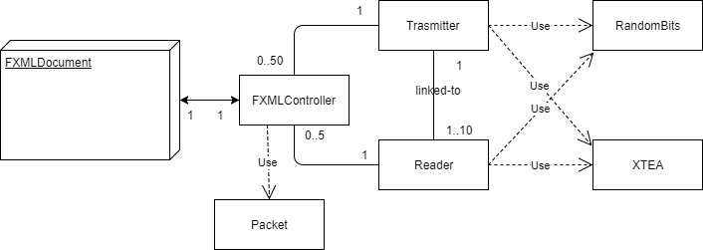
Systems Overview

Model Overview
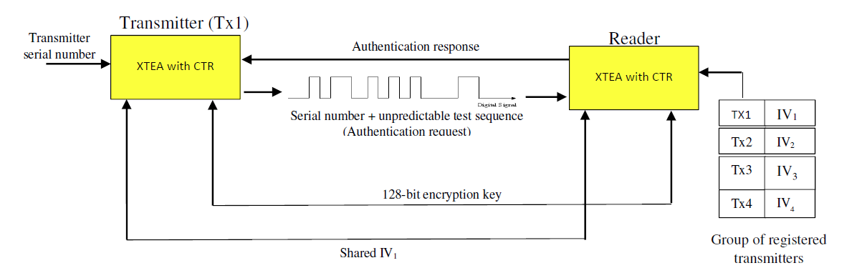

Authentication Protocol

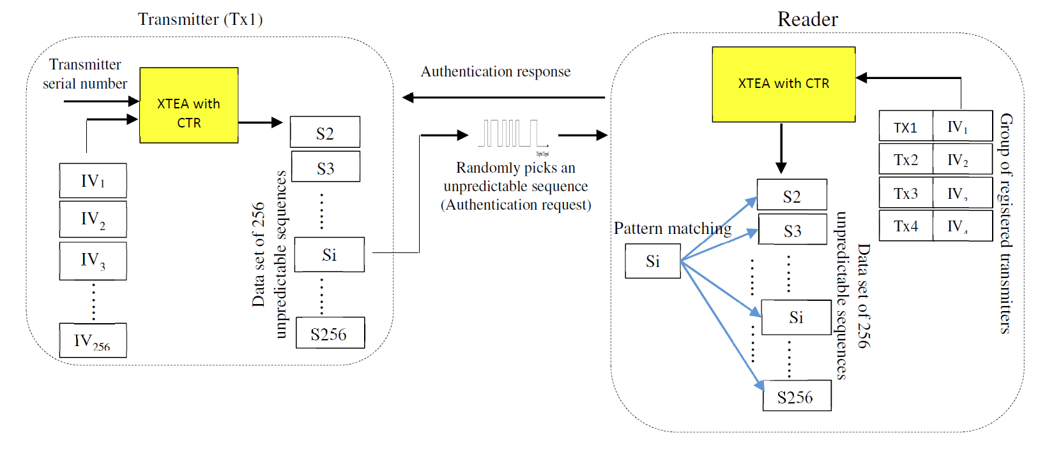
Request Packet
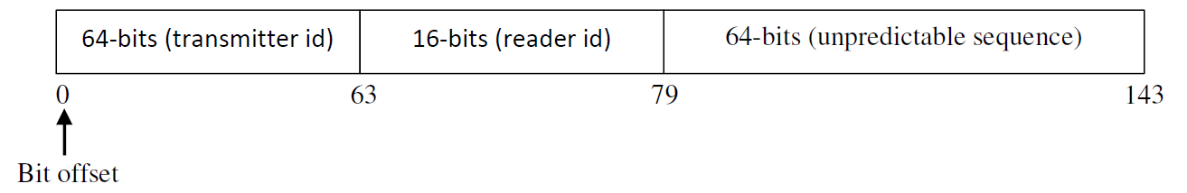
Response Packet
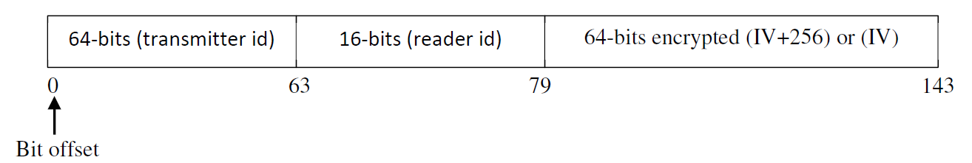

Approach for Design Validation
The validation will be discussed at length in the Experimental Results section of this document, but the approach was primarily modularized component testing. In the experimental results, we will provide the code used to test separate components, such as the XTEA method. In general, after each class was created, a separate tester class was created to run through mock operations.
This helped prevent the system from becoming unwieldy when parts were combined. For instance, if the XTEA class failed to properly encrypt and decrypt 64-bits given a shared key, then the entire authentication protocol would be broken. Since both the reader and the transmitter have dependencies on the XTEA class, breaking the XTEA class breaks the entire system.
Additional validation was performed through the GUI. Since transmitter values can be modified from the GUI, testing can be performed by changing specific values. GUI testing will be elaborated on with pictures in the Experimental Results section.

Implementation Notes (3-6 pages; 30 points – Complete / Needs Proofread)
The RCAS is implemented in Java in two packages: the GUI package for the front-end logic, and the rollingcodeauthentication package for the project’s domain logic. The GUI package contains the FXMLDocument class and the FXMLDocumentController class, along with a nested package called validatetextfields. The validatetextfields package contains the logic for validating four types of field constructs that are interacted with on the GUI by a user: IntNumberField, LongNumberField, NumberOfTXTextField, and ShortNumberField. The rolingcodeauthentication package contains the Transmitter and Reader classes, along with the helper classes: Main, Packet, RandomBits, and XTEA.
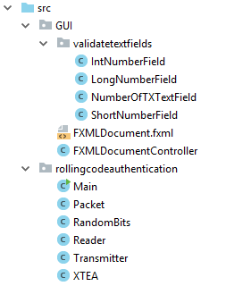
In addition to the application logic, there is a package for testing called, testing. In this package, the authentication protocol is tested with all its dependencies independent of the GUI, and the XTEA method is unit tested independent of other classes (zero dependencies). These two classes will be elaborated on in Experimental Results rather than in Implementation Notes.
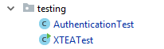
FXMLDocument.fxml
This is the document that contains markdown for the GUI. The validation text fields are imported at the top of the document. Here is a snippet of the source code:
<!-- Import validation fields. -->
<?import GUI.validatetextfields.*?>
<!-- Create labels-->
<Label fx:id="currentValuesHeader" alignment="TOP_CENTER" layoutX="15.0" layoutY="325.0" text="Current Values of Selected TX" textAlignment="CENTER">
<font>
<Font name="System Bold" size="20.0" />
</font>
</Label>
<Label fx:id="currentRdID" layoutX="61.0" layoutY="369.0">
<graphic>
<Label alignment="BOTTOM_CENTER" text="Linked Reader ID:" />
</graphic>
</Label>
<Label fx:id="currentTxID" alignment="BOTTOM_CENTER" layoutX="61.0" layoutY="412.0">
<graphic>
<Label fx:id="txIDLabel" alignment="BOTTOM_CENTER" text="Transmitter ID: " />
</graphic>
</Label>
<!—Create ShortNumberField that has validation and a hover over tooltip-->
<ShortNumberField fx:id="readerIDField" layoutX="641.0" layoutY="365.0">
<tooltip>
<Tooltip text="Changing the linked reader ID will unlink this transmitter from this reader. If you try to link this transmitter to another reader, you will not be able to authenticate because you do not share a key nor does the reader have the corresponding tx IV's in its records." />
</tooltip>
</ShortNumberField>

GUI Demo Image
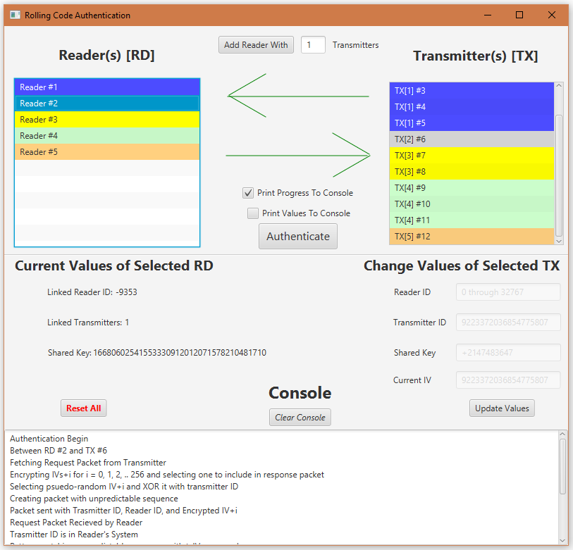

GUI Breakdown
The GUI contains two list views for displaying the transmitters and readers that have been created. For simplicity we will call these transmitter list view and reader list view. Between these two list views is the option to add a new reader with a field to enter how many transmitters to link it to. Upon filling out the number of transmitters field and clicking the add reader button, a reader is added to the reader list view, and the number of linked transmitters are added to the transmitter list view. To aid the user in identifying linked transmitters, a reader and its linked transmitter share the same color.
Below the add reader option are two arrows that can be one of three colors: black, red, and green. Black is a neutral state, a green right-facing arrow implies that the request packet was successfully sent from the transmitter and received by the reader. If something goes wrong in authentication, the left-facing arrow will turn red. These two arrows provide an “at a glance” assessment of the state of the authentication protocol. Below the arrows are checkboxes that enable authentication protocol updates to be displayed in the console. These are the notification checkboxes and enabling them provides a verbose analysis of what is happening during the authentication protocol.
Below the list views and status arrows and to the left are the values of the selected reader or transmitter (for simplicity we will call this values view). To the right are fields for changing the values of a selected transmitter. The ability to change values of a reader does not exist because it is not a realistic scenario for a hacker to change a reader since a hacker is trying to spoof a transmitter to fool the reader (for simplicity we will call this the change-value fields). Under the values view is the option button to reset all, which removes all readers and transmitters and puts the application in the state accessed when it was first opened. Below, the change-value fields is a button to change the transmitter’s records to the values entered in each of the fields (if they were entered).
Finally, at the bottom of the screen is the console. The console is the primary medium for communication with the user. It displays the status of any activity taken in the app, and the status of the authentication protocol when enacted. If the notification checkboxes are enabled, the output provided by enabling each is displayed in the console. Above the console is a button that allows the user to clear the console. Clearing the console does not reset any values like the reset all button. It simply clears the clutter of the console by removing any output text.
Validation Classes
There are four validator classes that all have a similar shape. The primary difference between the validator classes is the validate method. The logic within each validate method distinguishes each type of field by validating a specific thing. For instance, the ShortNumberField only takes numbers for each digit inputted into the field, and then checks to make sure that the combination of digits into a decimal number does not exceed the maximum value that can be stored in a Java short primitive.
This validation makes sure that the authentication process can accurately be demonstrated when a user manually alters a reader ID linked to a transmitter. When a user enters a value that does not make sense for a transmitter to have, the user is prevented from entering that value. Likewise, when a user changes an IV value or transmitter ID, the LongNumberField validator is used to make sure that the value entered does not exceed that which can be stored in a Java long primitive.
The other two validator classes are IntNumberField, for the shared XTEA key, and the NumberOfTTXField that makes sure the entered value is an integer between 1 and 10. The NumberOfTXField is used when specifying the number of transmitters seeking to be linked to a reader that the user will create upon typing the number and clicking the “Add Reader” button. If the value entered exceeds 10, the value is automatically changed to 10, and if the value is less than 1, the value is automatically changed to 1.
Below is the code for the ShortNumberField class. Its shape gives the general idea of how each validator class is implemented. If one wished to create the others, the logic in the validate method is all that needs to be adjusted.
import javafx.scene.control.TextField;
/* Validator class for Number Field in range of Java Short primitives */
public class ShortNumberField extends TextField {
// Prompt text to show accepted input range
public ShortNumberField() {
this.setPromptText("0 through " + Short.toString(Short.MAX_VALUE));
}
/* replaceText and replaceSelection are necessary for validate functionality */
@Override
public void replaceText(int i, int i1, String string) {
if (string.matches("[0-9]") || string.isEmpty()) {
super.replaceText(i, i1, string);
}
this.validate();
}
@Override
public void replaceSelection(String string) {
super.replaceSelection(string);
}
/* Checks that value is within range of short integers */
public void validate() {
String newValue = this.getText();
// Confirm that entered digit is a number 0 through 9
if (newValue.matches("[0-9]+")) {
long value = Long.parseLong(newValue);
// If exceeds or goes under range, appropriately set to min or max
if (value < Short.MIN_VALUE) {
super.setText(Short.toString(Short.MIN_VALUE));
} else if (value > Short.MAX_VALUE) {
super.setText(Short.toString(Short.MAX_VALUE));
}
}
}
}

FXMLDocumentController.java
The controller class contains multiple methods for interacting with the GUI and the authenticate method that demonstrates the main purpose of the RCAS, and that is the authentication protocol between a reader and a selected transmitter. The only other logic that is not solely interacting with the GUI is in the addReader method that creates a reader and up to ten linked transmitters.
There is a class declaration contained in the FXMLDocumentController source code. This class overwrites System.out.print to redirect output to a textarea contained in the GUI. The logic that initiates this overwrite is in the initialize class. There are alternatives for providing status updates to the user, but this was the easiest for our project, and thus we decided to use it. Below is the code that implements the redirect.
@Override
public void initialize(URL url, ResourceBundle rb) {
// Create console to output status of the authentication
Console console = new Console(logConsole);
PrintStream ps = new PrintStream(console, true);
System.setOut(ps);
System.setErr(ps);
logConsole.setText("First, add a reader with linked transmitters. \n"
+ "Next, select two and press authenticate to begin authentication.");

/* Redirects System.out to Console TextArea located in the GUI */
public static class Console extends OutputStream {
private TextArea output;
public Console(TextArea ta) {
this.output = ta;
}
@Override
public void write(int i) throws IOException {
output.appendText(String.valueOf((char) i));
}
}

The following underlined headings are the various methods in the FXMLDocumentController class and a description of what they do.
addReader()
Adds a reader with the user specified number of transmitters. This method initializes the reader and calls the appropriate methods for linking each transmitter to a reader.
selectTX()
Logic for processing GUI reactions for when a transmitter is selected from the transmitter list view. This includes updating the values view with the respective values of the transmitter, and enables the change-value fields (which are disabled until a transmitter is actively selected).
selectRD()
Similar to the selectTX and selectRD methods, selectRD() contains the logic for processing GUI reactions for when a reader is selected form the reader list view. Reader values are displayed in the value fields, but there are no change-value fields for a reader, and the reasons for this were stated earlier in this section.
updateReaderID()
The logic for getting the user-provided reader ID value from the appropriate update-value fields and updating it for the selected transmitter. This will prevent a transmitter from sending a request packet to a target, since the target may not exist. However, if a reader ID of another reader is entered, then the reader will receive the request packet, but may not authenticate it unless the proper ID, IV, and key are changed as well.
updateTransmitterID()
The logic for getting the user-provided transmitter ID value from the appropriate update-value fields and updating it for the selected transmitter. This will prevent the transmitter from being properly authenticated by its linked reader.
updateKeyID()
The logic for getting the user-provided transmitter key value from the appropriate update-value fields and updating it for the selected transmitter. This is a prototype since the key provided is just a single Java int primitives rather than an array of four Java int primitives. As a prototype, this provides adequate functionality for demonstrating key manipulation to an invalid key.
updateIV()
The logic for getting the user-provided IV value from the appropriate update-value fields and updating it for the selected transmitter. This will affect reader authentication.
updateValues()
This is the main method for calling one or all of the previously described update methods in order to update the values of the transmitter selected from the transmitter list view. It checks for user input into the update-values fields and calls the appropriate update method(s).
resetAll()
Removes all readers, transmitters, and other session data. It is enabled by the reset all button and brings the session to the state it would have been in upon opening the application.
clearConsole()
Clears the output console of any text. Used to remove clutter or for clearing possible and undesirable error messages.
colorLeftArrow(String status)
Colors the left arrow green, red, or black depending on the status passed. This is a helped method that is called by other methods that need to update the arrow’s status.
colorRightArrow(String status)
Same logic and purpose as the colorLeftArrow method, but for the right-pointing arrow.
authenticate()
The most important method in the controller class. It contains the logic for emulating the authentication protocol between a reader and a transmitter; both of which are the ones currently selected from their appropriate list views. Below is the code with comments before each section explaining what it does.
/*
* Method that demonstrates applications main logic takes selected TX and
* selected RD and establishes communication through a request and response
* packet. The packets are both 144-bits and each can be displayed to
* Console if displayValues is true (checkbox is selected). For a further
* description of the application and the authentication process between TX
* and RD, view the README.md in the parent directory
*/
@FXML
public void authenticate() {
// Get selected TX and RD indexes
int txIndex = txList.getFocusModel().getFocusedIndex();
int rdIndex = rdList.getFocusModel().getFocusedIndex();
if (txIndex > -1 && rdIndex > -1) {
try {
// User index to get transmitter and see if linked reader ID exists
Reader reader = null;
Transmitter tx = TXs.get(txIndex);
for (Reader rd : RDs) {
// Check if transmitter ID matches a reader ID
if (tx.getReaderID() == rd.getReaderID()) {
// Check if the selected reader matches transmitter reader ID
if (RDs.get(rdIndex).getReaderID() == tx.getReaderID()) {
reader = rd;
}
}
}
// If the reader ID matches no reader, update status to failure
if (reader == null) {
logConsole.setText("Selected transmitter is not linked to the selected reader.");
colorRightArrow("fail");
colorLeftArrow("fail");
} else {
// Check to see if checkboxes are selected and update values if they are
boolean printingValues = printValues.isSelected();
boolean printingProgress = printProgress.isSelected();
logConsole.setText("Authentication Begin \n");
System.out.print("Between RD #" + Integer.toString(rdIndex+1));
System.out.println(" and TX #" + Integer.toString(txIndex+1));
/* In software we fetch the request packet from TX though the
* TX is the one that initalizes the authentication process */
Packet requestPacket = tx.getRequestPacket(printingProgress, printingValues);
colorLeftArrow("success"); // Color arrow green
if (printingValues) {
System.out.println("Request Packet: ");
System.out.println(requestPacket.toString());
}
// Send request packet to reader to get response packet
Packet responsePacket = reader.getResponsePacket(requestPacket, printingProgress, printingValues);
/* Send response packet to TX and update record if the IV is
* updated. If it isn't the response packet will be equal to
* the request packet */
boolean isSuccessful = tx.updateRecord(responsePacket, printingProgress, printingValues);
if (printingValues) {
System.out.println("Response Packet: ");
System.out.println(responsePacket.toString());
}
// Output result of authentication
if (isSuccessful) {
System.out.println("Authentication Completed Sucessfully");
colorRightArrow("success");
}
// Fail message
else {
System.out.println("Authentication Failed");
colorRightArrow("fail");
}
}
// If unobserved error occurs, notify user.
} catch (Exception e) {
e.printStackTrace();
System.out.println("Authentication Ended With Error. Please contact admin.");
}
}
}

Main.java
This is the entry point for the application. It simply overrides the start method that processes the FMXL document and sets the scene. The main method simply begins the GUI loop with the launch(args); command.
RandomBits.java
This class contains the logic for generating random bits of length: 16, 32, 64, and an array of 4 random 32-bits (for XTEA key). The methods in the class are static and are called directly from the Transmitter and Reader classes. Below is an example of random 32
private static final int INT_MAX = Integer.MAX_VALUE;

…

/* Returns random 32 bits represented as int primitive */
public static int random32() {
return (int) rand.nextInt(INT_MAX);
}

Packet.java
The packet class is for representing the 144-bit packets sent between the reader and transmitter. The last 64-bits are aptly named “block” since the last 64-bits are what changes between request and response packets. Below is the code for the packet class.
/*
* Packet holds a 64-bit transmitter ID, 16-bit reader ID, and a 64-bit block
*/
public class Packet {
private long txID;
private short readerID;
private long block;
Packet(long txID, short readerID, long block) {
this.txID = txID;
this.readerID = readerID;
this.block = block;
}
public long getTxId() {
return this.txID;
}
public short getReaderId() {
return this.readerID;
}
public long getBlock() {
return this.block;
}
@Override
public String toString() {
StringBuilder str = new StringBuilder(3);
str.append("Tx ID = " + Long.toBinaryString(this.txID) + "\n");
str.append("Reader ID = " + Integer.toBinaryString((int)this.readerID) + "\n");
str.append("64-bit Block = " + Long.toBinaryString(this.block));
return str.toString();
}
}

XTEA.java
The XTEA class contains the encrypt and decrypt methods, and both require that an XTEA object be initialized by a key. The commented code for the XTEA class is as follows.
/*
* XTEA Encryption and Decryption algorithms. Includes TEA implementations
* as well for potential option of using TEA instead of XTEA
*/
public class XTEA {
private int rounds = 64;
private long[] delta = new long[rounds];
private int[] keys;
/* Initalize XTEA Object with key and set initial value of delta */
public XTEA(int[] key) {
this.keys = key;
delta[0] = Long.parseLong("2654435769");
}
/* Takes 64-bit block and returns the XTEA encrypted bits */
public long encrypt(long block) {
int[] leftHalf = new int[64];
int[] rightHalf = new int[64];
// Split 64 bits into right and left halves and convert to integers
leftHalf[0] = (int)(block >> 32);
rightHalf[0] = (int)block;
// Encrypt using XTEA algorithm
int r = 0;
for (int i = 0; i < rounds - 1; i++) {
r = i + 1;
delta[i] = ((i+1) / 2 ) * delta[0];
// Left half[i] + round_function(right[i], Key[2i-1
leftHalf[i+1] = leftHalf[i] + ((rightHalf[i] << 4 ^ rightHalf[i] >>> 5) + rightHalf[i] ^ (int) delta[i] + keys[keyIndex(r)]);
rightHalf[i+1] = rightHalf[i] + ((leftHalf[i+1] << 4 ^ leftHalf[i+1] >>> 5) + leftHalf[i+1] ^ (int) delta[i+1] + keys[keyIndex(r)]);
}
long encrypted = (long)leftHalf[rounds-1] << 32 | rightHalf[rounds-1] & 0xFFFFFFFFL;
return encrypted;
}
/* Takes 64-bit block and returns the XTEA decrypted bits */
public long decrypt(long block) {
int[] leftHalf = new int[64];
int[] rightHalf = new int[64];
// Split 64 bits into right and left halves and convert to integers
leftHalf[0] = (int)(block >> 32);
rightHalf[0] = (int)block;
// Decrypt using XTEA algorithm
int r = 0;
for (int i = 0; i < rounds - 1; i++) {
r = i + 1;
delta[i] = ((i+1) / 2) * delta[0];
rightHalf[i+1] = rightHalf[i] - ((leftHalf[i] << 4 ^ leftHalf[i] >>> 5) + leftHalf[i] ^ (int) delta[i] + keys[keyIndex(r)]);
leftHalf[i+1] = leftHalf[i] - ((rightHalf[i+1] << 4 ^ rightHalf[i+1] >>> 5) + rightHalf[i+1] ^ (int) delta[i+1] + keys[keyIndex(r)]);
}
long decrypted = (long)leftHalf[rounds-1] << 32 | rightHalf[rounds-1] & 0xFFFFFFFFL;
return decrypted;
}
/* Function for selecting a pseudo-random number for the key index */
public int keyIndex(int round) {
if (round % 2 != 0) {
return (int) delta[(round-1)/2] & 0x3;
} else {
return (int) delta[round/2 >>> 11] & 0x3;
}
}
}

Reader.java
The reader class represents a reader object with the following attributes: reader ID, XTEA key, number of linked transmitters, and a list of transmitter IDs and their corresponding IVs. The code for the reader class is below.

/* Reader holds the shared ID and IVs of n linked TXs (Transmitters) */
public class Reader {
private int[] key = RandomBits.random32s(4);
private short readerID;
private int numOfLinkedTxs = 0;
private ArrayList<long[]> txIdsAndIvs;
private XTEA xtea = new XTEA(this.key);
/* Initialize Reader with just ID */
public Reader() {
this.readerID = RandomBits.random16();
}
/* Initialize Reader ID and known number of Transmitters to be linked */
public Reader(int n) {
this.readerID = RandomBits.random16();
this.txIdsAndIvs = new ArrayList<long[]>(n);
}
/* Link new TX if it isn't already linked and return this Reader's ID */
public short linkTransmitter(long txID, long txIV) {
long[] idAndIv = new long[]{txID, txIV};
if (!txIdsAndIvs.contains((long[])idAndIv)) {
txIdsAndIvs.add(idAndIv);
numOfLinkedTxs++;
} else {
System.out.println("Reader already TX with this ID");
}
return this.readerID;
}
/* Takes in request packet and returns response packet if verified */
public Packet getResponsePacket(Packet requestPacket, boolean printingProgress, boolean printingValues) {
if (printingProgress) System.out.println("Request Packet Recieved by Reader");
// Verify TX sent request to this reader
if (requestPacket.getReaderId() == this.readerID) {
// Verify TX's ID is linked to this reader (in the TX ID list)
if (printingProgress) System.out.println("Trasmitter ID is in Reader's System");
long txId = requestPacket.getTxId();
int[] txIdIvIndexes = this.indexPairOf(txId);
// If TxID is in system
if (txIdIvIndexes[0] != -1) {
long actualTxIv = this.txIdsAndIvs.get(txIdIvIndexes[0])[1];
long apparentTxIv;
long unpredictableSequence = requestPacket.getBlock();
boolean isValidIV = false;
// Run through 256 possibilites and find match by XOR with known IV and possible IV's
if (printingProgress) System.out.println("Pattern matching unpredictable sequence with txIV on record");
for (int i = 0; i < 256; i++) {
apparentTxIv = xtea.encrypt((long) actualTxIv + i);
isValidIV = (apparentTxIv ^ txId) == unpredictableSequence;
if (isValidIV) {
break;
}
}
// Return Response Packet with TX's IV + 256
if (isValidIV) {
if (printingProgress) System.out.println("Authentication Verified: "
+ "decrypted IV matches IV on Reader record!");
long updatedIV = actualTxIv + 256;
this.updateRecord(requestPacket.getTxId(), updatedIV, printingProgress, printingValues);
if (printingProgress) System.out.println("Sending Response Packet to Transmitter");
return new Packet(requestPacket.getTxId(),
requestPacket.getReaderId(),
xtea.encrypt(updatedIV));
// If no match return the request packet as the response packet
} else {
System.out.println("Authentication Failed: IVs don't match.");
return requestPacket;
}
} else {
System.out.println("Authentication Failed: TX ID is not linked to this reader");
}
} else {
System.out.println("Authentication Failed: TX ID is not in this Reader's System");
}
return requestPacket;
}
/* Returns the 2d index of the set in the TX ID and IV list */
public int[] indexPairOf(long set) {
for (int i = 0; i < this.numOfLinkedTxs; i++) {
long[] thisSet = this.txIdsAndIvs.get(i);
if (thisSet[0] == set) {
return new int[]{i, 0};
} else if (thisSet[1] == set) {
return new int[]{i, 1};
}
}
return new int[]{-1, -1};
}
/* Update TX in record identified by argument 1's ID with argument 2's IV */
public void updateRecord(long txID, long updatedIV, boolean printingProgress, boolean PrintingValues) {
// Replace old IV with new IV
if (printingProgress) System.out.println("Updating Reader's IV record with next IV");
if (PrintingValues) System.out.println("Next IV = IV + 256 = " + Long.toBinaryString(updatedIV));
this.txIdsAndIvs.set(this.indexPairOf(txID)[0], new long[]{txID, updatedIV});
}
/* Update IV corresponding to txID */
public void updateIV(long ID, long IV) {
this.txIdsAndIvs.set(this.indexPairOf(ID)[0], new long[]{ID, IV});
}
/* Update IV corresponding to txID */
public void updateID(long oldID, long newID, long IV) {
this.txIdsAndIvs.set(this.indexPairOf(oldID)[0], new long[]{newID, IV});
}
/* Get this Reader's ID */
public short getReaderID() {
return this.readerID;
}
/* Set this Reader's ID */
public void setReaderID(short newID) {
this.readerID = newID;
}
/* Get number of TX's linked to this Reader */
public int getNumOfTx() {
return this.numOfLinkedTxs;
}
/* Get this Reader's ID */
public int[] getXTEAKey() {
return this.key;
}
/* This key concatenated into a string */
public String getSharedKeyString() {
StringBuilder keyString = new StringBuilder(this.key.length);
for (int i = 0; i < this.key.length; i++) {
keyString.append(Integer.toString(this.key[i]));
}
return keyString.toString();
}
}

Transmitter.java
The transmitter class represents a transmitter object with the following attributes: linked reader ID, shared XTEA key, transmitter ID, transmitter IV, a linked Reader object, and a packet object containing the last send request packet. The code for the transmitter class is below.

/* TX (Transmitter) has its ID, IV and the ID of the reader it is linked to */
public class Transmitter {
private short linkedReaderID;
private int[] sharedKey;
private long txID;
private long txIV;
private XTEA xtea;
private Packet sentRequestPacket;
private Reader linkedReader;
/* Initialize TX with random ID and IV, unlinked to reader */
public Transmitter() {
this.txID = RandomBits.random64(); // 62 random Bits
this.txIV = RandomBits.random64();
}
/* Initialize TX with random ID and IV, linked the Reader in argument */
public Transmitter(Reader reader) {
linkedReader = reader;
this.txID = RandomBits.random64();
this.txIV = RandomBits.random64();
this.linkedReaderID = reader.linkTransmitter(this.txID, this.txIV);
this.sharedKey = reader.getXTEAKey();
this.xtea = new XTEA(this.sharedKey);
}
/* Get this TX's ID */
public long getID() {
return this.txID;
}
/* Sets this reader's ID and updates corresponding ID in reader's record */
public void setCurrentID(long newID) {
// linkedReader.updateID(this.txID, newID, this.txIV);
this.txID = newID;
}
/* Get the reader ID that this TX is linked to */
public short getReaderID() {
return this.linkedReaderID;
}
/* Sets linked reader ID. Reader not guarenteed to have TX ID in its record */
public void setReaderID(short readerID) {
this.linkedReaderID = readerID;
}
/* Returns this TX's current IV */
public long getCurrentIV() {
return this.txIV;
}
/* Sets this reader's IV and updates corresponding IV in reader's record */
public void setCurrentIV(long newIV) {
this.txIV = newIV;
// linkedReader.updateIV(this.txID, this.txIV);
}
/* Returns shared key as concatenated string */
public String getSharedKeyString() {
StringBuilder keyString = new StringBuilder(this.sharedKey.length);
for (int i = 0; i < this.sharedKey.length; i++) {
keyString.append(Integer.toString(this.sharedKey[i]));
}
return keyString.toString();
}
/* Sets an int to all four keys */
public void setSharedKey(int key) {
for (int i = 0; i < 4; i++) {
this.sharedKey[i] = key;
}
this.xtea = new XTEA(this.sharedKey);
}
/* Generate request packet with messages if arg is true, without if false*/
public Packet getRequestPacket(boolean printingProgress, boolean printingValues) {
if (printingProgress) System.out.println("Fetching Request Packet from Transmitter");
int ctr = 256;
long[] Ivs = new long[ctr];
// Encrypt IV+i for i=0-256 and psuedo-randomly select one
if (printingProgress) System.out.println("Encrypting IVs+i for i = 0, 1, 2, .. 256 and selecting one to include in response packet");
for (int i = 0; i < ctr; i++) {
Ivs[i] = xtea.encrypt((long) this.txIV + i);
}
// Psuedo-randomly select an encrypted IV and XOR it with TX ID
int randomIndex = 0 + (int)(Math.random() * ((ctr - 0) + 1));
if (printingProgress)
System.out.println("Selecting psuedo-random IV+i and XOR it with transmitter ID");
if (printingValues)
System.out.println("Selected IV+i = " + Long.toBinaryString(Ivs[randomIndex]));
long unpredictableSequence = Ivs[randomIndex] ^ this.txID;
if (printingProgress) System.out.println("Creating packet with unpredictable sequence");
/* Request Packet contains: TX ID, Reader ID, and IV+i encrypted IV */
this.sentRequestPacket = new Packet(this.txID,
this.linkedReaderID,
unpredictableSequence);
if (printingProgress) System.out.println("Packet sent with Trasmitter ID, Reader ID, and Encrypted IV+i");
return sentRequestPacket;
}
/* Update TX's IV if linked Reader sends verified response packet */
public boolean updateRecord(Packet responsePacket, boolean printingProgress, boolean printingValues) {
if (printingProgress) System.out.println("Response Packet recieved from reader");
if (responsePacket.getBlock() != this.sentRequestPacket.getBlock()) {
if (printingProgress) System.out.print("Updating Transmitter Record with next IV" );
// Update IV to the old IV + 256, as stored in response packet
this.txIV = xtea.decrypt(responsePacket.getBlock());
if (printingValues)
System.out.println("Decrypted IV to update records = " + Long.toBinaryString(this.txIV));
return true;
}
System.out.println("Not Updating Transmitter Record with next IV");
return false;
}
}

Experimental Results (3-7 pages; 20 points – Needs Proofread and Updated Images)
The validation of the RCAS was done through two mediums: the GUI and the testing package.
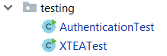

Authentication Protocol Testing
The testing package was used frequently in development. The authenticationTest code is as follows.
AuthenticationTest.java
package testing;
import rollingcodeauthentication.Packet;
import rollingcodeauthentication.Reader;
import rollingcodeauthentication.Transmitter;
public class AuthenticationTest {
public static void main(String[] args) {
try {
// Create a reader and link it with a transmitter
Reader reader = new Reader(1);
Transmitter tx = new Transmitter(reader);
// Turn both printing options on for troubleshooting
boolean printingValues = true;
boolean printingProgress = true;
/* In software we fetch the request packet from TX though the
* TX is the one that initializes the authentication process */
Packet requestPacket = tx.getRequestPacket(printingProgress, printingValues);
if (printingValues) {
System.out.println("Request Packet: ");
System.out.println(requestPacket.toString());
}
// Send request packet to reader to get response packet
Packet responsePacket = reader.getResponsePacket(requestPacket, printingProgress, printingValues);
/* Send response packet to TX and update record if the IV is
* updated. If it isn't the response packet will be equal to
* the request packet */
boolean isSuccessful = tx.updateRecord(responsePacket, printingProgress, printingValues);
if (printingValues) {
System.out.println("Response Packet: ");
System.out.println(responsePacket.toString());
}
// Output result of authentication
if (isSuccessful) {
System.out.println("Authentication Completed Sucessfully");
} else {
System.out.println("Authentication Failed");
}
} catch (Exception e) {
e.printStackTrace();
System.out.println("Authentication Ended With Error.");
}
}
}

If a user compares this code with the code from the authentication method in the controller class, they will find many similarities as this is the authentication protocol between the reader and the transmitter. For more elaborate testing, the set transmitter attribute methods can be called to emulate a fake transmitter by adding a few lines of code to the test method. Rather than running through all possibilities in the code as would be done in a professional project, fake transmitters can be spoofed through the GUI by altering transmitter values in the change-value fields.
Testing Cases of Spoofed Transmitters from the GUI
First, we create two readers, reader1 and reader2 each with a single linked transmitter, transmitter 1 and 2.
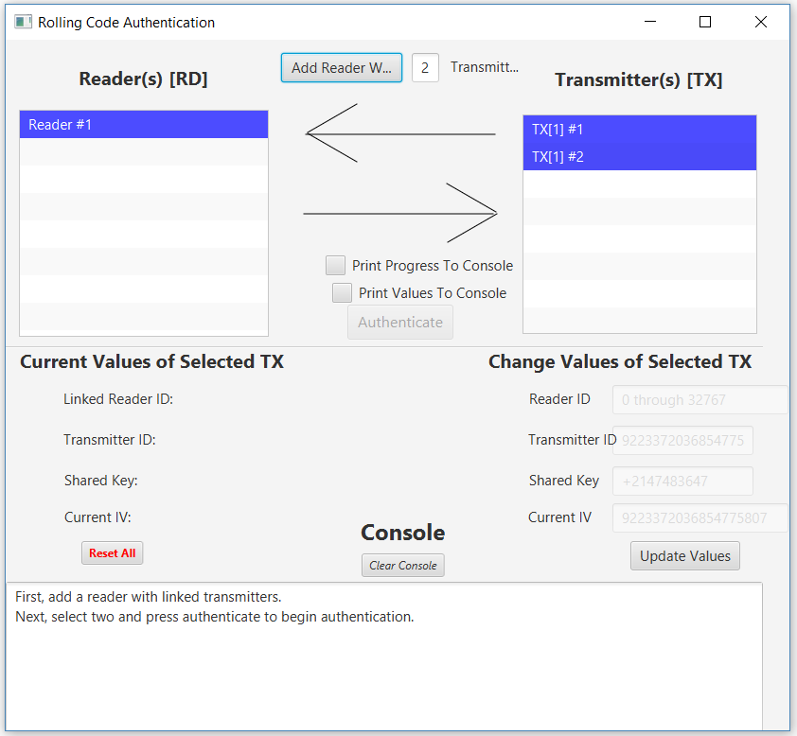
If we try to authenticate reader 1 with transmitter 2, we can immediately see that something did not work by the two red status arrows and the error message: “Selected transmitter is not linked to the selected reader.” Let us fix that by altering the reader ID of transmitter 2 to the reader ID of reader 1.
Now we can see that the reader accepted the request packet of the transmitter, but did not find the transmitter’s ID in the request packet and thus failed the authentication (by returning a request packet that does not update the transmitter’s record). Let us try to change the current ID of transmitter 2 to the ID of transmitter 1 to try and spoof reader 1 into thinking that transmitter 2 is transmitter 1.
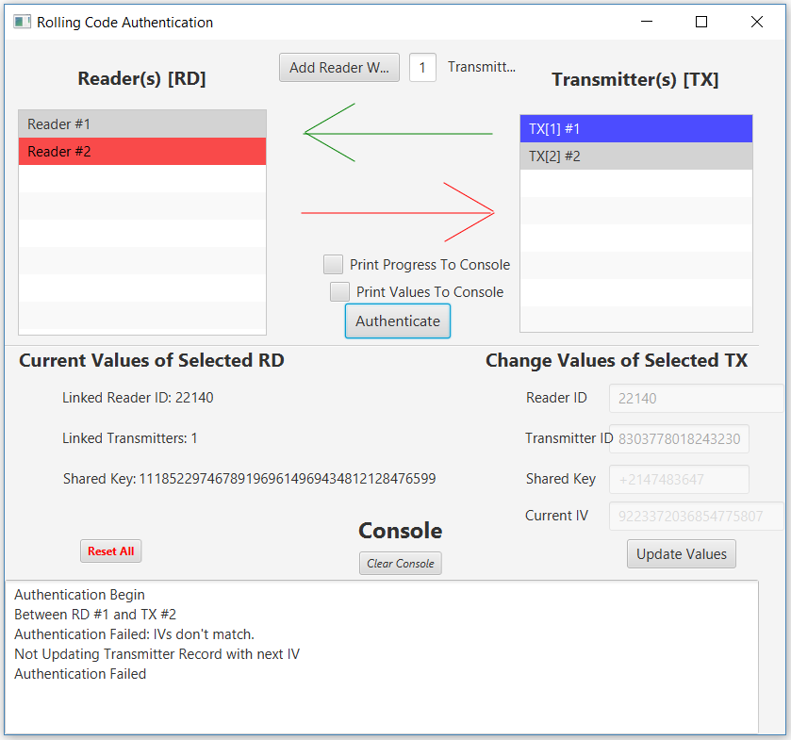
Again, we get an error message and one correct arrow. This time however we are told that we have an invalid IV. Let us try to change the IV and authenticate again.
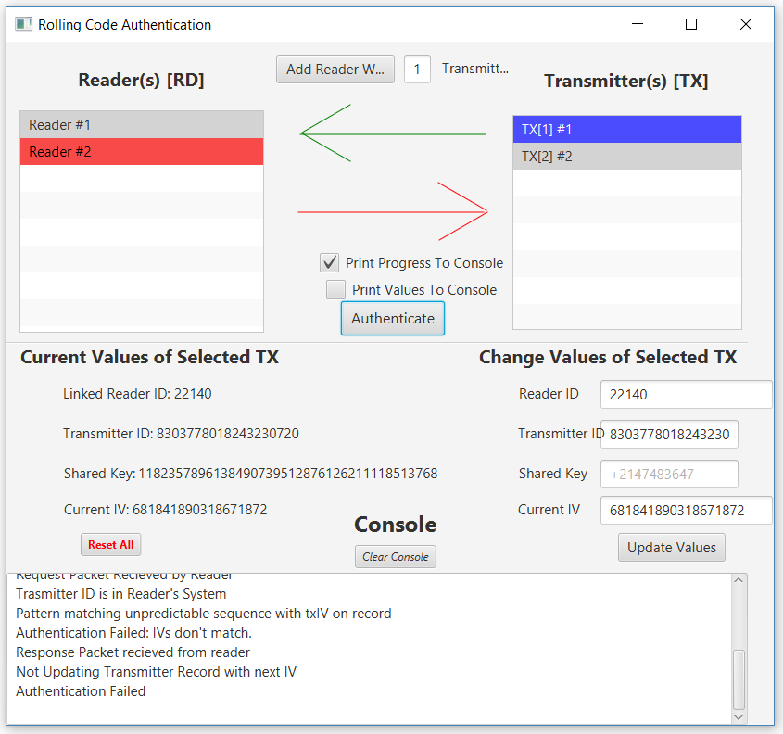
We receive the same error, meaning that when pattern matching the 256 IVs, the correct IV was not found. The reason we get this error message when the reader ID, Transmitter ID, and IV are correct is because the shared XTEA key is not correct, meaning that when we encrypt the IV on the transmitter side using the XTEA algorithms, we are providing the wrong value for the unpredictable sequence in the request packet. Thus, we would need the correct key in order to authenticate and that feature was not implemented in the GUI.
In the case that we could correctly set the shared 128-bit key as four Java int primitives, our authentication between reader and spoofed transmitter would be authenticated. However, after authentication the current IV is updated. Take this example of the current IV of the transmitter before and after authentication between the correctly linked reader 1 and transmitter 1.

Here we can see that the current IV updates after authentication to its old value plus 256. This added measure of security known as rolling codes helps prevent a user from spoofing a transmitter, because by the time they correctly found the transmitter ID, key, and IV, the IV would have likely been updated making the spoofed IV invalid. Thus, our project corrrectly implements rolling code authentication using the specified authentication protocol.

Modularized XTEA Testing
Since the entire authentication protocol depends on the accuracy of the XTEA method, it was tested frequently during development before being included in the authentication protocol. During development, the values for encryption and decryption were hard coded.
XTEATest.java
The following code was used to test the XTEA method with no dependancies on other RCAS classes.
package testing;
import rollingcodeauthentication.XTEA;
import java.util.Random;
/* A class with only a main method for testing the XTEA Class. */
public class XTEATest {
// Code for generating random 16, 32, and 64 bits.
public static void main(String[] args) {
Random rand = new Random(); // For all pseudo random operations
// Generate random 128 bit key as array of 4 32 bit integers
int[] key = new int[4];
for (int i = 0; i < 4; i++) {
key[i] = rand.nextInt(Integer.MAX_VALUE);
}
// Initialize xtea object with random key
XTEA xtea = new XTEA(key);
// Generate random 64 bits to act as Transmitter IV
long block = (long) (rand.nextDouble() * Long.MAX_VALUE);
System.out.println("Initial IV Value");
System.out.println(Long.toBinaryString(block));
// Encrypt 64 bits
long encrypted = xtea.encrypt(block);
System.out.println("\nEncrypted IV Value");
System.out.println(Long.toBinaryString(encrypted));
// Decrypt 64 bits
long decrypted = xtea.decrypt(encrypted);
System.out.println("\nDecrypted IV Value");
System.out.println(Long.toBinaryString(decrypted));
System.out.println("\nXTEA Works: ");
System.out.println(decrypted == block);
}
}

User’s Manuals (2-4 pages; 20 points)
This document should contain detailed (1) hardware installation (if there is one), (2) software installation, and (3) operation instructions for the users of your product(s). It should be aimed at the “average user” of your system (please identify the characteristics of such user) and should not require that the reader be an engineering professional.

6.1 Software Installation – Download Java SE Runtime Environment
- Download Java SE Runtime Environment in order to run Java program. Link: http://www.oracle.com/technetwork/java/javase/downloads/jre8-downloads-2133155.html. Click ‘Accept License Agreement’ and select the correct software for your operating system (You need to know if your operating system is 64-bit or 86-bit).
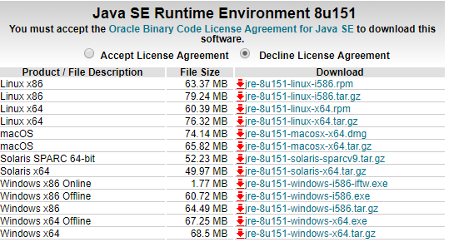
- Download should begin automatically.

- When download is complete, select to open installation wizard.
- Select ‘Yes’ to verify that program can make changes.
- Select ‘Install’ to begin wizard setup.
Image – Oracle 1
- Wait for software to install.
- Software installation complete. Click ‘Close’

6.2 Software Installation – Download Rolling Codes Authentication program
- Download Rolling Codes Authentication System. Link to webpage: https://github.com/Ebonsignori/RollingCodesAuthenticationSystem/blob/master/code/Hopping%20Codes%20Authentication%20System/out/artifacts/Hopping_Codes_Authentication_System_jar/Hopping%20Codes%20Authentication%20System.jar
- Select the download button in the top right or the ‘View Raw’ link to begin download process. When done, click on the downloaded .jar

- Program will begin execution. For a tutorial on how to use the RCAS, see the next section.

6.3 Using The Rolling Code Authentication Application
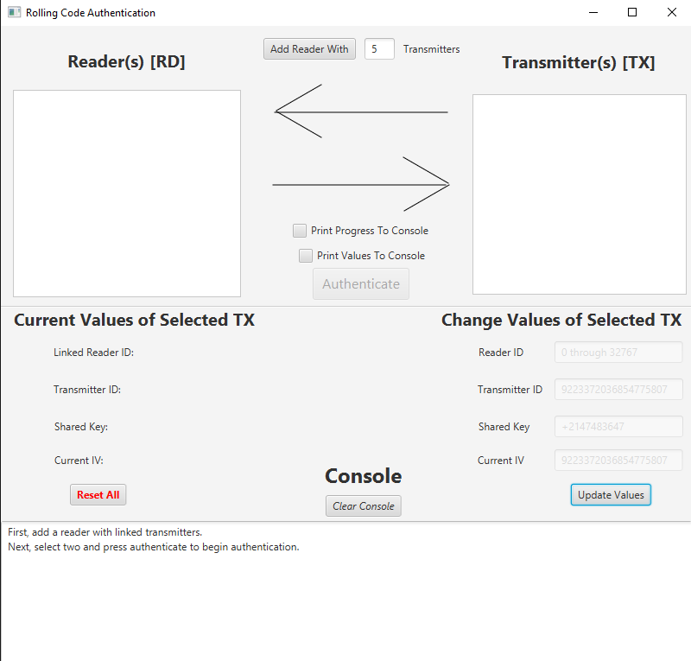
The purpose of the RCAS is to demonstrate the authentication protocol between a reader and the transmitter that it is linked with. To create a reader with up to ten linked transmitters, enter the number of transmitters to be linked with a reader in the top center of the page. Once the number is entered, press the “Add Reader With” button to create a reader object. For our example we will create two readers. The first transmitter will have three linked transmitters, and the second reader will have two linked transmitters.
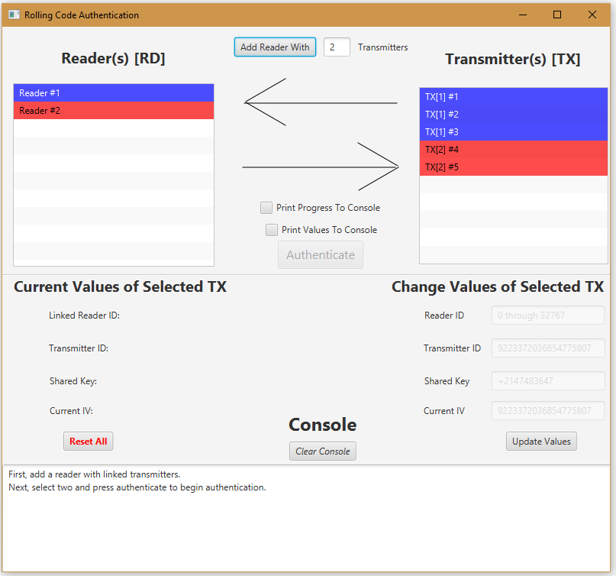
To begin the authentication process, select a reader from the reader list (titled, “Reader(s) [RD]”), by clicking one, and select a transmitter in the transmitter list (titled, “Transmitter(s) [TX]”), by clicking one. Notice that when a reader or transmitter is selected, the “Current Values of Selected TX/RD” section under the reader list is populated with values. Here a user can view certain attributes corresponding to the selected reader or transmitter. Also notice that when a transmitter is selected the user can enter values in the fields under the section titled “Change Values of Selected TX.” By entering an appropriate value and clicking “Update Values” the values stored in the transmitter will be changed and this update will be reflected in the “Current Values of Selected TX/RD” section.
At the bottom of the screen is the user console that shows the status of the authentication between a reader and a transmitter. To begin the authentication process, press the “Authenticate” button after selecting a transmitter and a reader from their appropriate lists. To view detailed information about the authentication process, check the “Print Progress To Console” checkbox before clicking authenticate. Additionally, users can select the “Print Values To Console” checkbox to see the values of elements during different phases of the authentication process.

The following image shows the application after selecting the first reader and transmitter and pressing the “Authenticate” button with the “Print Progress To Console” checkbox selected.
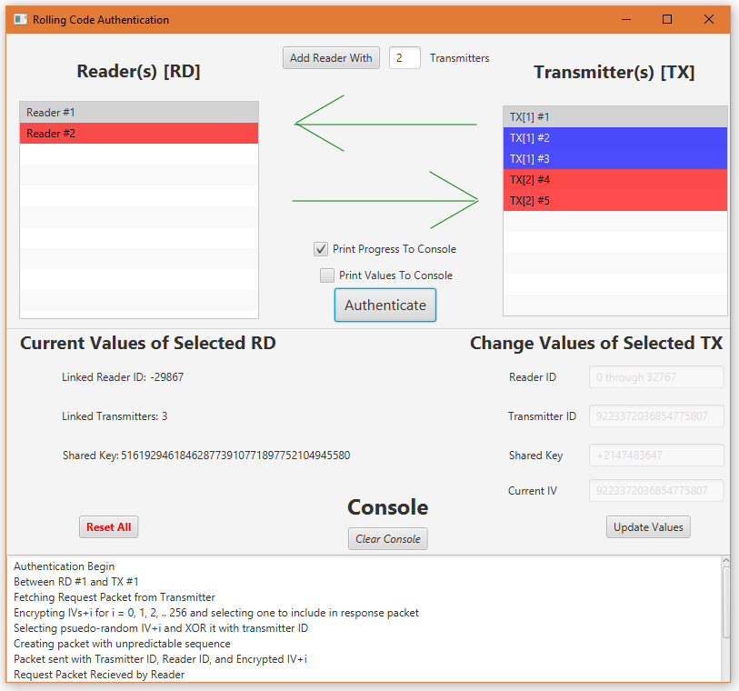
If the user scrolls down through the console they can view the process of the authentication at each step. At the bottom there should be the message, “Authentication Completed Successfully” if th

Appendices
Bits.java
The following is the code for the unused Bits class that was previously used to represent the bit strings of any given length.
package rollingcodeauthentication;
import java.math.BigInteger;
import java.util.Arrays;
/* Class for representing a series of bits */
public class Bits {
int[] bits;
int length;
/* Initalize a random bit array of size n */
public Bits(int n, boolean isRandom) {
this.length = n;
this.bits = new int[this.length];
if (isRandom) {
this.randomize();
}
}
/* Initalize a bit array from string */
public Bits(String bitStr) {
stringToBits(bitStr);
}
/* Initalize a bit array from an integer */
public Bits(int bitInt) {
this.stringToBits(Integer.toBinaryString(bitInt));
}
public Bits(int[] bits) {
this.bits = bits;
this.length = bits.length;
}
/* Randomizes each bit in bits */
public void randomize() {
for (int i = 0; i < this.length; i++) {
bits[i] = (int)Math.round(Math.random());
}
}
/* Takes binary string input and represents it as Bits object */
public void stringToBits(String bitStr) {
this.length = bitStr.length();
this.bits = new int[this.length];
for (int i = 0; i < this.length; i++) {
this.bits[i] = Character.getNumericValue(bitStr.charAt(i));
}
}
/* Pass a positive or negative n for respective right or left bit shift */
public void shift(int n) {
int[] result = new int[this.length];
if (n < 0) {
n = this.bits.length + (n);
}
System.arraycopy(this.bits, n, result, 0, this.bits.length-n);
System.arraycopy(this.bits, 0, result, this.bits.length-n, n);
this.bits = result;
}
/* Returns left shifted Bits by n */
public Bits shiftedLeft(int n) {
if (n < 0) {
System.out.print("Can't shift by negatives.");
return null;
} else if (n >= this.length - 1) {
n -= this.length;
}
int[] result = new int[this.length];
System.arraycopy(this.bits, n, result, 0, this.length-n);
System.arraycopy(this.bits, 0, result, this.length-n, n);
return new Bits(result);
}
/* Returns right shifted Bits by n */
public Bits shiftedRight(int n) {
if (n < 0) {
System.out.print("Can't shift by negatives.");
return null;
} else if (n > this.length ) {
n %= this.length;
int[] result = new int[this.length];
System.arraycopy(this.bits, 0, result, n, this.length-n);
System.arraycopy(this.bits, this.length-n, result, 0, n);
return new Bits(result);
} else {
int[] result = new int[this.length];
System.arraycopy(this.bits, 0, result, n, this.length-n);
System.arraycopy(this.bits, this.length-n, result, 0, n);
return new Bits(result);
}
}
/* Adds this Bits object with passed Bits object */
public void add(Bits bits2) {
// Convert Bits objects to their string representations
String bitStr1 = this.toString();
String bitStr2 = bits2.toString();
// Parse representations into integers and sum them
// Parse representations into bigInts and sum them
BigInteger intResult = new BigInteger(bitStr1, 2).add(new BigInteger(bitStr2, 2));
// Parse result back into string and convert string into Bits
String strResult = intResult.toString(2);
this.stringToBits(strResult);
}
public int[] addBin(Bits bitsIn) {
int[] bits2 = bitsIn.getBits();
int bits2Len = bits2.length;
int [] sum = new int [Math.min(this.length, bits2Len)+1];
for(int i =0; i < sum.length; i++) {
sum[i]= this.bits[i] + bits2[i];
}
return sum;
}
/* Adds this Bits object with passed Bits object. Return new Bits Object*/
public Bits added(Bits bits2) {
// Convert Bits objects to their string representations
String bitStr1 = this.toString();
String bitStr2 = bits2.toString();
// Parse representations into bigInts and sum them
BigInteger intResult = new BigInteger(bitStr1, 2).add(new BigInteger(bitStr2, 2));
// Parse result back into string and convert string into Bits
String strResult = intResult.toString(2);
return new Bits(strResult);
}
/* Subtracts this Bits object with passed Bits object */
public void subtract(Bits bits2) {
// Convert Bits objects to their string representations
String bitStr1 = this.toString();
String bitStr2 = bits2.toString();
// Parse representations into bigInts and sum them
BigInteger intResult = new BigInteger(bitStr1, 2).subtract(new BigInteger(bitStr2, 2)).abs();
// Parse result back into string and convert string into Bits
String strResult = intResult.toString(2);
this.stringToBits(strResult);
}
/* Subtracts this Bits object with passed Bits. Return new Bits Object*/
public Bits subtracted(Bits bits2) {
// Convert Bits objects to their string representations
String bitStr1 = this.toString();
String bitStr2 = bits2.toString();
// Parse representations into bigInts and sum them
BigInteger intResult = new BigInteger(bitStr1, 2).subtract(new BigInteger(bitStr2, 2));
// Parse result back into string and convert string into Bits
String strResult = intResult.toString(2);
return new Bits(strResult);
}
/* XORs this Bits object with passed Bits object */
public void xor(Bits bits2) {
int bits2Length = bits2.getLength();
int max = Math.max(this.length, bits2Length);
if (this.length < bits2Length) {
this.pad(max);
} else {
bits2 = bits2.padded(max);
}
for (int i = 0; i < this.length; i++) {
this.bits[i] = this.bits[i] ^ bits2.bitAt(i);
}
}
/* Xor this Bits object with passed Bits object. Return new Bits Object */
public Bits xored(Bits bits2) {
Bits result = null;
if (this.length < bits2.getLength()) {
result = new Bits(this.bits);
} else {
result = new Bits(bits2.getBits());
}
for (int i = 0; i < Math.min(this.length, bits2.length); i++) {
result.set(i, this.bits[i] ^ bits2.bitAt(i));
}
return result;
}
/* And this Bits object with passed Bits object */
public void and(Bits bits2) {
for (int i = 0; i < this.length; i++) {
this.bits[i] = this.bits[i] & bits2.bitAt(i);
}
}
/* And this Bits object with passed Bits object. Return new Bits Object */
public Bits anded(Bits bits2) {
Bits result = null;
if (this.length < bits2.getLength()) {
result = new Bits(this.bits);
} else {
result = new Bits(bits2.getBits());
}
for (int i = 0; i < Math.min(this.length, bits2.length); i++) {
result.set(i, this.bits[i] & bits2.bitAt(i));
}
return result;
}
/* Returns padded bits so that they are length 'n' */
public Bits padded(int n) {
if (this.length < n) {
int[] result = new int[n];
System.arraycopy(this.bits, 0, result, n-this.length, this.length);
return new Bits(result);
} else {
System.out.println("Padding length less than bit length");
return new Bits(this.bits);
}
}
/* Pad's these bits (add 0 to leftmost) so that they are length 'n' */
public void pad(int n) {
if (this.length < n) {
int[] result = new int[n];
System.arraycopy(this.bits, 0, result, n-this.length, this.length);
this.bits = result;
this.length = n;
} else {
System.out.println("Padding length less than bit length");
}
}
/* Returns left-most trimmed bits so that they are length 'n' */
public Bits trimmed(int n) {
if (this.length > n) {
int[] result = new int[n];
System.arraycopy(this.bits, n-this.length, result, 0, this.length - n);
return new Bits(result);
} else {
System.out.println("Trimmed length bigger than bit length");
return new Bits(this.bits);
}
}
// /* Trims these left-most bits to length 'n' */
// public void trim(int n) {
// if (this.length > n) {
// int[] result = new int[n];
// System.arraycopy(this.bits, this.length - n, result, 0, n);
// this.bits = result;
// this.length = n;
// } else {
// System.out.println("Trimmed length bigger than bit length");
// }
// }
/* Trims these right-most bits to length 'n' */
public void trim(int n) {
if (this.length > n) {
int[] result = new int[n];
System.arraycopy(this.bits, 0, result, 0, n);
this.bits = result;
this.length = n;
} else {
System.out.println("Trimmed length bigger than bit length");
}
}
/* Sets the bit at index to val */
public void set(int index, int val) {
this.bits[index] = val;
}
/* Swaps bit index 1 with bit index 2 */
public void swap(int i1, int i2) {
int temp = this.bits[i1];
this.bits[i1] = this.bits[i2];
this.bits[i2] = temp;
}
/* Returns bit at index 'x' */
public int bitAt(int x) {
return this.bits[x];
}
/* Return bit array */
public int[] getBits() {
return this.bits;
}
/* Return new Bits object which is a subset of these Bits from x1 to x2 */
public Bits subset(int x1, int x2) {
if (x2 > this.length || x1 < 0) {
System.out.print("Subset indexes must be in range");
return null;
}
int[] result = new int[x2 - x1];
System.arraycopy(this.bits, x1, result, 0, x2 - x1);
return new Bits(result);
}
/* Returns bit at index 'x' */
public int getLength() {
return this.length;
}
/* Returns integer of bits */
public int toInteger() {
return Integer.parseInt(this.toString(), 2);
}
/* Returns byte array of bits */
public byte[] toByteArray() {
return (new BigInteger(this.bits.toString(), 2)).toByteArray();
}
/* Returns long (64-bit) representation of Bits */
public long toLong() {
return Long.parseLong(this.bits.toString(), 2);
}
/* Returns hex string of bits */
public String toHexString() {
return (new BigInteger(this.toString(), 2)).toString(16);
}
/* Returns string in array form of bits */
public String toArrString() {
return Arrays.toString(this.bits);
}
/* Returns binary string of Bits. i.e. [1,0,1,0] becomes "1010" */
@Override
public String toString() {
StringBuilder binString = new StringBuilder(this.length);
for (int i = 0; i < this.length; i++) {
binString.append(bits[i]);
}
return binString.toString();
}
// public static void main(String[] args) {
// Bits b1 = new Bits(25);
// System.out.println(b1.toArrString());
// System.out.println(b1.subset(0, 5).toArrString());
// }
}

