THE GREAT CAKE SHOW
Pastry Chef / “Baker” minigame - implementation breakdown and visual guide
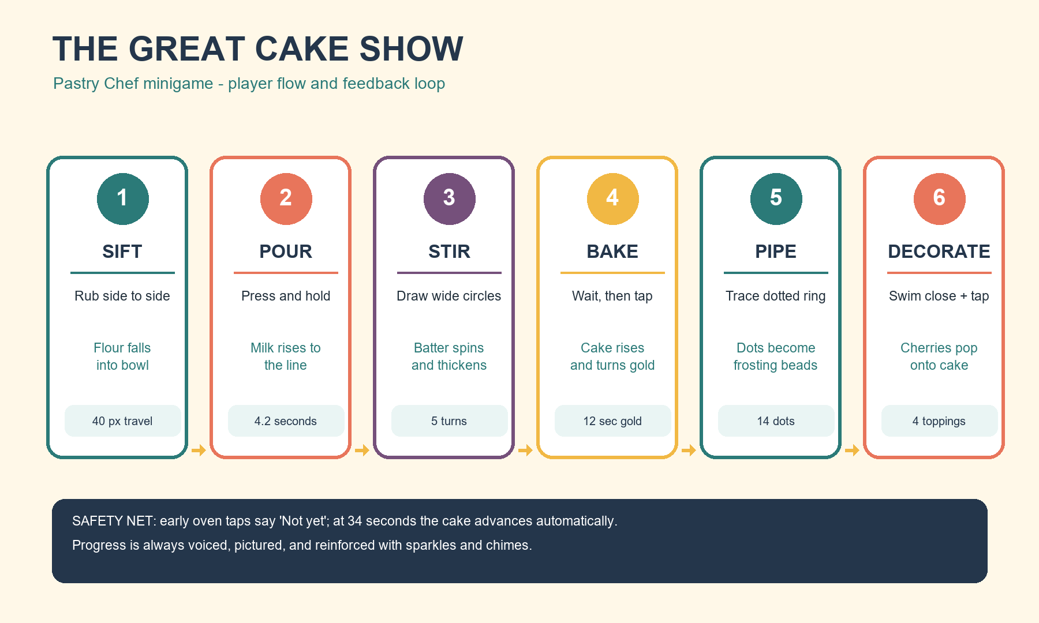
Visual guide - six distinct gestures form one forgiving cake-making performance.
Scope: current implementation in scripts/opera_house.gd and scripts/opera_act.gd, reviewed 2026-08-01. “Baker” is the Pastry Chef act, The Great Cake Show, on Floor 1 of the Pearl Opera House.

At a glance
Stage | Player gesture | Completion / visible response
Prelude | Swim + sparkle taps | Free the farmers from 6 mischief imps; their carrots become an optional carrot-cake variant.
1. Sift | Side-to-side rub | 40 px horizontal travel; flour flakes fall into the bowl.
2. Pour | Press and hold | 4.2 seconds; jug tips and milk rises to the orange line.
3. Stir | Wide circular drag | Each full circle adds a stir, speeds the bowl, and plays a rising chime; current threshold is 5 turns.
4. Bake | Wait, then tap | Cake rises for 12 seconds, turns golden, then accepts the tap.
5. Pipe | Trace dotted ring | Pass over 14 dots; each becomes a frosting bead.
6. Decorate | Swim close + tap | Tap four pink spots; a cherry pops onto each one, then the act wins.

Experience contract
- Designed for a non-reader: every stage has a voiced prompt, a picture-led target, HUD status, a pulsing pointer after inactivity, sparkles, and chimes.
- No fail state: a wrong/early oven tap only says “Not yet”; a distracted cook advances automatically after 34 seconds in the oven.
- Input varies deliberately: scrub, hold, circular drag, timed tap, trace, then proximity tap. It avoids repeating one gesture across the recipe.
- The stage is a pastry kitchen: reef backdrop, warm oven alcove at stage left, ingredient shelf at right, bowl upstage centre, and Pastry Chef GLB art with primitive fallbacks.

Phase-by-phase breakdown

Prelude - Rescue and ingredient story
The act is configured as a “shell” performance with six imps and a farmers rescue. Roshan pops the imps before the curtain opens. If the farmers’ carrot gift is in the persistent opera pantry, three carrots appear beside the bowl and the opening voice identifies the result as carrot cake. This changes the story and visuals, not the core input sequence.
Implementation gate: Transition: _build_order() immediately calls _begin_sift() for the chef finale. The legacy picture-order layer pads remain built as shared-engine scenery, but are not part of the live cake sequence.

1. Sift - flour into the bowl
The game enables drag mode and places the sieve over the centre bowl. The child rubs a finger horizontally; only sideways distance counts. Every roughly 2 progress points creates a falling flour flake, so the gesture is visibly legible rather than a hidden meter.
Implementation gate: Target: 40 units of accumulated horizontal movement (SIFT_NEED). Releasing the finger is harmless; it simply resets the “previous drag” position. Completion transitions directly to pouring.

2. Pour - hold the milk jug
A white jug appears above-left of the bowl, with an orange fill line as the visual goal. While the finger is down, the jug tilts toward -62 degrees, sparkles appear periodically, and the milk mesh rises. Releasing lets the jug settle back but does not erase progress.
Implementation gate: Target: 4.2 seconds held (POUR_NEED). The milk display permits a little visual overfill, but the stage moves on at the threshold. Drag control is cleared and the child is asked to stir.

3. Stir - circles around the bowl
Roshan must be within 7 world units of the bowl. At that point movement hands over to finger drag. A drag must begin at least 40 screen pixels from the bowl centre, then its accumulated angular travel is measured. Each full revolution adds one stir, rotates the bowl, intensifies the chime, and starts the bowl’s active art state on the first turn.
Implementation gate: Target: 5 completed revolutions in the current code. After 26 seconds at the bowl, a gentle rescue completes one stir automatically. Note: the HUD currently labels this as “/ 3”; that label is inconsistent with the actual 5-turn threshold and is worth correcting separately.

4. Bake - watch for golden
The batter becomes a separate cake object inside the glowing oven alcove. It starts squat, rises smoothly during the first 12 seconds, and then switches from pale to gold with a sparkle burst and voice prompt. The pointer targets the oven/cake.
Implementation gate: Target: tap after the cake is golden (12 seconds). An early tap gives a pale-cake sparkle and “Not yet” hint, with no reset. If no action happens by 34 seconds, the game calls the same success path automatically.

5. Pipe - trace the frosting ring
Drag mode returns. Fourteen pink dots form a circular guide around the cake. Passing the finger within 62 screen pixels of any visible dot hides it and creates a larger frosting bead with a pop tween. The dots may be collected in any order, keeping the trace forgiving.
Implementation gate: Target: all 14 guide dots. The last dot counts even if the finger lifts on that frame; drag mode then turns off and the decoration targets open.

6. Decorate - add cherries and finish
Four pink topping targets appear in an arc around the bowl/cake. Roshan swims near a target and taps the action control; the target vanishes and a red cherry scales up onto the cake. Pitch rises with each chime and sparkles mark each successful placement.
Implementation gate: Target: 4 toppings from the chef configuration. Completing the final target calls _win(), which runs the celebration and the configured carrot-cake win line.

Current implementation notes
Topic | What is currently shipped | Why it matters for review
Recipe order | The chef begins at sift; it does not ask the child to deliver the vanilla/coral/plum layers, despite older design notes and shared “order” scaffolding. | Test the live progression, not the historical spec.
Stir count | Code finishes at 5 full circular accumulations; the HUD displays “/ 3.” | This is the only clear player-facing count mismatch found in the phase flow.
Decoration gesture | The published redesign calls for drag-and-drop cherries. The current handler activates a spot when Roshan is within 4.5 world units and the action button is tapped. | The guide records actual behavior; decide separately whether to change implementation or documentation.
Baking timer | The design notes describe late taps as “still fine, just fewer sparkles.” Current code has no late-sparkle grading; it auto-advances at 34 seconds. | Useful distinction for future polish or probe expectations.

QA walkthrough
- Start a new Pastry Chef show; confirm the rescue opens the stage and carrots appear only when the farmers’ gift is owned.
- Perform each gesture once as named: horizontal scrub, held press, wide circular drag, golden-timing tap, ring trace, then proximity tap.
- Test the safety net: tap the oven before gold, release during pouring, and wait past 34 seconds in bake. None should restart or lose progress.
- Confirm feedback remains readable on the target tablet: voice line, target/pointer, HUD meter or count, visible transformation, and chime/sparkle response.

