**Biometrics: Automated Face Recognition Using Artificial Neural Networks**

1. **Project idea in detail:**

Facial recognition is a way of identifying or confirming an individual’s identity using their face. Facial recognition systems can be used to identify people in photos, videos, or in real time.

Facial recognition is a category of biometric security. Other forms of biometric software include voice recognition, fingerprint recognition, and eye retina or iris recognition. The technology is mostly used for security and law enforcement, though there is increasing interest in other areas of use.

Now let’s discuss how facial recognition works.

Face recognition systems use computer algorithms to pick out specific, distinctive details about a person’s face. These details, such as the distance between the eyes or the shape of the chin, are then converted into a mathematical representation and compared to data on other faces collected in a face recognition database. The data about a particular face is often called a face template and is distinct from a photograph because it’s designed to only include certain details that can be used to distinguish one face from another.

Some face recognition systems, instead of positively identifying an unknown person, are designed to calculate a probability match score between the unknown person and specific face templates stored in the database. These systems will offer up several potential matches, ranked in order of likelihood of correct identification, instead of just returning a single result.

Face recognition systems vary in their ability to identify people under challenging conditions such as poor lighting, low quality image resolution, and suboptimal angle of view (such as in a photograph taken from above looking down on an unknown person).

When it comes to errors, there are two key concepts to understand:

A “false negative” is when the face recognition system fails to match a person’s face to an image that is, in fact, contained in a database. In other words, the system will erroneously return zero results in response to a query.

A “false positive” is when the face recognition system does match a person’s face to an image in a database, but that match is actually incorrect. This is when a police officer submits an image of “Joe,” but the system erroneously tells the officer that the photo is of “Jack.”

When researching a face recognition system, it is important to look closely at the “false positive” rate and the “false negative” rate, since there is almost always a trade-off. For example, if you are using face recognition to unlock your phone, it is better if the system fails to identify you a few times (false negative) than it is for the system to misidentify other people as you and lets those people unlock your phone (false positive). If the result of a misidentification is that an innocent person goes to jail (like a misidentification in a mugshot database), then the system should be designed to have as few false positives as possible.

But what are the main functionalities of face recognition?

1. Unlocking phones
2. Law enforcement: Facial recognition is regularly being used by law enforcement. According to this NBC report, technology is increasing amongst law enforcement agencies within the US, and the same is true in other countries. Police collect mugshots from arrestees and compare them against local, state, and federal face recognition databases. Once an arrestee’s photo has been taken, their picture will be added to databases to be scanned whenever police carry out another criminal search.
3. Airports and border control
4. Finding missing persons: Facial recognition can be used to find missing persons and victims of human trafficking. Suppose missing individuals are added to a database. In that case, law enforcement can be alerted as soon as they are recognized by face recognition — whether it is in an airport, retail store, or other public space.
5. Reducing retail crime: Facial recognition is used to identify when known shoplifters, organized retail criminals, or people with a history of fraud enter stores. Photographs of individuals can be matched against large databases of criminals so that loss prevention and retail security professionals can be notified when shoppers who potentially represent a threat enter the store.
6. Banking: Biometric online banking is another benefit of face recognition. Instead of using one-time passwords, customers can authorize transactions by looking at their smartphone or computer. With facial recognition, there are no passwords for hackers to compromise. If hackers steal your photo database, 'liveless' detection – a technique used to determine whether the source of a biometric sample is a live human being or a fake representation – should (in theory) prevent them from using it for impersonation purposes. Face recognition could make debit cards and signatures a thing of the past.
7. Marketing and advertising: Marketers have used facial recognition to enhance consumer experiences. For example, frozen pizza brand DiGiorno used facial recognition for a 2017 marketing campaign where it analyzed the expressions of people at DiGiorno-themed parties to gauge people’s emotional reactions to pizza. Media companies also use facial recognition to test audience reaction to movie trailers, characters in TV pilots, and optimal placement of TV promotions. Billboards that incorporate face recognition technology – such as London’s Piccadilly Circus – means brands can trigger tailored advertisements.
8. Healthcare: Hospitals use facial recognition to help with patient care. Healthcare providers are testing the use of facial recognition to access patient records, streamline patient registration, detect emotion and pain in patients, and even help to identify specific genetic diseases. Ai Cure has developed an app that uses facial recognition to ensure that people take their medication as prescribed. As biometric technology becomes less expensive, adoption within the healthcare sector is expected to increase.

2- Main functionalities from the user’s perspective:

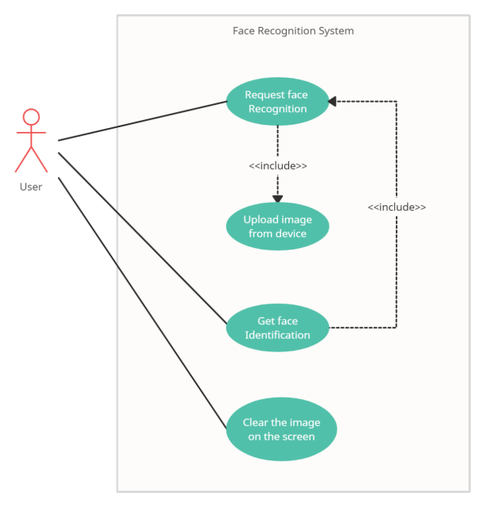

3-There are many similar applications in the markets:

* **Amazon** previously promoted its cloud-based face recognition service named **Recognition** to law enforcement agencies. However, in a June 2020 blog spot, the company announced it was planning a one-year moratorium on the use of its technology by police. The rationale for this was to allow time for US federal laws to be initiated, to protect human rights and civil liberties.
* **Apple** uses facial recognition to help users quickly unlock their phones, log in to apps, and make purchases.
* **British Airways** enables facial recognition for passengers boarding flights from the US. Travelers’ faces can be scanned by a camera to have their identity verified to board their plane without showing their passport or boarding pass. The airline has been using the technology on UK domestic flights from Heathrow and is working towards biometric boarding on international flights from the airport.
* **Cigna**, a US-based healthcare insurer, allows customers in China to file health insurance claims which are signed using a photo, rather than a written signature, in a bid to cut down on instances of fraud.
* **Coca-Cola** has used facial recognition in several ways across the world. Examples include rewarding customers for recycling at some of its vending machines in China, delivering personalized ads on its vending machines in Australia, and for event marketing in Israel.
* **Facebook** began using facial recognition in the US in 2010 when it automatically tagged people in photos using its tag suggestions tool. The tool scans a user's face and offers suggestions about who that person is. Since 2019, Facebook has made the feature opt-in as part of a drive to become more privacy-focused. Facebook provides information on how you can opt in or out of face recognition [here](https://www.facebook.com/help/187272841323203).
* **Google** incorporates the technology into **Google Photos** and uses it to sort pictures and automatically tag them based on the people recognized.
* **MAC make-up** uses facial recognition technology in some of its brick-and-mortar stores, allowing customers to virtually "try on" make-up using in-store augmented reality mirrors.
* **McDonald’s** has used facial recognition in its Japanese restaurants to assess the quality of customer service provided there, including analyzing whether its employees are smiling while assisting customers.
* **Snapchat** is one of the pioneers of facial recognition software: it allows brands and organizations to create filters which mold to the user’s face — hence the ubiquitous puppy dog faces and flower crown filters seen on social media.

**4. Review of Literature**

**- Face Recognition Based on HOG Multi-feature Fusion and Random Forest**

**A novel approach to face recognition, which is based on HOG multi-feature fusion and Random Forest, was proposed to solve the problems of low face recognition rate in complex environments. This approach introduces the HOG descriptor (Histograms of Oriented Gradients) to extract information of the facial feature. Firstly, the face image grid is set to extract the holistic HOG features of the entire face, and the face image is divided into homogeneous subblocks, and local HOG features are extracted in the sub-blocks which contain key components of the face. After that, the dimensions of holistic and local HOG features are reduced using 2D Principal Component Analysis (2D PCA) and Linear Discriminant Analysis (LDA)and the final classification features are formed by the feature level's fusion. Finally, the random forest classifier is employed to classify the final features. Experimental results on FERET CAS-PEAL-R1 and real scene database demonstrate that the proposed approach not only significantly raises the recognition rate and reduces the computing time but also has certain robustness to the influence of light.**

**- Human face recognition using random forest-based fusion of à-trous wavelet transform coefficients from thermal and visible images**

**This paper presents a new image fusion algorithm based on the visible and thermal IR face images, which exploits the advantages of both kinds of images. The proposed fusion algorithm utilizes the translation-invariant à-trous wavelet transform and random forest (RF) classifier to decide the contribution of the visible and thermal IR face images in the formation of fused images. The Universal Image Quality Index is used to evaluate the quality of fused images and results are quite satisfactory. The fused face images are recognized by RF classifiers. The recognition performances of the proposed fusion scheme are 99.07% and 100% for UGC-JU and IRIS benchmark face databases respectively, which is better than those if only visible or thermal IR faces are used.**

**-Facial Recognition using Modified Local Binary Pattern and Random Forest**

**Random forest makes no distinction between the relevance of features during construction of the forest. Each node is created randomly with equal probability. Because of this, feature redundancy may arise and increase the generalization error. These redundant features can produce unreasonably large trees which will produce huge computational load. However, RF avoids this problem by producing a measure of importance of each variable, called variable importance. The algorithm estimates the importance of a variable by looking at how much prediction error increases when OOB data for that variable is modified while all other variables are left unchanged. We decide to use the variables with the highest variable importance to build our RF feature selector. This allows the vectors to be greatly reduced and potentially remove any harmful features that can cause erroneous predictions. The feature selection using RF can be summarized as follows [19]:**

**1. Select the bootstrap samples of the training data form a RF and estimate the error rate by using OOB predictions.**

**2. For each tree of the forest, exclude the OOB cases and count the number of votes for the correct class. Randomly permute the values of the first variable in the OOB cases and exclude these cases from the tree. Subtract the number of votes for the correct class in the first variable permuted OOB data from the number of votes for the correct class in the untouched OOB data.**

**3. The average of this number, over all trees in the forest, is regarded as the raw importance score for this variable.**

**4. Repeat the above step for all variables.**

**In this research effort, we have selected the LBP and MLBP features with the highest variable importance scores using the RF.**

**- An efficient three-dimensional face recognition system based random forest and geodesic curves**

**3D Face recognition is being extensively recognized as a biometric performance refers to its non-intrusive environment. Despite large research on 2-D face recognition, it suffers from low recognition rate due to illumination variations, pose changes, poor image quality, occlusions and facial expression variations, while 3D face models are insensitive to all these conditions. In this paper, we present an efficient 3D face recognition approach based on Geodesic Distance (GD) of Riemannian geometry and Random Forest (RF), named GD-FM+RF. Therefore, to compute the geodesic distance between the specified pairs of the points of 3D faces, we applied Fast Marching (FM) algorithm, to solve the Eikon Al equation. Then, these extracted features presented by the geodesic facial curves are used by Principal Component Analysis (PCA) algorithm to analyses class separability. Afterwards, these features were utilized as input of RF classifier. To test our approach and assess its effectiveness, simulated series of tests were implemented on 3D Shape Retrieval Contest 2008 database (SHREC'08). As a result, our proposed approach enhances the recognition rate and achieves promising results compared to state of the art methods, getting 99.11% in terms of recognition rate.**

**- Face Recognition with Decision Tree-Based Local Binary Patterns**

**Many state-of-the-art face recognition algorithms use image descriptors based on features known as Local Binary Patterns (LBPs). While many variations of LBP exist, so far none of them can automatically adapt to the training data. We introduce and analyse a novel generalization of LBP that learns the most discriminative LBP-like features for each facial region in a supervised manner. Since the proposed method is based on Decision Trees, we call it Decision Tree Local Binary Patterns or DT-LBPs. Tests on standard face recognition datasets show the superiority of DT-LBP with respect of several state-of-the-art feature descriptors regularly used in face recognition applications.**

**Resources**

**1. GUO Jin-Xin, CHEN Wei, School of Optical-Electrical and Computer Engineering, the University of Shanghai for Science and Technology.**

**2. AEU - International Journal of Electronics and Communications.**

**3. Brian O’Connor, and Kaushik Roy Department of Computer Science, North Carolina A&T State University, Greensboro, NC 27411.**

**4. LGS, National School of Applied Sciences, Ibn Tofail University, B.P. 241, university campus, Kenitra, Morocco.**

**5. Computer Vision – ACCV 2010, Daniel Maturana , Domingo Mery , Álvaro Soto.**

**5. Dataset**

Brief information about Olivetti Dataset:

* There are ten different images of each of 40 distinct people
* There are 400 face images in the dataset
* Face images were taken at different times, with varying lightening, facial expression and facial detail
* All face images have a black background
* The images are gray level
* Size of each image is 64x64
* Image pixel values were scaled to [0, 1] interval
* Names of 40 people were encoded to an integer from 0 to 39

**In this study, face recognition was performed using the face images in the Olivetti data set**

**Dataset Link:** [Face Recognition on Olivetti Dataset | Kaggle](https://www.kaggle.com/code/serkanpeldek/face-recognition-on-olivetti-dataset/notebook)

**6. Details of The Algorithm**

**- All the details of the AI/Machine-Learning algorithm(s)/approach(es) used to develop the project.**

An ANN is composed of a network of artificial neurons also known as "nodes". These nodes are connected to each other, and the strength of their connections to one another is assigned a value based on their strength: inhibition (maximum being -1.0) or excitation (maximum being +1.0). If the value of the connection is high, then it indicates that there is a strong connection. Within each node's design, a transfer function is built in. There are three types of neutrons in an ANN, input nodes, hidden nodes, and output nodes.

**The Block Diagram:**

**-** **Artificial Neural network**

**- The First Algorithm applied is Artificial neural network, by using the default values of the ANN model hyperparameters, we got that the accuracy of training increases gradually which is obvious in the following figure:**

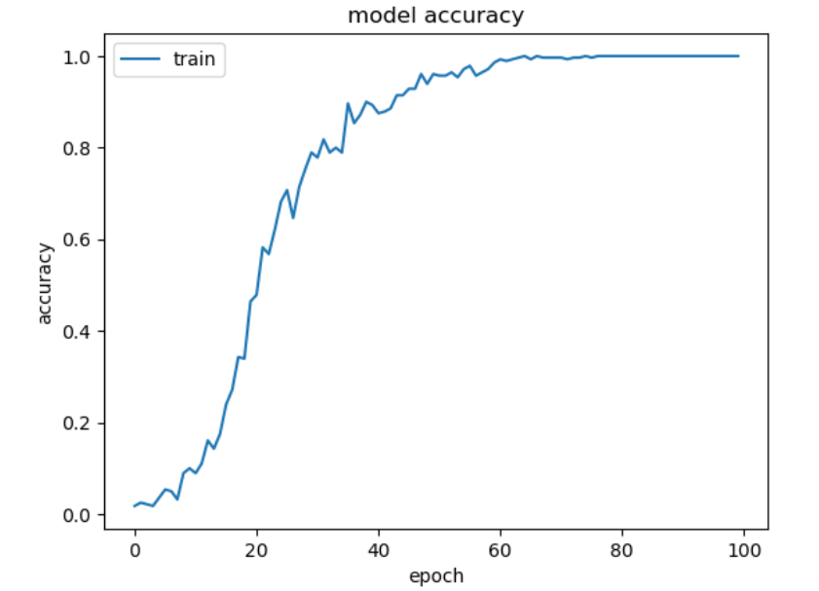

**And also, the data loss decreases gradually which is also obvious in the following figure:**

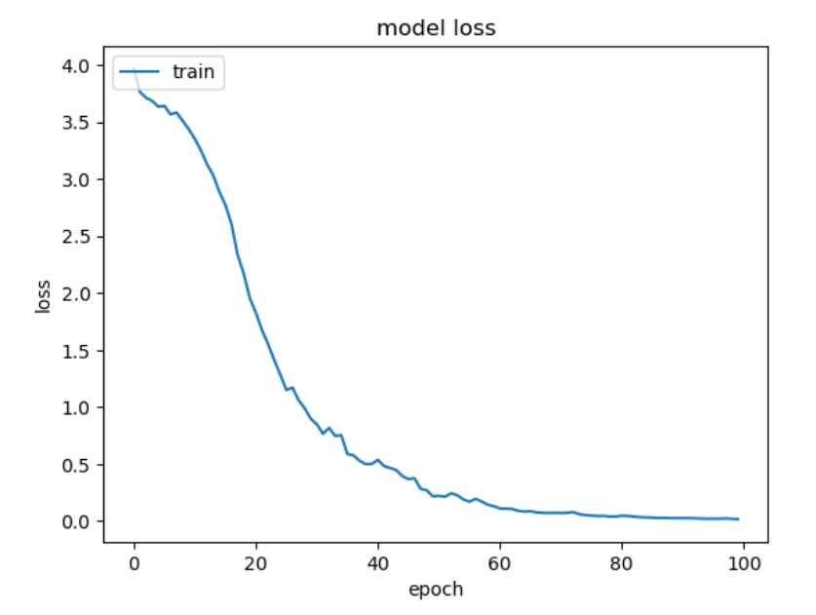

**There is the ROC curve** (**receiver operating characteristic curve**) which is a graph showing the performance of a classification model at all classification thresholds. This curve plots two parameters:

* True Positive Rate (TPR)
* False Positive Rate (FPR)

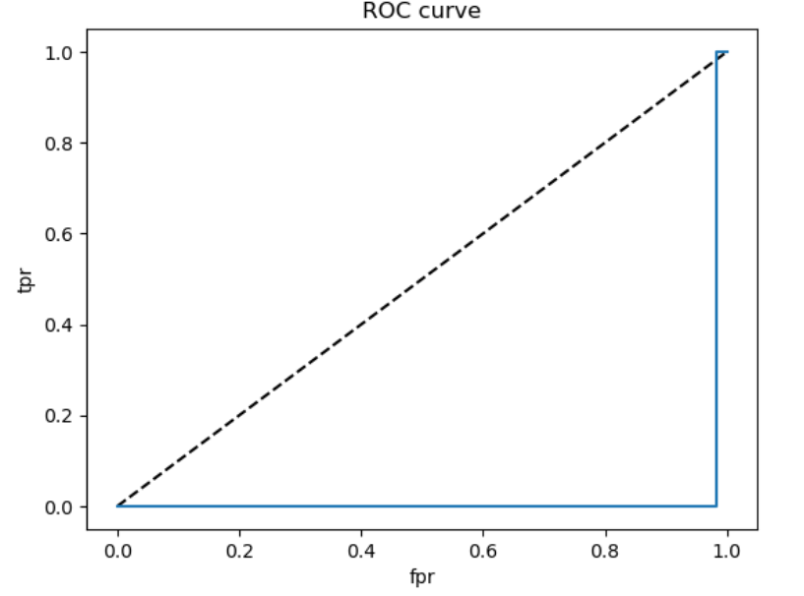

a **confusion matrix**, also known as an error matrix, is a specific table layout that allows visualization of the performance of an algorithm. It is a special kind of [contingency table](https://en.wikipedia.org/wiki/Contingency_table), with two dimensions ("actual" and "predicted"), and identical sets of "classes" in both dimensions (each combination of dimension and class is a variable in the contingency table).The following figure shows the confusion matrix of the ANN algorithm result:

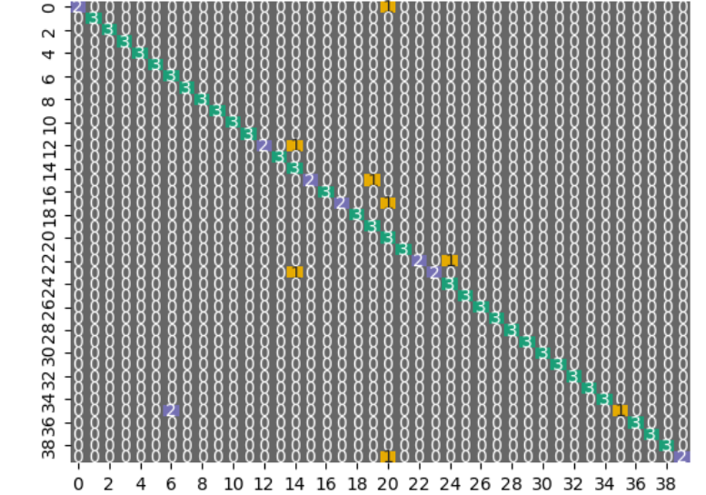

**- Solution tested on the testing images by uploading it and detecting the face on the image then extracting the features of the face and preprocessing it then applying the preprocessed features of the face to the model to predict and classify it.**

7- Development Platform:

**Tools: Spyder and Jupiter**

**Programming Language: Python**

**Libraries: NumPy, pandas, TensorFlow, matplotib, sklearn, random, os.cv2, glob,**

**TensorFlow.Keras, pathlib, and seaborn**