

Progress Report #2 Senior Project

Development of a Web-Based Faculty Recruitment and Onboarding System

Names | IDs
Ebraheim Rashed Alkaabi | U21200538
Falah Ali Alhefeiti | U21200759
Mohamed Ghanim Alketbi | U21200567
Khalifa Obaid Alkaabi | U22107615

Supervisor: Dr. Isam Al Jawarneh
9 / 11 / 2025
Fall 2025 – 2026
Introduction:
In this report we just explain what we did int the second phase of our senior project:
Development of a Web-Based Faculty Recruitment and Onboarding System for the University of Sharjah (UoS).
The idea of the whole process of is to make hiring and onboarding teachers online and easier, at the beginning we focused on learning how the UoS hiring system actually works and then we built a front-end which is the part where the applicant sees, and we developed some back-end endpoints and database tables.

Technical Progress: Front-End Implementation:
Talent Request Submission Form
Goal: Gives department heads (HoDs) the ability to request new faculty members.
Features: Document upload (official advertisement), Emirati preference flag, qualifications, and position details fields.
Benefit: Offers a structured, measurable procedure for submitting recruitment requests in accordance with institutional guidelines.
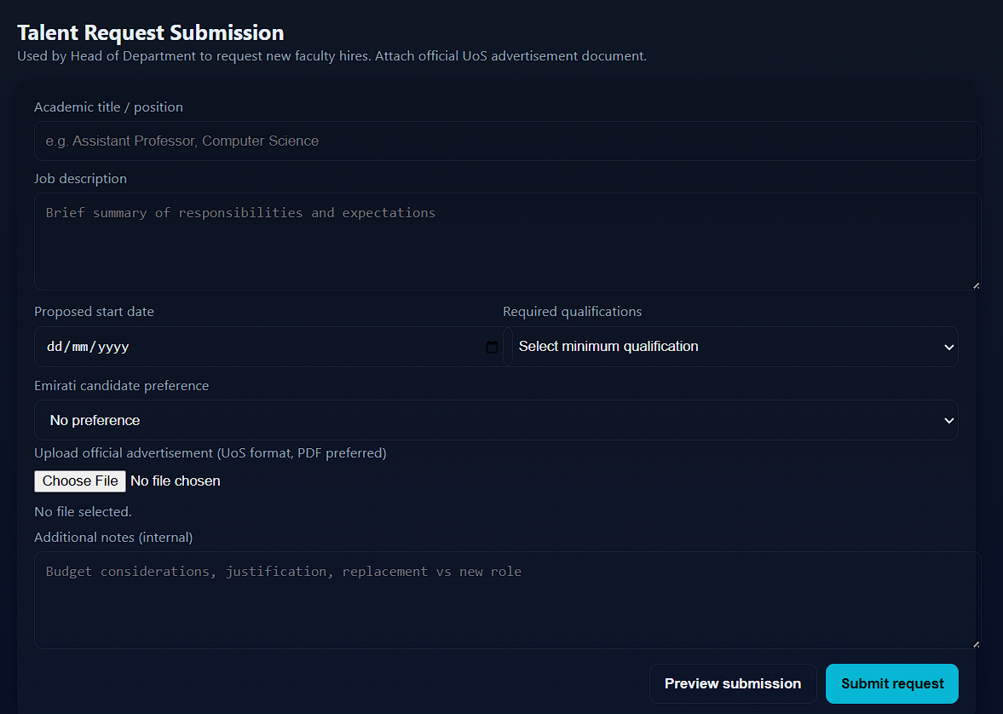
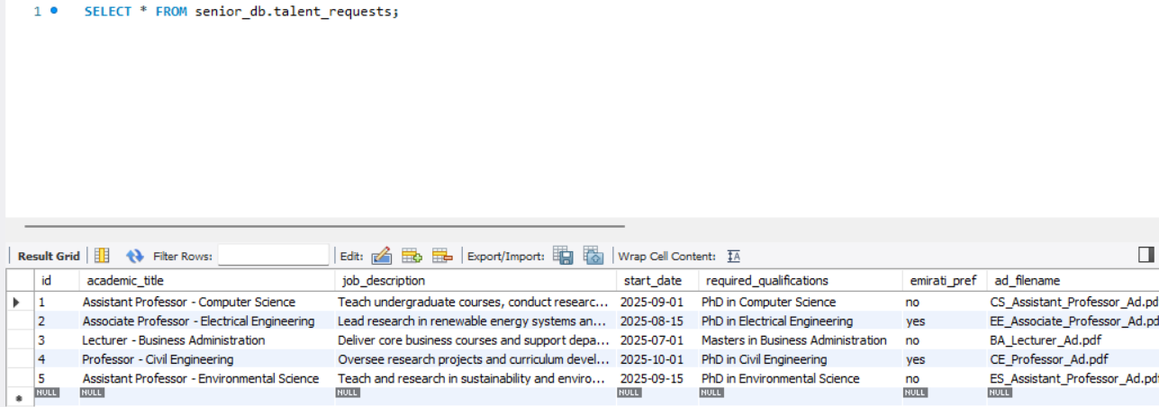
Recruitment Dashboard (HR View)
Goal: A central location for HR to track the status of applications and open positions.
Features include progress tracking for each role, quick statistics (applicants, under review, and on hold), and the stages of the recruitment pipeline displayed.
Benefit: Provides HR with a data-driven, visual representation of hiring trends and bottlenecks.
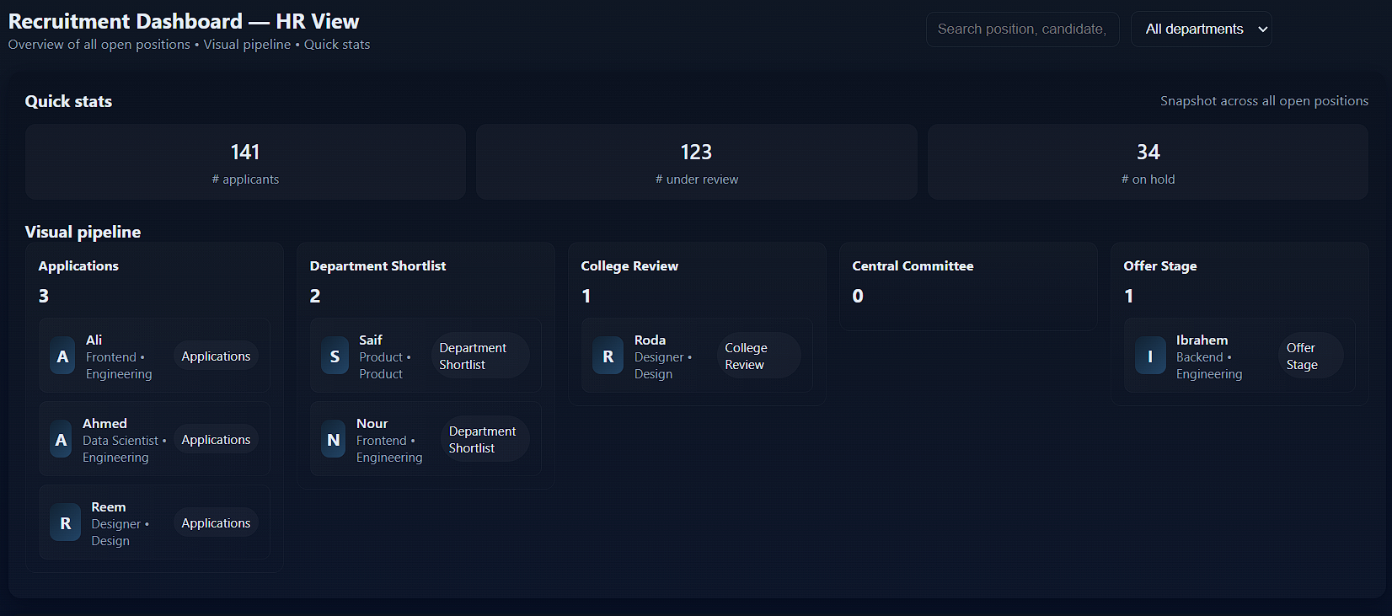
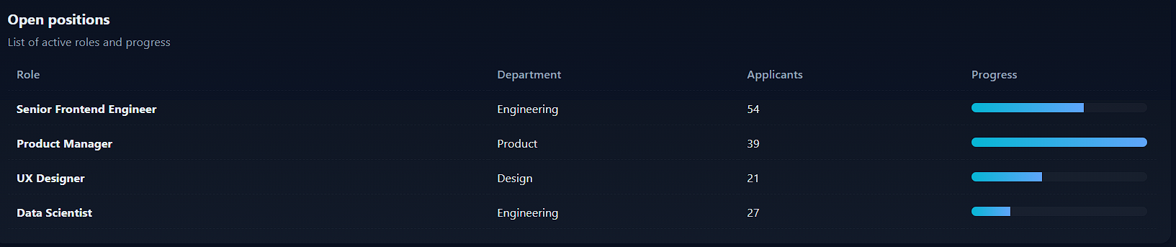
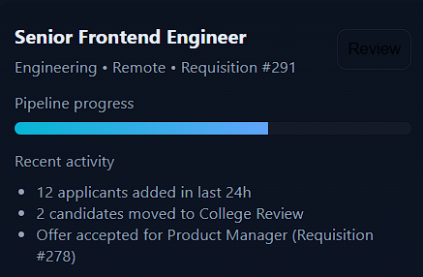
Application Review Interface
Goal: A platform for reviewers to assess each applicant separately.
Features include a filtered applicant list, a comprehensive profile view, a structured evaluation form with behavioural, technical, and values components, and decision buttons labelled "Recommend" and "Reject."
Benefit: For consistency and fairness, evaluation criteria are standardized and documented.
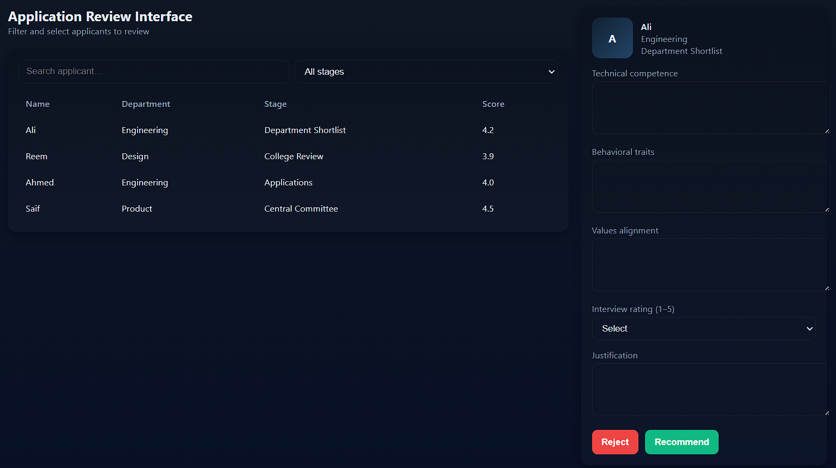

Interview Scheduling & Feedback Page
Goal: Oversee the logistics of interviews and post-interview assessments.
Features include an interviewer feedback form, an automated panel recommendation collection system, and a mock calendar for scheduling.
Benefit: Makes coordination easier and guarantees that interview data is recorded in a methodical manner.
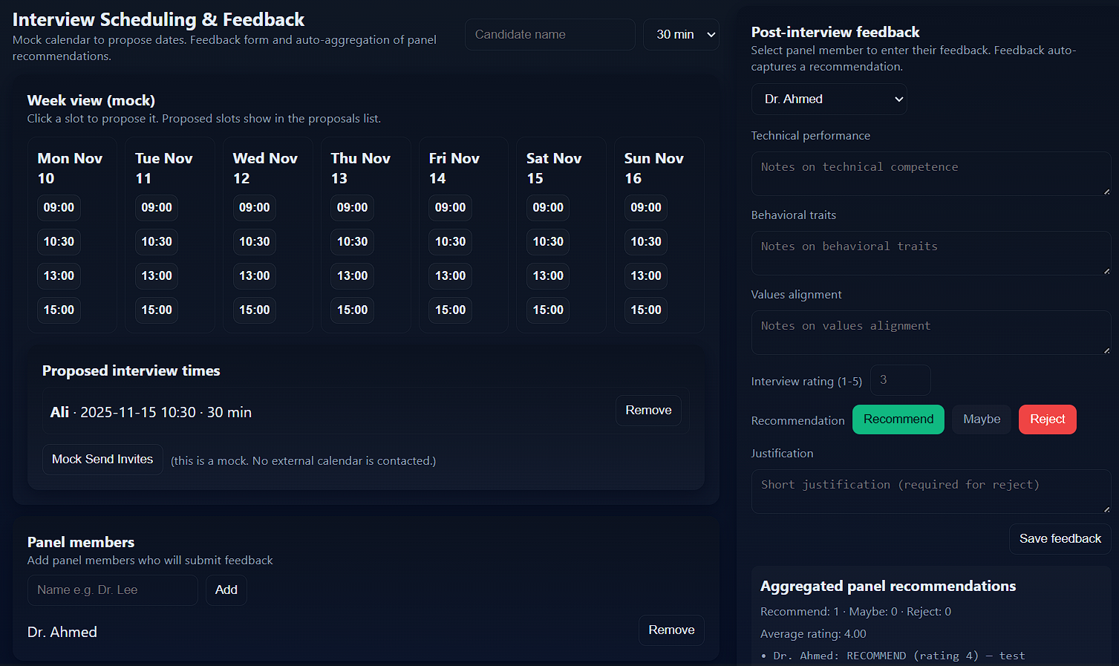
Each page contributes to a modular recruitment system: from request initiation, through application review and interviews, to HR-level tracking and management.

Challenges Faced:
Many challenges explored during this part:
Data validation: Ensuring frontend form inputs and backend constraints (dates, files, enums) remain consistent.
File handling: Managing uploads securely with proper format, size, and storage mapping to database fields.
State management: Keeping UI elements (feedback forms, schedules) synced with backend data updates.
Access control: Defining user roles (HR, HoD, reviewers) and securing CRUD operations in backend logic.

Next Steps:
The next step is to finish the project completely, develop all front-end, back-end and database components, and test the functionality of the project.
Pages to be developed:
- Pre-Joining Checklist Portal
- HR Onboarding Management Page
- New Faculty Welcome / Induction Page

