**MVC PROJECT Explanation**

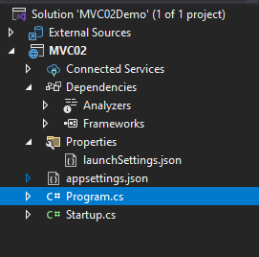

**LaunchSetting =>** this file has all information about hosting your Application using IIS EXPRESS Or Kesteral Application..

**Program.cs =>** this file has the Main Method to launch your application.

**Startup.cs=>** this file has the methods that handle your request through the pipeline request

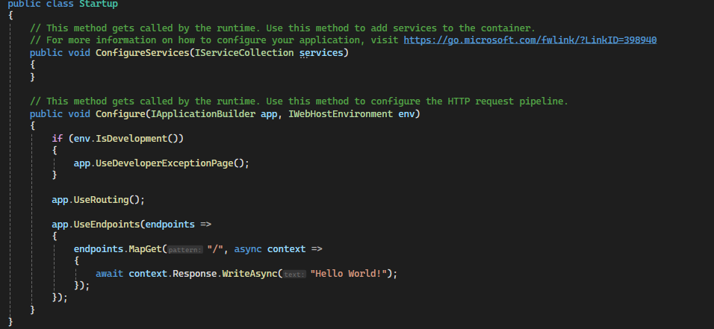

ConfigureServices Method – Configure Method

Ex: Assume we have a kitchen full of tools and ingredients to cook for some People and another room for serve this food and eat it.

ConfigureServices -> Kitchen that Has all the ingredients and Tools to Cook

Configure -> Configure and use the Tools that ConfigureServices has to Make the Dinner.

So they server each other To Complete the Full Pic.

**MiddleWare**

**Middleware is like a gate the request must go through It and pass some rules to go to another page and so on**

**Finally if the request is finished all the Middlewares he finnaly go to routing then controller**

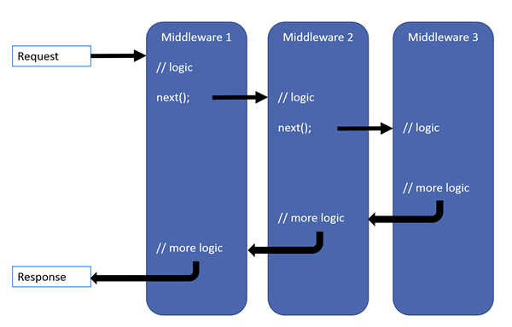

Add Default Routing Pattern:

If we send a request to the server

from server side how he know the rule that this request is valid or not?

We must provide some rules or pattern to follow to serve a valid request

If we need to Add Route pattern we use endpoint.MapControllerRoute (ExtentionMethod)

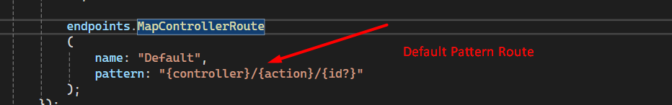

We told the server to accept any url like this : --/Home/Index

But befor that we need to add The service to allow us to add Default Route

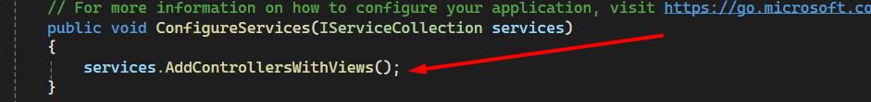

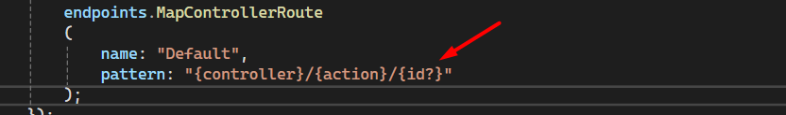Id? -> meaning it’s allow null

There is some constrains we can Put on it to validate it like it must be int

Id:int? -> allow null and must be int

**RouteConstrains**

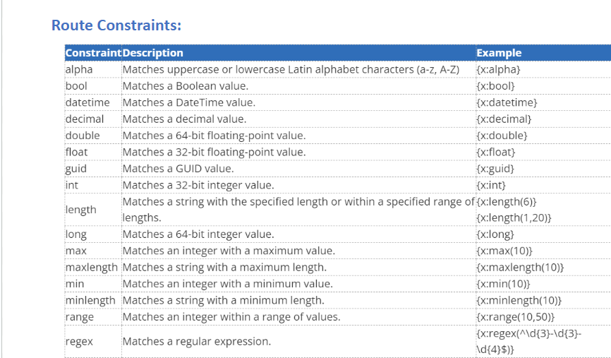

**Cycle Of Handle Request**

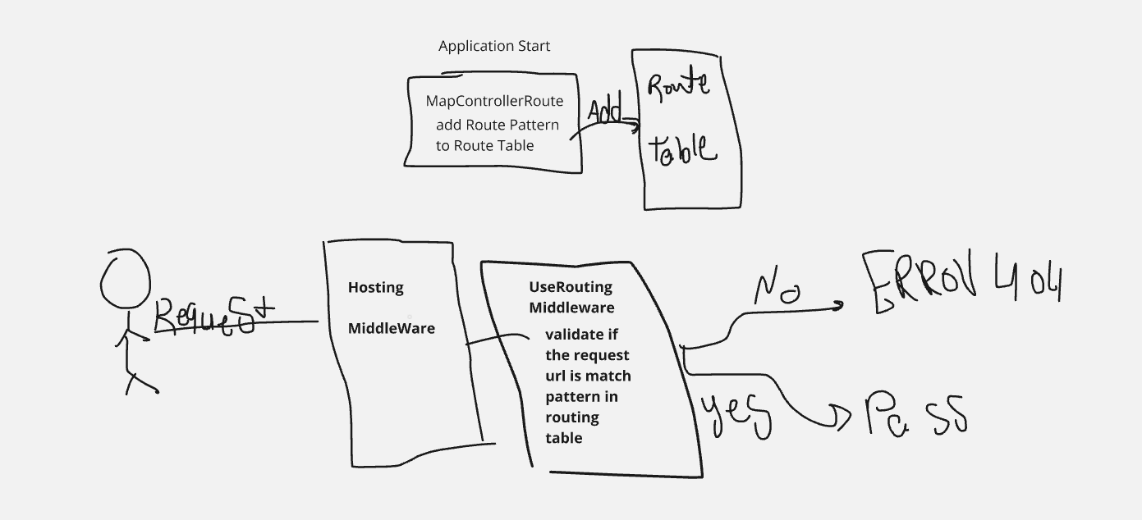

Action Parameter Pinding

If we need to pind a parameter into the url

We can Bind it in :

1 – Form

2 - Sigment

3 – Query String

4 – File -> Old Way