3 Tier – Architeture

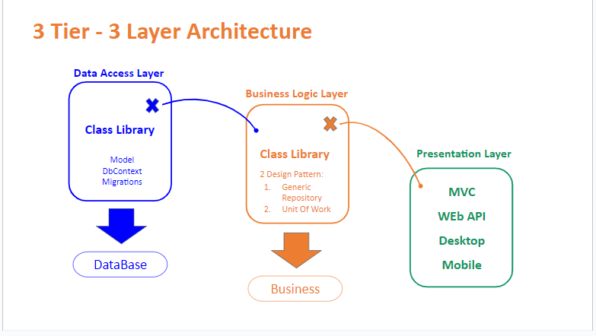

Simply we can say it’s a way to organize our application into 3 Sections

1 – Data Acess Layer -> This will hold all information about our models and database

2 – Bussiness Logic layer -> this will hold all logic behind our Models

3 – Presination layer -> will hold all view to Our Client

**Data Acess Layer**

**This access layer will hold all Infromation About OUR DataBase configuration**

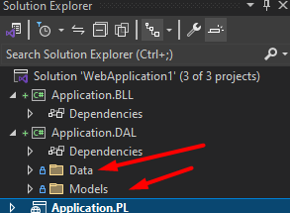

**Data Folder -> will Hold Context Folder and Configuration Folder**

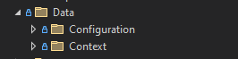

**In our Data access layer we create two Folders**

**Data -> will hold all Data connetions info**

**Models -> will hold all Models Info**

**DataConnection Configuration:**

**When we create A repository we told him to create object from ApplicationContext class to establish a database connection to make an operations on it**

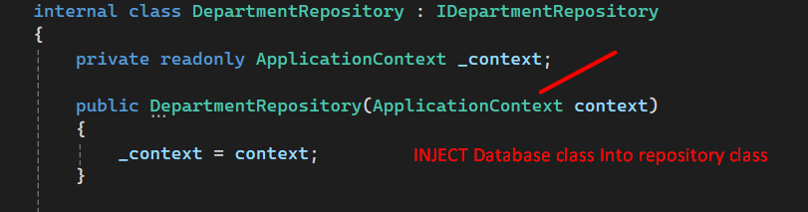

**When we run the application and request the Department Repository the CLR Will inject ApplicationContext then try to create object from it.**

**When clr go to ApplicationContext**

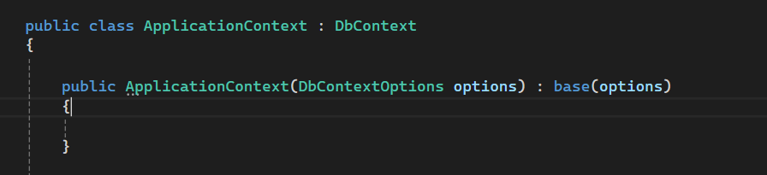

**He will find that we inject another DbcontextOption class to it so he need to create another object then pass it to the parent.**

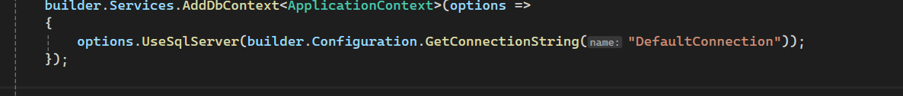

**In this clase we told the compiler that clr will handle creating object OF dBCONTEXTOPTION and use the connection string in the appsetting.json**

**Validate Inputs And Insert Data into Database:**

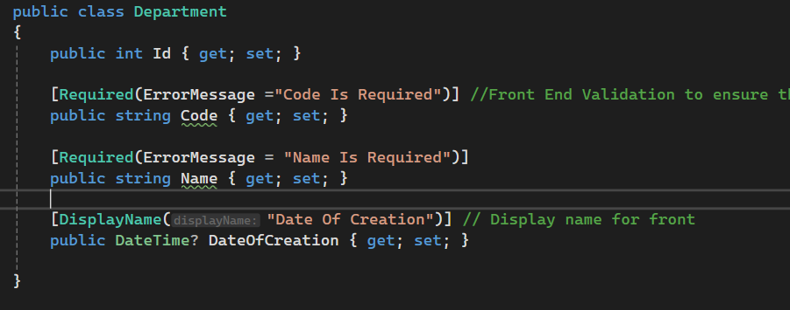

**[Required] attributes make this field is required into database and front end**

**And Error message this message will show if we put null into this field**

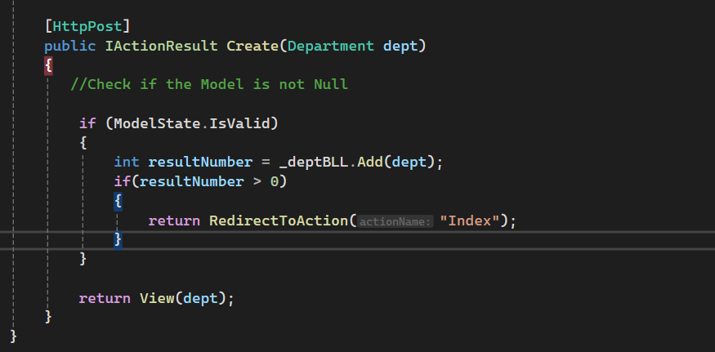

**[HttpPost] -> meaning this will be a Post request into database**

**Modelstate.IsValid -> this check if the model is empty or not and validate the Model in our database**

**Or our Model in DAL**

**If true then check if the number returned from database is larger than 0 that meaning it’s inserted sucssesfuly**

**So redirect the user to the index**

**Else make the request to the same Create page and show error message to him**

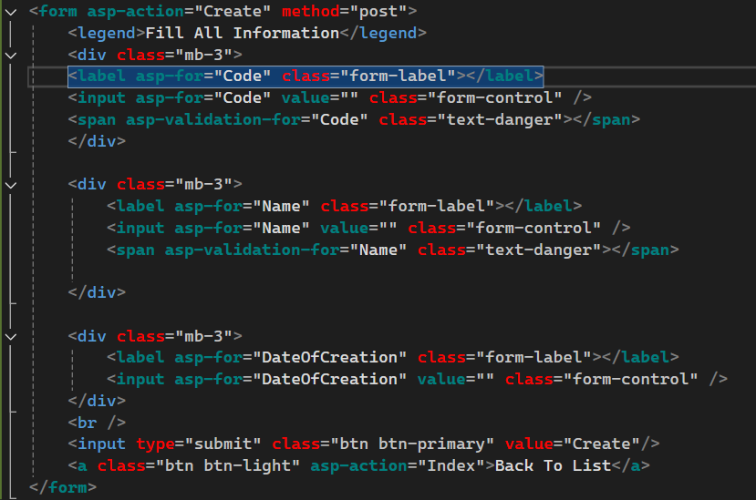

**Business Logic Layer:**

**This layer act as a kitchen it will cook all the meals.**

**In our case This layer act as a waiter take the Request from the controller in PL layer then go to talk to the Data acess layer then back with the information**

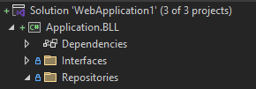

**Interface -> will hold the Defenetion or the Bluebrint of the Method in the repository**

**Repository -> each model will has a repository (Waiter)**

**Asp.Net core MVC Session 04 Notes :**

**Generic Repository**

**The Generic Repository is a design pattern that abstracts the application’s data layer, making it easier to manage data access logic across different data sources.**

* **Why Use a Generic Repository?** 
  + **Reduces Code Duplication: Common CRUD operations (Create, Read, Update, Delete) are written once in the generic repository and can be reused across all entities.**
  + **Centralizes Data Access Logic: All data access logic is managed in a centralized location, making the codebase easier to manage and understand.**
  + **Promotes DRY Principle: "Don't Repeat Yourself" by reducing redundancy in data access code.**
  + **Testability: Allows for easier unit testing by using dependency injection and mocking.**

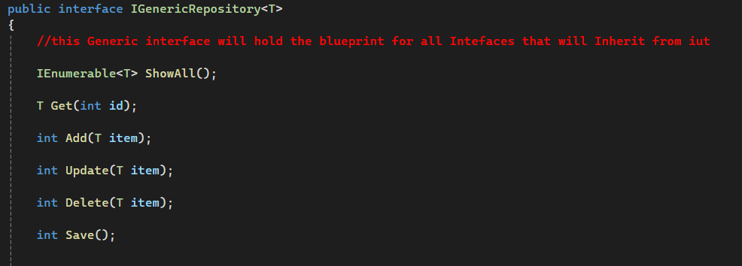

**Implementing It**

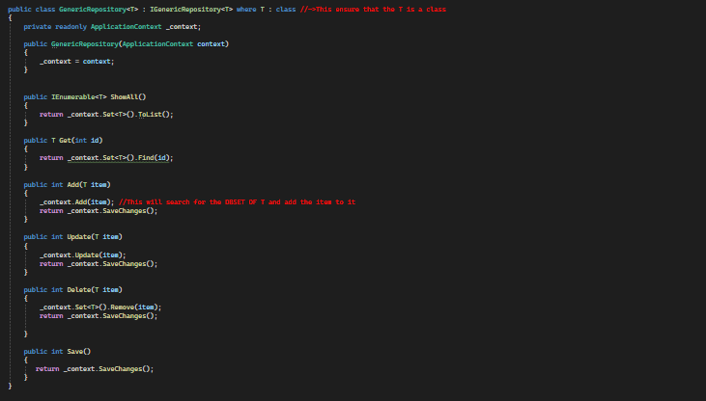

* **A Partial View is essentially a view that renders a portion of HTML and can be reused across multiple views or layouts.**
* **They allow you to break down large views into smaller, reusable components that can be included in different views or layouts.**
* **Partial Views are similar to regular views, but they do not run on their own, they must be embedded within other views.**
* **Partial views are perfect for rendering small, reusable parts of the UI like navigation bars, forms, or lists that are used across different parts of an application.**

**MVC Session 05**

View Model (Mapping):

* **What is a View Model?**
  + A **ViewModel is a** class that contains properties representing the data that will displayed in the view.
  + It is specifically designed to serve the needs of the user interface and does not necessarily map directly to the domain model or database entities.
  + The primary purpose of a View Model is to encapsulate all the data that the view needs to render, making it easier to pass this data from the controller to the view.
  + It acts as an intermediary between the controller and the view, encapsulating the data displayed or edited on the view.

Why Use a View Model?

* + **Separation of Concerns:** ViewModels keep the logic and data that a view needs separate from the domain models, making it easier to manage and modify.
  + **Customization:** A ViewModel can combine data from multiple models, transform or format data, and only pass what the view requires.
  + **Simplification:** Using ViewModels reduces complexity, ensuring that the view only gets the data it needs and nothing more, enhancing security and performance.

**Step 1: Define the View Model:**

**Create a ViewModel Class in a ViewModels folder that includes properties relevant to the view’s needs.**

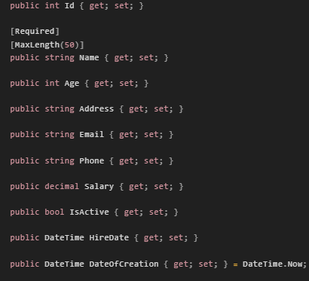

**ViewModel Class:**

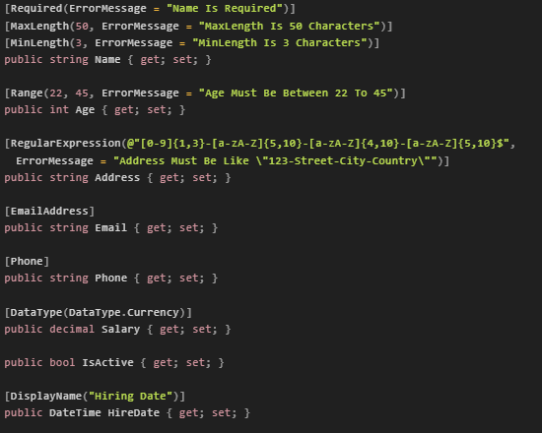

**This class will hold the property that will be displayed in the view**

**What is AutoMapper?**

**AutoMapper is a simple library that helps us to transform one object type into another. It is a convention-based object-to-object mapper that requires very little configuration.**

**Unit of Work Pattern:**

* **The Unit of Work (UOW) is a design pattern in software development that helps manage changes to multiple entities and coordinates these changes so that they can be committed to the database as a single transaction.**
* **The Unit of Work Pattern groups one or more operations (usually database CRUD operations) into a single transaction and executes them by applying the principle of doing everything or nothing.**
* **The Unit of Work pattern is commonly used alongside the Repository pattern to decouple business logic from data access logic.**
* **It helps maintain a clean separation of concerns and ensures that all database operations are committed or rolled back in a transactional manner.**