**Name : Ebrahim Wagih Ebrahim katab**

**B.N: 15**

**Date : 27/5/2020**

**Topic:** **Artificial intelligence**

**Github link :** [**https://github.com/Ebrahim-wagih911/eceoo1**](https://github.com/Ebrahim-wagih911/eceoo1)

**Github page:** [**https://ebrahim-wagih911.github.io/eceoo1/**](https://ebrahim-wagih911.github.io/eceoo1/)

**Application brief :**

The beginnings of this generation began in April 1982 when Japan announced the

production of an institute that will oversee, manage and organize 10-year research

and development projects for a new generation of computers this fifth generation

(5th), the knowledge industry generation or the generation of artificial intelligence.

*This institute is the Institute of New Generation Computer Technology:

This idea came out of a vacuum because the Japanese worked for many years before

1982 in the field of global technology but as copying plans because they were

imitating American-European products in the field of technology and the big idea

came a declaration ahead of them to the developed world and enter a new era of

high-tech processing and launched their new revolution called cognitive procedural

processing systems for information. After working in the field of technology for

many years before 1982, the Japanese realized that they were still dealing in the

field of copying plans and imitating third-party technology in a non-dramatic way

and found that the data are constants that cannot be resonated because they are real

values and they found that working even in the mechanization of information is not

the ideal value of a people who played in technology for many years before 1982

and that they are able to challenge the greatest challenge to the world.

But the Japanese knew that the wealth and wealth of the new nations in Japan would

not come easily from their mines, stones, agricultural lands, shops or even factories

without enhancing and deepening knowledge and trapping them in the minds of the

knowledge-hungry.

*Japanese techno scientists decided that the computer of their fifth generation is

different from the computers of the previous four generations, the computers of the

first generation were computers for vacuum electronic valves, the second generation

were computers transistor, the third with integrative circuits, and the fourth were

computers with wide-measuring integrative circuits, but this generation the

Japanese decided to be an independent generation of all previous technologies and

to be a generation for parallel processing.

**Screenshots :**

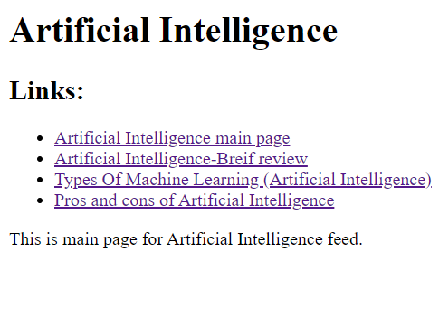

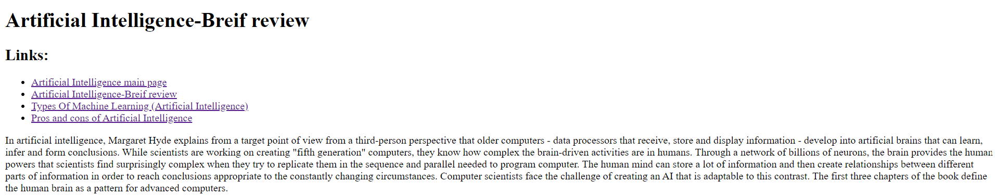

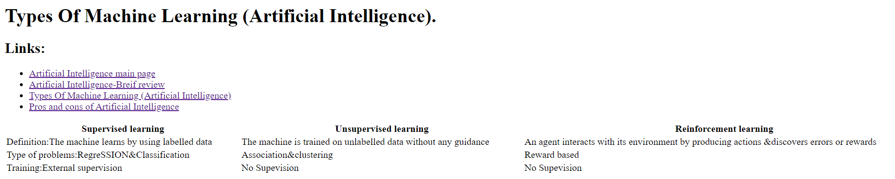

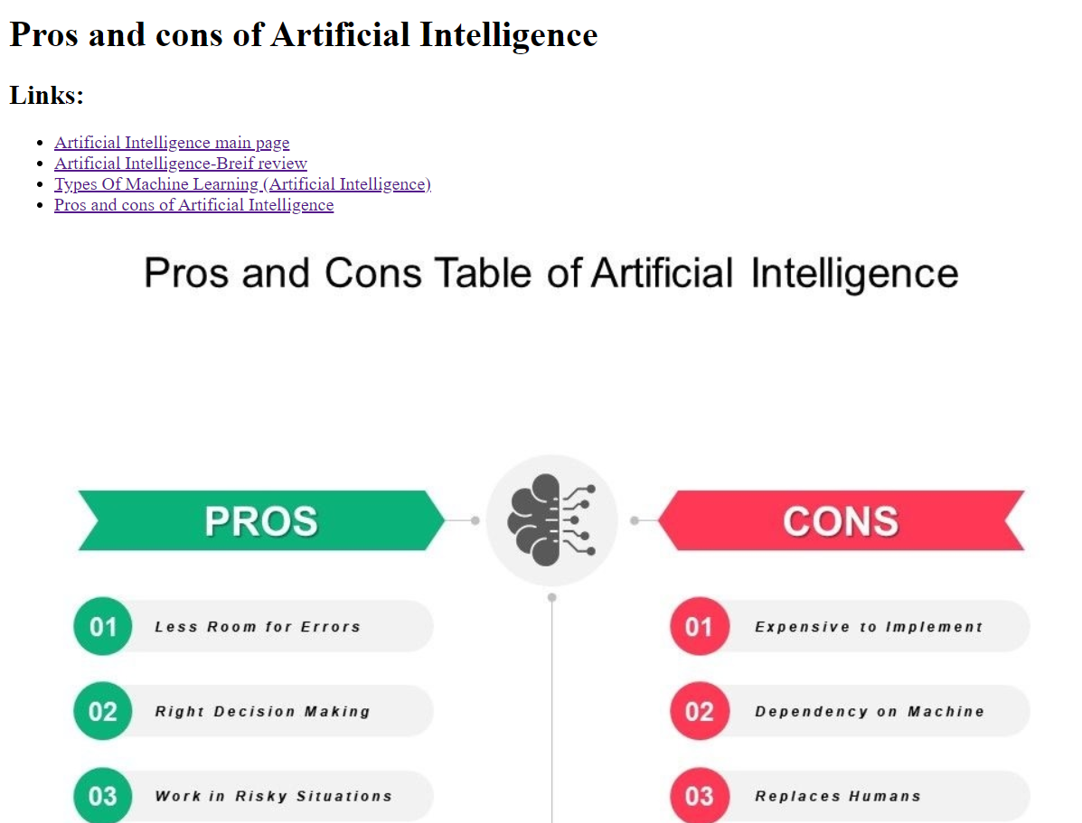

**Source code screenshots:**

