Foody App — System Documentation
Audience: Anyone joining the project — developers, testers, product managers, or non-technical stakeholders.
Goal: Understand how the whole system works without reading every line of code.

Table of Contents
- Big Picture — How Everything Connects
- Authentication — Keycloak & JWT
- Registration & Login Flow
- Database Structure
- API Structure — Symfony / API Platform
- Food Offer Lifecycle
- Order Lifecycle
- Customer Dashboard
- Business Partner Dashboard
- Admin Dashboard
- Caching Architecture
- Tech Stack Reference

1. Big Picture

Architecture Diagram
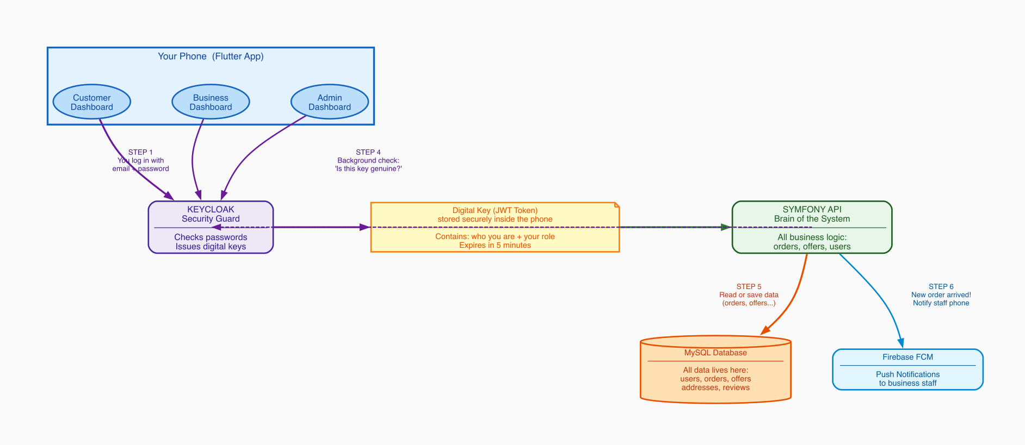
Architecture Diagram

Arrow color meaning
Color | Meaning | Which steps
Purple | Security / Login flow — proving who you are | Steps 1, 2, and the background check in Step 4
Green | Data request — asking for or sending data | Step 3 (app → Symfony)
Orange | Database access — reading or writing to MySQL | Step 5 (Symfony → MySQL)
Blue | Push notification — alerting business staff | Step 6 (Symfony → Firebase)

Step-by-Step: What Happens When You Use the App
Step 1 — You log in (phone → Keycloak)
When you tap “Log In”, the app sends your email and password to Keycloak — a dedicated security service running on the server. Its only job is to check passwords and decide who gets in. Your password never goes anywhere else.
Step 2 — You receive a digital key (Keycloak → phone)
If your password is correct, Keycloak creates a small digital key called a JWT token and sends it back. Think of it like a wristband at a venue — you show your passport once at the door, receive the wristband, then show the wristband at every door inside. The token contains who you are, your role, and an expiry time (5 minutes). The app stores it in the phone’s encrypted keychain.
Step 3 — Every request carries the digital key (phone → Symfony)
From this point, every time the app needs data — loading offers, placing an order, viewing history — it sends the JWT token automatically. The user never sees this. It is the equivalent of showing your wristband at every door.
Step 4 — Background security check (Symfony → Keycloak, dashed)
When Symfony receives a request, it verifies the digital signature of the token in milliseconds. If the token is invalid, expired, or tampered with, the request is rejected immediately. The user never notices — it is completely silent.
Step 5 — Read or write data (Symfony → MySQL)
Once the token is verified, Symfony talks to the MySQL database to get or save data. Every user, order, food offer, address, and review lives in MySQL.
Step 6 — Push notification (Symfony → Firebase)
When a customer places a new order, Symfony sends a push notification to the business partner’s staff phones via Firebase FCM. This is what makes the “New order!” alert appear instantly on the business partner’s screen.

Real example
Maria opens the app and taps “Browse Food”. Steps 1+2 already happened at login. Now: the app asks Symfony “give me all active food offers” with the JWT token attached. Symfony verifies the token (Step 4, invisible). Symfony asks MySQL for active offers (Step 5). MySQL returns the list. Maria sees it on screen — in under a second.

What each layer does
Layer | Technology | Simple explanation
Mobile App | Flutter | The app users see. Three separate dashboards (Customer, Business, Admin) in one codebase.
Security Guard | Keycloak (Docker) | Checks passwords at login. Issues digital key (JWT). Never involved again until the key expires.
API / Brain | Symfony + API Platform | Does all the real work: manages orders, offers, prices, stock, addresses. Trusts the digital key.
Storage | MySQL (Docker) | Stores everything permanently: every user, order, offer, address, review.
Push Alerts | Firebase FCM | Delivers instant push notifications to business staff phones when a new order arrives.
Infrastructure | Docker | Keycloak and MySQL each run in isolated containers. Easy to deploy and maintain.

2. Authentication

Auth Flow Diagram
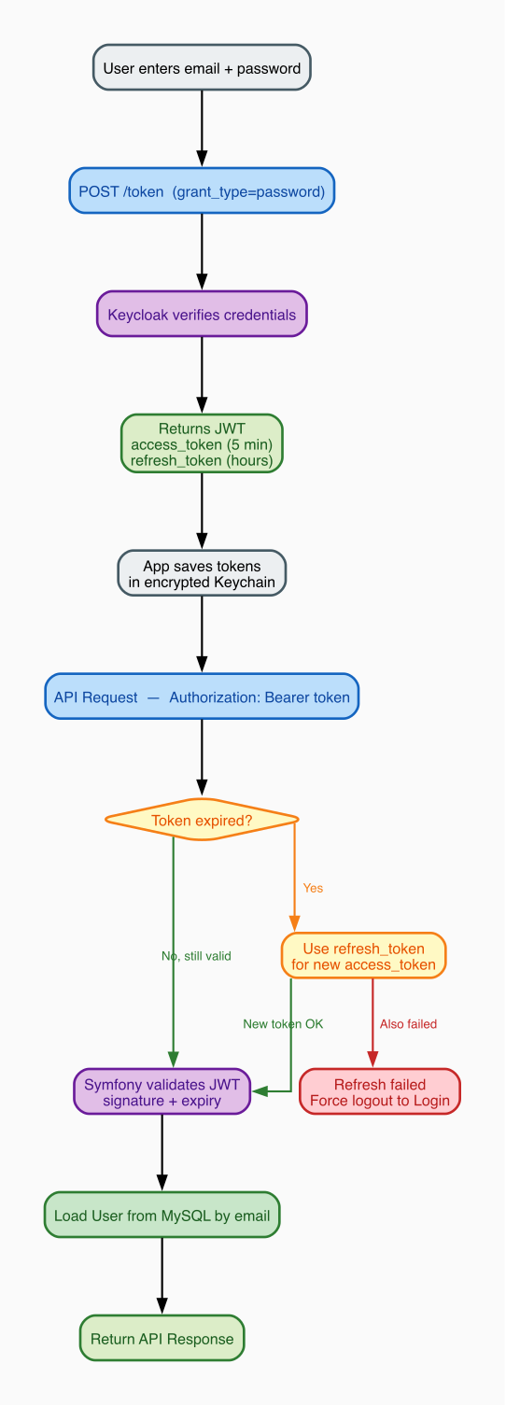
Authentication Flow

JWT Token Structure
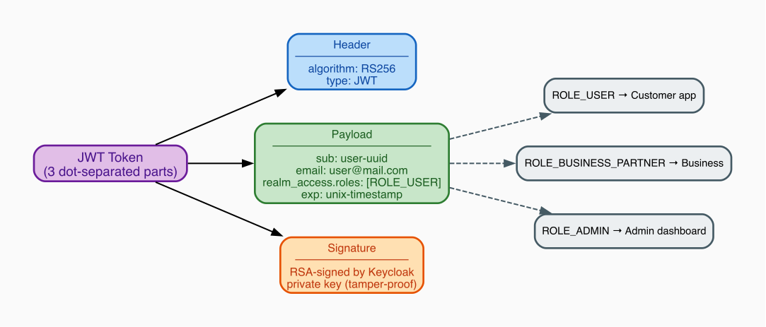
JWT Token Structure

What is Keycloak?
Keycloak is a dedicated login service — its only job is managing passwords and issuing tokens. The app never stores or verifies passwords directly. It runs on our own Docker infrastructure (no third-party).

What is a JWT Token?
A JWT (JSON Web Token) is a small encoded text string passed with every API request. It has three dot-separated sections:
- Header — which algorithm signed it (RS256)
- Payload — your identity: UUID, email, roles, expiry time
- Signature — Keycloak’s cryptographic seal; any tampering breaks this

Token storage
Key | Content | Lifetime | Storage
kc_access_token | JWT sent with every request | ~5 minutes | iOS Keychain / Android Keystore (encrypted)
kc_refresh_token | Used to silently get a new token | Hours | Same encrypted storage
kc_id_token | User profile info | ~5 minutes | Same encrypted storage
Token Expiry: Access tokens expire after 5 minutes. The app automatically uses the refresh token to get a new one silently — the user never sees a re-login prompt unless the refresh token also expires.

Auth Interceptor — Automatic Token Management
A Dio HTTP interceptor runs before every API call. It: 1. Reads the stored access token 2. Checks if it will expire in the next 30 seconds 3. If yes, silently calls Keycloak with the refresh token to get a new one 4. Attaches the valid token to the request header 5. If refresh also fails — clears tokens and redirects to Login screen

Physical Device — Dev Host Detection
On development builds the app must reach the backend running on a laptop. The IP changes per network. ApiConstants.resolveDevHost() probes each known IP in a priority list by opening a TCP socket and uses the first one that responds.
Where it runs: resolveDevHost() is called from AuthGate._bootstrap() — the real splash/entry screen. It runs in parallel with the auth check and the minimum 1.6 s animation delay, so host resolution never adds extra wait time for the user.
AuthGate opens
├─ resolveDevHost() ← probes all hosts simultaneously
├─ isLoggedIn() check ← reads stored tokens
└─ 1600 ms animation delay
All three finish → navigate to correct screen
Probe strategy: Both ports (8082 Keycloak, 8081 API) are probed in parallel per host, with a 1 000 ms timeout each. All hosts are also probed in parallel. Worst case (all hosts unreachable): 1 000 ms total — comfortably within the animation window.
10.0.2.2 → Android emulator (fixed alias to host machine)
localhost → iOS simulator (shares Mac's network stack)
192.168.x.x → local home/office router (physical device)
10.202.x.x → hotspot
Falls back to the first entry if none respond.
Dio base URL — dynamic resolution: The ApiService Dio instance is created at app startup before resolveDevHost() has run. To avoid freezing the base URL at the wrong host, an interceptor rewrites baseUrl on every request:
// In ApiService constructor — runs before every HTTP call:
dio.interceptors.add(InterceptorsWrapper(
onRequest: (options, handler) {
options.baseUrl = ApiConstants.baseUrl; // reads the resolved host each time
handler.next(options);
},
));
This means even if the Dio instance was created before the host was known, every request uses the correct resolved host.
Auth Dio also has explicit connectTimeout (8 s) and receiveTimeout (10 s) so connection errors on physical devices surface a meaningful message instead of hanging indefinitely.

3. Registration & Login Flow

Registration Flow
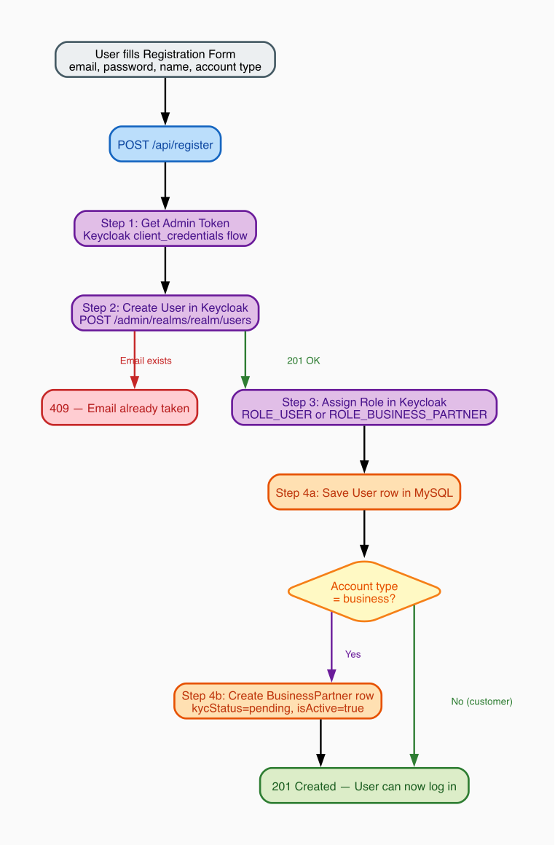
Registration Flow
Why two systems? Keycloak owns authentication (passwords, sessions). MySQL owns business data (orders, offers, addresses). When registering, both must be updated in one request — the Symfony backend coordinates this automatically.
KYC Gate: A business with kycStatus = 'pending' cannot publish food offers. An Admin must approve the account first.

Role-Based Routing After Login
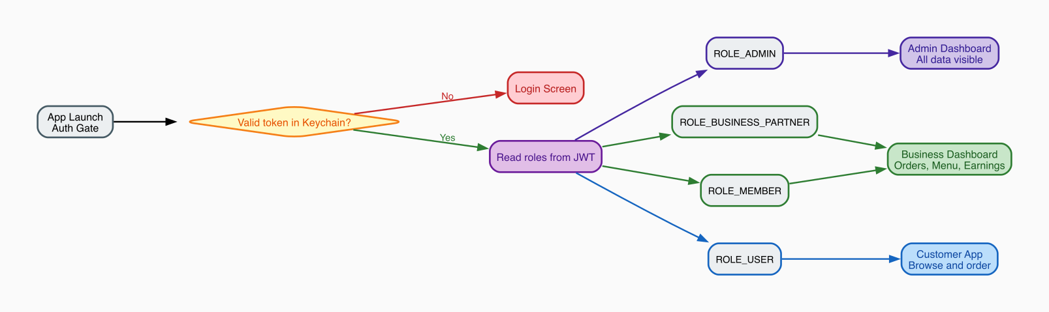
Role-Based Routing
After login the app reads the roles from the JWT and navigates to the correct dashboard:
Role | Destination | What they see
ROLE_ADMIN | Admin Dashboard | Platform-wide stats, all users, all orders, KYC approval
ROLE_BUSINESS_PARTNER | Business Dashboard | Their orders, menu management, earnings
ROLE_MEMBER | Business Dashboard | Same as business partner (staff account)
ROLE_USER | Customer App | Browse offers, place orders, favorites

4. Database Structure

Entity Relationship Diagram
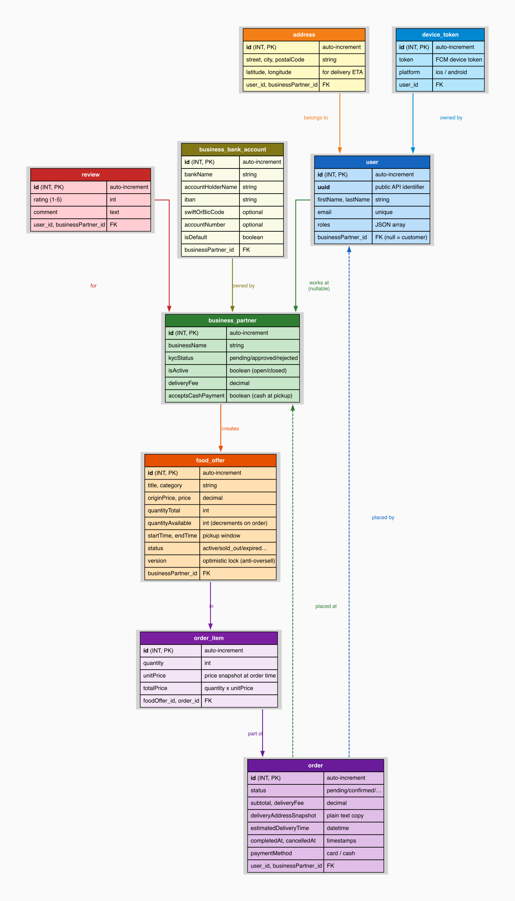
Database Entity Diagram

How to Read the Diagram
Each table is a box with its columns listed inside. Arrows between boxes show a relationship — for example “order belongs to user”. An arrow with a dashed line means the relationship is optional.

Real Example — Maria Orders a Sushi Bag from Mario’s Bistro
Let’s trace exactly which database records are created or updated:
- user table — Maria’s row already exists. email=maria@mail.com, roles=["ROLE_USER"], businessPartner_id=NULL (she is a customer).
- business_partner table — Mario’s Bistro row: businessName="Mario's Bistro", isActive=true, kycStatus="approved", deliveryFee=2.50.
- food_offer table — The “Sushi Bag” row: salePrice=5.99, quantityAvailable=3. When Maria orders 1 bag, quantityAvailable drops to 2.
- order table — New row created: status=pending, paymentStatus=pending, subtotal=5.99, deliveryFee=2.50, deliveryAddressSnapshot="Karl-Marx-Str. 12, 12043 Berlin" (plain text copy — never changes), user_id=Maria's id, businessPartner_id=Mario's id.
- order_item table — New row: quantity=1, unitPrice=5.99 (copied from food_offer at this moment), totalPrice=5.99, titleSnapshot="Sushi Bag" (copied from food_offer title at this moment), categorySnapshot="restaurant" (copied from food_offer category at this moment).
Why is the price copied? If Mario later changes the Sushi Bag to €7.99, Maria’s old order still correctly shows €5.99 — because we saved the price at the time she ordered. Just like a paper receipt.
Why are title and category copied? If Mario deletes the “Sushi Bag” offer later, Maria’s order history still shows the correct item name and category — because titleSnapshot and categorySnapshot were saved at order time on order_item. The app uses these snapshots as the primary display value and only falls back to the live offer data for orders placed before the snapshot fields were introduced.

Table-by-Table Explanation

user — every person who uses the app
Column | Example | What it means
uuid | 550e8400-e29b-… | Public unique ID used in all API responses
email | maria@mail.com | Unique — also matches the Keycloak login
roles | ["ROLE_USER"] | Controls which dashboard appears after login
businessPartner_id | NULL / 7 | NULL = customer. A number = this person works at that restaurant

business_partner — each restaurant or shop
Column | Example | What it means
kycStatus | pending / approved | Only approved businesses can publish food offers
isActive | true / false | false = restaurant closed; offers disappear from customer Home
deliveryFee | 2.50 | Added to every order total for this business
acceptsCashPayment | true / false | When true, customers see a “Pay at Pickup (Cash)” option on checkout
contactPhone | +49 30 123456 | Optional public contact phone number for the business
contactEmail | info@mario.de | Optional public contact email address for the business

food_offer — a surplus food bag listing
Column | Example | What it means
originalPrice | 12.00 | Full retail price shown struck-through (was originPrice before migration)
salePrice | 5.99 | Discounted price the customer pays (was price before migration)
quantityAvailable | 3 → 2 → 0 | Decrements with each order; 0 = shown as “sold out”. NULL for weight-based offers.
startTime / endTime | 18:00 – 20:00 | Pickup window; after endTime the offer is “expired”
status | active | Raw stored value — the API computes the real status at runtime
version | 1, 2, 3… | Optimistic lock — prevents two customers buying the last bag simultaneously
isWeightBased | false / true | When true, quantity fields are NULL and weight fields are used instead
pricePerKg | 3.50 | Price per kilogram — only used when isWeightBased = true
weightTotalKg | 5.0 | Total weight in kg available — only for weight-based offers
weightAvailableKg | 4.5 | Remaining kg available — decrements per order
minOrderKg | 0.5 | Minimum order in kg — optional, only for weight-based offers
Piece-based vs weight-based: Most offers (bread bags, meal boxes) are piece-based — the customer buys N bags. Butchers, delis, or fishmongers may sell by weight — the customer specifies how many kg they want. The isWeightBased flag selects the right model for each offer.

order + order_item — the customer’s purchase
Column | Example | What it means
status | pending → confirmed → completed | Tracks where the order is in the lifecycle
paymentStatus | pending / paid / refunded | Tracks payment state separately from delivery status
cancellationReason | "Changed my mind" | Optional free-text reason stored when an order is cancelled
deliveryAddressSnapshot | "Karl-Marx-Str. 12, Berlin" | Plain text copy saved at order time — immune to future address changes
paymentMethod | card / cash | Records how the customer chose to pay at checkout. Only card or cash are valid values.
order_item.unitPrice | 5.99 | Price copied from food_offer at order time — immune to future price changes
order_item.titleSnapshot | "Sushi Bag" | Title copied from food_offer at order time — survives offer deletion
order_item.categorySnapshot | "restaurant" | Category copied from food_offer at order time — survives offer deletion

business_bank_account — bank accounts per business
Column | Example | What it means
bankName | ING | Display name of the bank
accountHolderName | Mario Rossi | Name on the account
iban | NL91 ABNA 0417 … | International bank account number
swiftOrBicCode | INGBNL2A | Optional international routing code
accountNumber | 0417164300 | Optional local account number
isDefault | true / false | One account per business marked as default for payouts

Other tables
Table | Purpose
address | Delivery and pickup locations. Latitude/longitude used for ETA calculation.
review | Star ratings (1–5) + comments. Average rating computed on-the-fly, not stored. Submitting a second review for the same business returns HTTP 409 Conflict.
device_token | FCM token per staff device. All tokens for a business receive a push when a new order arrives.
image | Food offer photos and user avatars. Linked to food_offer or user.

Key Design Decisions
Why deliveryAddressSnapshot instead of a foreign key?
If we stored only a link to the address table, deleting a saved address would break old order history. The snapshot saves the plain text “Main Street 1, 10115 Berlin” at order time — just like a printed receipt.
Why titleSnapshot and categorySnapshot on order_item?
If a business deletes or edits a food offer after the customer ordered, the order history would show blank item names or the wrong category. The snapshots freeze the display info at order time, independent of the live offer record.
Why a version column on food_offer?
If two customers both try to buy the last bag at the exact same millisecond, both pass the stock check simultaneously. The version column means only the first one to write to the database succeeds — the second sees a version mismatch and is rejected. No overselling possible.
Why separate paymentStatus and status?
Order status tracks logistics (pending → confirmed → completed). paymentStatus tracks the money (pending → paid → refunded). They advance independently — for example an order can be completed logistically but still pending payment for cash-at-pickup orders.

5. API Structure

API Platform Diagram
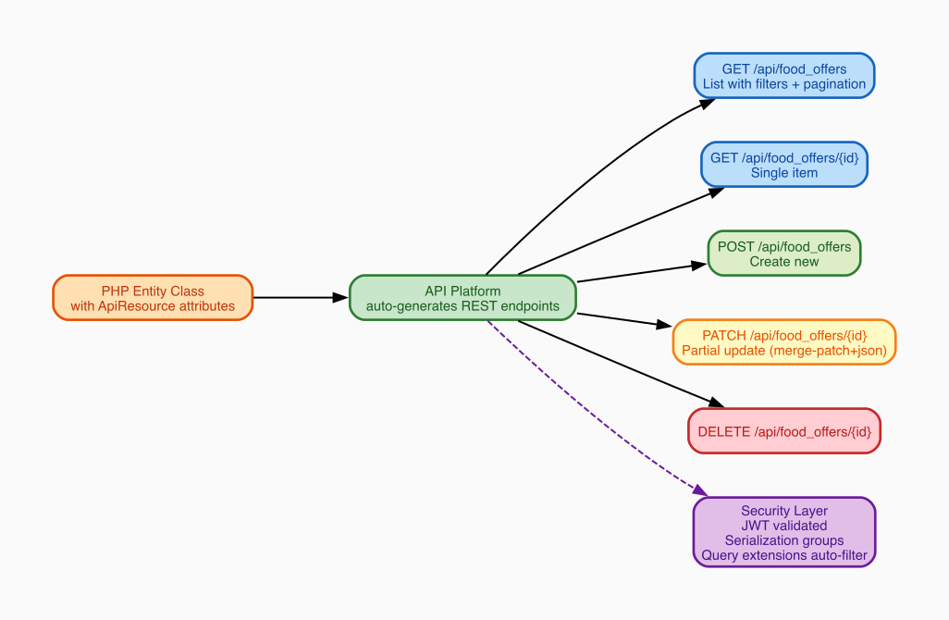
API Structure

What API Platform Does
API Platform is a Symfony bundle that automatically generates REST endpoints from PHP entity classes. Instead of writing a controller for every endpoint, you annotate the entity and it gets full CRUD immediately.

Available API Resources
Resource | Base URL | Who uses it
User | /api/users | Auth, profile management
BusinessPartner | /api/business_partners | Business owners + Admin
FoodOffer | /api/food_offers | Customers (browse) + Business (manage)
Order | /api/orders | Customers (place) + Business (manage)
Address | /api/addresses | Customer delivery addresses
Image | /api/images | Food photos, avatars
Review | /api/reviews | Customer ratings
DeviceToken | /api/device_tokens | Push notification registration
BusinessBankAccount | /api/business_bank_accounts | Business partner bank accounts for payout management

Custom Endpoints
Endpoint | Method | Purpose
/api/register | POST | Create user in Keycloak + MySQL in one step
/api/users/me | GET | Current user’s profile + linked business partner
/api/orders/{id}/status | PUT | Change order status with transition validation
/api/images/upload | POST | Upload food offer photo or avatar
/api/favorite_offers/{id} | POST/DELETE | Save or remove a saved food offer
/api/food_offers/sections | GET | Home screen initial load — all non-empty categories in one request
/api/food_offers/sections/{category} | GET | Load the next page of offers for one category row

Home Screen Sections API
These two endpoints replace the old pattern of sending one request per category. Instead the home screen loads everything in one request and paginates each row independently as the user scrolls.

Initial load — GET /api/food_offers/sections?limit=10
Returns every category that has at least one active offer. Empty categories are skipped automatically by the backend.
Example response:
{
"sections": [
{
"category": "pizza",
"label": "Pizza",
"total": 24,
"limit": 10,
"hasMore": true,
"nextPage": 2,
"items": [ ...10 offer objects... ]
},
{
"category": "bakery",
"label": "Bakery",
"total": 5,
"limit": 10,
"hasMore": false,
"nextPage": null,
"items": [ ...5 offer objects... ]
}
]
}
- total — live offer count in that category right now
- limit — echoed back so the client always uses the same page size for subsequent requests
- hasMore: false + nextPage: null — row is fully loaded, no pagination needed
- hasMore: true + nextPage: 2 — more items exist; scroll right to fetch them

Scroll load-more — GET /api/food_offers/sections/{category}?page=2&limit=10
Called when the user scrolls near the right edge of a category row. The page and limit values come directly from the previous response — the client never calculates them.
Example: User scrolls to the end of the Pizza row. The app reads nextPage=2 and limit=10 from the stored FoodSectionModel and calls GET /api/food_offers/sections/pizza?page=2&limit=10. The new items are appended to the existing row without affecting any other category.
Response: Same shape as a single section object above (without the sections wrapper).
Route priority note: The sections controller is registered with priority: 10 in Symfony so it takes precedence over API Platform’s auto-generated GET /api/food_offers/{id} route. Without this, /api/food_offers/sections would be matched as an item-GET with id="sections" and return 404.

Breaking Changes — Price Field Names
The price fields on FoodOffer were renamed in the backend. The old names no longer exist in API responses:
Old JSON key | New JSON key | Meaning
originPrice | originalPrice | Full retail price (shown struck-through)
price | salePrice | Discounted sale price the customer pays
The Flutter FoodOfferModel.fromJson reads both old and new keys with a fallback (json['originalPrice'] ?? json['originPrice']) so that entries cached in GetStorage before the migration still parse correctly without clearing user data.
All PATCH and POST request bodies must use the new names (originalPrice, salePrice).

Payment Method Validation
The paymentMethod field on orders is validated server-side. Only two values are accepted:
Value | Meaning
card | Customer pays by card (default)
cash | Customer pays cash at pickup
Any other value defaults to card in the Flutter model to prevent invalid data reaching the UI.

Review Conflict
POST /api/reviews returns HTTP 409 Conflict if the authenticated user has already submitted a review for the same business partner. The app should catch this response and show a message like “You have already reviewed this business.”

Automatic Query Filtering
These filters run automatically — the client never passes them manually:
Extension | What it does
CurrentUserExtension | Customers only see their own orders
OrderBusinessPartnerExtension | Business staff only see orders from their restaurant
OrderExtension | Orders always sorted newest-first

Pagination and Total Count
Order list responses include pagination metadata. The Flutter OrderController reads the server-reported total and stores it as:
final totalOrders = 0.obs; // set from result.totalOrders (hydra:totalItems)
This is the total count across all pages, not just the current page. It is shown in the My Orders header badge and the Profile stat card. Using the server-reported total means the number is correct even when only the first page of orders has been loaded.

Serialization Groups — Who Sees What
Each API operation uses a named group to control which fields are included:
GET /api/food_offers → group: foodOffer:collection:get
GET /api/food_offers/7 → group: foodOffer:item:get
POST /api/food_offers → group: foodOffer:item:post
PATCH /api/food_offers/7 → group: foodOffer:item:patch
Banking details, password hashes, and internal IDs are excluded from public groups automatically.
BusinessBankAccount uses groups businessBankAccount:collection:get, businessBankAccount:item:get, and businessBankAccount:item:post. The isDefault field must be present in the collection group for the default indicator to display correctly after re-login.

6. Food Offer Lifecycle

Lifecycle Diagram
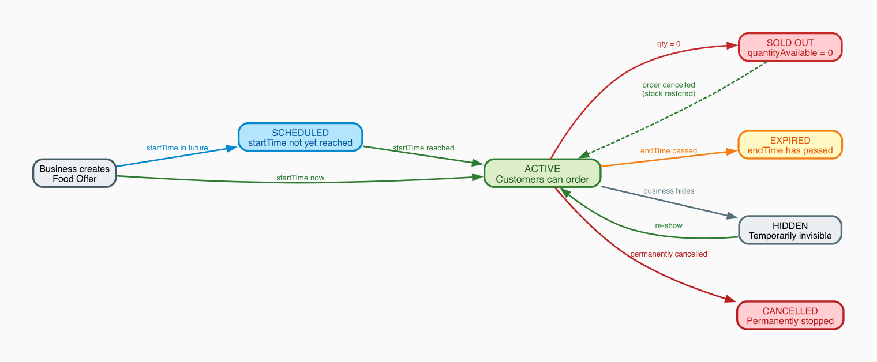
Food Offer Lifecycle

How to Read the Diagram
Each box is a status the food offer can be in. Arrows show what event moves the offer between states. Solid arrows are normal transitions; the dashed arrow (Sold Out → Active) is exceptional — only happens when a cancelled order restores stock.

Color Legend
Color | Status | Meaning
Green | ACTIVE | Customers can see and order right now
Blue | SCHEDULED | Exists but pickup window hasn’t started
Red | SOLD OUT / CANCELLED | No more orders — sold out is temporary, cancelled is permanent
Yellow | EXPIRED | Pickup window ended
Grey | HIDDEN / INACTIVE | Business manually disabled — can re-enable any time

Real Example — “Morning Pastry Bag” at a Bakery
Mario creates the offer at 7:00 AM: quantityAvailable=5, startTime=09:00, endTime=10:30.
Time | Event | Status
07:00 | Mario creates the offer | SCHEDULED (startTime not yet reached)
09:00 | Clock reaches startTime | ACTIVE (computed at runtime — no DB write needed)
09:10 | Maria orders 2 bags | ACTIVE, quantityAvailable=3
09:30 | Two more customers order 1 each | ACTIVE, quantityAvailable=1
09:45 | Last customer buys the final bag | SOLD OUT (quantityAvailable=0)
09:50 | Maria cancels her order | ACTIVE again (quantityAvailable=2 restored)
10:30 | endTime passes | EXPIRED (no more orders accepted)
How does the status stay correct? The status column stores the raw value (‘active’). When any client requests the offer, the server runs a quick check: if quantityAvailable=0 → return ‘sold_out’; if now > endTime → return ‘expired’; otherwise return what’s stored. No background job needed.

Weight-Based Offers
Not all food is sold in fixed bags. Butchers, fishmongers, and delis sell by weight. For these offers isWeightBased=true and the piece-based fields (salePrice, quantityTotal, quantityAvailable) are NULL. Instead:
Field | Example | Meaning
pricePerKg | 3.50 | Price per kilogram
weightTotalKg | 5.0 | Total kg available when created
weightAvailableKg | 4.2 | Remaining kg (decrements per order)
minOrderKg | 0.5 | Minimum purchase in kg (optional)
At checkout the customer enters how many kg they want (≥ minOrderKg). The server computes subtotal = requestedKg × pricePerKg. The “Sold Out” threshold is weightAvailableKg = 0.

Food Offer Categories
The backend uses a 17-value category enum. All category values are snake_case strings:
API value | Display label
fast_food | Fast Food
pizza | Pizza
bakery | Bakery
restaurant | Restaurant
supermarket | Supermarket
cafe | Café
meals | Meals
bread_pastries | Bread & Pastries
fruits_vegetables | Fruits & Vegetables
groceries | Groceries
hot_drinks | Hot Drinks
cheese_dairy | Cheese & Dairy
butcher | Butcher
fish | Fish
deli_catering | Deli & Catering
flowers | Flowers
salads | Salads
The Flutter app centralizes label resolution in FoodCategories.label(String cat) — all screens call this one method so category display names are consistent and fully translated. Legacy values from an earlier backend (caffe, meal, vegetables, drinks, florist) are mapped to their modern equivalents inside this method.

What the Business Can Control Manually
Action | Result | Reversible?
Hide offer | Disappears from customer app immediately | Yes — un-hide any time
Set inactive | Same as hidden, signals longer-term pause | Yes
Cancel offer | Permanently stopped | No — final state

Overselling Prevention
Two safety nets:
- Application check — Before saving any order, the server reads quantityAvailable and rejects if less than the quantity requested. Example: only 1 bag left, customer orders 3 → “Not enough stock”.
- Optimistic lock — Two customers tap “Order” on the last bag at exactly the same millisecond. Both pass the application check simultaneously. But the version column means only the first one to write succeeds. The second sees a version mismatch and is rejected automatically.

7. Order Lifecycle

Lifecycle Diagram
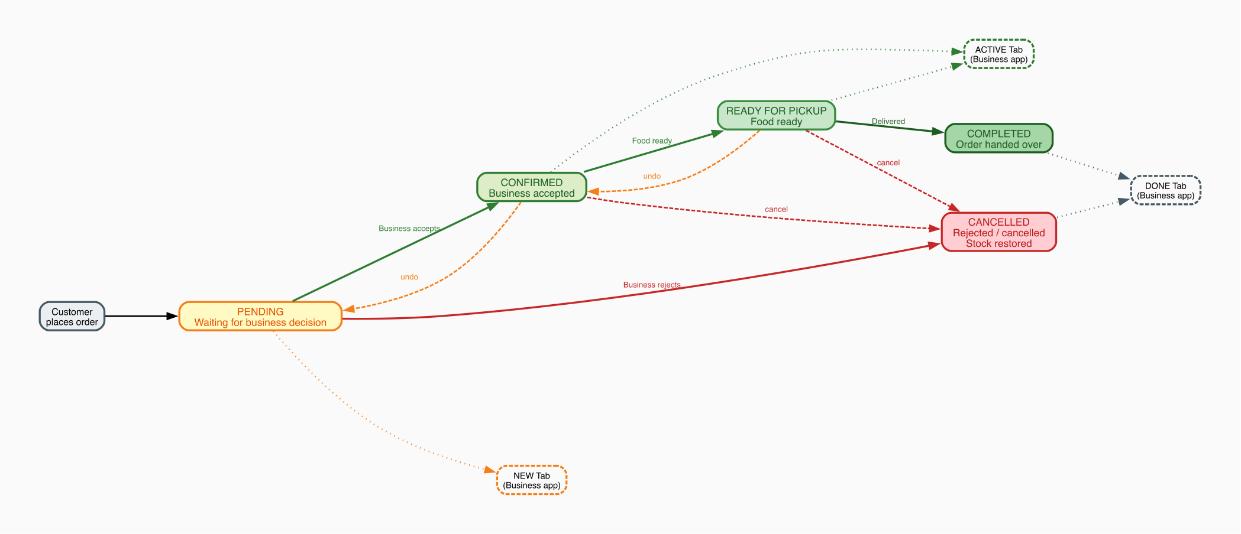
Order Lifecycle

How to Read the Diagram
Each box is a status. Solid arrows = normal path forward. Dashed arrows = undo or alternative paths. Dotted lines connect each status to the tab in the Business app where it appears.

Color Legend
Color | Status | Business App Tab
Yellow | PENDING — waiting for business decision | NEW tab
Light green | CONFIRMED — business accepted, food being prepared | ACTIVE tab
Medium green | READY FOR PICKUP — food is packed | ACTIVE tab
Dark green | COMPLETED — order handed over | DONE tab
Red | CANCELLED — rejected or cancelled | DONE tab

Real Example — Maria Orders, Mario Accepts
- Maria places the order → status = pending. Order appears in Mario’s NEW tab. Mario’s phone buzzes: “New order arrived!”
- Mario taps Accept → status = confirmed. Card immediately moves from NEW to ACTIVE tab (optimistic update — no waiting for server response).
- Mario finishes packing → taps “Mark Ready” → status = ready_for_pickup. Still in ACTIVE tab.
- Order is delivered → Mario taps “Complete” → status = completed. Card moves to DONE tab.

Alternative Path — Mario Rejects
- Mario taps Reject → status = cancelled
- Order moves directly to DONE tab
- Stock restored — quantityAvailable goes back up (2 Sushi Bags returned to inventory)
- Maria sees “Cancelled” in her order history
Rules enforced by the server: You cannot skip steps. Trying to jump from PENDING directly to COMPLETED returns a 422 error. COMPLETED and CANCELLED are final states — they cannot be undone.

Status Transitions
Current Status | Allowed Next | Who triggers it
pending | confirmed, cancelled | Business partner
confirmed | ready_for_pickup, cancelled, pending | Business partner
ready_for_pickup | completed, cancelled, confirmed | Business partner
completed | — (final) | —
cancelled | — (final) | —

Payment Status
paymentStatus is tracked independently of the delivery lifecycle:
Value | Meaning | When it appears
pending | Payment not yet confirmed | All new orders — shown in blue
paid | Payment received | After payment is confirmed — shown in green
refunded | Money returned to customer | After a refund is processed — shown in amber
Both the customer order detail screen and the business order detail screen show the payment method and payment status in the price summary section.

Order Placement — What the Server Does Behind the Scenes
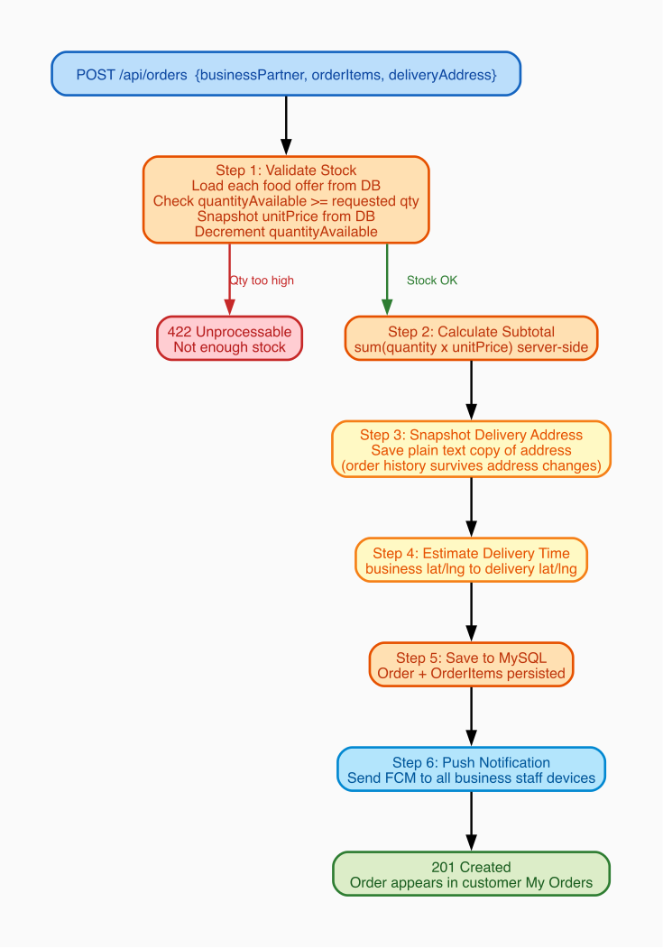
Order Placement
When a customer taps “Confirm Order”, the server silently runs 6 steps before responding.
Example: Maria orders 2 Sushi Bags (€5.99 each) + €2.50 delivery fee
Step 1 — Validate Stock
Server reads quantityAvailable=3. Maria wants 2. OK — stock decremented to 1. Server reads the price from the database (€5.99) — it never trusts the price the app sent.
If stock was 1 and Maria tried to order 2 → “Not enough stock” error, order not created.
Step 2 — Calculate Subtotal (server-side)
2 × €5.99 = €11.98. Calculated on the server — the app cannot send a fake lower amount.
Step 3 — Snapshot the Delivery Address
Saves "Karl-Marx-Str. 12, 12043 Berlin, Germany" as plain text on the order. Even if Maria deletes her saved address tomorrow, this order permanently shows the correct delivery location.
Step 4 — Estimate Delivery Time
Uses the business and customer coordinates (latitude/longitude) to calculate an ETA and save it on the order.
Step 5 — Save Everything to MySQL
Order + all OrderItems saved in one transaction. Total = €11.98 + €2.50 = €14.48. titleSnapshot and categorySnapshot are written to each order_item row.
Step 6 — Send Push Notification
Looks up all staff device tokens for Mario’s Bistro. Sends FCM push to every device: “New order! Maria — 2 × Sushi Bag — €14.48”. Mario’s phone buzzes in under 2 seconds.

8. Customer Dashboard

Customer Journey Diagram
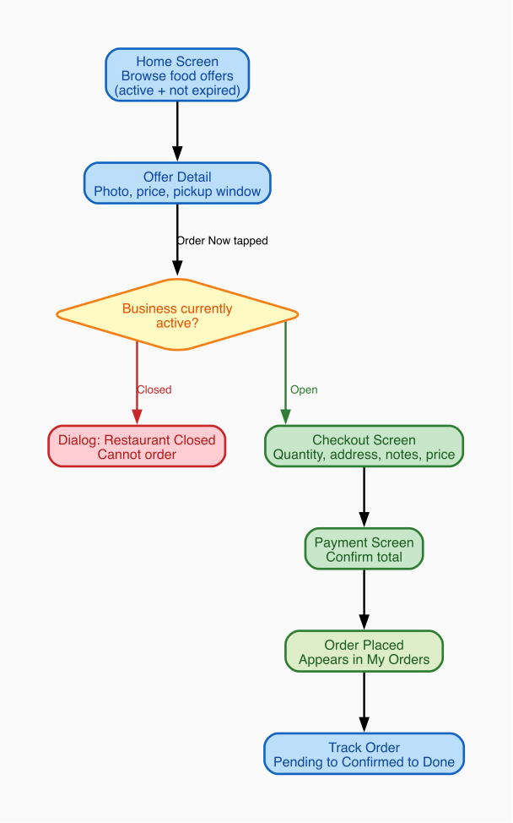
Customer Journey

How to Read the Diagram
Each box is a screen. Arrows show what action takes you to the next screen. The red path shows what happens when a restaurant is closed (dead end — cannot order). The green path is the happy path: successful order from browsing to tracking.

Real Example — Maria Finds and Orders a Sushi Bag
Step | Screen | What happens
1 | Home Screen | Maria sees a list of available offers. Only active offers from open restaurants are shown. Closed restaurant offers are hidden automatically.
2 | Offer Detail | Maria taps “Sushi Bag”. Sees photo, original price (€12.00), sale price (€5.99), 3 bags left, pickup 18:00–20:00.
3 | Business Active Check | Maria taps “Order Now”. App checks if Mario’s Bistro is open. Open → proceeds to Checkout. Closed → dialog: “Mario’s Bistro is temporarily closed.” Cannot continue.
4 | Checkout Screen | Maria selects 2 bags, chooses delivery address “Karl-Marx-Str. 12”, types “no wasabi please”. Price: subtotal €11.98 + delivery €2.50 = €14.48.
5 | Payment Screen | Maria confirms payment and taps “Place Order”.
6 | Order Placed | Screen shows “Waiting for confirmation.” Order appears in My Orders as Pending.
7 | Track Order | Maria watches status update: Pending → Confirmed → Ready → Done.

Home Screen — How Data Loads
The home screen uses the sections API (see Section 5). One request returns all non-empty categories at once.
Before (old approach): 17 parallel requests fired at startup — one per category. Every category always fetched, even empty ones.
Now: Single GET /api/food_offers/sections?limit=10. Only categories with active offers are returned. The network cost at startup is one round-trip regardless of how many categories exist.
Per-row load-more: Each horizontal category row manages its own pagination cursor independently. Scrolling the Pizza row never affects the Bakery row.
App opens
↓
GET /api/food_offers/sections?limit=10
→ sections: [ pizza(10), bakery(5), cafe(10), ... ]
→ UI renders each row immediately
User scrolls Pizza row to the right edge
↓
GET /api/food_offers/sections/pizza?page=2&limit=10
→ 10 more pizza items appended to the Pizza row
→ Bakery, Cafe rows unchanged
Category pill tap: When the user taps “Pizza” in the pill row, the app calls GET /api/food_offers/sections/pizza?page=1&limit=10 and shows only that one row. Tapping “All” returns to the full multi-row view.
Filters applied by the backend on every sections request:
Filter | What it does | Example
status=active | Only active offers | Hides sold-out, expired, hidden offers
endTime after now | Pickup window still open | Hides bags whose window closed at 18:00 if it’s now 18:30
businessPartner.isActive=true | Only open restaurants | Hides all Mario’s Bistro offers if he toggled “Closed”

My Orders Screen
The My Orders screen shows the customer’s full order history with live status updates.
Total order count: The green header badge shows the server-reported total (OrderController.totalOrders, sourced from hydra:totalItems in the API response). This is the count across all pages — accurate even when pagination means only the first 20 orders have been loaded into memory.
The same total is shown on the Profile tab’s Orders stat card. Both update reactively via Obx whenever the controller refreshes.
Per-order display: Each order card shows order ID, business name, category badge (using titleSnapshot/categorySnapshot), delivery address, date, and total price.

Customer Navigation (Bottom Bar)
Tab | Content | Example use
Home | All available food offers | Maria browses for tonight’s dinner deal
My Orders | All orders with live status + total count badge | Maria checks if Mario accepted yet
Favorites | Saved offers | Maria’s favourite bakery bag — one tap to re-order
Profile | Order count stat, addresses, settings, logout | Maria checks her total order history count

Multi-Language Support
The app fully supports English and Persian (Farsi). Language preference is stored in GetStorage under the key locale_lang and persists across app restarts. All user-visible strings go through GetX’s .tr system — no hardcoded text in UI widgets.
Persian uses the Vazirmatn font (via google_fonts) which correctly renders RTL text. Filter chip rows that must stay left-to-right (e.g. sort chips, category pills) are wrapped in Directionality(textDirection: TextDirection.ltr) to avoid layout mirroring.

9. Business Partner Dashboard

Dashboard Diagram
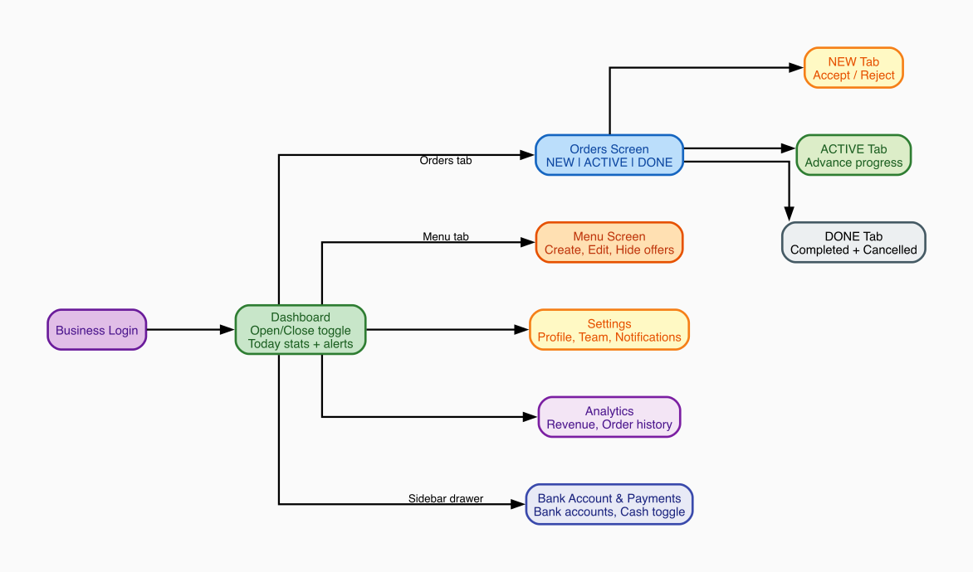
Business Partner Dashboard

How to Read the Diagram
Login leads to the main Dashboard. From there, areas branch off. The Orders branch is the most important for daily operation — it splits into three tabs that directly map to the order lifecycle. The Sidebar drawer gives access to the Bank Account & Payments screen.

Real Example — Mario’s Tuesday Morning

Step 1 — Open the Restaurant (Dashboard)
Mario logs in and taps the Open/Closed toggle → restaurant becomes Open (isActive=true). The app updates instantly. Behind the scenes the server saves the change. Mario’s food offers now appear on every customer’s Home screen.
If the toggle were “Closed”, every customer tapping “Order Now” would see: “Mario’s Bistro is temporarily closed” — no order possible.

Step 2 — Publish a Food Offer (Menu Screen)
Mario goes to Menu and taps “Add New Offer”:
Field | Mario types | What it controls
Title | Sushi Bag | What customers see on the card
Category | Restaurant | Customer filter on Home screen (one of 17 backend values)
Original price | €12.00 | Shown struck-through (discount indicator) — sent as originalPrice
Sale price | €5.99 | What customer pays — sent as salePrice; locked into order_item at order time
Quantity | 5 | Sets quantityAvailable=5; decrements per order (piece-based mode)
Sell by weight | (toggle) | Switches to weight mode: pricePerKg + weightAvailableKg + optional minOrderKg
Pickup window | 18:00 – 20:00 | startTime/endTime; offer expires after 20:00
Photo | (uploads image) | Stored in image table; shown on offer card
Mario taps “Publish” → offer is ACTIVE on customer Home screen immediately.
KYC gate: If Mario’s account is kycStatus=pending, the Publish button is disabled. He can save drafts but they won’t show to customers until an Admin approves his account.

Step 3 — Receiving a New Order (Orders Screen — NEW tab)
Mario’s phone buzzes: “New order! Maria — 2 × Sushi Bag — €14.48”. He opens the NEW tab:
Action | What happens | Where the order goes
Tap Accept | Status → confirmed. Card moves instantly (optimistic update). | NEW → ACTIVE tab
Tap Reject | Status → cancelled. Stock restored (+2 bags). Card moves instantly. | NEW → DONE tab
Optimistic update: When Mario taps Accept, the card moves immediately — no spinner. If the server call fails (e.g. no internet), the card snaps back and Mario sees an error.

Step 4 — Advancing the Order (ACTIVE tab)
- Food packed → “Mark Ready” → status = ready_for_pickup (stays in ACTIVE)
- Order delivered → “Complete” → status = completed → moves to DONE tab
If Mario made a mistake, he can tap “Move Back” to undo one step, or “Cancel” to cancel entirely. When cancelling, Mario can optionally enter a cancellationReason which is stored on the order for customer-facing display.

Step 5 — End of Day (DONE tab)
View-only. Shows all completed and cancelled orders — customer name, total, completion time. Useful for daily revenue reconciliation.
Limit filter: At the top of the DONE tab, Mario can choose how many recent orders to display: Last 5 / Last 10 / Last 20 / Last 50 / All. This is a client-side filter on the already-loaded list, not a new API call. The chip row scrolls horizontally so it never overflows regardless of language or screen width.

Menu Management
Action | When to use | Effect on customers
Publish new offer | New bag available today | Appears on Home screen immediately
Edit offer | Fix typo or change quantity | Customers see updated info
Hide offer | “Not ready yet, 30 min” | Disappears from Home — can un-hide any time
Set inactive | Done for today | Same as hidden, signals longer pause
Delete offer | Permanent removal | Gone forever; linked images also deleted

Team Members
Mario invites his colleague Luigi by email. Luigi gets ROLE_MEMBER, his account links to Mario’s Bistro. Luigi sees the same Business Dashboard. When a new order arrives, both Mario’s and Luigi’s phones receive the push notification.

Bank Account & Payments
Mario navigates to the Bank Account & Payments screen from the sidebar drawer.
Feature | What it does
Multiple bank accounts | Mario can add several bank accounts (IBAN, SWIFT/BIC, holder name, account number)
Default account | Tapping a card sets it as the default — the radio indicator animates smoothly. Only one account can be default at a time.
Edit / Delete | Each card has an Edit button (opens a bottom sheet) and a Delete button with a confirmation dialog.
Cash at Pickup toggle | Mario enables “Accept Cash at Pickup” — customers then see a “Pay at Pickup (Cash)” option at checkout.
Payment badge on orders | Order cards show a “Cash” or “Card” badge based on how the customer paid.

10. Admin Dashboard

What the Admin Sees
The Admin bypasses all automatic query filters. Where a customer sees only their own orders, the Admin sees every order on the platform.
Tab | Content | Key Actions
Overview | Total users, orders today, revenue, live count | Platform health
Partners | All business partners | Approve / reject KYC, view their offers and orders
Customers | All customer accounts | View order history, contact info
Orders | All orders platform-wide | Filter by status, date, business
Offers | All food offers | See active, expired, sold-out across all businesses

KYC Approval Workflow
- Business registers → kycStatus = 'pending'
- Admin sees the business in Partners tab with a “Pending” badge
- Admin reviews registration details (business name, registration number, tax info)
- Admin taps Approve → PATCH /api/business_partners/{id} sets kycStatus = 'approved'
- Business can now create and publish food offers

11. Caching Architecture
The app uses two independent caching layers with different purposes:

Layer 1 — API Data Cache (GetStorage / DataCacheService)
Library: get_storage
Purpose: Show data immediately on app launch before the network request completes. Users see content within milliseconds instead of waiting for a round-trip to the server.
How it works:
App launches
↓
DataCacheService.load('offers_home') → returns cached JSON instantly → UI renders
↓ (in parallel)
API call fires → response arrives → controller updates .obs state → UI re-renders with fresh data
Storage format: Each entry is stored under a namespaced key (data_cache__<name>) as:
{ "ts": 1751234567890, "data": { ...raw API JSON... } }
The ts field is the Unix timestamp (ms) of when the data was saved. Controllers can compare this against DateTime.now() to decide if the cache is stale.
Stale banner: When the UI is showing cached data (not live), a yellow banner appears at the top of the list with a “Refresh” button. This makes it visible to the user that they may be seeing outdated content.
Home screen cache: The sections response is cached under the key food_sections_v1 as a List<FoodSectionModel>. Each section includes all the items loaded so far plus hasMore, nextPage, and limit. On next launch the cached sections are shown instantly while the fresh GET /api/food_offers/sections call is in flight.
The cache key includes a version suffix (_v1) so that if the response shape changes in the future, old incompatible cache entries are simply ignored rather than causing parse errors.
Cache invalidation: Calling DataCacheService.remove(key) deletes one entry. DataCacheService.clearAll() deletes all data_cache__* entries (called from Settings → Clear Cache).
Backward-compatible reads after API field rename:
When the backend renamed originPrice → originalPrice and price → salePrice, existing cache entries still had the old keys. Rather than invalidating all cached data (losing every user’s locally stored offers on first launch), FoodOfferModel.fromJson uses a dual-key fallback:
originalPrice: (json['originalPrice'] ?? json['originPrice'])?.toString(),
price: (json['salePrice'] ?? json['price'] )?.toString(),
Old cached entries parse correctly with the old keys. New API responses parse correctly with the new keys. No user data is lost.

Layer 2 — Image Pixel Cache (flutter_cache_manager / CachedNetworkImage)
Library: cached_network_image + flutter_cache_manager
Purpose: Avoid re-downloading food offer photos and avatars on every screen visit. Images are saved to the device’s disk cache by flutter_cache_manager and displayed instantly on subsequent loads.
How it works: CachedNetworkImage shows a placeholder while the image downloads on first load, then stores the decoded pixels on disk. On subsequent visits the image appears immediately from disk — no network request.

Layer 3 — Avatar URL Cache (GetStorage)
Purpose: Store the resolved CDN URL for user and business avatars so they don’t have to be re-fetched from the profile API on every app open.
Keys: Prefixed with avatar_url__ in GetStorage.

Cache Clear (Settings Screen)
The CacheService.confirmAndClear() method shows a confirmation dialog and then clears all three layers in sequence:
- Remove all avatar_url__* keys from GetStorage
- Call DataCacheService.clearAll() — removes all data_cache__* keys
- Call DefaultCacheManager().emptyCache() — deletes all cached image files from disk
What is NOT cleared: - locale_lang — language preference is preserved - Auth tokens — stored in flutter_secure_storage (iOS Keychain / Android Keystore), completely separate from GetStorage and never touched by cache clearing

12. Tech Stack Reference
Layer | Technology | Why chosen
Mobile UI | Flutter (Dart) | Single codebase for iOS + Android; fast native UI
State Management | GetX | Reactive state + routing + dependency injection in one package
HTTP Client | Dio | Interceptors for automatic token injection and refresh
Secure Storage | FlutterSecureStorage | iOS Keychain / Android Keystore — tokens stored encrypted
API Data Cache | GetStorage | Fast key-value store for raw JSON blobs; survives app restarts; cleared from Settings
Image Cache | flutter_cache_manager | Disk-based image cache; used by CachedNetworkImage; cleared from Settings
Multi-language | GetX Translations | .tr on any string key; FA/EN string files; RTL support via Directionality wrapper
Auth Server | Keycloak | Open-source, self-hosted; manages passwords, JWT signing, roles
API Framework | Symfony + API Platform | Auto-generates REST endpoints; built-in filters, pagination, serialization groups
ORM | Doctrine | Maps PHP classes to MySQL; handles migrations, transactions, optimistic locks
Database | MySQL | Relational structure; strong ACID guarantees for orders and stock
Infrastructure | Docker | Keycloak and MySQL isolated in containers
Push Notifications | Firebase FCM | Cross-platform iOS + Android push delivery

Flutter App Architecture (GetX Pattern)
Screen (View) — displays UI only, zero business logic
│ reads .obs reactive values
▼
Controller — holds state (.obs) + calls services
│ calls
▼
Service — makes HTTP calls with Dio, parses JSON
│ returns
▼
Model (fromJson) — plain Dart data class, no UI, no network
When a controller updates an .obs value, every Obx() widget that reads it rebuilds automatically. No setState() needed.

Full API Request Lifecycle
1. User taps button in the UI
2. Screen calls a method on the Controller
3. Controller calls a Service method
4. Service calls Dio to make an HTTP request
5. AuthInterceptor runs:
a. Reads stored access token
b. If expired: calls Keycloak with refresh_token for a new token
c. Attaches "Authorization: Bearer <token>" to the request
6. HTTP request leaves the phone
7. Symfony receives the request
8. Keycloak JWT Guard validates the token signature + expiry
9. KeycloakUserProvider looks up the User in MySQL by email
10. Doctrine query extensions add automatic WHERE clauses
(e.g. "AND order.user_id = :current_user_id")
11. API Platform serializes the result using the active group
(only allowed fields included)
12. JSON response returns to Dio
13. Service parses JSON into a Model via fromJson()
14. Controller updates .obs reactive state
(e.g. totalOrders.value = result.totalOrders from hydra:totalItems)
15. DataCacheService.save() writes the raw JSON to GetStorage
16. Obx() widgets rebuild automatically
17. User sees the updated UI

