Name: Ebrahim AbdElrahman Ahmed Dewedar

Group : python

Lab : 1

1. List all rentals with customer names.

1. Show all films available in inventory with their titles.

1. Display all actors with the films they appeared in.

1. Show customer names with their addresses

5. Find customers who have never rented a film

6. Find actors who appear in more than 10 films

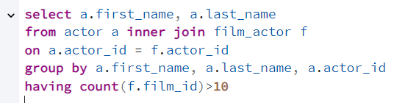

7. Find all films with a rental rate higher than the average rental rate

8. Count how many films are in each rating category

9. List customers who made at least 10 rentals



