## Mastering Embedded System Online Diploma

[www.learn-in-depth.com](http://www.learn-in-depth.com)

First Term (Final Project 1)

Eng. Ebram Edward Fouad Habib

My Profile:

<https://www.learn-in-depth.com/online-diploma/ebramedward7@gmail.com>

# List of Contents:

# Project Description

# Assumptions

# Requirements Diagram

# System Analysis: 1. Use Case Diagram 2. Activity Diagram 3. Sequence Diagram

# System Design (Modules with its own state machines)

# Implementation of each module in C

# .c & .h for each module (An Image for each file.c & file.h with the Corresponding state machine)

# MakeFile

# Startup.c

# Linker_Script.ld

# SW analysis .map file & symbols table & Section tables

# Proteus Simulation

Pressure Controller

# Project Description:

### A pressure controller informs the crew of a cabin with an alarm when the pressure exceeds 20 bars in the cabin.

### The alarm duration equals 60 seconds.

Assumptions:

* The controller set up and shutdown procedures are not modeled
* The controller maintenance is not modeled
* The pressure sensor never fails
* The alarm never fails
* The controller never faces power cut

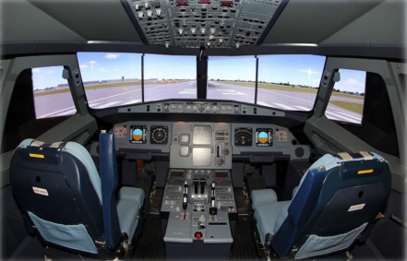

# Requirements Diagram:

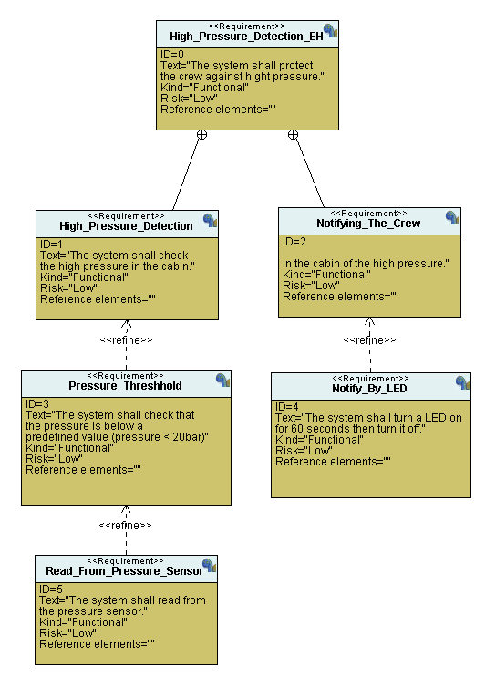

# System Analysis: 1. Use Case Diagram E:\Downloads\Embedded Here We Go Again\Kerolos Shenoda's Diploma\Programs\TTool\TTool\figures\usecase.png

# 2. Activity Diagram E:\Downloads\Embedded Here We Go Again\Kerolos Shenoda's Diploma\Programs\TTool\TTool\figures\act.png 3. Sequence DiagramE:\Downloads\Embedded Here We Go Again\Kerolos Shenoda's Diploma\Programs\TTool\TTool\figures\seq.png System Design (Modules with its own state machines) E:\Downloads\Embedded Here We Go Again\Kerolos Shenoda's Diploma\Programs\TTool\TTool\figures\des.png

# 1-Pressure Sensor State Diagram:

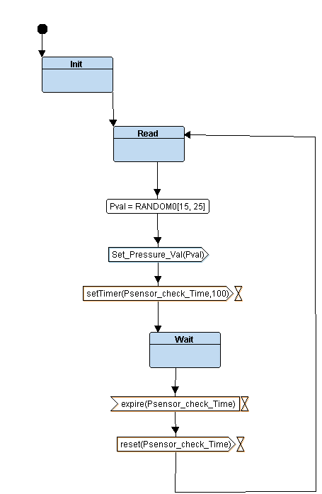

# 2-Main Algorithm State Diagram:E:\Downloads\Embedded Here We Go Again\Kerolos Shenoda's Diploma\Programs\TTool\TTool\figures\main.png

# 3-Alarm LED State Diagram:

# 

# 4- Alarm Monitor State Diagram:

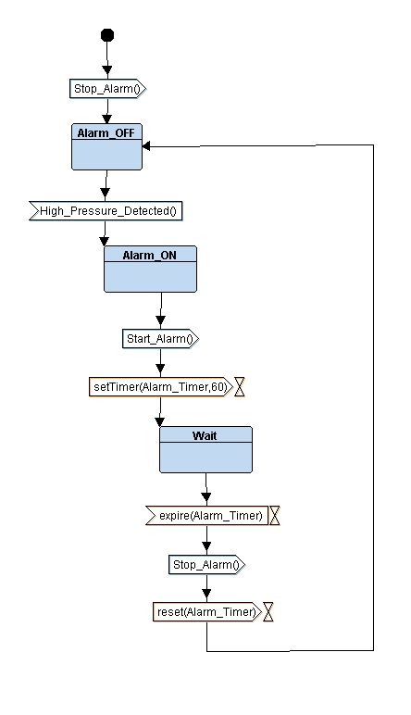

# - System Design Simulation:

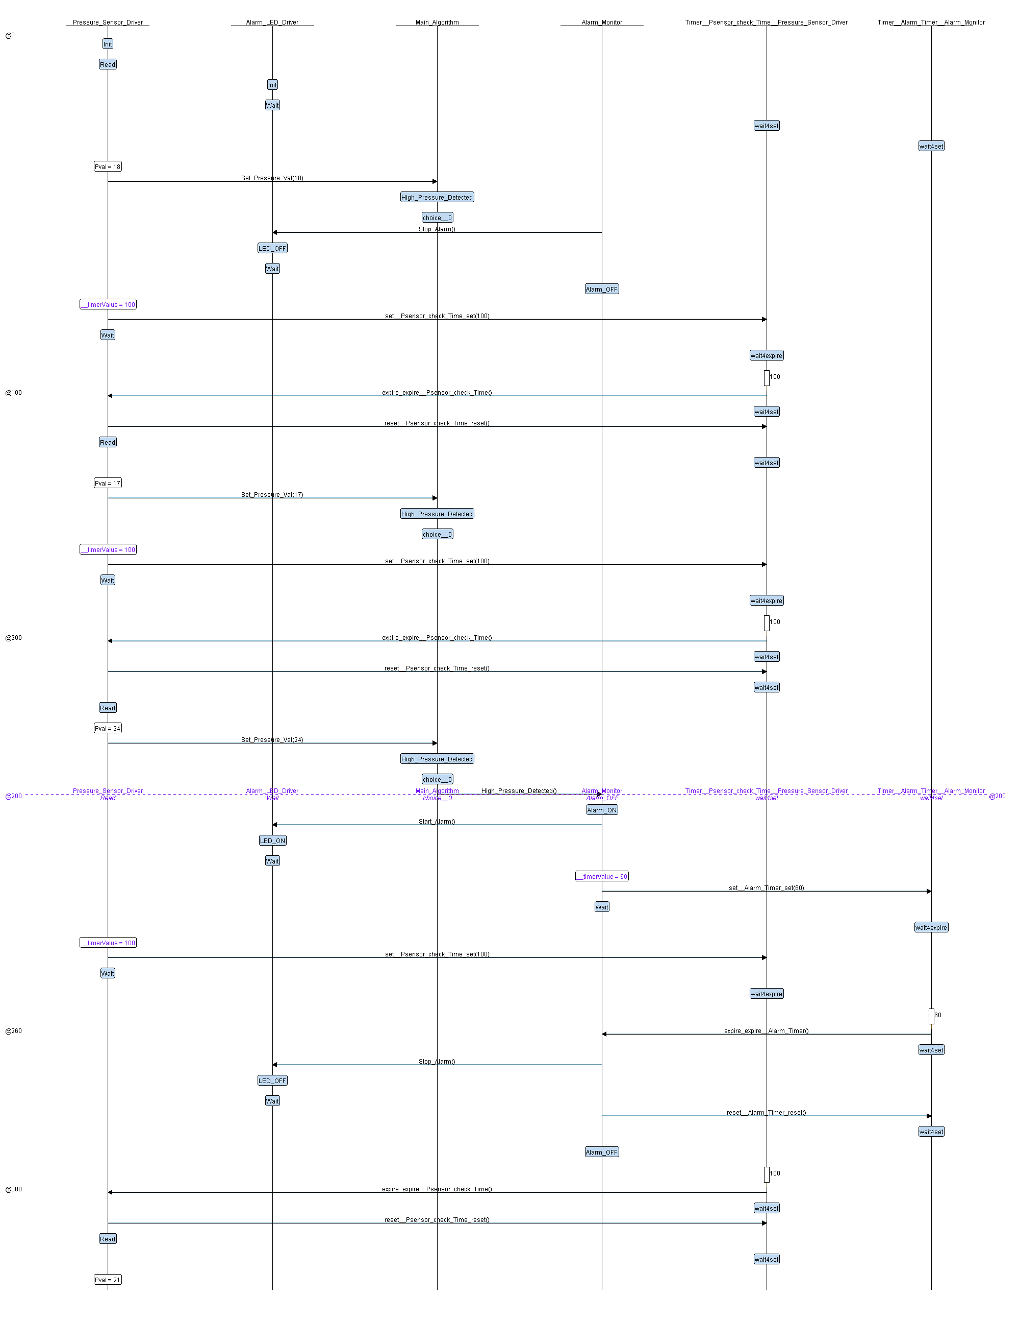

# Implementation of each module in C: (An Image for each file.c & file.h with the Corresponding state machine) main.c

# State.h Util.h

# GPIO_Driver.h

# GPIO_Driver.c

# Startup.c MakeFile

# 

# Linker_Script.ld

# 

# 

# Pressure_Sensor_Driver

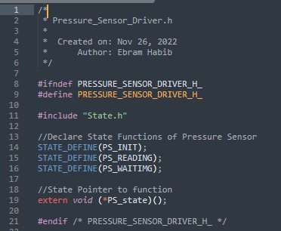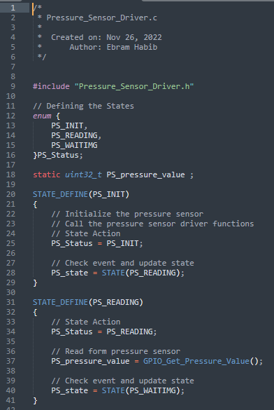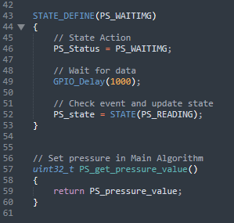

# Alarm_LED_Driver

# 

# 

# Alarm_Monitor E:\Downloads\Embedded Here We Go Again\Kerolos Shenoda's Diploma\Programs\TTool\TTool\figures\wat.png

# 

# Main_Algorithm

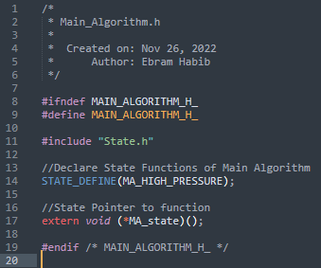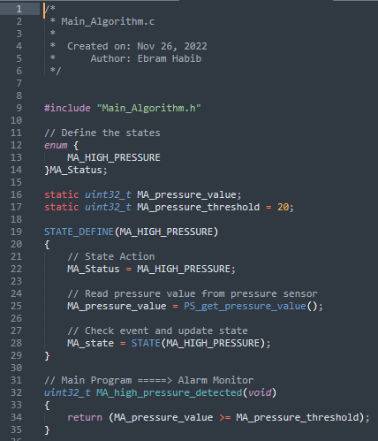

# SW analysis:

# 1- Map file

# 2- Symbols table

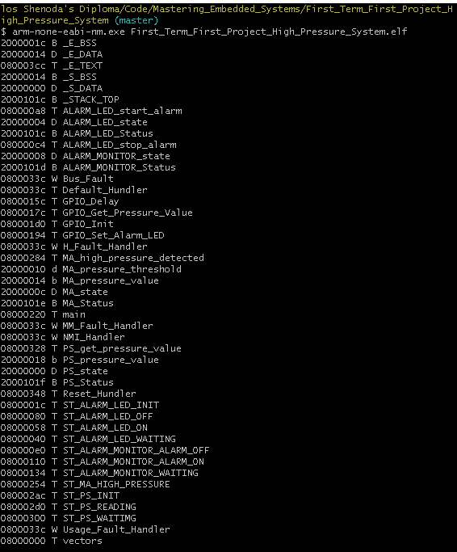

# 3- Section tables 4- Entry Point Address

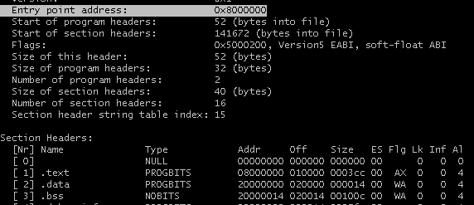

# Proteus Simulation