# Lab 2

# Description:

Create a bare-metal Software to toggle a LED on Stm32f103CX board.

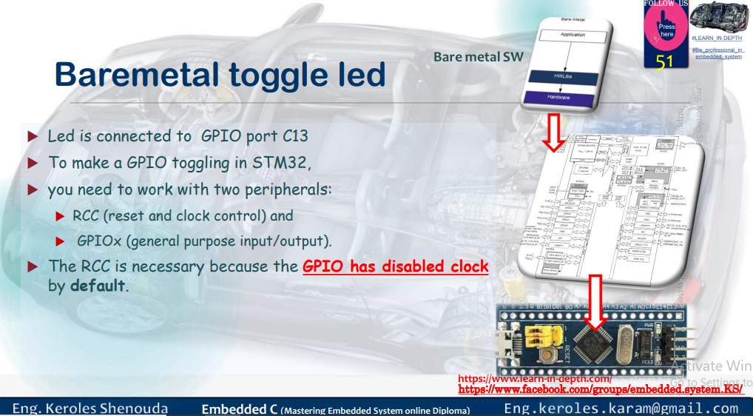

# Files Created:

# Analysis Files:

* main.o
* Map_file.map
* startup.o
* main.c
* linker_script.ld
* startup.c
* startup.s
* Makefile

# Executable Files:

* learn-in-depth_cortex_m3.elf
* learn-in-depth_cortex_m3.bin

# Section Headers:

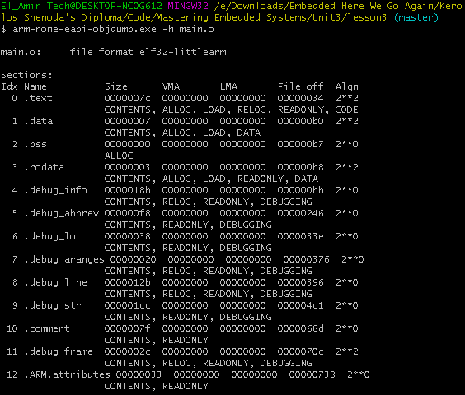

## Symbols:

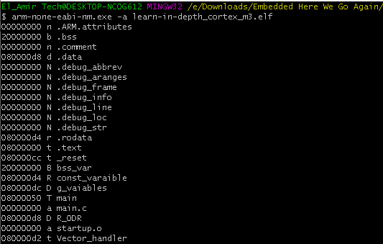

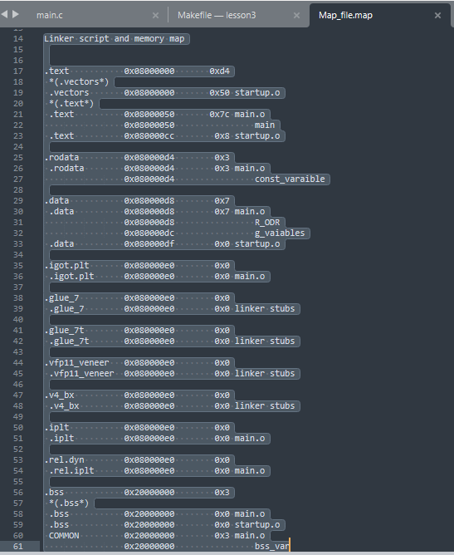

## Entry Point:

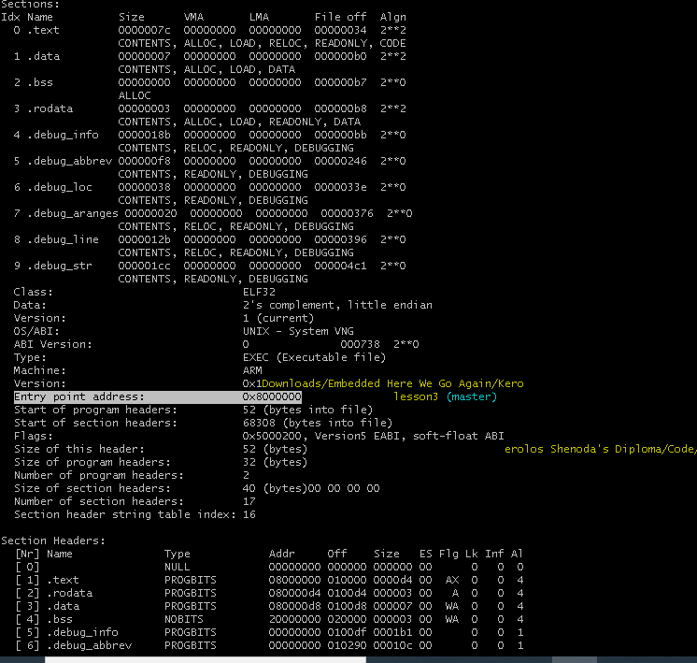

Proteus Simulation

## Simulation working:

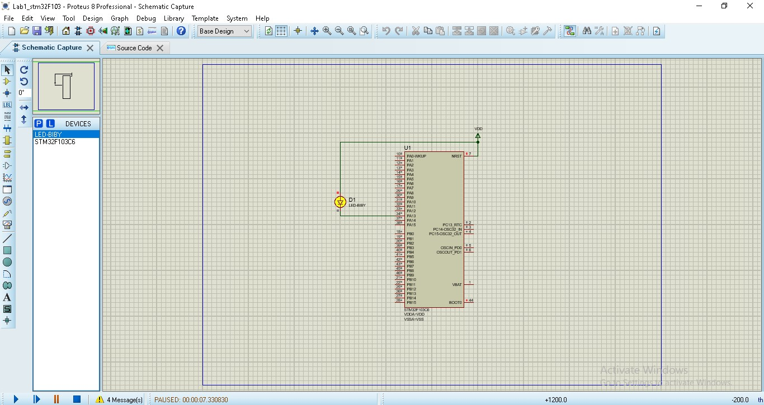

## Debug_information:

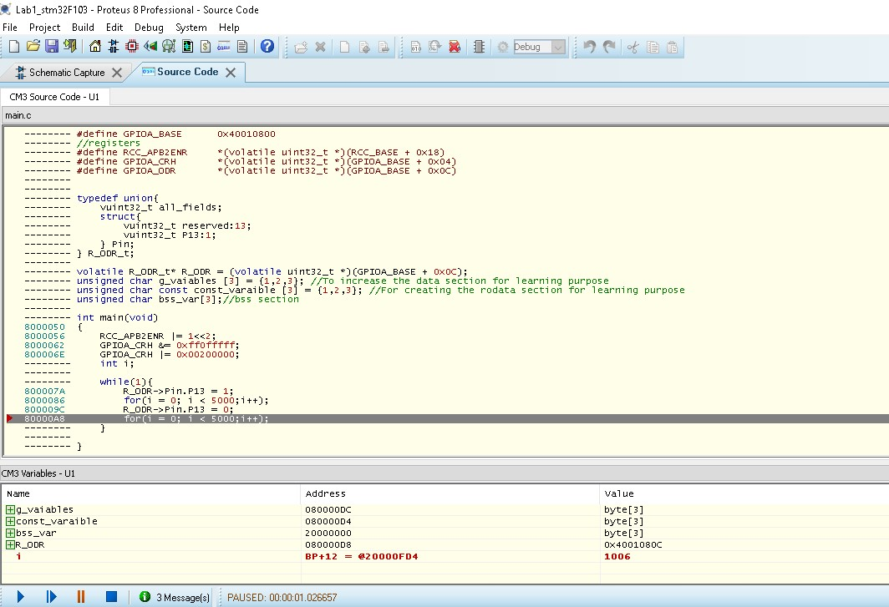

## Ram and Flash Memories:

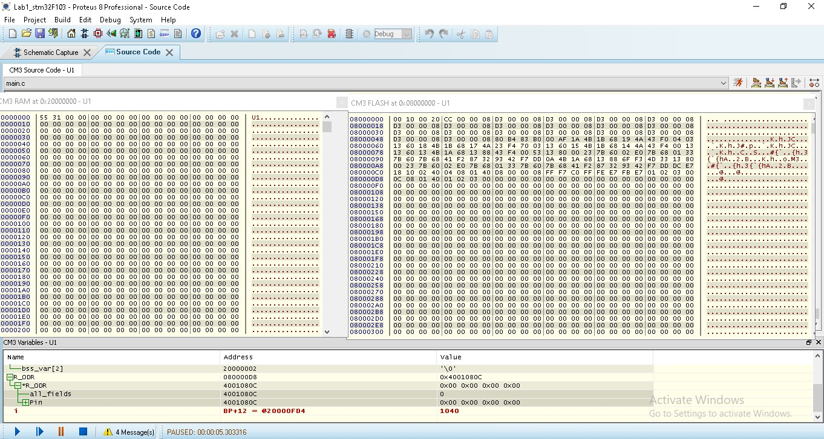

## Variables:

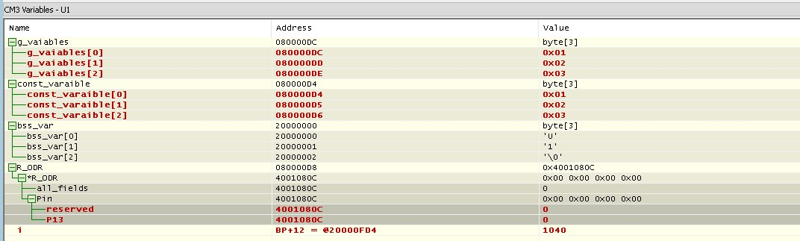

## Registers:

