## Explain the concept of Hybrid Mobile App Development

The concept about hybrid apps are that you are able to create a mobile application via web technologies and then use Cordova/PhoneGap as a layer to interpret the web code to native code. Thereby making app creation for multiple platforms easy.

## Explain the Pros and Cons of using Hybrid Mobile App Development compared to Native App Development

Hybrid apps are very easy to create and only demands a programmer with knowledge to web technologies. You only need one code base to compile for android iOS etc. The disadvantage is the speed and some native specific functions to be unavailable.

## Explain about the building blocks involved in an ionic Hybrid Application

The building blocks of a Hybrid app has three key blocks:

* The codebase, made with webtechnologies
* Compiler/Intepretor, PhoneGap/Ionic
* Runtime, Native platform

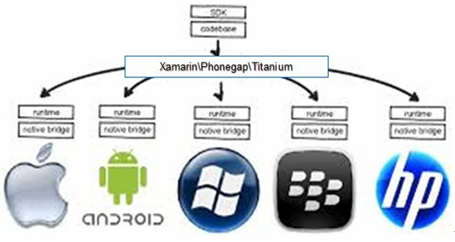

## Explain and demonstrate ways to debug Hybrid Mobile Applications Running on a real device

* Enable USB debugging on your device.
* Open Chrome on your desktop (development) machine and navigate to: chrome://inspect.
* Select Discover USB Devices.
* Select your Device.
* To use your device to debug a web application that is running on your developments machine:
  + Click port forwarding
  + Set the device port and the localhost port
  + Set enable port forwarding

## Explain when and why CORS is a problem for Hybrid Mobile Applications

Usually you will have an application that uses a backend, sends, and receives data from somewhere else. This can cause a problem, as your backend would not allow requests from the unspecified address. To solve this you can either make an access-control-allow-origin to allow requests from all locations or specify the request to go through a proxy and then allowing the proxy to talk to the backend. If you do not want to spend time, creating the backend, you can use Firebase, which also solves the CORS issue.

## Explain using an example the fundamentals of an ionic application

## Explain using an example how your Hybrid Application communicates with a backend and how CORS problems were solved