LIBRARY:
LIB-ID | LIB-NAME | LOCATION | COUNTACT-NUM | ESTB-YEARS

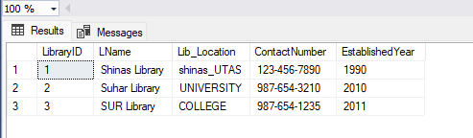

BOOK:
BOOK-ID | ISBN | TITAL | GENDER | PRICE | AVI-STATS | LIB-ID  - - - - - - | LOCATION

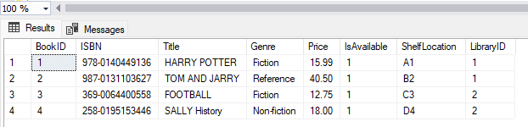

MEMBER

MEMB-ID | FULL NAME | EMAIL | PHO-NUM | MEMB-DATE | BOOK-ID  - - - - - - -

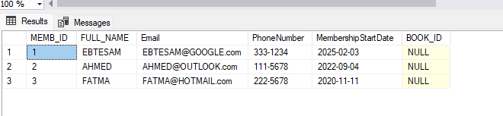

LOAN

LOAN-ID | loan date | due date | return date | status | MEMB-ID  - - - - - - - - | BOOK-ID  - - - - - - - -

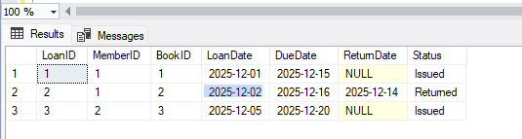

PAYMENT

payment -ID | amount | method | payment date | LOAN-ID  - - - - - - -

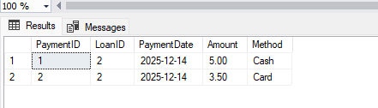

STAFF

STAFF-ID | FULL NAME | POSTION | COUNTACT-NUM | LIB-ID  - - - - - - - - - -

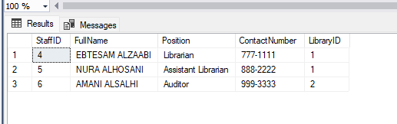

REVIEW

RATIN | comments | Review date | BOOK-ID  - - - - - - - - | MEMB-ID  - - - - - - - - | REVIE-ID

