CODES:

# Importing necessary libraries

import pandas as pd

import numpy as np

import matplotlib.pyplot as plt

from sklearn.model_selection import train_test_split

from sklearn.tree import DecisionTreeClassifier

from sklearn.metrics import accuracy_score, precision_score, recall_score, f1_score

# Load the Brain Tumor dataset

file_path = 'path/to/your/Brain Tumor (1).csv'

dataset = pd.read_csv(file_path)

# Display dataset shape and head

print("Dataset shape:", dataset.shape)

print("First few rows of the dataset:")

print(dataset.head())

# Data preprocessing (handle missing values, outliers, etc.)

# For simplicity, we assume the dataset does not have missing values or outliers

# Splitting the dataset into features (X) and target variable (y)

X = dataset.drop(columns=["Class"])

y = dataset["Class"]

# Splitting the dataset into training and testing sets (80% training, 20% testing)

X_train, X_test, y_train, y_test = train_test_split(X, y, test_size=0.2, random_state=42)

# Initialize and train the Decision Tree classifier

dt_classifier = DecisionTreeClassifier(random_state=42)

dt_classifier.fit(X_train, y_train)

# Making predictions on the testing set

y_pred = dt_classifier.predict(X_test)

# Evaluation metrics

accuracy = accuracy_score(y_test, y_pred)

precision = precision_score(y_test, y_pred, average='macro')

recall = recall_score(y_test, y_pred, average='macro')

f1 = f1_score(y_test, y_pred, average='macro')

# Print evaluation metrics

print("Decision Tree Classifier Performance:")

print("Accuracy:", accuracy)

print("Precision:", precision)

print("Recall:", recall)

print("F1-Score:", f1)

# Optional: Plot the Decision Tree (requires Graphviz installed)

from sklearn.tree import plot_tree

plt.figure(figsize=(20,10))

plot_tree(dt_classifier, filled=True, feature_names=X.columns, class_names=['No Tumor', 'Tumor'])

plt.show()

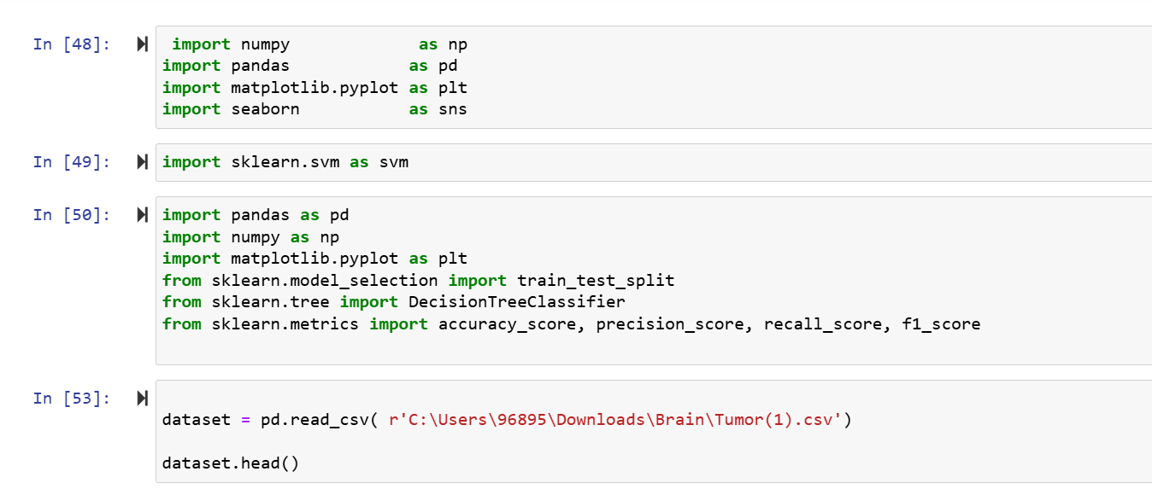

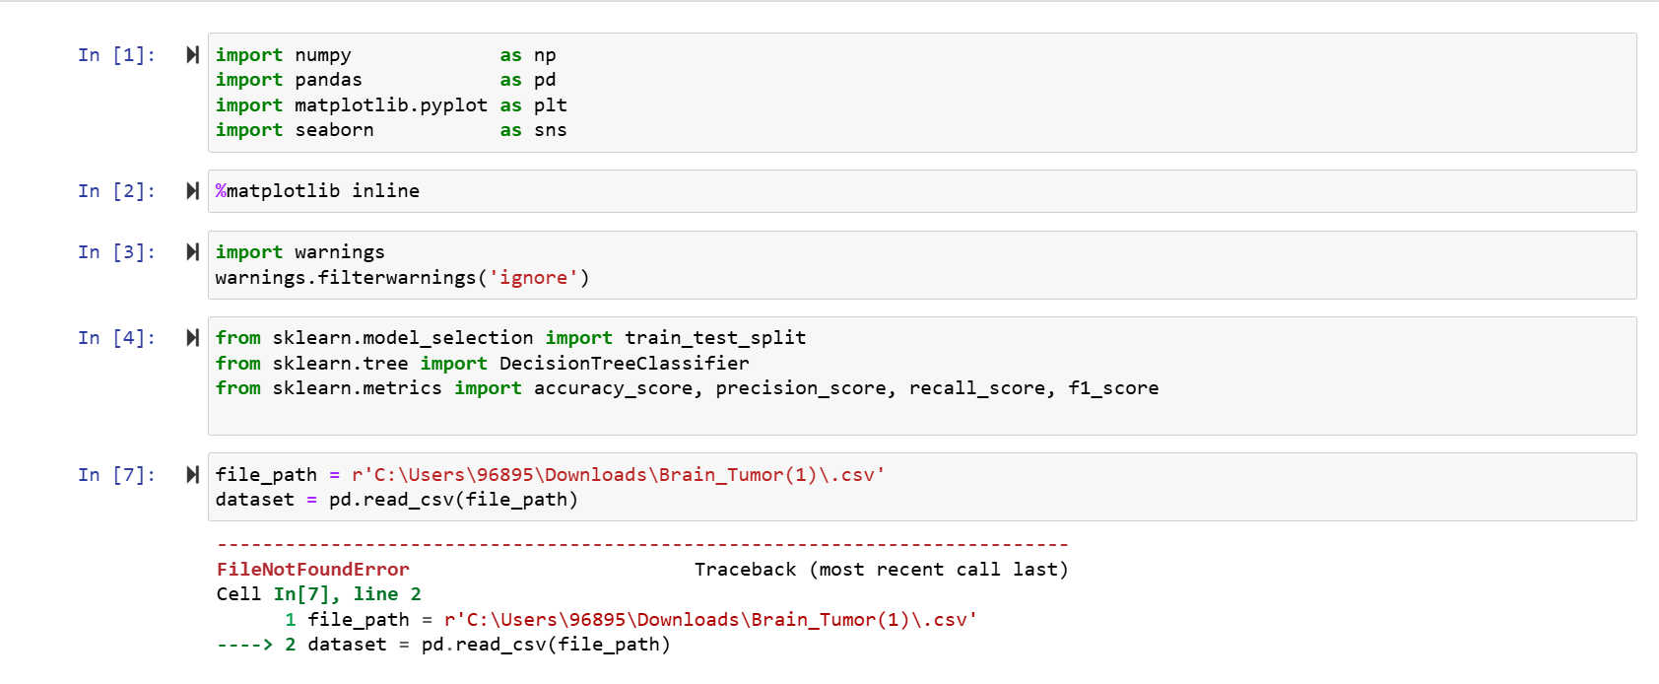

Brain tumor. (n.d.). Kaggle: Your Machine Learning and Data Science Community. <https://www.kaggle.com/datasets/jakeshbohaju/brain-tumor>