F.3 Chapter 3 Solutions
3.1
 | N-Type | P-Type
Gate=1 | closed | open
Gate=0 | open | closed

3.3 There can be 16 different two input logic functions.

3.5
A | B | C |  | OUT
0 | 0 | 0 |  | 1
0 | 0 | 1 |  | 0
0 | 1 | 0 |  | 1
0 | 1 | 1 |  | 0
1 | 0 | 0 |  | 1
1 | 0 | 1 |  | 0
1 | 1 | 0 |  | 0
1 | 1 | 1 |  | 0

3.7 There is short circuit (path from Power to Ground) when either A = 1 and B = 0 or A = 0 and B = 1.
  - The circuit is floating when A = 0 and creates a short-circuit when A = 1, which is guaranteed to burn out the power supply.
  - When A = 0, Out = 3.3 V
When A = 1, Out is floating, but power and ground are shorted, which will result in very high current and possible breakdown.
  - *NOTE: This problem was mistakenly included in Chapter 3 when it should belong in Chapter 5. See ERRATA for more information*
OUT = 1 signifies that the instruction is a branch instruction, and the branch will be taken. OUT = 0 means otherwise.

3.15
A | B |  | NOT(NOT(A) OR NOT(B))
0 | 0 |  | 0
0 | 1 |  | 0
1 | 0 |  | 0
1 | 1 |  | 1

AND gate has the same truth table.

3.17 a. Three input And-Gate
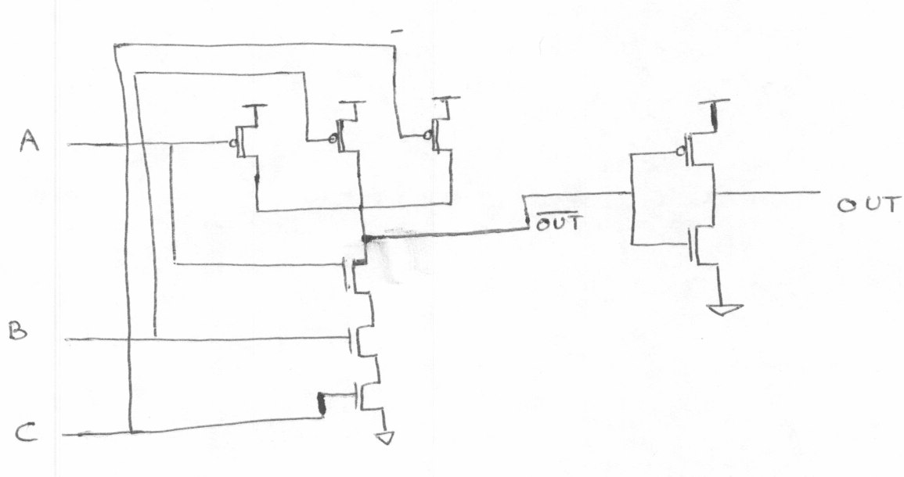
Three input OR-Gate
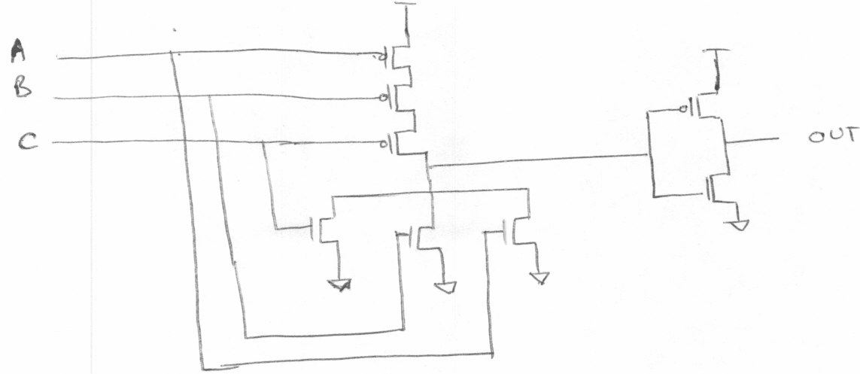

b. (1) A = 1, B = 0, C = 0.

AND Gate
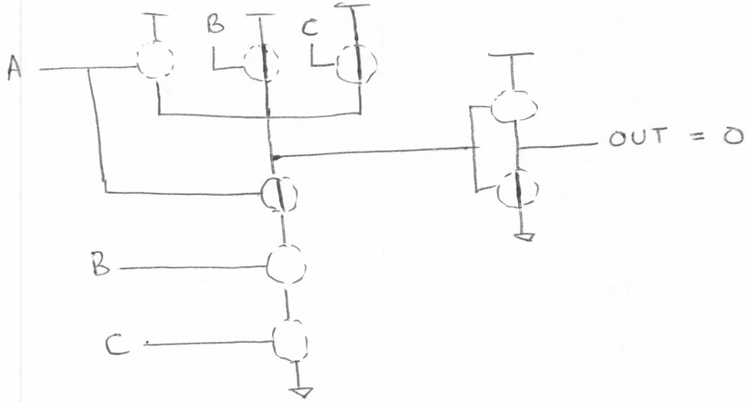

OR Gate
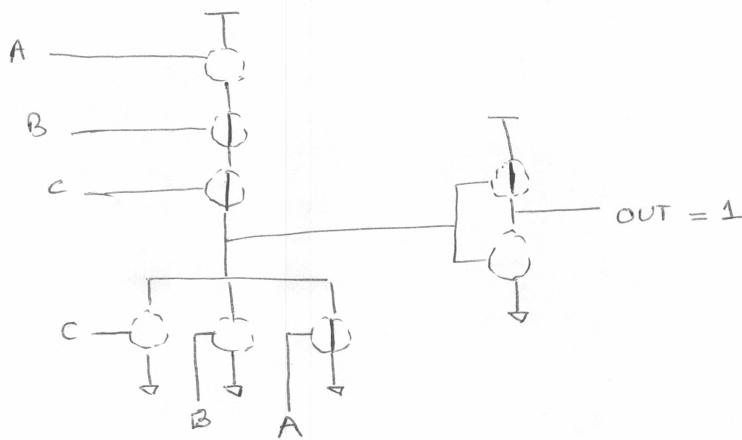

b. (2) A = 0, B = 0, C = 0

AND Gate
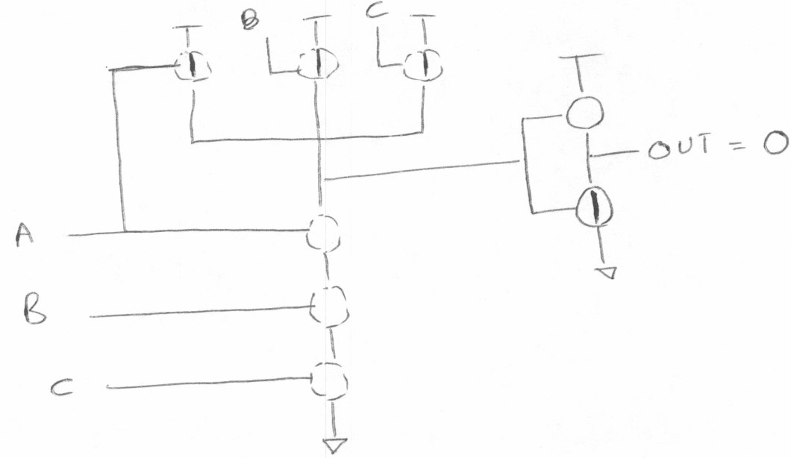
OR Gate
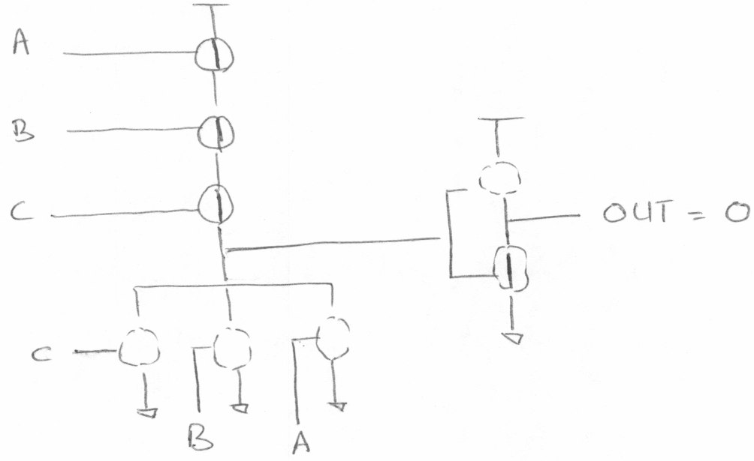

b. (3) A = 1, B = 1, C = 1

AND Gate
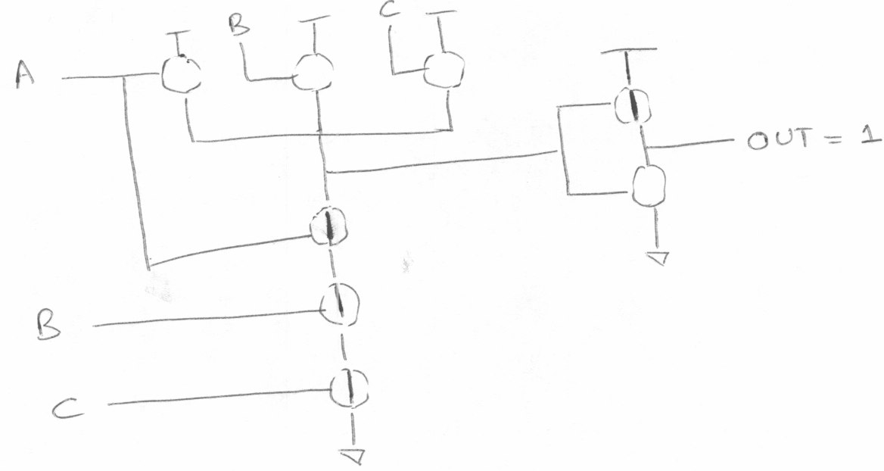

OR Gate
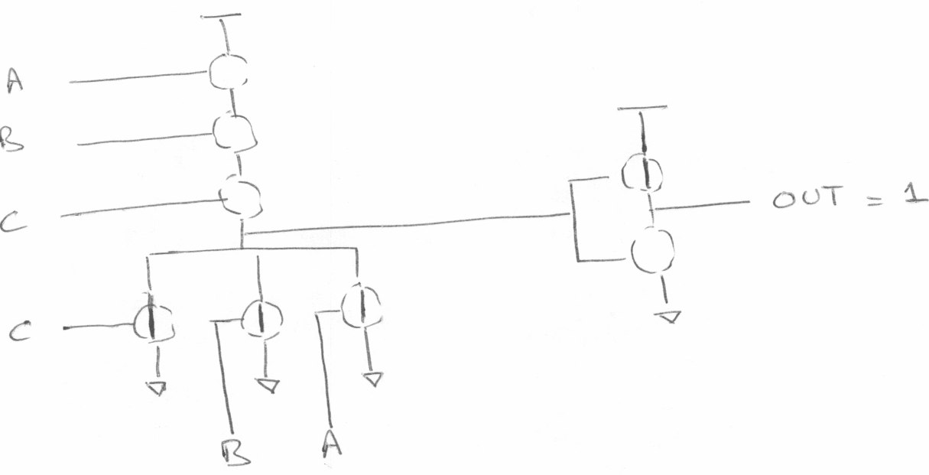

3.19 A five input decoder will have 32 output lines.

3.21
Cin | 1 | 1 | 1 | 0
A | 0 | 1 | 1 | 1
B | 1 | 0 | 1 | 1
S | 0 | 0 | 1 | 0
Cout | 1 | 1 | 1 | 1

A = 7, B = 11, A + B = 18.
In the above calculation, the result (S) is 2 !! This is because 18 is too large a number to be represented in 4 bits. Hence there is an overflow - Cout[3] = 1.

3.23 (a) The truth table will have 16 rows. Here is the truth table for Z = XOR (A, B, C, D). Any circuit with at least seven input combinations generating 1s at the output will work.

A | B | C | D |  | Z
0 | 0 | 0 | 0 |  | 0
0 | 0 | 0 | 1 |  | 1
0 | 0 | 1 | 0 |  | 1
0 | 0 | 1 | 1 |  | 0
0 | 1 | 0 | 0 |  | 1
0 | 1 | 0 | 1 |  | 0
0 | 1 | 1 | 0 |  | 0
0 | 1 | 1 | 1 |  | 1
1 | 0 | 0 | 0 |  | 1
1 | 0 | 0 | 1 |  | 0
1 | 0 | 1 | 0 |  | 0
1 | 0 | 1 | 1 |  | 1
1 | 1 | 0 | 0 |  | 0
1 | 1 | 0 | 1 |  | 1
1 | 1 | 1 | 0 |  | 1
1 | 1 | 1 | 1 |  | 0

Z = XOR (A,B,C,D)

(b)

Z
A B C D

3.25 Figure 3.36 is a simple combinational circuit. The output value depends ONLY on the input values as they currently exist. Figure 3.37 is an R-S Latch. This is an example of a logic circuit that can store information. That is, if A, B are both 1, the value of D depends on which of the two (A or B) was 0 most recently.

3.27 2 * 2¹⁴ = 2¹⁵ = 32768 nibbles

3.29
A | B | C |  | Z
0 | 0 | 0 |  | 0
0 | 0 | 1 |  | 0
0 | 1 | 0 |  | 0
0 | 1 | 1 |  | 0
1 | 0 | 0 |  | 0
1 | 0 | 1 |  | 0
1 | 1 | 0 |  | 0
1 | 1 | 1 |  | 0

3.31 (a) 3 gate delays

3.31 (b) 3 gate delays

3.31 (c) 3*4 = 12 gate delays

3.31 (d) 3*32 = 96 gate delays

3.33(a) When S=0, Z = A

3.33(b) When S=1, Z retains its previous value. 3.33(c) Yes; the circuit is a storage element.
3.35 No. The original value cannot be recovered once a new value is written into a register.

3.37. 8 * (2^3) = 64 bytes

3.39.(a) To read the 4th memory location, A[1,0] = 11, WE = 0

3.39.(b) A total of 6 address lines are required for a memory with 60 locations. The addressability of the memory will remain unchanged.

3.39.(c) A program counter of width 6 can address 2^6 = 64 locations. So without changing the width of the program counter, 64-60 = 4 more locations can be added to the memory.

3.41 Total bits of storage = 2^22 * 3 = 12582912

3.43 There are a total of four possible states in this lock. Any other state can be expressed as one of states A, B, C or D. For example, the state performed one correct followed by one incorrect operation is nothing but state A as the incorrect operation reset the lock.

  - No. An arc is needed between the two states.
    - Game in Progress:
Texas * Oklahoma
Fouls:4 Fouls: 4
73 68
First Half 7:38
Shot Clock : 14

    - Texas Win:
Texas * Oklahoma
Fouls:10 Fouls: 10
85 70
Second Half 0:00
Shot Clock : 0

    - Oklahoma Win:
Texas * Oklahoma
Fouls:10 Fouls: 10
81 90
First Half 7:38
Shot Clock : 0

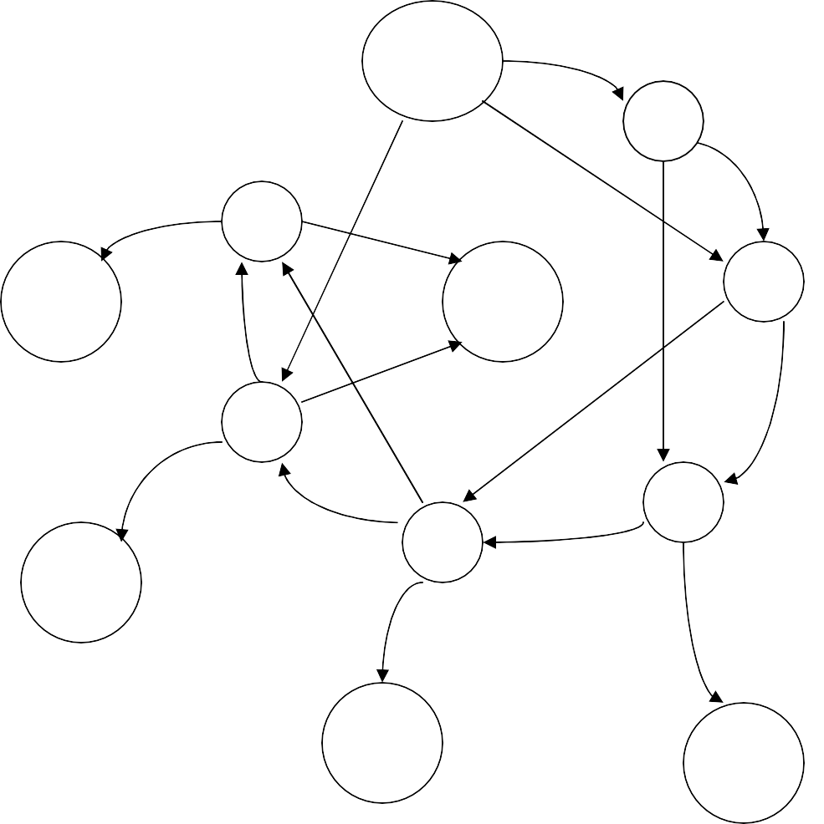3.47
No coins
N
Q
5
D/Q
Q
N
30
N
D
D
35+
ch
N
D
35
10
Q
D
Q
25
N
D
D
15
35+
ch
N
20
N
Q Q
35+
ch
35+
ch

3.49
a)
S1 | S0 | X |  | D1 | D0 | Z
0 | 0 | 0 |  | 0 | 0 | 0
0 | 0 | 1 |  | 0 | 0 | 0
0 | 1 | 0 |  | 0 | 0 | 1
0 | 1 | 1 |  | 1 | 0 | 1
1 | 0 | 0 |  | 1 | 1 | 1
1 | 0 | 1 |  | 1 | 1 | 1
1 | 1 | 0 |  | 1 | 0 | 1
1 | 1 | 1 |  | 1 | 0 | 1

b)
0/1
0
00
01
0/1
1
11
10
0/1

3.51 Flip-Flop

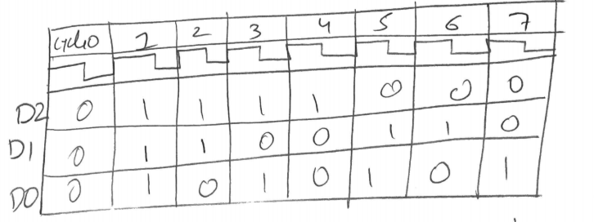
3.53
The circuit is a decrementing 3-bit counter.

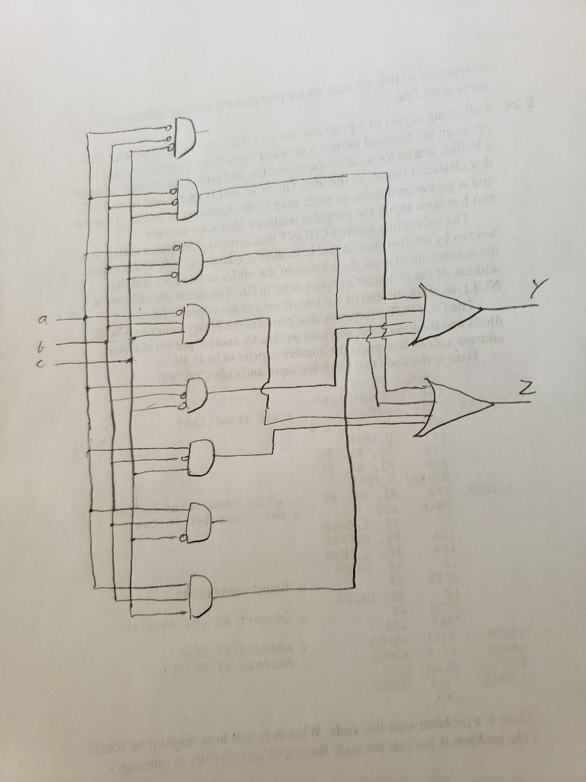
3.55

a | b | c |  | Y | Z
0 | 0 | 0 |  | 0 | 0
0 | 0 | 1 |  | 1 | 0
0 | 1 | 0 |  | 1 | 1
0 | 1 | 1 |  | 0 | 1
1 | 0 | 0 |  | 1 | 1
1 | 0 | 1 |  | 0 | 1
1 | 1 | 0 |  | 0 | 0
1 | 1 | 1 |  | 1 | 0

3.57

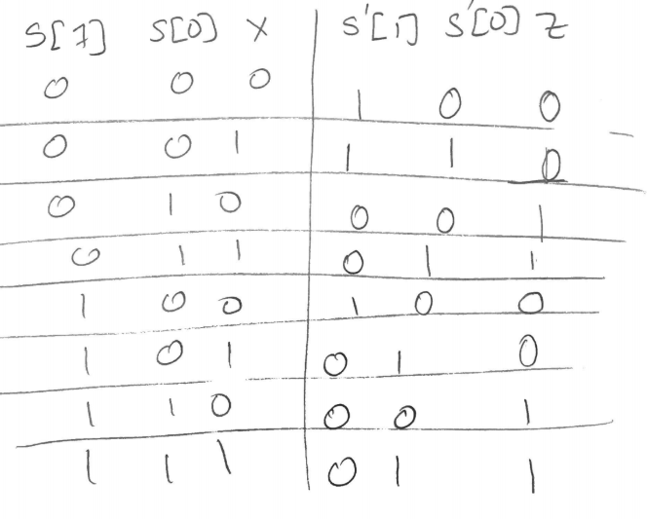
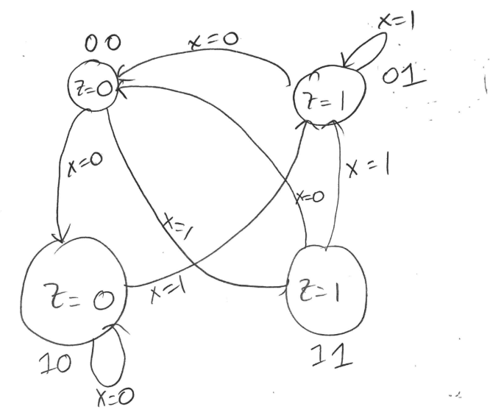

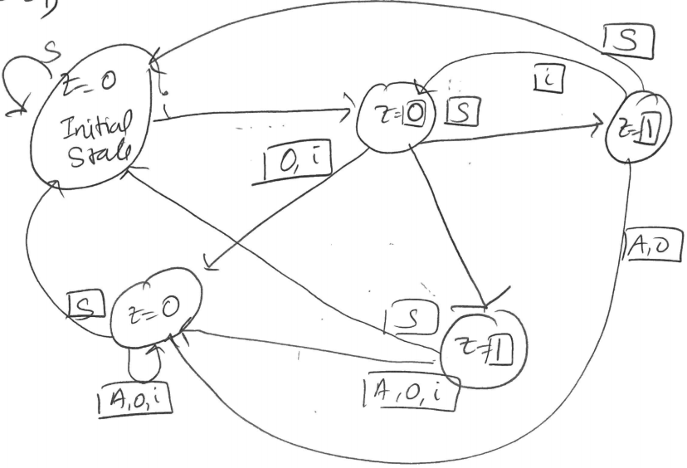
3.59

S1 | S0 | X |  | Z | S1’ | S0’
0 | 0 | 0 |  | 1 | 0 | 0
0 | 0 | 1 |  | 1 | 0 | 1
0 | 1 | 0 |  | 0 | 1 | 0
0 | 1 | 1 |  | 0 | 0 | 0
1 | 0 | 0 |  | 0 | 0 | 1
1 | 0 | 1 |  | 0 | 1 | 0
1 | 1 | 0 |  | 0 | 0 | 0
1 | 1 | 1 |  | 0 | 0 | 0
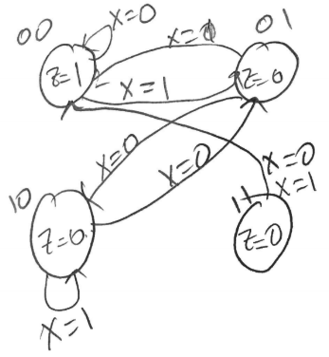
3.61

