Ministerul Educaţiei, Culturii și Cercetării al Republicii Moldova Universitatea Tehnică a Moldovei
Departamentul Ingineria Software și Automatică

RAPORT

Lucrare de laborator nr.4
Disciplina: Programarea declarativă
Tema: Tratare, analiză și reprezentare date

A efectuat: st.gr. TI-223, Botnarenco Ecaterina

A verificat : lect. univ., Rusu Mariana

Chișinău 2024

Lucrarea de laborator nr. 4
Scopul: Tratarea, analiza și reprezentarea datelor utilizând funcțiile R și funcțiile proprii
Obiectivele lucrării:
- Calcularea matricei de corelație
- Identificarea corelațiilor puternice
- Îmbinarea vizualizărilor într-un singur grafic
- Împărțirea setului de date în eșantioane
Mersul lucrării:
Încărcați următoarele fișiere de date: „Auto MPG”, „Student”.
Pentru fiecare set de date, efectuați următorul studiu:
- Analizați și explicați variabilele din setul de date.
>>Auto MPG
data_path <- 'C:/Users/Adry/Documents/lab4/auto-mpg.data'
> names_path <- 'C:/Users/Adry/Documents/lab4/auto-mpg.names'
> data_content <- readLines(data_path)
> head(data_content)
[1] "18.0 8 307.0 130.0 3504. 12.0 70 1\t\"chevrolet chevelle malibu\""
[2] "15.0 8 350.0 165.0 3693. 11.5 70 1\t\"buick skylark 320\""
[3] "18.0 8 318.0 150.0 3436. 11.0 70 1\t\"plymouth satellite\""
[4] "16.0 8 304.0 150.0 3433. 12.0 70 1\t\"amc rebel sst\""
[5] "17.0 8 302.0 140.0 3449. 10.5 70 1\t\"ford torino\""
[6] "15.0 8 429.0 198.0 4341. 10.0 70 1\t\"ford galaxie 500\""
> names_content <- readLines(names_path)
> names_content
[1] "1. Title: Auto-Mpg Data"
[2] ""
[3] "2. Sources:"
[4] " (a) Origin: This dataset was taken from the StatLib library which is"
[5] " maintained at Carnegie Mellon University. The dataset was "
[6] " used in the 1983 American Statistical Association Exposition."
[7] " (c) Date: July 7, 1993"
[8] ""
[9] "3. Past Usage:"
[10] " - See 2b (above)"
[11] " - Quinlan,R. (1993). Combining Instance-Based and Model-Based Learning."
[12] " In Proceedings on the Tenth International Conference of Machine "
[13] " Learning, 236-243, University of Massachusetts, Amherst. Morgan"
[14] " Kaufmann."
[15] ""
[16] "4. Relevant Information:"
[17] ""
[18] " This dataset is a slightly modified version of the dataset provided in"
[19] " the StatLib library. In line with the use by Ross Quinlan (1993) in"
[20] " predicting the attribute \"mpg\", 8 of the original instances were removed "
[21] " because they had unknown values for the \"mpg\" attribute. The original "
[22] " dataset is available in the file \"auto-mpg.data-original\"."
[23] ""
[24] " \"The data concerns city-cycle fuel consumption in miles per gallon,"
[25] " to be predicted in terms of 3 multivalued discrete and 5 continuous"
[26] " attributes.\" (Quinlan, 1993)"
[27] ""
[28] "5. Number of Instances: 398"
[29] ""
[30] "6. Number of Attributes: 9 including the class attribute"
[31] ""
[32] "7. Attribute Information:"
[33] ""
[34] " 1. mpg: continuous"
[35] " 2. cylinders: multi-valued discrete"
[36] " 3. displacement: continuous"
[37] " 4. horsepower: continuous"
[38] " 5. weight: continuous"
[39] " 6. acceleration: continuous"
[40] " 7. model year: multi-valued discrete"
[41] " 8. origin: multi-valued discrete"
[42] " 9. car name: string (unique for each instance)"
[43] ""
[44] "8. Missing Attribute Values: horsepower has 6 missing values"
[45] ""
> col_names <- c("mpg", "cylinders", "displacement", "horsepower:", "weight", "acceleration", "model year", "origin", "car name")
> auto_mpg <- read.table(data_path, header = FALSE, col.names = col_names,na.strings = "?", stringsAsFactors = FALSE)
> auto_mpg[1:10,]
mpg cylinders displacement horsepower. weight acceleration model.year origin car.name
1 18 8 307 130 3504 12.0 70 1 chevrolet chevelle malibu
2 15 8 350 165 3693 11.5 70 1 buick skylark 320
3 18 8 318 150 3436 11.0 70 1 plymouth satellite
4 16 8 304 150 3433 12.0 70 1 amc rebel sst
5 17 8 302 140 3449 10.5 70 1 ford torino
6 15 8 429 198 4341 10.0 70 1 ford galaxie 500
7 14 8 454 220 4354 9.0 70 1 chevrolet impala
8 14 8 440 215 4312 8.5 70 1 plymouth fury iii
9 14 8 455 225 4425 10.0 70 1 pontiac catalina
10 15 8 390 190 3850 8.5 70 1 amc ambassador dpl
>>Student-mat
> student_mat <- read.csv('~/lab4/student-mat.csv', sep=";")
> student_mat[1:10,]
school sex age address famsize Pstatus Medu Fedu Mjob Fjob reason guardian
1 GP F 18 U GT3 A 4 4 at_home teacher course mother
2 GP F 17 U GT3 T 1 1 at_home other course father
3 GP F 15 U LE3 T 1 1 at_home other other mother
4 GP F 15 U GT3 T 4 2 health services home mother
5 GP F 16 U GT3 T 3 3 other other home father
6 GP M 16 U LE3 T 4 3 services other reputation mother
7 GP M 16 U LE3 T 2 2 other other home mother
8 GP F 17 U GT3 A 4 4 other teacher home mother
9 GP M 15 U LE3 A 3 2 services other home mother
10 GP M 15 U GT3 T 3 4 other other home mother
traveltime studytime failures schoolsup famsup paid activities nursery higher internet
1 2 2 0 yes no no no yes yes no
2 1 2 0 no yes no no no yes yes
3 1 2 3 yes no yes no yes yes yes
4 1 3 0 no yes yes yes yes yes yes
5 1 2 0 no yes yes no yes yes no
6 1 2 0 no yes yes yes yes yes yes
7 1 2 0 no no no no yes yes yes
8 2 2 0 yes yes no no yes yes no
9 1 2 0 no yes yes no yes yes yes
10 1 2 0 no yes yes yes yes yes yes
romantic famrel freetime goout Dalc Walc health absences G1 G2 G3
1 no 4 3 4 1 1 3 6 5 6 6
2 no 5 3 3 1 1 3 4 5 5 6
3 no 4 3 2 2 3 3 10 7 8 10
4 yes 3 2 2 1 1 5 2 15 14 15
5 no 4 3 2 1 2 5 4 6 10 10
6 no 5 4 2 1 2 5 10 15 15 15
7 no 4 4 4 1 1 3 0 12 12 11
8 no 4 1 4 1 1 1 6 6 5 6
9 no 4 2 2 1 1 1 0 16 18 19
10 no 5 5 1 1 1 5 0 14 15 15
>> Student-por
> student_mat <- read.csv('~/lab4/student-por.csv', sep=";")
> student_mat[1:10,]
school sex age address famsize Pstatus Medu Fedu Mjob Fjob reason guardian
1 GP F 18 U GT3 A 4 4 at_home teacher course mother
2 GP F 17 U GT3 T 1 1 at_home other course father
3 GP F 15 U LE3 T 1 1 at_home other other mother
4 GP F 15 U GT3 T 4 2 health services home mother
5 GP F 16 U GT3 T 3 3 other other home father
6 GP M 16 U LE3 T 4 3 services other reputation mother
7 GP M 16 U LE3 T 2 2 other other home mother
8 GP F 17 U GT3 A 4 4 other teacher home mother
9 GP M 15 U LE3 A 3 2 services other home mother
10 GP M 15 U GT3 T 3 4 other other home mother
traveltime studytime failures schoolsup famsup paid activities nursery higher internet
1 2 2 0 yes no no no yes yes no
2 1 2 0 no yes no no no yes yes
3 1 2 0 yes no no no yes yes yes
4 1 3 0 no yes no yes yes yes yes
5 1 2 0 no yes no no yes yes no
6 1 2 0 no yes no yes yes yes yes
7 1 2 0 no no no no yes yes yes
8 2 2 0 yes yes no no yes yes no
9 1 2 0 no yes no no yes yes yes
10 1 2 0 no yes no yes yes yes yes
romantic famrel freetime goout Dalc Walc health absences G1 G2 G3
1 no 4 3 4 1 1 3 4 0 11 11
2 no 5 3 3 1 1 3 2 9 11 11
3 no 4 3 2 2 3 3 6 12 13 12
4 yes 3 2 2 1 1 5 0 14 14 14
5 no 4 3 2 1 2 5 0 11 13 13
6 no 5 4 2 1 2 5 6 12 12 13
7 no 4 4 4 1 1 3 0 13 12 13
8 no 4 1 4 1 1 1 2 10 13 13
9 no 4 2 2 1 1 1 0 15 16 17
- no 5 5 1 1 1 5 0 12 12 13
2. Calculați statisticile de bază.
>>Auto MPG
> summary(auto_mpg)
mpg cylinders displacement horsepower. weight acceleration model.year
Min. : 9.00 Min. :3.000 Min. : 68.0 Min. : 46.0 Min. :1613 Min. : 8.00 Min. :70.00
1st Qu.:17.50 1st Qu.:4.000 1st Qu.:104.2 1st Qu.: 75.0 1st Qu.:2224 1st Qu.:13.82 1st Qu.:73.00
Median :23.00 Median :4.000 Median :148.5 Median : 93.5 Median :2804 Median :15.50 Median :76.00
Mean :23.51 Mean :5.455 Mean :193.4 Mean :104.5 Mean :2970 Mean :15.57 Mean :76.01
3rd Qu.:29.00 3rd Qu.:8.000 3rd Qu.:262.0 3rd Qu.:126.0 3rd Qu.:3608 3rd Qu.:17.18 3rd Qu.:79.00
Max. :46.60 Max. :8.000 Max. :455.0 Max. :230.0 Max. :5140 Max. :24.80 Max. :82.00
NA's :6
origin car.name
Min. :1.000 Length:398
1st Qu.:1.000 Class :character
Median :1.000 Mode :character
Mean :1.573
3rd Qu.:2.000
Max. :3.000

>> Student-mat
> summary(student_mat)
school sex age
Length:395 Length:395 Min. :15.0
Class :character Class :character 1st Qu.:16.0
Mode :character Mode :character Median :17.0
Mean :16.7
3rd Qu.:18.0
Max. :22.0
address famsize Pstatus
Length:395 Length:395 Length:395
Class :character Class :character Class :character
Mode :character Mode :character Mode :character

Medu Fedu Mjob
Min. :0.000 Min. :0.000 Length:395
1st Qu.:2.000 1st Qu.:2.000 Class :character
Median :3.000 Median :2.000 Mode :character
Mean :2.749 Mean :2.522
3rd Qu.:4.000 3rd Qu.:3.000
Max. :4.000 Max. :4.000
Fjob reason guardian
Length:395 Length:395 Length:395
Class :character Class :character Class :character
Mode :character Mode :character Mode :character

traveltime studytime failures
Min. :1.000 Min. :1.000 Min. :0.0000
1st Qu.:1.000 1st Qu.:1.000 1st Qu.:0.0000
Median :1.000 Median :2.000 Median :0.0000
Mean :1.448 Mean :2.035 Mean :0.3342
3rd Qu.:2.000 3rd Qu.:2.000 3rd Qu.:0.0000
Max. :4.000 Max. :4.000 Max. :3.0000
schoolsup famsup paid
Length:395 Length:395 Length:395
Class :character Class :character Class :character
Mode :character Mode :character Mode :character

activities nursery higher
Length:395 Length:395 Length:395
Class :character Class :character Class :character
Mode :character Mode :character Mode :character

internet romantic famrel
Length:395 Length:395 Min. :1.000
Class :character Class :character 1st Qu.:4.000
Mode :character Mode :character Median :4.000
Mean :3.944
3rd Qu.:5.000
Max. :5.000
freetime goout Dalc
Min. :1.000 Min. :1.000 Min. :1.000
1st Qu.:3.000 1st Qu.:2.000 1st Qu.:1.000
Median :3.000 Median :3.000 Median :1.000
Mean :3.235 Mean :3.109 Mean :1.481
3rd Qu.:4.000 3rd Qu.:4.000 3rd Qu.:2.000
Max. :5.000 Max. :5.000 Max. :5.000
Walc health absences
Min. :1.000 Min. :1.000 Min. : 0.000
1st Qu.:1.000 1st Qu.:3.000 1st Qu.: 0.000
Median :2.000 Median :4.000 Median : 4.000
Mean :2.291 Mean :3.554 Mean : 5.709
3rd Qu.:3.000 3rd Qu.:5.000 3rd Qu.: 8.000
Max. :5.000 Max. :5.000 Max. :75.000
G1 G2 G3
Min. : 3.00 Min. : 0.00 Min. : 0.00
1st Qu.: 8.00 1st Qu.: 9.00 1st Qu.: 8.00
Median :11.00 Median :11.00 Median :11.00
Mean :10.91 Mean :10.71 Mean :10.42
3rd Qu.:13.00 3rd Qu.:13.00 3rd Qu.:14.00
Max. :19.00 Max. :19.00 Max. :20.00
>> Student-por
> summary(student_por)
school sex age address famsize Pstatus Medu Fedu Mjob
Length:649 Length:649 Min. :15.00 Length:649 Length:649 Length:649 Min. :0.000 Min. :0.000 Length:649
Class :character Class :character 1st Qu.:16.00 Class :character Class :character Class :character 1st Qu.:2.000 1st Qu.:1.000 Class :character
Mode :character Mode :character Median :17.00 Mode :character Mode :character Mode :character Median :2.000 Median :2.000 Mode :character
Mean :16.74 Mean :2.515 Mean :2.307
3rd Qu.:18.00 3rd Qu.:4.000 3rd Qu.:3.000
Max. :22.00 Max. :4.000 Max. :4.000
Fjob reason guardian traveltime studytime failures schoolsup famsup paid
Length:649 Length:649 Length:649 Min. :1.000 Min. :1.000 Min. :0.0000 Length:649 Length:649 Length:649
Class :character Class :character Class :character 1st Qu.:1.000 1st Qu.:1.000 1st Qu.:0.0000 Class :character Class :character Class :character
Mode :character Mode :character Mode :character Median :1.000 Median :2.000 Median :0.0000 Mode :character Mode :character Mode :character
Mean :1.569 Mean :1.931 Mean :0.2219
3rd Qu.:2.000 3rd Qu.:2.000 3rd Qu.:0.0000
Max. :4.000 Max. :4.000 Max. :3.0000
activities nursery higher internet romantic famrel freetime goout Dalc Walc
Length:649 Length:649 Length:649 Length:649 Length:649 Min. :1.000 Min. :1.00 Min. :1.000 Min. :1.000 Min. :1.00
Class :character Class :character Class :character Class :character Class :character 1st Qu.:4.000 1st Qu.:3.00 1st Qu.:2.000 1st Qu.:1.000 1st Qu.:1.00
Mode :character Mode :character Mode :character Mode :character Mode :character Median :4.000 Median :3.00 Median :3.000 Median :1.000 Median :2.00
Mean :3.931 Mean :3.18 Mean :3.185 Mean :1.502 Mean :2.28
3rd Qu.:5.000 3rd Qu.:4.00 3rd Qu.:4.000 3rd Qu.:2.000 3rd Qu.:3.00
Max. :5.000 Max. :5.00 Max. :5.000 Max. :5.000 Max. :5.00
health absences G1 G2 G3
Min. :1.000 Min. : 0.000 Min. : 0.0 Min. : 0.00 Min. : 0.00
1st Qu.:2.000 1st Qu.: 0.000 1st Qu.:10.0 1st Qu.:10.00 1st Qu.:10.00
Median :4.000 Median : 2.000 Median :11.0 Median :11.00 Median :12.00
Mean :3.536 Mean : 3.659 Mean :11.4 Mean :11.57 Mean :11.91
3rd Qu.:5.000 3rd Qu.: 6.000 3rd Qu.:13.0 3rd Qu.:13.00 3rd Qu.:14.00
Max. :5.000 Max. :32.000 Max. :19.0 Max. :19.00 Max. :19.00
- Calculați matricea de corelație și salvați rezultatele într-un fișier .csv.
>>Auto MPG
numeric_data <- auto_mpg[sapply(auto_mpg, is.numeric)]
> matrice_corelatie <- cor(numeric_data, use = "complete.obs")
> matrice_corelatie
mpg cylinders displacement horsepower. weight acceleration model.year origin
mpg 1.0000000 -0.7776175 -0.8051269 -0.7784268 -0.8322442 0.4233285 0.5805410 0.5652088
cylinders -0.7776175 1.0000000 0.9508233 0.8429834 0.8975273 -0.5046834 -0.3456474 -0.5689316
displacement -0.8051269 0.9508233 1.0000000 0.8972570 0.9329944 -0.5438005 -0.3698552 -0.6145351
horsepower. -0.7784268 0.8429834 0.8972570 1.0000000 0.8645377 -0.6891955 -0.4163615 -0.4551715
weight -0.8322442 0.8975273 0.9329944 0.8645377 1.0000000 -0.4168392 -0.3091199 -0.5850054
acceleration 0.4233285 -0.5046834 -0.5438005 -0.6891955 -0.4168392 1.0000000 0.2903161 0.2127458
model.year 0.5805410 -0.3456474 -0.3698552 -0.4163615 -0.3091199 0.2903161 1.0000000 0.1815277
origin 0.5652088 -0.5689316 -0.6145351 -0.4551715 -0.5850054 0.2127458 0
.1815277 1.0000000

> write.table(matrice_corelatie, "matrice_corelatie.csv", row.names = TRUE, sep = ";", col.names = NA)
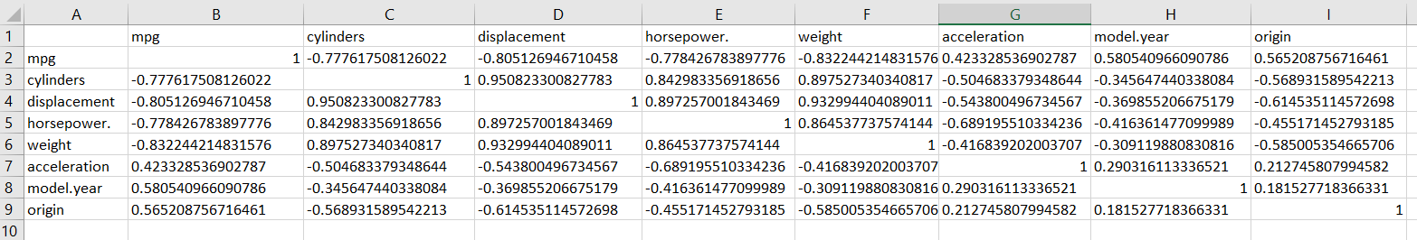

>>Student-mat
> numeric_student_mat <- student_mat[sapply(student_mat, is.numeric)]
> matrice_corelatie_student_mat <- cor(numeric_student_mat, use = "complete.obs")
> matrice_corelatie_student_mat
age Medu Fedu traveltime studytime
age 1.000000000 -0.163658419 -0.163438069 0.070640721 -0.004140037
Medu -0.163658419 1.000000000 0.623455112 -0.171639305 0.064944137
Fedu -0.163438069 0.623455112 1.000000000 -0.158194054 -0.009174639
traveltime 0.070640721 -0.171639305 -0.158194054 1.000000000 -0.100909119
studytime -0.004140037 0.064944137 -0.009174639 -0.100909119 1.000000000
failures 0.243665377 -0.236679963 -0.250408444 0.092238746 -0.173563031
famrel 0.053940096 -0.003914458 -0.001369727 -0.016807986 0.039730704
freetime 0.016434389 0.030890867 -0.012845528 -0.017024944 -0.143198407
goout 0.126963880 0.064094438 0.043104668 0.028539674 -0.063903675
Dalc 0.131124605 0.019834099 0.002386429 0.138325309 -0.196019263
Walc 0.117276052 -0.047123460 -0.012631018 0.134115752 -0.253784731
health -0.062187369 -0.046877829 0.014741537 0.007500606 -0.075615863
absences 0.175230079 0.100284818 0.024472887 -0.012943775 -0.062700175
G1 -0.064081497 0.205340997 0.190269936 -0.093039992 0.160611915
G2 -0.143474049 0.215527168 0.164893393 -0.153197963 0.135879999
G3 -0.161579438 0.217147496 0.152456939 -0.117142053 0.097819690
failures famrel freetime goout Dalc
age 0.24366538 0.053940096 0.01643439 0.126963880 0.131124605
Medu -0.23667996 -0.003914458 0.03089087 0.064094438 0.019834099
Fedu -0.25040844 -0.001369727 -0.01284553 0.043104668 0.002386429
traveltime 0.09223875 -0.016807986 -0.01702494 0.028539674 0.138325309
studytime -0.17356303 0.039730704 -0.14319841 -0.063903675 -0.196019263
failures 1.00000000 -0.044336626 0.09198747 0.124560922 0.136046931
famrel -0.04433663 1.000000000 0.15070144 0.064568411 -0.077594357
freetime 0.09198747 0.150701444 1.00000000 0.285018715 0.209000848
goout 0.12456092 0.064568411 0.28501871 1.000000000 0.266993848
Dalc 0.13604693 -0.077594357 0.20900085 0.266993848 1.000000000
Walc 0.14196203 -0.113397308 0.14782181 0.420385745 0.647544230
health 0.06582728 0.094055728 0.07573336 -0.009577254 0.077179582
absences 0.06372583 -0.044354095 -0.05807792 0.044302220 0.111908026
G1 -0.35471761 0.022168316 0.01261293 -0.149103967 -0.094158792
G2 -0.35589563 -0.018281347 -0.01377714 -0.162250034 -0.064120183
G3 -0.36041494 0.051363429 0.01130724 -0.132791474 -0.054660041
Walc health absences G1 G2 G3
age 0.11727605 -0.062187369 0.17523008 -0.06408150 -0.14347405 -0.16157944
Medu -0.04712346 -0.046877829 0.10028482 0.20534100 0.21552717 0.21714750
Fedu -0.01263102 0.014741537 0.02447289 0.19026994 0.16489339 0.15245694
traveltime 0.13411575 0.007500606 -0.01294378 -0.09303999 -0.15319796 -0.11714205
studytime -0.25378473 -0.075615863 -0.06270018 0.16061192 0.13588000 0.09781969
failures 0.14196203 0.065827282 0.06372583 -0.35471761 -0.35589563 -0.36041494
famrel -0.11339731 0.094055728 -0.04435409 0.02216832 -0.01828135 0.05136343
freetime 0.14782181 0.075733357 -0.05807792 0.01261293 -0.01377714 0.01130724
goout 0.42038575 -0.009577254 0.04430222 -0.14910397 -0.16225003 -0.13279147
Dalc 0.64754423 0.077179582 0.11190803 -0.09415879 -0.06412018 -0.05466004
Walc 1.00000000 0.092476317 0.13629110 -0.12617921 -0.08492735 -0.05193932
health 0.09247632 1.000000000 -0.02993671 -0.07317207 -0.09771987 -0.06133460
absences 0.13629110 -0.029936711 1.00000000 -0.03100290 -0.03177670 0.03424732
G1 -0.12617921 -0.073172073 -0.03100290 1.00000000 0.85211807 0.80146793
G2 -0.08492735 -0.097719866 -0.03177670 0.85211807 1.00000000 0.90486799
G3 -0.05193932 -0.061334605 0.03424732 0.80146793 0.90486799 1.00000000
> write.table(matrice_corelatie_student_mat, "matrice_corelatie_student_mat.csv", row.names = TRUE, sep = ";", col.names = NA)
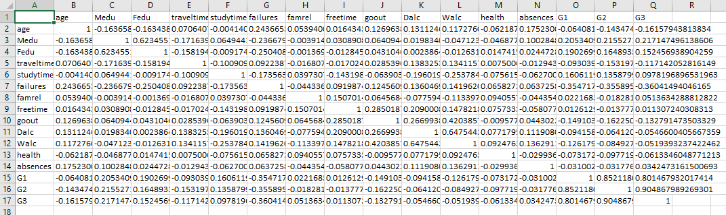
>> Student-por
numeric_student_por <- student_por[sapply(student_por, is.numeric)]
> matrice_corelatie_student_por <- cor(numeric_student_por, use = "complete.obs")
> matrice_corelatie_student_por
age Medu Fedu traveltime studytime failures famrel freetime goout Dalc Walc health
age 1.000000000 -0.107831822 -0.1210504970 0.0344900196 -0.008415115 0.31996795 -0.020559455 -0.0049102592 0.112804621 0.1347682684 0.08635735 -0.008750117
Medu -0.107831822 1.000000000 0.6474766091 -0.2650790028 0.097005833 -0.17221029 0.024420573 -0.0196862982 0.009536494 -0.0070183191 -0.01976579 0.004614056
Fedu -0.121050497 0.647476609 1.0000000000 -0.2082879785 0.050399648 -0.16591501 0.020255885 0.0068406310 0.027689743 0.0000607749 0.03844470 0.044909788
traveltime 0.034490020 -0.265079003 -0.2082879785 1.0000000000 -0.063153904 0.09772975 -0.009521185 0.0009367341 0.057454196 0.0928242836 0.05700718 -0.048261206
studytime -0.008415115 0.097005833 0.0503996477 -0.0631539042 1.000000000 -0.14744055 -0.004127129 -0.0688292222 -0.075442211 -0.1375847394 -0.21492510 -0.056432694
failures 0.319967948 -0.172210287 -0.1659150054 0.0977297501 -0.147440545 1.00000000 -0.062645163 0.1089946218 0.045077776 0.1059490922 0.08226626 0.035588213
famrel -0.020559455 0.024420573 0.0202558848 -0.0095211845 -0.004127129 -0.06264516 1.000000000 0.1292156766 0.089706569 -0.0757672250 -0.09351081 0.109559217
freetime -0.004910259 -0.019686298 0.0068406310 0.0009367341 -0.068829222 0.10899462 0.129215677 1.0000000000 0.346351788 0.1099035594 0.12024388 0.084526426
goout 0.112804621 0.009536494 0.0276897429 0.0574541957 -0.075442211 0.04507778 0.089706569 0.3463517880 1.000000000 0.2451259886 0.38867976 -0.015741131
Dalc 0.134768268 -0.007018319 0.0000607749 0.0928242836 -0.137584739 0.10594909 -0.075767225 0.1099035594 0.245125989 1.0000000000 0.61656138 0.059067458
Walc 0.086357345 -0.019765786 0.0384447003 0.0570071780 -0.214925105 0.08226626 -0.093510806 0.1202438807 0.388679761 0.6165613821 1.00000000 0.114987972
health -0.008750117 0.004614056 0.0449097884 -0.0482612064 -0.056432694 0.03558821 0.109559217 0.0845264260 -0.015741131 0.0590674577 0.11498797 1.000000000
absences 0.149998190 -0.008577495 0.0298586640 -0.0081490874 -0.118389370 0.12277884 -0.089533654 -0.0187160282 0.085373827 0.1729524910 0.15637297 -0.030234864
G1 -0.174322240 0.260472290 0.2175006506 -0.1541196211 0.260875380 -0.38421048 0.048794603 -0.0944966059 -0.074052633 -0.1951709342 -0.15564949 -0.051647415
G2 -0.107119079 0.264035300 0.2251389297 -0.1544888706 0.240497999 -0.38578222 0.089587783 -0.1066779265 -0.079469194 -0.1894799352 -0.16485219 -0.082179084
G3 -0.106505391 0.240150757 0.2117996791 -0.1271729668 0.249788690 -0.39331555 0.063361128 -0.1227049258 -0.087640723 -0.2047193972 -0.17661887 -0.098851241
absences G1 G2 G3
age 0.149998190 -0.17432224 -0.10711908 -0.10650539
Medu -0.008577495 0.26047229 0.26403530 0.24015076
Fedu 0.029858664 0.21750065 0.22513893 0.21179968
traveltime -0.008149087 -0.15411962 -0.15448887 -0.12717297
studytime -0.118389370 0.26087538 0.24049800 0.24978869
failures 0.122778835 -0.38421048 -0.38578222 -0.39331555
famrel -0.089533654 0.04879460 0.08958778 0.06336113
freetime -0.018716028 -0.09449661 -0.10667793 -0.12270493
goout 0.085373827 -0.07405263 -0.07946919 -0.08764072
Dalc 0.172952491 -0.19517093 -0.18947994 -0.20471940
Walc 0.156372970 -0.15564949 -0.16485219 -0.17661887
health -0.030234864 -0.05164742 -0.08217908 -0.09885124
absences 1.000000000 -0.14714924 -0.12474493 -0.09137906
G1 -0.147149242 1.00000000 0.86498163 0.82638712
G2 -0.124744933 0.86498163 1.00000000 0.91854800
G3 -0.091379056 0.82638712 0.91854800 1.00000000

write.table(matrice_corelatie_student_por, "matrice_corelatie_student_por.csv", row.names = TRUE, sep = ";", col.names = NA)
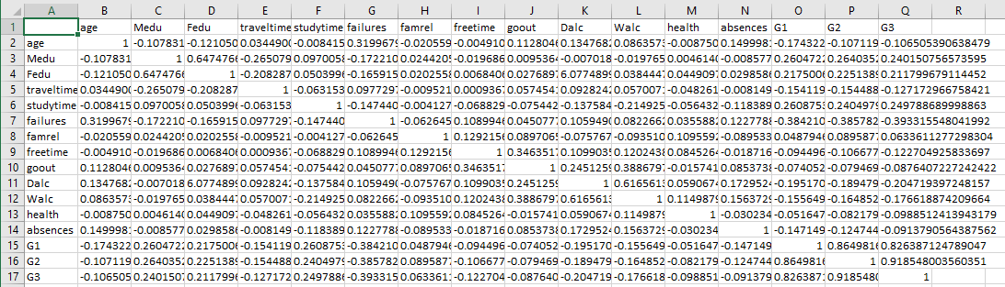
4) Afișați variabile foarte corelate (negativ, pozitiv) și salvați rezultatul într-un fișier.
>>Auto MPG
> prag_corelatie <- 0.75
> corelatii_puternice <- which(abs(matrice_corelatie) > prag_corelatie & abs(matrice_corelatie) < 1, arr.ind = TRUE)
> rezultate_corelatii <- data.frame(
+ Variabila1 = rownames(matrice_corelatie)[corelatii_puternice[, 1]],
+ Variabila2 = colnames(matrice_corelatie)[corelatii_puternice[, 2]],
+ Coeficient = matrice_corelatie[corelatii_puternice]
+ )
> write.table(rezultate_corelatii, "corelatii_foarte_puternice.csv", row.names = TRUE, sep = ";", col.names = NA)
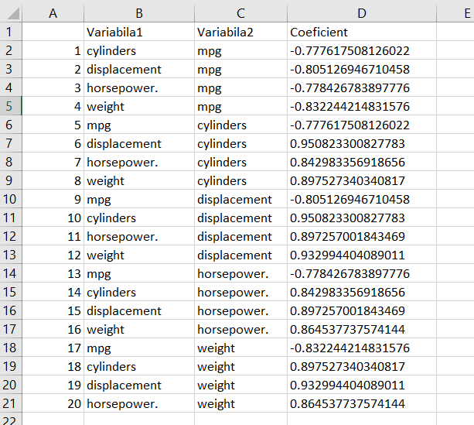
>>Student-mat
> corelatii_puternice_student_mat <- which(abs(matrice_corelatie_student_mat) > prag_corelatie & abs(matrice_corelatie_student_mat) < 1, arr.ind = TRUE)
> rezultate_corelatii_student_mat <- data.frame(
+ Variabila1 = rownames(matrice_corelatie_student_mat)[corelatii_puternice_student_mat[, 1]],
+ Variabila2 = colnames(matrice_corelatie_student_mat)[corelatii_puternice_student_mat[, 2]],
+ Coeficient = matrice_corelatie_student_mat[corelatii_puternice_student_mat]
+ )
>
> write.table(rezultate_corelatii_student_mat, "corelatii_foarte_puternice_std_mat.csv", row.names = TRUE, sep = ";", col.names = NA)
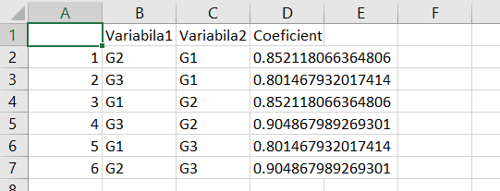
>>Student-por
> corelatii_puternice_student_por <- which(abs(matrice_corelatie_student_por) > prag_corelatie & abs(matrice_corelatie_student_por) < 1, arr.ind = TRUE)
> rezultate_corelatii_student_por <- data.frame(
+ Variabila1 = rownames(matrice_corelatie_student_por)[corelatii_puternice_student_por[, 1]],
+ Variabila2 = colnames(matrice_corelatie_student_por)[corelatii_puternice_student_por[, 2]],
+ Coeficient = matrice_corelatie_student_por[corelatii_puternice_student_por]
+ )
>
> write.table(rezultate_corelatii_student_por, "corelatii_foarte_puternice_std_por.csv", row.names = TRUE, sep = ";", col.names = NA)
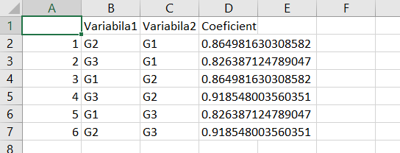
- Afișați diagramele cu casete (box plots) pentru toate variabilele și interpretați rezultatele.
>>Auto MPG
> library(ggplot2)
> library(tidyr)
> data_long <- pivot_longer(numeric_data, cols = everything(),
+ names_to = "variable", values_to = "value")
> box_plot <- ggplot(data_long, aes(x = variable, y = value)) +
+ geom_boxplot(fill = "lightgreen", color = "darkgreen") +
+ theme_minimal() +
+ labs(title = "Diagrame cu casete pentru setul de date Auto MPG",
+ x = "Variabile",
+ y = "Valori")
>
> print(box_plot)

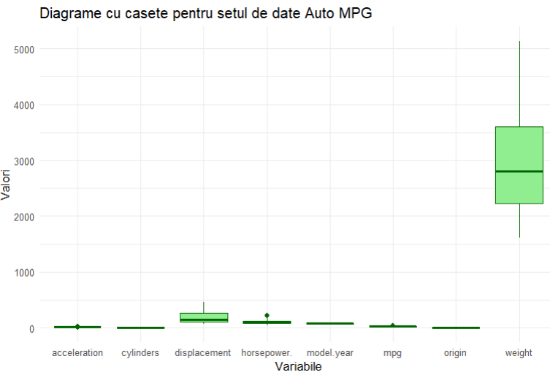
>>Student-mat
> data_long_std_mat <- pivot_longer(numeric_student_mat, cols = everything(),
+ names_to = "variable", values_to = "value")
>
> box_plot_std_mat <- ggplot(data_long_std_mat, aes(x = variable, y = value)) +
+ geom_boxplot(fill = "lightgreen", color = "darkgreen") +
+ theme_minimal() +
+ labs(title = "Diagrame cu casete pentru setul de date Student mat",
+ x = "Variabile",
+ y = "Valori")
>
> print(box_plot_std_mat)
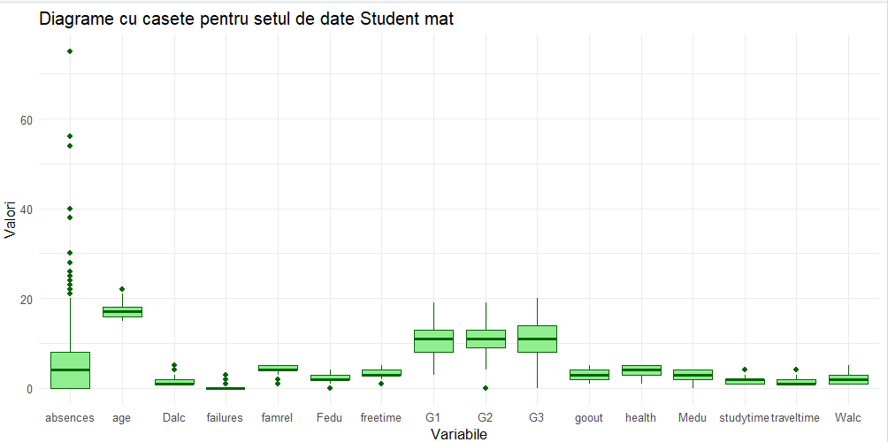
>>Student-por
data_long_std_mat <- pivot_longer(numeric_student_mat, cols = everything(),
+ names_to = "variable", values_to = "value")
>
> box_plot_std_mat <- ggplot(data_long_std_mat, aes(x = variable, y = value)) +
+ geom_boxplot(fill = "lightgreen", color = "darkgreen") +
+ theme_minimal() +
+ labs(title = "Diagrame cu casete pentru setul de date Student mat",
+ x = "Variabile",
+ y = "Valori")
>
> print(box_plot_std_mat)
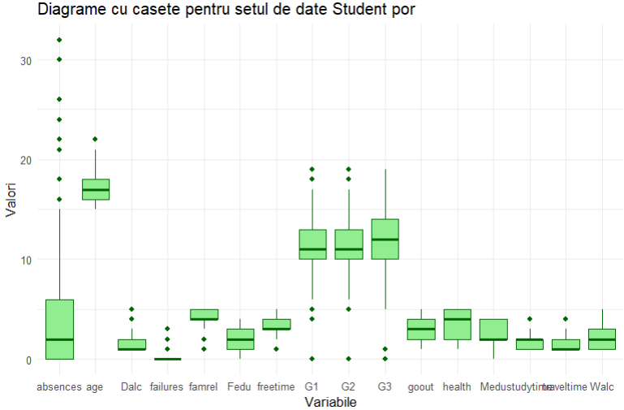
>>Auto MPG
- Afișați diagrama pe perechi (pairwise plot) și interpretați rezultatele.
- library(GGally)
- Registered S3 method overwritten by 'GGally':
- method from
- +.gg ggplot2
- >
- > pair_plot <- ggpairs(numeric_data) +
- + ggtitle("Diagrama pe perechi pentru setul de date Auto MPG")
- >
- > print(pair_plot)

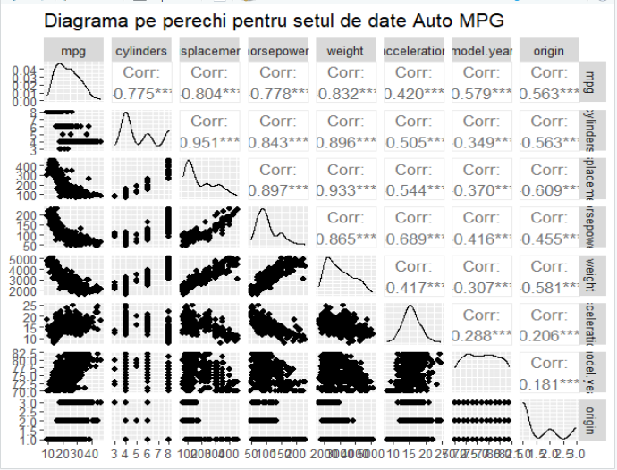

>>Student-mat
print(pair_plot)
There were 15 warnings (use warnings() to see them)
> pair_plot_std_mat <- ggpairs(numeric_student_mat) +
+ ggtitle("Diagrama pe perechi setul de date Student mat")
> pair_plot_std_mat

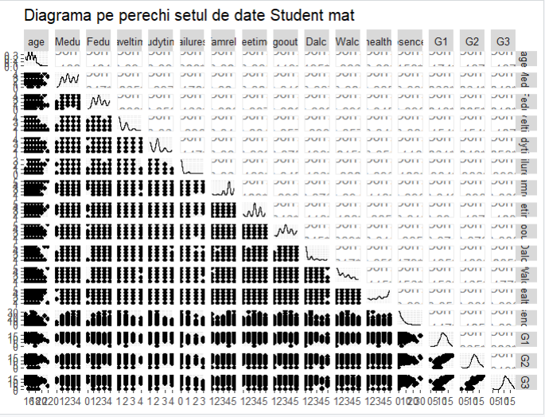
>>Student-por
> pair_plot_std_por <- ggpairs(numeric_student_por) +
+ ggtitle("Diagrama pe perechi setul de date Student por")
> pair_plot_std_por

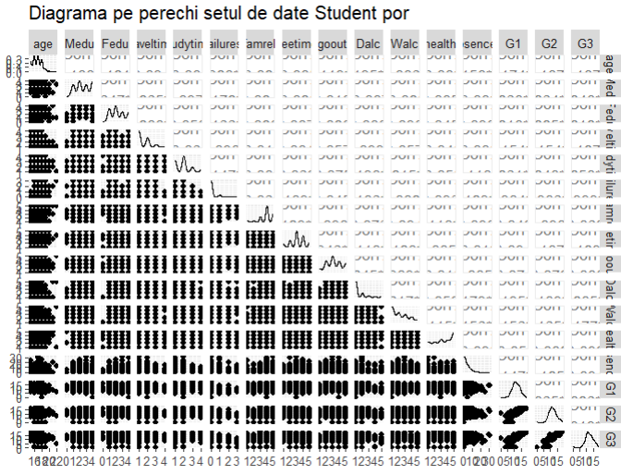
7) Afișați diagrama pe perechi și diagramele cu casete într-un singur grafic.
>>Auto MPG

library(gridExtra)
> grid.arrange(grobs = list(ggmatrix_gtable(pair_plot), box_plot), ncol = 2)
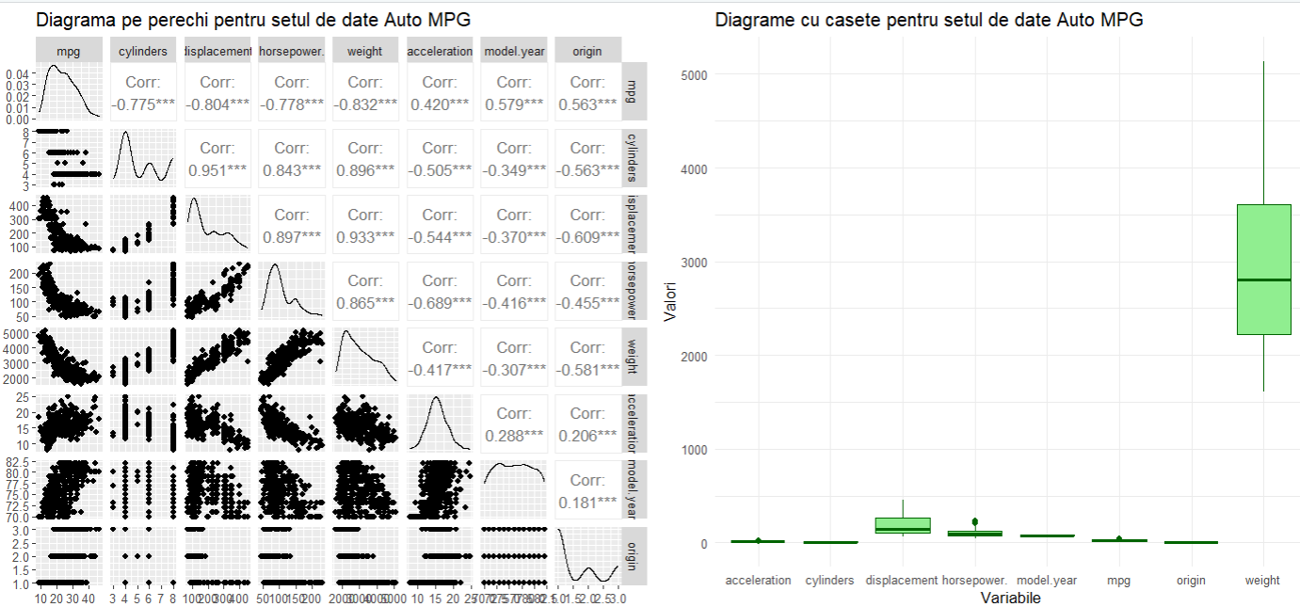
grid.arrange(grobs = list(ggmatrix_gtable(pair_plot_std_por), box_plot_std_por), ncol = 2)

>>Student-por

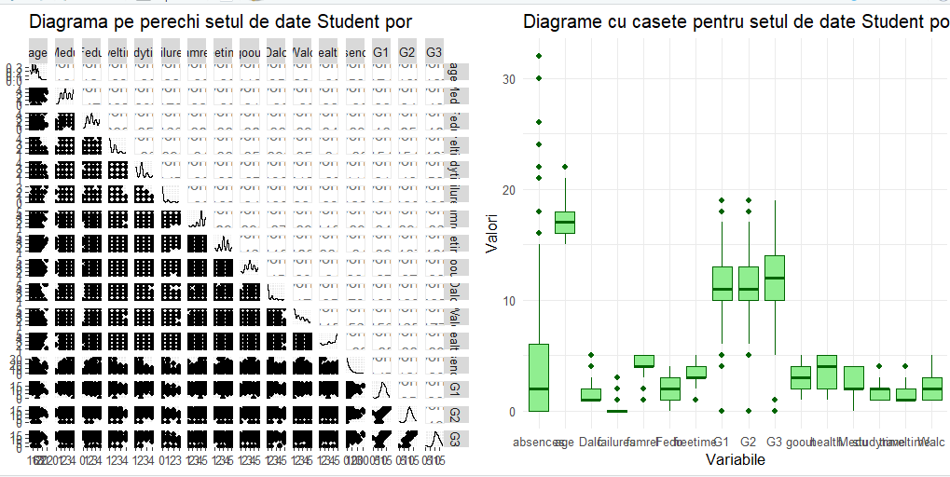
> grid.arrange(grobs = list(ggmatrix_gtable(pair_plot_std_mat), box_plot_std_mat), ncol = 2)

>>Student-mat
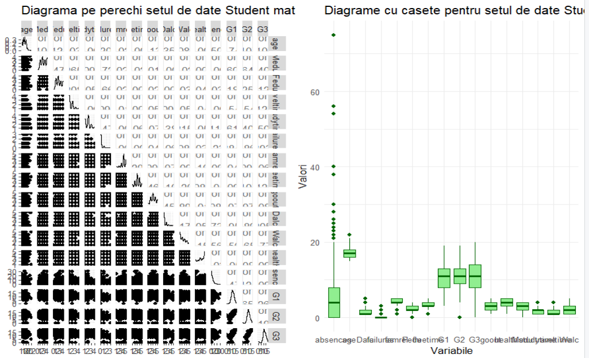8) Înlocuiți valorile lipsă cu media sau modul (după caz).
>>Auto MPG
could not find function "%>%"
> # Definește funcția calculate_abs pentru a calcula moda
> calculate_abs <- function(x) {
+ uniqx <- unique(x)
+ uniqx[which.max(tabulate(match(x, uniqx)))]
+ }
>
> # Înlocuiește valorile NA pentru coloanele numerice și de tip caracter
> auto_mpg_cleaned <- auto_mpg
>
> # Pentru coloanele numerice, înlocuiește NA cu media
> numeric_cols <- sapply(auto_mpg_cleaned, is.numeric)
> auto_mpg_cleaned[numeric_cols] <- lapply(auto_mpg_cleaned[numeric_cols], function(x) {
+ ifelse(is.na(x), mean(x, na.rm = TRUE), x)
+ })
>
> # Pentru coloanele de tip caracter, înlocuiește NA cu moda
> character_cols <- sapply(auto_mpg_cleaned, is.character)
> auto_mpg_cleaned[character_cols] <- lapply(auto_mpg_cleaned[character_cols], function(x) {
+ ifelse(is.na(x), calculate_abs(x), x)
+ })
>
> # Afișează primele 10 rânduri
> auto_mpg_cleaned[1:10, ]
mpg cylinders displacement horsepower. weight acceleration model.year origin
1 18 8 307 130 3504 12.0 70 1
2 15 8 350 165 3693 11.5 70 1
3 18 8 318 150 3436 11.0 70 1
4 16 8 304 150 3433 12.0 70 1
5 17 8 302 140 3449 10.5 70 1
6 15 8 429 198 4341 10.0 70 1
7 14 8 454 220 4354 9.0 70 1
8 14 8 440 215 4312 8.5 70 1
9 14 8 455 225 4425 10.0 70 1
10 15 8 390 190 3850 8.5 70 1
car.name
1 chevrolet chevelle malibu
2 buick skylark 320
3 plymouth satellite
4 amc rebel sst
5 ford torino
6 ford galaxie 500
7 chevrolet impala
8 plymouth fury iii
9 pontiac catalina
10 amc ambassador dpl

>>Student-mat
# Calculăm media pentru valorile numerice lipsă și moda pentru valorile de tip caracter
> student_mat_cleaned <- student_mat
>
> # Înlocuim valorile NA pentru coloanele numerice
> numeric_cols <- sapply(student_mat_cleaned, is.numeric)
> student_mat_cleaned[numeric_cols] <- lapply(student_mat_cleaned[numeric_cols], function(x) {
+ ifelse(is.na(x), mean(x, na.rm = TRUE), x)
+ })
>
> # Înlocuim valorile NA pentru coloanele de tip caracter
> character_cols <- sapply(student_mat_cleaned, is.character)
> student_mat_cleaned[character_cols] <- lapply(student_mat_cleaned[character_cols], function(x) {
+ ifelse(is.na(x), calculate_abs(x), x)
+ })
>
> # Afișăm primele 10 rânduri
> student_mat_cleaned[1:10, ]
school sex age address famsize Pstatus Medu Fedu Mjob Fjob reason guardian
1 GP F 18 U GT3 A 4 4 at_home teacher course mother
2 GP F 17 U GT3 T 1 1 at_home other course father
3 GP F 15 U LE3 T 1 1 at_home other other mother
4 GP F 15 U GT3 T 4 2 health services home mother
5 GP F 16 U GT3 T 3 3 other other home father
6 GP M 16 U LE3 T 4 3 services other reputation mother
7 GP M 16 U LE3 T 2 2 other other home mother
8 GP F 17 U GT3 A 4 4 other teacher home mother
9 GP M 15 U LE3 A 3 2 services other home mother
10 GP M 15 U GT3 T 3 4 other other home mother
traveltime studytime failures schoolsup famsup paid activities nursery higher internet
1 2 2 0 yes no no no yes yes no
2 1 2 0 no yes no no no yes yes
3 1 2 3 yes no yes no yes yes yes
4 1 3 0 no yes yes yes yes yes yes
5 1 2 0 no yes yes no yes yes no
6 1 2 0 no yes yes yes yes yes yes
7 1 2 0 no no no no yes yes yes
8 2 2 0 yes yes no no yes yes no
9 1 2 0 no yes yes no yes yes yes
10 1 2 0 no yes yes yes yes yes yes
romantic famrel freetime goout Dalc Walc health absences G1 G2 G3
1 no 4 3 4 1 1 3 6 5 6 6
2 no 5 3 3 1 1 3 4 5 5 6
3 no 4 3 2 2 3 3 10 7 8 10
4 yes 3 2 2 1 1 5 2 15 14 15
5 no 4 3 2 1 2 5 4 6 10 10
6 no 5 4 2 1 2 5 10 15 15 15
7 no 4 4 4 1 1 3 0 12 12 11
8 no 4 1 4 1 1 1 6 6 5 6
9 no 4 2 2 1 1 1 0 16 18 19
10 no 5 5 1 1 1 5 0 14 15 15
>> Student-por
# Definim funcția calculate_abs pentru a calcula moda
> calculate_abs <- function(x) {
+ uniqx <- unique(x)
+ uniqx[which.max(tabulate(match(x, uniqx)))]
+ }
>
> # Cream o copie a setului de date original
> student_por_cleaned <- student_por
>
> # Înlocuim valorile NA pentru coloanele numerice
> numeric_cols <- sapply(student_por_cleaned, is.numeric)
> student_por_cleaned[numeric_cols] <- lapply(student_por_cleaned[numeric_cols], function(x) {
+ ifelse(is.na(x), mean(x, na.rm = TRUE), x)
+ })
>
> # Înlocuim valorile NA pentru coloanele de tip caracter
> character_cols <- sapply(student_por_cleaned, is.character)
> student_por_cleaned[character_cols] <- lapply(student_por_cleaned[character_cols], function(x) {
+ ifelse(is.na(x), calculate_abs(x), x)
+ })
>
> # Afișăm primele 10 rânduri
> student_por_cleaned
school sex age address famsize Pstatus Medu Fedu Mjob Fjob reason guardian
1 GP F 18 U GT3 A 4 4 at_home teacher course mother
2 GP F 17 U GT3 T 1 1 at_home other course father
3 GP F 15 U LE3 T 1 1 at_home other other mother
4 GP F 15 U GT3 T 4 2 health services home mother
5 GP F 16 U GT3 T 3 3 other other home father
6 GP M 16 U LE3 T 4 3 services other reputation mother
7 GP M 16 U LE3 T 2 2 other other home mother
8 GP F 17 U GT3 A 4 4 other teacher home mother
9 GP M 15 U LE3 A 3 2 services other home mother
10 GP M 15 U GT3 T 3 4 other other home mother
11 GP F 15 U GT3 T 4 4 teacher health reputation mother
12 GP F 15 U GT3 T 2 1 services other reputation father
13 GP M 15 U LE3 T 4 4 health services course father
14 GP M 15 U GT3 T 4 3 teacher other course mother
15 GP M 15 U GT3 A 2 2 other other home other
16 GP F 16 U GT3 T 4 4 health other home mother
17 GP F 16 U GT3 T 4 4 services services reputation mother
18 GP F 16 U GT3 T 3 3 other other reputation mother
19 GP M 17 U GT3 T 3 2 services services course mother
20 GP M 16 U LE3 T 4 3 health other home father
21 GP M 15 U GT3 T 4 3 teacher other reputation mother
22 GP M 15 U GT3 T 4 4 health health other father
23 GP M 16 U LE3 T 4 2 teacher other course mother
24 GP M 16 U LE3 T 2 2 other other reputation mother
25 GP F 15 R GT3 T 2 4 services health course mother
26 GP F 16 U GT3 T 2 2 services services home mother
27 GP M 15 U GT3 T 2 2 other other home mother
28 GP M 15 U GT3 T 4 2 health services other mother
29 GP M 16 U LE3 A 3 4 services other home mother
30 GP M 16 U GT3 T 4 4 teacher teacher home mother
traveltime studytime failures schoolsup famsup paid activities nursery higher internet
1 2 2 0 yes no no no yes yes no
2 1 2 0 no yes no no no yes yes
3 1 2 0 yes no no no yes yes yes
4 1 3 0 no yes no yes yes yes yes
5 1 2 0 no yes no no yes yes no
6 1 2 0 no yes no yes yes yes yes
7 1 2 0 no no no no yes yes yes
8 2 2 0 yes yes no no yes yes no
9 1 2 0 no yes no no yes yes yes
10 1 2 0 no yes no yes yes yes yes
11 1 2 0 no yes no no yes yes yes
12 3 3 0 no yes no yes yes yes yes
13 1 1 0 no yes no yes yes yes yes
14 2 2 0 no yes no no yes yes yes
15 1 3 0 no yes no no yes yes yes
16 1 1 0 no yes no no yes yes yes
17 1 3 0 no yes no yes yes yes yes
18 3 2 0 yes yes no yes yes yes no
19 1 1 3 no yes yes yes yes yes yes
20 1 1 0 no no no yes yes yes yes
21 1 2 0 no no no no yes yes yes
22 1 1 0 no yes yes no yes yes yes
23 1 2 0 no no no yes yes yes yes
24 2 2 0 no yes no yes yes yes yes
25 1 3 0 yes yes no yes yes yes yes
26 1 1 0 no yes no no no yes yes
27 1 1 0 no yes no no yes yes yes
28 1 1 0 no no no no yes yes yes
29 1 2 0 yes yes yes yes yes yes yes
30 1 2 0 no yes yes yes yes yes yes
romantic famrel freetime goout Dalc Walc health absences G1 G2 G3
1 no 4 3 4 1 1 3 4 0 11 11
2 no 5 3 3 1 1 3 2 9 11 11
3 no 4 3 2 2 3 3 6 12 13 12
4 yes 3 2 2 1 1 5 0 14 14 14
5 no 4 3 2 1 2 5 0 11 13 13
6 no 5 4 2 1 2 5 6 12 12 13
7 no 4 4 4 1 1 3 0 13 12 13
8 no 4 1 4 1 1 1 2 10 13 13
9 no 4 2 2 1 1 1 0 15 16 17
10 no 5 5 1 1 1 5 0 12 12 13
11 no 3 3 3 1 2 2 2 14 14 14
12 no 5 2 2 1 1 4 0 10 12 13
13 no 4 3 3 1 3 5 0 12 13 12
14 no 5 4 3 1 2 3 0 12 12 13
15 yes 4 5 2 1 1 3 0 14 14 15
16 no 4 4 4 1 2 2 6 17 17 17
17 no 3 2 3 1 2 2 10 13 13 14
18 no 5 3 2 1 1 4 2 13 14 14
19 no 5 5 5 2 4 5 2 8 8 7
20 no 3 1 3 1 3 5 6 12 12 12
21 no 4 4 1 1 1 1 0 12 13 14
22 no 5 4 2 1 1 5 0 11 12 12
23 no 4 5 1 1 3 5 0 12 13 14
24 no 5 4 4 2 4 5 2 10 10 10
25 no 4 3 2 1 1 5 2 10 11 10
26 no 1 2 2 1 3 5 6 10 11 12
27 no 4 2 2 1 2 5 8 11 12 12
28 no 2 2 4 2 4 1 0 11 11 11
29 no 5 3 3 1 1 5 2 12 12 13
30 yes 4 4 5 5 5 5 4 12 11 12
[ reached 'max' / getOption("max.print") -- omitted 619 rows ]

9 ) Creați 2 eșantioane aleatoriu cu dimensiunea de 80% și respectiv 20% din date.
> set.seed(400)
>
> n <- nrow(auto_mpg)
> sample_size_80 <- floor(0.8 * n)
>
> indices_80 <- sample(seq_len(n), size = sample_size_80)
> esantion_80 <- auto_mpg[indices_80, ]
> esantion_20 <- auto_mpg[-indices_80, ]
>
> cat("Dimensiune eșantion 80%:", nrow(esantion_80), "\n")
Dimensiune eșantion 80%: 318
> cat("Dimensiune eșantion 20%:", nrow(esantion_20), "\n")
Dimensiune eșantion 20%: 80

>> Student-mat
set.seed(400)
>
> n <- nrow(student_mat)
> sample_size_80 <- floor(0.8 * n)
>
> indices_80 <- sample(seq_len(n), size = sample_size_80)
> esantion_80_std_mat <- student_mat[indices_80, ]
> esantion_20_std_mat <- student_mat[-indices_80, ]
>
> esantion_80_std_mat
school sex age address famsize
101 GP M 16 U GT3
374 MS F 17 R GT3
279 GP F 18 U GT3
343 GP M 18 U LE3
220 GP F 17 U GT3
342 GP M 18 U GT3
156 GP M 15 R GT3
14 GP M 15 U GT3
13 GP M 15 U LE3
142 GP M 16 U LE3
327 GP M 17 U GT3
41 GP F 16 U LE3
91 GP F 16 U GT3
255 GP M 17 R GT3
102 GP M 16 U GT3
382 MS M 18 R GT3
284 GP F 18 U GT3
82 GP M 15 U GT3
53 GP M 15 U LE3
367 MS M 18 U LE3
292 GP F 17 U GT3
65 GP F 15 U LE3
238 GP F 16 U GT3
325 GP F 17 U LE3
246 GP M 16 U GT3
54 GP F 15 U GT3
351 MS M 19 R GT3
185 GP F 16 U GT3
213 GP F 16 U GT3
340 GP F 17 R GT3
Pstatus Medu Fedu Mjob Fjob
101 T 4 4 services services
374 T 1 2 other other
279 T 4 4 health health
343 T 3 4 services other
220 T 2 2 at_home at_home
342 T 4 4 teacher services
156 T 2 3 at_home services
14 T 4 3 teacher other
13 T 4 4 health services
142 T 2 2 services services
327 T 3 3 other services
41 T 2 2 other other
91 T 3 3 other other
255 T 2 1 other other
102 T 4 4 services teacher
382 T 2 1 other other
284 T 1 1 other other
82 T 2 3 other other
53 A 4 2 health health
367 T 4 4 teacher services
292 T 4 3 health services
65 T 4 3 services services
238 T 2 1 other other
325 T 0 2 at_home at_home
246 T 2 1 other other
54 T 4 4 services services
351 T 1 1 other services
185 T 3 2 other other
213 A 2 2 other other
340 A 3 2 other other
reason guardian traveltime
101 other mother 1
374 course mother 1
279 reputation father 1
343 home mother 1
220 course mother 1
342 home father 1
156 course mother 1
14 course mother 2
13 course father 1
142 reputation father 2
327 reputation mother 1
41 home mother 2
91 home mother 1
255 course mother 1
102 other father 1
382 other mother 2
284 home mother 2
82 home mother 1
53 other father 2
367 other mother 2
292 reputation mother 1
65 reputation father 1
238 home mother 1
325 home father 2
246 course mother 3
54 course mother 1
351 home other 3
185 reputation mother 1
213 reputation mother 1
340 home mother 1
studytime failures schoolsup famsup
101 1 0 yes yes
374 1 0 no no
279 2 1 yes yes
343 2 0 no no
220 3 0 no yes
342 2 1 no yes
156 2 0 yes no
14 2 0 no yes
13 1 0 no yes
142 1 2 no yes
327 1 0 no no
41 2 1 no yes
91 3 0 no yes
255 1 0 no no
102 3 0 no yes
382 1 0 no no
284 2 0 yes no
82 3 0 yes no
53 1 1 no no
367 3 0 no no
292 3 0 no yes
65 2 0 yes no
238 1 0 no no
325 3 0 no no
246 1 0 no no
54 1 0 yes yes
351 2 3 no no
185 2 0 no yes
213 2 0 yes yes
340 2 0 no yes
paid activities nursery higher
101 yes yes yes yes
374 no yes yes yes
279 no yes yes yes
343 no yes yes yes
220 yes yes yes yes
342 no yes yes yes
156 yes yes yes yes
14 yes no yes yes
13 yes yes yes yes
142 no yes yes yes
327 no yes no yes
41 no yes no yes
91 yes no yes yes
255 no no no yes
102 no yes yes yes
382 no yes no yes
284 no yes yes yes
82 yes no no yes
53 no no yes yes
367 yes no yes yes
292 yes no yes yes
65 no yes yes yes
238 no no yes yes
325 no no yes yes
246 no no yes yes
54 yes no yes yes
351 no no yes yes
185 yes no yes yes
213 yes no yes yes
340 yes no yes yes
internet romantic famrel freetime
101 yes no 4 5
374 yes no 3 5
279 yes yes 2 4
343 yes yes 4 3
220 yes no 4 3
342 yes no 4 3
156 no no 4 4
14 yes no 5 4
13 yes no 4 3
142 yes no 2 3
327 yes no 4 3
41 yes yes 3 3
91 yes yes 4 3
255 yes no 4 4
102 yes yes 4 4
382 yes yes 4 4
284 yes no 5 4
82 yes no 5 3
53 no no 5 5
367 yes yes 4 2
292 yes no 4 2
65 yes yes 4 4
238 yes yes 4 5
325 yes no 3 3
246 yes no 4 3
54 yes no 3 3
351 yes no 5 4
185 yes no 1 2
213 yes no 3 3
340 yes no 4 3
goout Dalc Walc health absences G1 G2
101 5 5 5 4 14 7 7
374 5 1 3 1 14 6 5
279 4 1 1 4 15 9 8
343 3 1 3 5 11 16 15
220 3 1 1 4 4 9 10
342 3 2 2 2 0 10 10
156 4 1 1 1 2 11 8
14 3 1 2 3 2 10 10
13 3 1 3 5 2 14 14
142 3 2 2 2 8 9 9
327 5 3 5 5 3 14 15
41 3 1 2 3 25 7 10
91 3 1 3 4 0 7 7
255 2 2 4 5 0 8 12
102 3 1 1 4 0 16 17
382 3 1 3 5 5 7 6
284 4 1 1 4 4 8 9
82 2 1 2 5 4 11 10
53 5 3 4 5 6 11 11
367 2 2 2 5 0 13 13
292 2 1 2 3 0 15 15
65 4 2 4 2 0 10 10
238 2 1 1 5 20 13 12
325 3 2 3 2 0 16 15
246 3 1 1 4 6 18 18
54 4 2 3 5 0 8 10
351 4 3 3 2 8 8 7
185 2 1 2 1 14 12 13
213 4 1 1 4 0 12 13
340 3 2 3 2 4 9 10
G3
101 5
374 5
279 8
343 15
220 10
342 0
156 8
14 11
13 14
142 9
327 16
41 11
91 8
255 12
102 17
382 7
284 10
82 11
53 10
367 13
292 15
65 10
238 12
325 15
246 18
54 11
351 8
185 12
213 14
340 10
esantion_20_std_mat
school sex age address famsize Pstatus Medu Fedu Mjob Fjob reason
1 GP F 18 U GT3 A 4 4 at_home teacher course
5 GP F 16 U GT3 T 3 3 other other home
6 GP M 16 U LE3 T 4 3 services other reputation
7 GP M 16 U LE3 T 2 2 other other home
8 GP F 17 U GT3 A 4 4 other teacher home
15 GP M 15 U GT3 A 2 2 other other home
19 GP M 17 U GT3 T 3 2 services services course
28 GP M 15 U GT3 T 4 2 health services other
29 GP M 16 U LE3 A 3 4 services other home
37 GP M 15 U LE3 T 4 3 teacher services home
38 GP M 16 R GT3 A 4 4 other teacher reputation
39 GP F 15 R GT3 T 3 4 services health course
52 GP F 15 U LE3 T 4 2 health other other
57 GP F 15 U GT3 A 4 3 services services reputation
60 GP F 16 U GT3 T 4 2 services other course
64 GP F 16 U GT3 T 4 3 teacher health home
70 GP F 15 R LE3 T 3 1 other other reputation
74 GP M 16 U GT3 T 3 1 other other reputation
83 GP F 15 U LE3 T 3 2 services other reputation
86 GP F 15 U GT3 T 4 4 services services reputation
88 GP F 15 U GT3 T 4 2 other other reputation
94 GP F 16 U GT3 T 4 2 teacher services home
97 GP M 16 R GT3 T 4 3 services other reputation
99 GP F 16 U GT3 T 4 4 other other reputation
103 GP M 15 U GT3 T 4 4 services other course
105 GP M 15 U GT3 A 3 4 services other course
107 GP F 15 U GT3 T 2 2 other other course
111 GP M 15 U LE3 A 4 4 teacher teacher course
114 GP M 15 U LE3 T 4 2 teacher other course
116 GP M 16 U GT3 T 4 4 teacher teacher course
guardian traveltime studytime failures schoolsup famsup paid activities nursery
1 mother 2 2 0 yes no no no yes
5 father 1 2 0 no yes yes no yes
6 mother 1 2 0 no yes yes yes yes
7 mother 1 2 0 no no no no yes
8 mother 2 2 0 yes yes no no yes
15 other 1 3 0 no yes no no yes
19 mother 1 1 3 no yes no yes yes
28 mother 1 1 0 no no yes no yes
29 mother 1 2 0 yes yes no yes yes
37 mother 1 3 0 no yes no yes yes
38 mother 2 3 0 no yes no yes yes
39 mother 1 3 0 yes yes yes yes yes
52 mother 1 2 0 no yes yes no yes
57 mother 1 2 0 no yes yes yes yes
60 mother 1 2 0 no yes no no yes
64 mother 1 3 0 yes yes yes yes yes
70 father 2 4 0 no yes no no no
74 mother 1 1 0 no no no yes yes
83 mother 1 2 0 no yes yes no yes
86 father 2 2 2 no no yes no yes
88 mother 1 3 0 no yes no yes yes
94 mother 2 2 0 no yes yes yes yes
97 mother 2 1 0 yes yes no yes no
99 mother 1 1 0 no no no yes no
103 mother 1 1 0 no yes no yes no
105 mother 1 2 0 no yes yes yes yes
107 mother 1 4 0 yes yes yes no yes
111 mother 1 1 0 no no no yes yes
114 mother 1 1 0 no no no no yes
116 father 1 2 0 no yes no yes yes
higher internet romantic famrel freetime goout Dalc Walc health absences G1 G2 G3
1 yes no no 4 3 4 1 1 3 6 5 6 6
5 yes no no 4 3 2 1 2 5 4 6 10 10
6 yes yes no 5 4 2 1 2 5 10 15 15 15
7 yes yes no 4 4 4 1 1 3 0 12 12 11
8 yes no no 4 1 4 1 1 1 6 6 5 6
15 yes yes yes 4 5 2 1 1 3 0 14 16 16
19 yes yes no 5 5 5 2 4 5 16 6 5 5
28 yes yes no 2 2 4 2 4 1 4 15 16 15
29 yes yes no 5 3 3 1 1 5 4 11 11 11
37 yes yes no 5 4 3 1 1 4 2 15 16 18
38 yes yes yes 2 4 3 1 1 5 7 15 16 15
39 yes yes no 4 3 2 1 1 5 2 12 12 11
52 yes yes no 4 3 3 1 1 5 2 11 13 13
57 yes yes no 4 3 2 1 1 1 0 14 15 15
60 yes yes no 4 2 3 1 1 5 2 15 16 16
64 yes yes no 3 4 4 2 4 4 2 10 9 9
70 yes yes no 4 4 2 2 3 3 12 16 16 16
74 yes no no 5 3 2 2 2 5 2 12 12 14
83 yes yes no 4 4 4 1 1 5 10 7 6 6
86 yes yes yes 4 4 4 2 3 5 6 7 9 8
88 yes yes no 5 3 3 1 3 1 4 13 14 14
94 yes yes no 5 3 3 1 1 1 0 11 10 10
97 yes yes no 3 3 3 1 1 4 2 11 15 15
99 yes yes no 5 3 4 1 2 1 6 11 14 14
103 yes yes no 5 3 3 1 1 5 4 10 13 14
105 yes yes no 5 4 4 1 1 1 0 16 18 18
107 yes yes no 5 1 2 1 1 3 8 7 8 8
111 yes yes no 5 5 3 1 1 4 6 18 19 19
114 yes yes no 3 5 2 1 1 3 10 18 19 19
116 yes yes no 5 4 4 1 2 5 2 15 15 16

>> Student-por
set.seed(400)
>
> n <- nrow(student_por)
> sample_size_80 <- floor(0.8 * n)
>
> indices_80 <- sample(seq_len(n), size = sample_size_80)
> esantion_80_std_por <- student_por[indices_80, ]
> esantion_20_std_por <- student_por[-indices_80, ]
>
> cat("Dimensiune eșantion 80%:", nrow(esantion_80_std_por), "\n")
Dimensiune eșantion 80%: 519
> cat("Dimensiune eșantion 20%:", nrow(esantion_20_std_por), "\n")
Dimensiune eșantion 20%: 130
10) Creați 3 eșantioane de dimensiuni egale aleatoriu.
> number_rows <- nrow(auto_mpg)
> sample_size <- number_rows / 3
> esantion_1 <- auto_mpg %>% sample_n(sample_size)
> esantion_2 <- auto_mpg %>% sample_n(sample_size)
> esantion_3 <- auto_mpg %>% sample_n(sample_size)
> cat(nrow(esantion_1))
132
> cat(nrow(esantion_2))
132
> cat(nrow(esantion_3))
132

> esantion_1_std_mat <- student_mat %>% sample_frac(1/3)
> esantion_2_std_mat <- student_mat %>% sample_frac(1/3)
> esantion_3_std_mat <- student_mat %>% sample_frac(1/3)
> cat(nrow(esantion_1_std_mat))
132
> cat(nrow(esantion_2_std_mat))
132
> cat(nrow(esantion_3_std_mat))
132
>>Student-por
> esantion_1_std_por <- student_por %>% sample_frac(1/3)
> esantion_2_std_por <- student_por %>% sample_frac(1/3)
> esantion_3_std_por <- student_por %>% sample_frac(1/3)
> cat(nrow(esantion_1_std_por))
216
> cat(nrow(esantion_2_std_por))
216
> cat(nrow(esantion_3_std_por))

216

11) Creați o funcție pe care o veți numi Analyse și care va răspunde la întrebările 2), 3), 4), 5), 6).

# Importăm pachetele necesare
library(dplyr)
library(tidyr)
library(ggplot2)
library(GGally)

# Funcția de analiză a unui set de date
Analyse <- function(data_frame) {

# 1. Sumarul datelor
cat("Sumar date:\n")
print(summary(data_frame))

# 2. Selectarea datelor numerice și calcularea matricei de corelație
numeric_data_frame <- data_frame[sapply(data_frame, is.numeric)]
matrice_corelatie <- cor(numeric_data_frame, use = "complete.obs")

cat("\nMatricea de corelație:\n")
print(matrice_corelatie)

# Salvarea matricei de corelație într-un fișier CSV
write.table(matrice_corelatie, "matrice_corelatie.csv", row.names = TRUE, sep = ";", col.names = NA)

# 3. Identificarea corelațiilor puternice
prag_corelatie <- 0.75
corelatii_puternice <- which(abs(matrice_corelatie) > prag_corelatie & abs(matrice_corelatie) < 1, arr.ind = TRUE)

rezultate_corelatii <- data.frame(
Variabila1 = rownames(matrice_corelatie)[corelatii_puternice[, 1]],
Variabila2 = colnames(matrice_corelatie)[corelatii_puternice[, 2]],
Coeficient = matrice_corelatie[corelatii_puternice]
)

# Salvarea corelațiilor puternice într-un fișier CSV
write.table(rezultate_corelatii, "corelatii_foarte_puternice_2.csv", row.names = TRUE, sep = ";", col.names = NA)

# 4. Crearea unui box plot pentru fiecare variabilă numerică
data_long <- pivot_longer(numeric_data_frame, cols = everything(),
names_to = "variable", values_to = "value")

box_plot <- ggplot(data_long, aes(x = variable, y = value)) +
geom_boxplot(fill = "lightblue", color = "darkblue") +
theme_minimal() +
labs(title = "Diagrame cu casete ale variabilelor numerice",
x = "Variabile",
y = "Valori")

cat("\nAfișăm box plot-ul...\n")
print(box_plot)

# 5. Diagrama de perechi a variabilelor numerice
pair_plot <- ggpairs(numeric_data_frame) +
ggtitle("Diagrama pe perechi pentru variabilele numerice")

cat("\nAfișăm diagrama de perechi...\n")
print(pair_plot)
}

# Apelarea funcției pentru setul de date auto_mpg
Analyse(auto_mpg)

12) Creați o funcție pe care o veți numi Analysis_by_class și care va răspunde la întrebările 2), 3), 4), 5), 6) pentru fiecare clasă a setului de date.
# Importăm pachetele necesare
library(dplyr)
library(tidyr)
library(ggplot2)
library(GGally)

# Funcție pentru analiza setului de date după o clasă specifică
Analysis_by_class <- function(data_frame, class_column) {

# Verificăm dacă coloana specificată există în setul de date
if (!(class_column %in% colnames(data_frame))) {
stop("Coloana specificată nu există în setul de date.")
}

# Obținem clasele unice din coloana specificată
unique_classes <- unique(data_frame[[class_column]])
results <- list()

# Iterăm prin fiecare clasă și aplicăm analiza
for (class in unique_classes) {

# Subsetăm datele pentru clasa curentă
subset_data <- data_frame %>% filter(!!sym(class_column) == class)

# Calculăm statisticile sumare pentru subset
summary_stats <- summary(subset_data)

# Selectăm datele numerice și calculăm matricea de corelație
numeric_data <- subset_data[sapply(subset_data, is.numeric)]
correlation_matrix <- cor(numeric_data, use = "complete.obs")

# Identificăm corelațiile puternice
strong_correlations <- which(abs(correlation_matrix) > 0.75 & abs(correlation_matrix) < 1, arr.ind = TRUE)

# Stocăm rezultatele în listă
if (length(strong_correlations) > 0) {
results[[class]] <- list(
Class = class,
Summary = summary_stats,
CorrelationMatrix = correlation_matrix,
StrongCorrelations = data.frame(
Variable1 = rownames(correlation_matrix)[strong_correlations[, 1]],
Variable2 = colnames(correlation_matrix)[strong_correlations[, 2]],
Coefficient = correlation_matrix[strong_correlations]
)
)
} else {
results[[class]] <- list(
Class = class,
Summary = summary_stats,
CorrelationMatrix = correlation_matrix,
StrongCorrelations = NULL
)
}

# Creăm un box plot pentru fiecare variabilă numerică în clasa curentă
data_long <- pivot_longer(numeric_data, cols = everything(),
names_to = "variable", values_to = "value")
box_plot <- ggplot(data_long, aes(x = variable, y = value)) +
geom_boxplot(fill = "lightgreen", color = "darkgreen") +
theme_minimal() +
labs(title = paste("Diagrame cu casete pentru clasa", class),
x = "Variabile",
y = "Valori")

# Creăm diagrama pe perechi pentru variabilele numerice în clasa curentă
pair_plot <- ggpairs(numeric_data) +
ggtitle(paste("Diagrama pe perechi pentru clasa", class))

# Afișăm graficele
print(box_plot)
print(pair_plot)
}

return(results)
}

# Apelarea funcției pentru setul de date auto_mpg și coloana "model.year"
Analysis_by_class(auto_mpg, "model.year")

