Integrating Theory, Methods, & Social Justice

Rachel M. Smith

24 April 2017

# I. Background & Significance

The purpose of the present review is to ultimately inform intervention and prevention strategies specific to same-gender intimate partner violence among sexual minority women (SMW). Over the past several decades, there has been a considerable development of research and community action across the globe working to address intimate partner violence (IPV). In the United States, this research and activism stemmed primarily from first-and-second-wave feminist movements, which collectively led way to the U.S. Violence Against Women and, more specifically, the U.S. Domestic Violence Movement beginning around the 1980s. The public policies and community-based services specific to intimate partner violence resulting from this mainstream work continue to be almost exclusively focused on men's abuse toward women (e.g., Black et al., 2011; Tjaden & Thoennes, 2000). Consequently, intimate partner violence occurring among members of the Lesbian, Gay, Bisexual, Transgender, and Queer (LGBTQ) population has been critically overlooked and the IPV-related needs of this population have gone unmet with severe consequences (Ristock, 2001; Walters, Chen, & Breiding, 2013). Importantly, recent nation-level data indicate that LGBTQ individuals experience IPV at rates comparable to heterosexual individuals, and are in many ways at higher risk of experiencing violence than heterosexual population (Walters et al., 2013). Pertinent to this study, these data provide evidence that the prevalence of female same-sex intimate partner violence (FSSIPV) in particular occurs at much higher rates than expected by researchers conducting national-scale intimate partner violence survey work (Walters et al., 2013). This, along with historic data corroborating these statistics, suggests that the prevalence of FSSIPV has been grossly misrepresented throughout the U.S. Women's and Domestic Violence Movements. The causes and consequences of this misrepresentation lie in historical notions that regard female same-sex intimate partner violence as a phenomenon that is either non-existent (Cecere, 1986), not possible (Hammond, 1989), or not worthy of consideration based on anti-LGBTQ ideological viewpoints (Durish, 2011; Ristock, 2001, 2011). The relative lack of research on female same-sex IPV is characteristic of a long history of oppressions committed against sexual and gender minorities and traditional gender role stereotypic expectations of women to be nonviolent, or the notion that women do not possess the ability to be violent, or at least violent enough to inflict pain on others (Gilbert, 2002; Girshick, 2002; Hassouneh & Glass, 2008; Little & Terrance, 2010).

In line with the heteronormative stereotypic notion of women's incapability of violence, FSSIPV-inclusive research to date has tended to fall into one or both of the following categories: (1) reports of the estimated national prevalence of FSSIPV; and/or (2) heterosexual groups' and individuals' gender role stereotypes about women's same-gender relationships, and the possibility of violence in those relationships (e.g., McClennen, 2005; Messinger, 2011). Compared to attention given to issues collectively faced by the LGBTQ population, the relatively large dedication of federal, state, and private funding for research related to violence against women and domestic violence since the original signing of the Violence Against Women Act (VAWA) has been almost exclusively used for developing services for presumed heterosexual, cis-gender, female survivors of abuse perpetrated by male intimate partners with similarly presumed heterosexual and cis-gender characteristics (Ristock, 2001). However, results of research related to IPV occurring within this narrowly defined population are not necessarily representative of the prevalence, causes, and correlates of IPV experienced by members of the LGBTQ population (Burke & Follingstad, 1999; Hassouneh & Glass, 2008; Ristock, 2001). Thus, domestic violence services that emerged out of the U.S. Women's and Domestic Violence movements of the 1980s and 1990s (e.g., emergency shelters for survivors and batterer intervention programs), which are largely based on this heterosexual-IPV-focused research, remain ill-equipped to serve LGBTQ IPV survivors, perpetrators, and their families (B. Hart, 1986; Lobel, 1986; McLaughlin & Rozee, 2001; Ristock, 2001; C. Smith, 2011).

## Rationale

The above-described barriers to IPV-related research, intervention, and prevention efforts specific to sexual minority women necessitate a research approach that takes into account this unique context. Community psychological theory values the notion that the communities in which research is taking place and/or affecting (whether directly or indirectly) should be as involved as possible in all phases of the research process, rather than solely as anonymous data points in the analysis. Community psychology thus favors inclusion over exclusion, participant voices equally with researchers' voices, and participatory and/or purposive sampling methods over convenience sampling methods. The reviewed literature will be evaluated and critiqued according to these types of community psychological standards regarding (1) *research methodologies*, (2) *data analytic approaches*, (3) *interpretations of findings*, and (4) *research dissemination.*

## Research Questions (RQs)

**RQ-1:** To what extent are community psychological theories and methodologies implemented, or not, in community psychology-based research related to intimate partner violence (IPV)?

**RQ-2:** How has the implementation of community psychological research has evolved over time since the origination of the field, as well as potential trajectories based on the current state of discourse within community-psychology and closely related research and practice disciplines?

# II. Theoretical Grounding

The present systematic review is situated within an ecological framework and posits that individuals are both affecting and affected by their environmental settings (Espino & Trickett, 2008; J. G. Kelly, Snowden, & Munoz, 1977). This review is further grounded in an action-oriented theoretical and methodological framework (Brydon-Miller, Greenwood, & Maguire, 2003; Chandler & Torbert, 2003; Friedman-Nimz et al., 2006; J. Kelly et al., 2004; Noffke, 1997; Prilleltensky, 1997, 2001; Seidman, 2012), as well as social scientific theories related to IPV and sexual minority women (Meyer, 1995, 2003, 2015). These frameworks collectively incorporate the key community-psychological concepts discussed below.

* Theory Specific to Community-Psychology:
  + *The Action Research Cycle & Community-Based Participatory Action Research (CBPR)* (Anders, 1966; Brydon-Miller et al., 2003; Chandler & Torbert, 2003; M. Fine et al., 2004; Friedman-Nimz et al., 2006; J. Kelly et al., 2004; Noffke, 1997; Prilleltensky, 1997, 2001; Seidman, 2012)
  + *Ecological systems theory and the Social Ecological Model* (Anderies, Janssen, & Ostrom, 2004; Baral, Logie, Grosso, Wirtz, & Beyrer, 2013; Centers for Disease Control and Prevention (CDC) & others, 2015; Kloos & Shah, 2009; Stokols, 1996, 1996; Visser, 2007; Walker et al., 2006)
  + *Community Empowerment & Individual Empowerment* (Beeker, Guenther-Grey, & Raj, 1998; Cobb, 1993; Collins, 2002; Riger, 1993; Speer & Hughey, 1995)
  + Community Health Promotion (Stokols, 1996)
* Theory Related to Both Community Psychology & IPV Intervention and Prevention:
  + *Coordinated Community Response (CCR)* (Barner & Carney, 2011; Dutton & Corvo, 2007; Edward W. Gondolf, 2007)
  + Minority Stress (MS) Theory & Resilience (Meyer, 1995, 2003, 2010, 2015)
  + *Risk Factors vs. Protective Factors* (Baral et al., 2013; Heckert & Gondolf, 2004; Tharp et al., 2013; Walton-Moss, Manganello, Frye, & Campbell, 2005; P. Whitaker, 2014)
* Intersecting Community Psychology Theory & Research Methodology:
  + *Grounded Theory Methods* (Charmaz, 2006; Corbin & Strauss, 1990; Strauss & Corbin, 1994)
  + *Mixed-Methods Research* (Creswell, 2013; Greene, Caracelli, & Graham, 1989; Johnson, Onwuegbuzie, & Turner, 2007; Morgan, 2014)
  + *Program Evaluation* (Greene et al., 1989; Kidder & Fine, 1987; Mertens & Wilson, 2012; Owen & Rogers, 1999; Royse, Thyer, & Padgett, 2009)

The underlying purpose of this systematic review is to examine the intersections that exist across these theoretical, methodological, and problem-specific domains in terms of their actual applications and manifestations in various settings. The action-oriented research framework within which this review is based is specifically defined according to two core components: (1) a focus on developing and implementing innovative and inclusive research methodologies, data analytic approaches, and dissemination strategies; and (2) a diligent focus on the importance of critical reflexivity throughout the research process. The action-oriented and values-transparent community psychological research approach was born out of a resistance to research methodologies, social policies, and implementation practices that ultimately served to reinforce and/or strengthen social and economic inequalities. This foundation necessitates vigilance in critical reflexivity throughout and beyond the research process. The critical literature review provided here is intended to serve this key characteristic of community psychology.

# III. Systematic Literature Review Methodology

The purpose of this review is to provide a critical methodological overview of the available empirical research related to intimate partner violence (IPV) intervention and prevention efforts through a community psychological lens. As such, this review is specifically focused on the *applied* methodologies employed within community-based and action-oriented research frameworks. This overarching purpose stems primarily from the goal of informing IPV intervention and prevention approaches specific to same-gender IPV perpetration among female-identified individuals. However, while there is currently a burgeoning body of research related to the causes, correlates, and consequences of IPV within the context of women's same-gender relationships, the below-described literature searches indicated that there is no currently available empirical evaluation research examining interventions implemented to address IPV within such contexts.

## Literature search strategy

Six separate literature searches were conducted using the [*PsycINFO*](http://www.apa.org/pubs/databases/psycinfo/) and [*Web of Science*](http://wokinfo.com) online citation indexing databases via the [Portland State University library website](library.pdx.edu):

1. Intimate Partner Violence, Domestic Violence, or Partner Abuse - General
2. Intimate Partner Violence, Domestic Violence, or Partner Abuse Interventions
3. Intimate Partner Violence, Domestic Violence, or Partner Abuse Intervention Evaluations
4. Female Same-Sex/Same-Gender Domestic Violence, or Partner Abuse - General
5. Female Same-Sex/Same-Gender Domestic Violence, or Partner Abuse Interventions
6. Female Same-Sex/Same-Gender Domestic Violence, or Partner Abuse Intervention Evaluations

Because this review is not intended to provide a cross-national examination of IPV interventions research, each of the above literature searches was restricted to empirical studies conducted within the United States. In addition, to focus the review around a community psychological framework and intimate partner violence, results were initially confined to articles published in scholarly peer-reviewed journals specific to Community Psychology. The list Community Psychology journals included *The American Journal of Community Psychology* and the additional publications, provided in Table 1, endorsed by the Society for Community Research and Action (SCRA) as related to Community Psychology (The Society for Community Research and Action (SCRA), 2017). This restriction yielded a limited number of empirical articles specific to intimate partner violence interventions in general, and yielded zero (0) IPV intervention-related studies specifically inclusive of sexual minority women. Thus, the literature searches were revised to also include articles published in any of the following violence-specific publications: *Journal of Interpersonal Violence*, *Journal of Family Violence*, *Violence Against Women*, or *Violence and Victims*. These additional publications were included based on results from a database search of IPV-related terms conducted with no constraints imposed on the publishing journal, which revealed that these journal publish the majority of IPV-related research ( $n_{articles}=$*978*, *883*, *882* and *528*, respectively), and (2) the alignment of the topical and methodological foci of these violence-related journals with community psychological principles and values. Finally, each database search was restricted to empirical studies published between 1965 and 2017 (i.e., the year of the [Swampscott conference](http://www.scra27.org/publications/tcp/tcp-past-issues/tcpsummer2014/remembering-swampscott/) and the present year; Fryer, 2008).

Details regarding the number of results obtained from each of the above-listed database searches are provided in Table 2. Collectively, the literature database searches yielded 106 journal articles, of which 41 focused on intimate partner violence prevention and intervention programs, approaches, and evaluations, ; whereas the remaining 65 consisted of research specific or closely related to IPV among sexual minority women and LGBTQ populations in general, but not necessarily specific to IPV prevention nor intervention among these populations. The majority of the latter research sub-category's initial results focused primarily on the prevalence of IPV among sexual minority populations, as well as causal antecedents, risk factors, correlates, and consequences of IPV among members of these target sub-populations.

Through a systematic evaluation of the full set of results obtained from the database searches, described below, a large number of the latter category's articles published in the included violence-specific journals were determined to be, at best, loosely relevant to the community-psychological focus of this review. Specifically, among the two empirical research articles returned from the database search seeking IPV interventions research specifically inclusive of sexual minority women (Edelen, McCaffrey, Marshall, & Jaycox, 2009; i.e., Witte, Mulla, & Weaver, 2015), one examined college students general attitudes about same-gender IPV, and another detailed an item-response theory approach to measuring teens' attitudes about dating violence among heterosexual adolescents. As such, results from the LGBTQ-IPV research sub-category were restricted to studies published within any of the community-psychology-related scholarly journals (see Table 1) in an effort to maintain the overall community-psychological focus of this review (The Society for Community Research and Action (SCRA), 2017). The final set of 31 articles included in this review therefore consists of 24 empirical studies related to IPV intervention and prevention program evaluations in general, and 7 studies specific to sexual minority populations.

## Systematic Review Methodology

The selection of empirical literature, representing a community-psychology-focused subset of the U.S.-based IPV-related literature, was reviewed using a primarily deductive *qualitative comparative analytic approach* (*QCA*, see Appenix B; Leech & Onwuegbuzie, 2007; Onwuegbuzie & Weinbaum, 2017). This review approach was conducted in two phases, each of which was primarily conducted using of the *R Statistical Programming Language and Environment* (R-packages Huang, 2014; R Core Team, 2016).[1]

The first QCA phase served as the initial data reduction, organization, and quality-control process undertaken to determine the final set of articles to be included in the formal review. Each article in the full set of results ($N=106$) from the previously-described literature database searches was first assessed according to the basic criteria for inclusion in the present review (i.e., U.S.-based empirical research). The content of each of the articles retained from this first filtering procedure was subsequently evaluated in terms of its overall relevance to the present review. Thus, any articles returned from the above-described database searches that either did not meet the basic inclusion criteria for this review or were determined to be unrelated to the topics of interest for the current review were excluded from the set of formally reviewed articles ($N_{excluded}=8$).

The final set of $N_{included}=31$ is divided into two categories: (C1) IPV intervention evaluations research ($n_{c_{1}}=24$), and (C2) community-psychology-specific research specific to LGBTQ-IPV and inclusive of sexual minority women ($n_{c_{2}}=7$).

The second QCA phase served as a systematic method for examining the similarities, differences, and anomalies among the final set of reviewed articles according to the above-described two categories determined in the first QCA phase data reduction and organization process (Onwuegbuzie & Weinbaum, 2017; Onwuegbuzie, Dickinson, Leech, & Zoran, 2009). That is, the reviewed literature was categorized according to the commonalities in overarching research topics, target populations, sampling frames, sampling and data collection methodologies and measures, data analytic approaches and procedures, findings, and implications.

# V. Integrative Literature Description and Review

As previously noted, the research reviewed here is conducted within a Community Psychological or closely related research framework and thus represents a subset of the available IPV-related empirical literature. The majority of the below-reviewed literature specific to evaluating IPV perpetration interventions were published in during or before 2008, whereas the subset of IPV-related research specifically inclusive of sexual minority women, reviewed in later sections, did not begin to emerge until 2005. Given this timeline and history, the review below provides details regarding the research methods and key findings from the set of earlier (i.e., published during or before 2008) evaluations of IPV perpetrator interventions. The first review is intended to provide an overview of the foundational research related to IPV interventions conducted within frameworks aligning with applied community-psychological theory and methods.

## IPV Perpetrator Intervention Program Evaluations

**Brief History of U.S. IPV Perpetrator Interventions.** Efforts to address violence against women and in particular intimate partner and sexual violence in the United States began with an overall focus on treatment and tertiary intervention approaches, which, understandably, were primarily focused on addressing the immediate needs of victims. Until IPV perpetration became a crime in all 50 states, these efforts were in large part initiated and sustained on "grassroots" levels, connecting with and building upon one another toward efforts to affect more large-scale changes at the policy and structural levels. The criminalization of IPV perpetration was eventually followed by the enactment and enforcement of mandatory arrest laws across the country, which, while varied in scope and levels of implementation, essentially require police officers responding to calls deemed characteristic of domestic violence impose some level of punitive action against the accused offender in the situation. These laws were created and continue to be enforced under the goal of ensuring victims' safety. The U.S. 1994 Violence Against Women Act shared a similarly victim-safety-centered purpose and, among a plethora of policy implications, was the first national-level policy providing at least a minimal amount of federal and state-level funding allocations specifically for developing and sustaining services for victims of IPV in each U.S. state.

During the same time period described above, work was also being done to address the issue of IPV perpetration, which ultimately led to the emergence of various programs and focused on tertiary and secondary levels of IPV prevention across the country (Tolman & Edleson, 1995). Overarching approaches to IPV perpetrator interventions in the U.S. varied substantially throughout the late 1980s and through the early 2000s, and a majority of programs today have tend to follow a combination of approaches. For instance, cognitive behavioral therapy is often combined with the Duluth curriculum, which primarily targets intervention recipients' endorsement and internalization of patriarchal values of gaining and maintaining power and control over others (Pence, 1983; Price & Rosenbaum, 2009).

A common thread exists across the various approaches to IPV perpetrator interventions that is particularly relevant to the underlying purposes of the present review. As previously discussed, the IPV-related research foci of the late 1900s and early 2000s is beset aligned with the mainstream second-wave feminist movement in the U.S., as is the general focus of intervention and prevention efforts throughout the past several decades. As such, IPV perpetrator intervention approaches, such as the Duluth curriculum (Pence, 1983) target heterosexual men's experiences, attitudes, and behaviors. Thus, while the underlying purpose of this review remains to inform IPV intervention and prevention efforts inclusive of sexual minority women, the available IPV interventions research, both within and outside of Community-Psychology and related disciplines, does not allow for any meaningful analysis of interventions with this specific population.

## Key Findings from Early Evaluations of IPV Perpetrator Intervention Programs

Using naturalistic observations and key informant reports of IPV perpetrators' reassault rates during the first 15 months following their initial intake into the intervention program, Edward W Gondolf (1999) provides a comparative evaluation of four IPV perpetrator intervention systems in four U.S. cities (i.e., Pittsburg, PA; Houston, TX; Dallas, TX; and Denver, CO). Findings from this study are, however, somewhat mixed in that comparisons to evaluate differences in reassault rates across the four study sites, representing a continuum of least-to-most comprehensive IPV perpetration intervention systems, showed few meaningful differences across intervention sites. Distinctions across the four sites are, however, more evident when individual perpetrator characteristics (e.g., psychopathology, substance abuse, previous arrests, etc.) and referral sources (e.g., court-mandated versus referral sources outside the court system) are also taken into account. Further, while there was no significant effect of intervention site on reassault rates, the effect of the most comprehensive intervention system among the four included in the study does tend toward significance, particularly when this site's effect is compared with the least comprehensive intervention system included in this evaluation.

Overall, the total recidivism rate observed across all four programs evaluated in Edward W Gondolf (1999)'s investigation ($n_{total}=656$) was 32% for physical abuse and 43-70% for non-physical abuse (i.e., controlling behaviors, 45%; verbal abuse, 70%; and threats, 43%). In addition, 72% partner respondents reported that they "feel 'very safe'" and 66% indicated that they were "'very unlikely' to be hit". However, only 12% rated their overall quality of life following their partners' completion of the intervention as "better", another 12% rated their quality of life as "worse", while 22% rated their quality of life as the "same" as it was prior to their partners' intervention participation (p. 53).

Despite these mixed findings, Edward W Gondolf (1999)'s, relatively, early investigation into the possible differential effects of IPV perpetrator intervention systems representing four distinct points along a continuum from least-to-most comprehensive systems informs questions regarding system-, dyadic-, and individual-level factors that may influence these systems' efficacy at reducing reassault among men who have perpetrated IPV toward one or more female intimate partners. In particular, Edward W Gondolf (1999)'s findings regarding differences across the four intervention systems were most informative to understanding the effectiveness of IPV perpetrator programs when multiple levels of analysis are considered. That is, the effects of intervention systems' characteristics (i.e., comprehensiveness of services and intervention program length) on reassault rates appears rather sensitive to the inclusion of system-level variables not specific to the IPV perpetrator intervention itself (e.g., referral sources) and dyadic- and individual-level variables (e.g., victim-perpetrator contact during the 15-month study period, perpetrators' IPV-related and non-IPV-related criminal backgrounds, perpetrators' substance use or abuse, etc.) in each analysis.

The primary data source for Edward W Gondolf (1999)'s study's outcome variables is key informant reports provided by participating IPV perpetrators' current romantic partners, regardless of whether those partners were the original victims leading to the men's intervention program participation. This sampling and data collection method is an interesting approach to evaluating IPV perpetrator interventions, and the use of key informant reports (e.g., victims', current and/or past romantic partners', and intervention program facilitators' perspectives used as primary or secondary reports of program participants' behavior) is somewhat thematic across a subset of subsequently-published literature included in this review (e.g., Gregory & Erez, 2002; Silvergleid & Mankowski, 2006). An additionally notable characteristic of Edward W Gondolf (1999)'s evaluation report is the transparency with which the study's results are presented. While the evaluation ultimately provided, at best, mixed support for more the effect of more comprehensive IPV perpetration intervention systems, the results are presented such a way that acknowledge the state of this specific practice's field, which, at the time of the study's publication, is possibly best characterized as disjointed and in need of a more concrete and consistent evidence-base.

In a separate effort to inform the question of IPV perpetrator intervention effectiveness from the victims'/survivors' perspectives, Gregory & Erez (2002) conducted in-depth one-on-one interviews with 33 women identified via police reports as having experienced IPV victimization perpetrated by men referred to a local IPV perpetrator intervention program in a rural Ohio county. Interview questions sought information regarding the offenders' behaviors before, during, and after their participation in the intervention. Regarding survivors' accounts of offenders' behaviors prior to being referred to the intervention, the authors found that many of the men entering the intervention had also been physically violent with past romantic partners, close relatives, and male friends. In addition, a substantial proportion of survivor respondents indicated that jealousy, substance abuse, and family-related issues (e.g., issues related to children, finances, household chores, etc.) were apparent causes of conflict leading to the perpetrators' use of violence. Survivors' also provided insights into their assessments of more underlying causes of abuse, including issues related to power and control, their partners' low self-esteem, and conflict related to sexual/intimacy issues and the perpetrators' infidelity in the relationship. Regarding program participants' partners' accounts of the intervention's effectiveness, the majority of the 33 respondents in Gregory & Erez (2002)'s evaluation indicated either a decrease or complete elimination of violence in their relationships, while a third of the partners reported that the intervention program in fact became a new source of conflict in their relationship, and 19% reported abuse during or following the offenders' program completion.

A particularly notable descriptive finding from Gregory & Erez (2002)'s investigation is that, on average, over seven years lapsed between the first occurrence of IPV in the relationships accounted for by the study's survivor respondents and the IPV incident resulting in the perpetrators' referrals to the intervention program. Although not explicitly connected in the study's findings report nor discussion, this finding may inform survivor respondents' apparent consensus that jail time should be an immediate and/or unconditional sanction imposed against individuals found guilty and/or under investigation for IPV perpetration. Further, an average time-lapse of this magnitude indicates a potentially critical flaw in the implantation of any form of a coordinated community response to IPV (B. J. Hart, 1995).

Gregory & Erez (2002)'s evaluation is restricted to female survivors' accounts of male IPV perpetrators court-mandated, either as part of post-sentencing probationary requirements or deferred-sentencing conditions, to complete the intervention, and therefore does not include accounts of the intervention programs' participants who are not referred to the program by the courts. Gregory & Erez (2002)'s sample further excludes accounts of same-gender IPV perpetration or victimization, as well as IPV perpetrated by female-identified individuals toward male-identified partners. This sampling frame is similar to that defined in Edward W Gondolf (1999)'s investigation (summarized above) both in terms of the specific included and excluded populations, as well as the fact that the sampling restrictions in both studies are, at least to some degree, a function of the populations served by the study sites themselves. That is, at the time the studies were conducted, the intervention programs evaluated in both investigations provided IPV perpetrator intervention services only to male-identified individuals who perpetrated IPV toward female-identified partners.

Hendricks, Werner, Shipway, & Turinetti (2006) conducted a comparative evaluation of two IPV perpetrator intervention programs in a small metropolitan Wisconsin county (Ingram & Franco, 2012). Although Hendricks et al. (2006) ultimately describes the programs evaluated their investigation as two independent interventions, one of the programs, *"Reasoning & Rehabilitation (R&R)"* is in fact evaluated as a sort of nested or secondary intervention within the county's larger IPV perpetrator intervention system, *"Stopping Abuse for Everyone (SAFE)"* (p. 704). That is, individuals are referred to the *R&R* program if they are determined as in need of greater levels of supervision based on a clinical assessment administered during the *SAFE* program's intake process. Such individuals are expected to return to and complete the *SAFE* program's intervention after completing the additional *R&R* program. Hendricks et al. (2006)'s investigation also included an evaluation of the predictive validity of the *Level of Service Inventory–Revised* (*LSI-R*; Andrews & Bonta, 1995), which is the assessment administered to determine intervention participants' levels of risk and need at intake for the *SAFE* program. Regarding the latter, results from logistic regression analyses provided minimal support for the LSI-R scale's accuracy, sensitivity, and specificity in correctly classifying recidivating intervention participants (overall classification accuracy = 66% correct). However, while formal logistic regression analysis was not similarly conducted to examine the measure's predictive accuracy regarding program placement, comparisons via cross-tabulations and chi-square ($\chisq$) analyses revealed significant differences in both LSI-R scores and recidivism rates among intervention participants. Specifically, participants who completed the *SAFE* program without referral to the *R&R* program (14.4% recidivated) had significantly lower recidivism rates than those who completed both interventions (32.4% recidivated; $\chisq(1) = 6.26,~p < .05$). As Hendricks et al. (2006) note, because participants were referred to the *R&R* program on the basis of their LSI-R scores, these differences in recidivism rates do not necessarily inform comparisons regarding each intervention program's individual effectiveness at reducing or preventing future violence perpetration among participants. However, a possibly missing point in Hendricks et al. (2006)'s report and analytic conclusions is that these observed differences may provide support for the discriminant validity of the LSI-R as a measure effective in determining the relative risk and needs levels of IPV perpetration intervention participants.

In general, research on the effectiveness of IPV perpetrator intervention programs in the late 1990s and early 2000s, including the above-reviewed research, provides a mixture of evidence in favor and not in favor of these programs' effectiveness (Feder & Wilson, 2005). The above-reviewed subset of the IPV-related literature reiterates the general ambiguity regarding effective approaches to IPV interventions (Dutton & Corvo, 2006, 2007; Gelles, 2001; Edward W. Gondolf, 2007). Unfortunately, this ambiguity has persisted, as is evidenced by the continued mixed findings presented throughout the overall body of IPV-interventions-related literature (Arias, Arce, & Vilariño, 2013; Babcock et al., 2016; Eckhardt et al., 2013). This ambiguity has often been interpreted over the years as an ultimately adverse outcome such that the overall efficacy of IPV perpetrator interventions to prevent program participants' future IPV perpetration remains, at best, in question, and in some views non-existent (Dutton & Corvo, 2006, 2007). However, such conclusions neglect attention to the full extent of the available evidence. It is crucial to consider that these interventions are in fact quite varied in terms of the underlying program theories, overall program structures, treatment modalities, and implementation (Gelles, 2001). Further, the empirical community-psychology related literature reviewed above does provide some evidence that certain approaches to and components of IPV perpetrator interventions may be more effective than others (e.g., Edward W Gondolf, 1999; Hendricks et al., 2006).

It is, therefore, important to explore the processes underlying successful outcomes (e.g., reduced or eliminated recidivism among participants) in these interventions. Silvergleid & Mankowski (2006) provide one such exploration of the key processes facilitating positive change among men who successfully completed an IPV perpetrator intervention program in Portland, Oregon. Silvergleid & Mankowski (2006) conducted in-depth, semi-structured, one-on-one interviews with ten intervention group facilitators and nine men who were within two-weeks of having completed their participation in the intervention and who were nominated by group facilitators. Four levels of change processes were identified through inductive thematic analysis of the interview data: (1) "community and extratherapeutic influences", (2) "organizational influences", (3) "group processes", and (4) "individual psychological development" (p. 144). The group-level processes seem especially influential in terms of facilitating a *process* of change, in that this level of influence is further categorized into three sub-processes that appear to build from one another: (1) balancing support and confrontation, (2) sharing and hearing stories, and (3) modeling and mentoring. Facilitators' accounts further emphasized the group-level influences as instrumental in the process underlying intervention participants' "'resocialization' into a new manhood" (Silvergleid & Mankowski, 2006, p. 151).

Contrino, Dermen, Nochajski, Wieczorek, & Navratil (2007) quantitatively examined intervention program participants' levels of compliance with program requirements (e.g., attendance, engagement with the program, maintaining sobriety, nonviolence, etc.) and the extent to which participants retain key components of the intervention's content (e.g., power and control dynamics versus non-controlling behaviors). This investigation's focus aligns with Silvergleid & Mankowski (2006)'s qualitative findings regarding key influences underlying and facilitating IPV perpetrator intervention program participants' change processes. Specifically, interviewees in Silvergleid & Mankowski (2006)'s sample emphasized the importance of learning new skills (e.g., taking a 'time-out') and engagement with program activities (e.g., reading required texts, journaling, acknowledging their past violent behaviors and the impact of those behaviors on others, etc.) in the change processes experienced by program participants:

"The most emphasized aspect of awareness was the participant’s new understanding of the effects of their abuse on others. For many men, truly sit- ting with that understanding, the devastating impact of their actions on those around them, was a strong impetus for change" (Silvergleid & Mankowski (2006), p. 153).

Findings from Contrino et al. (2007)'s process evaluation somewhat reiterate the above-described processes and corresponding outcomes among intervention participants. For instance, Contrino et al. (2007) examined the differential effects of intervention participants' levels of compliance (high versus low) with program expectation domains on the extent of participants' intake and internalization of the intervention, operationalized in Contrino et al. (2007)'s analysis as recall of key components of the intervention's content (e.g., forms power and control). Participants' recall of power and control forms was found to vary as a function of four out of the ten assessed program expectation domains including (1) using techniques to avoid violence, (2) process-consciousness and communication skills, (3) self-disclosure and non-defensiveness, and (4) use of respectful or sensitive language. However, domains including participants' sustained sobriety and nonviolence throughout their enrollment in the intervention, help-seeking, consistent program attendance, and active engagement in group sessions were not associated with the number of forms of power and control they were able to recall. The lack of effect of the latter two domains (i.e., program attendance and active engagement with the program) on participants' recall of intervention content is particularly interesting in light of the four domains for which such an effect was evident.

At a conceptual level, the above-listed four program expectation domains shown to influence intervention intake and internalization, appear thematically grouped as representing processes of change via internalization and application of the intervention. It seems logical that such change processes would coincide with being both physically and mentally present during the intervention itself. That no relationship was found among the attendance and engagement program expectation domains and participants' intake and internalization of the intervention is contradictory to these conceptual themes. The measure used to assess program expectation compliance is described in Contrino et al. (2007)'s report as an adaptation of Edward Gondolf's "discharge criteria" (Contrino et al., 2007, p. 1559). The description provides limited information beyond the list of program expectation domains assessed, description of the 5-point likert-type response scale, and brief scoring information. Unfortunately, no sample items are provided for the original discharge criteria nor the adapted measure used in Contrino et al. (2007)'s investigation, and the web address provided in the citation for Gondolf's original discharge criteria[2] does not appear to provide the original measure itself nor additional information regarding the measure's content. However, Gondolf's "discharge criteria" measure is provided by Edward W Gondolf & Wernik (2009), along with details regarding its development, content, and usage with reference to its use in Contrino et al. (2007)'s investigation. The *Discharge Criteria Form* as published in Edward W Gondolf & Wernik (2009) is provided in Appendix []. The measure assesses intervention participants' level of compliance with the previously mentioned program expectation domains via a single question per domain. This structure limits the assessment tool in terms of its ability to capture the range of qualities and behaviors it is intended to measure. For instance, the item assessing the active engagement domain is written in such a way that, most likely, could only reliably capture explicit behavioral displays of engagement, thereby potentially omitting information regarding active engagement among participants whose expressions of engagement in the program may be less extraverted or more introspective. This limitation may help explain the above-described conceptual discrepancies apparent in Contrino et al. (2007)'s findings. The measure itself could be improved in terms of its general applicability and sensitivity to the diversities that may exist among IPV intervention participants adding additional items assessing varying forms of the target behaviors for each of the assessed domains.

The above-described IPV perpetrator intervention evaluation studies (Contrino et al., 2007; i.e., Edward W Gondolf, 1999; Gregory & Erez, 2002; Hendricks et al., 2006; Silvergleid & Mankowski, 2006) was published in either the *Journal of Interpersonal Violence* or *Violence Against Women*. Each of these evaluations focuses on IPV perpetrator interventions best characterized at the tertiary level of intervention and prevention such that the overarching target population in each evaluated intervention program is comprised entirely of individuals who have perpetrated IPV at least once in their lifetimes and the primary purpose each intervention program is to prevent these individuals' future IPV perpetration. Importantly, each programs' target treatment population is restricted to adult men who have perpetrated IPV toward a female-identified intimate partner.

Interestingly, Price & Rosenbaum (2009)'s findings from a national survey of 276 IPV perpetrator intervention programs ( $N=45$ U.S. states represented in the sample) suggest that, although the vast majority of these intervention programs serve a ratio of male-identified to female-identified IPV perpetrators is 9:1, $74\%$ of respondents to Price & Rosenbaum (2009)'s survey indicated that they do offer programming for non-male-identified perpetrators, and 78% offer programming for homosexual IPV perpetrators. Thus, the target population restrictions of the IPV intervention programs evaluated in the above-reviewed literature may not be representative of the typical target population restrictions across the U.S., but are nonetheless representative of the typical recipients of IPV perpetrator interventions across the country.

# Critical Methodological Review of Community-Psychology IPV Interventions Research

The previously reviewed literature represents a subset of the foundational IPV perpetrator interventions literature, as the reviewed studies were specifically selected from the larger body of IPV literature based on (a) their general relevance to the substantive research focus of the present review (i.e., IPV interventions), and (b) their alignment with applied community-psychological theory and methods. The remainder of this review, however, will focus specifically on empirical research conducted within disciplines specifically related to community-psychology. Specifically, a methodological critical review of the community-psychology-focused IPV interventions literature is provided in the sections that follow, with a particular focus on the relevance to and implications for IPV intervention and prevention efforts inclusive of sexual minority women (Balsam & Szymanski, 2005; Blosnich & Bossarte, 2009; Boal & Mankowski, 2014; Edwards, Littleton, Sylaska, Crossman, & Craig, 2016; Foshee et al., 2004; Glass et al., 2008; Lewis, Milletich, Derlega, & Padilla, 2014; Oswald, Fonseca, & Hardesty, 2010; Sylaska & Edwards, 2015; R. S. Thompson et al., 2000).

## Publication Years

Although the previously-described database searches allowed for any research published between 1965 and the current year (2017), the earliest publication date in the literature reviewed here is 2000. This timespan is somewhat aligned with the previously-discussed political and legislative history of U.S. domestic violence policy and social movement(s). For instance, the original Violence Against Women Act (VAWA), which imposed provisions to actually enforce the illegality of family violence perpetration and gave way to more funding allocations for IPV-related research across multiple scientific disciplines, was passed in 1994, (D. M. Fine, 1998; LeGates, 2001, Ch. 3; Modi, Palmer, & Armstrong, 2014; The White House, Office of the Vice President, & Biden, 2014). The two-fold implications of the legislative passing of the 1994 VAWA is of particular import to the present review, as the combination of (a) acknowledgement of IPV as a public health issue and (b) widespread government attention and funding being directed toward addressing IPV across multiple levels of analysis and disciplines could provide a nearly ideal landscape for conducting and cultivating innovative community-based action-oriented research.

## Specific Research Topics

The overarching research topics across the community-psychological empirical literature reviewed here span individual, organizational, community, and structural levels of analysis. Specific topics at the community and structural levels of analysis include (1) development, improvement, and/or evaluations of coordinated community responses to IPV, (2) communities' capacities to address IPV, (3) and public policy related to IPV. Organizational level topics include (1) evaluation of IPV perpetration and/or victimization intervention or prevention programs, (2) evaluation of intervention program policies, and (3) interventions implemented in Non-IPV specific community-based service provider settings (e.g., hospitals). At the individual level, the majority of the reviewed SMW-inclusive research focuses on individual risk factors for IPV victimization and/or perpetration. Additional individual level topics include investigations of perspectives about or perceptions of IPV among individuals with no history of IPV or who are not a part of an intervention's or research investigation's target population, help-seeking behaviors among IPV victims, and consequences of IPV for individual victims or perpetrators.

### IPV Interventions Research

Three of the reviewed studies published in community-psychology-related journals focus on some type of IPV intervention evaluation, two of which (Boal & Mankowski, 2014; Foshee et al., 2004) are specific to IPV perpetrator interventions, whereas the remaining intervention-focused investigation (R. S. Thompson et al., 2000) evaluates an IPV victimization-focused intervention. Despite the relatively small number of IPV intervention evaluation studies published in community-psychology-related journals, these investigations collectively cover a range levels of analysis and intervention, settings, and evaluation methods. R. S. Thompson et al. (2000) evaluated the efficacy of an intervention implemented in a primary healthcare setting designed to improve healthcare providers' and support staff's identification of IPV among patients and the level and quality of care provided to patients identified as IPV victims. Foshee et al. (2004), on the other hand, implemented a multi-site, multi-wave intervention, the *"Safe Dates Project"*, targeting 8th-grade (at baseline) adolescents enrolled in ten public schools in North Carolina. The Safe Dates program was designed as a secondary teen dating violence prevention intervention, and comprised a 10-session treatment curriculum, a student-performed theatre production, a treatment booster in the form of an 11-page newsletter mailed to intervention recipients' homes three years after the initial treatment, and a telephone follow-up from a health educator shortly after the booster was mailed. It is somewhat difficult to evaluate the implementation and evaluation of the Safe Dates program using only information provided in Foshee et al. (2004)'s relatively brief report. This is troublesome primarily because the treatment booster was found to be associated with *increased* post-intervention psychological abuse perpetration among adolescents with high baseline psychological abuse scores. Details regarding the content of the booster are not available in the report, most likely due to space restrictions imposed by the publishing journal (*American Journal of Public Health*), which may provide better insight regarding the possible mechanisms by which the treatment booster caused increases in violence perpetration.

Finally, Boal & Mankowski (2014) provide evaluated the implementation of legislative policies guiding IPV perpetrator intervention program practices. This particular investigation mirrors the earlier IPV perpetrator interventions literature published in violence-specific journals reviewed in the previous section in that the authors' evaluation spanned multiple levels of analysis (i.e., structural/policy- and organizational). The overarching research design employed in Boal & Mankowski (2014)'s longitudinal investigation of the implementation of standards for IPV perpetrator programs reflects a careful examination of the multiple factors influencing these programs' overall and day-to-day practices. However, similar to the earlier perpetrator interventions literature, Boal & Mankowski (2014)'s analysis is bound by the limits of the policy and programs under evaluation, as is reflected in the evaluated policy's focus on program practices as they relate to intervention with male-identified individuals who have perpetrated abuse toward female-identified intimate partners.

# VI. Integrative Literature Critique

Research conducted within the subset of community psychology focused around intimate partner violence was initially evaluated according to the level of inclusion and exclusion of the historically marginalized population of particular interest for the purposes of this review: sexual minority women (SMW). The implementation of action-oriented community-psychology methodologies and analytic approaches was then reviewed within each of these categories (i.e., inclusion or exclusion of SMW) in terms of (1) the appropriateness of the methods to the research question(s), (2) how the methods facilitated the inclusion or exclusion of sexual minority women, and (3) whether and how (where applicable) exclusion of sexual minority women is justified.

## Definition of Methodological Rigor

The notion of "scientific rigor" is particularly important in evaluating a set of applied social science research studies employing varying methodologies. This is because "rigor" is not necessarily clearly defined across methodologies, and some research philosophies do not consider certain methodologies as capable of achieving scientific rigor at all. For the purposes of this review, methodological rigor is broadly defined as the extent to which a given study employs research methods that best address the overarching research question(s) and/or hypothesis/hypotheses, and the quality of the implementation of those methods. This definition of methodological rigor therefore does not prioritize a particular method nor category of methods (e.g., quantitative over qualitative, mixed-methods over single-methods, etc.), but rather prioritizes the choice and implementation of methods employed to address a given study's purposes. In addition, this definition of methodological rigor allows for more specific and in-depth consideration of the limitations presented, and not presented, in each study's report.

Rigor in action-oriented community-based research methods was evaluated according to the choice, description, justification, appropriateness, and execution of each reviewed study's design (i.e., experimental or cross-sectional) and overarching methodology (i.e., quantitative, qualitative, or mixed-methods). Each of these aspects of the reviewed literature was identified in terms of each evaluated study's purpose, hypotheses, and/or research questions description, sampling frame definition, sampling and data collection methods, analytic approach(es), and description of findings and limitations. Because the underlying goals of this systematic review are motivated by the continued relative absence of sexual minority women in the larger body of IPV-related empirical research literature, especially in terms of IPV perpetrator interventions research, particular attention was given to the sampling frame definitions and sampling methods employed among the empirical studies reviewed here. That is, the evaluated research included in the present review was specifically evaluated in terms of how the methods facilitate the inclusion or exclusion of specific populations, particularly sexual minority women, and whether and how the exclusion of specific populations is justified in each empirical study's report.

In addition, to assess transparency and reproducibility of the research methods and findings, the overall presentation, dissemination mechanism(s), application, and accessibility of the research was noted where available or applicable. These latter assessments of research transparency and reproducibility also incorporated considerations regarding the incorporation of key and/or distal stakeholders' input. The accessibility of the research to primary and distal stakeholders would be reflected according to whether and how stakeholders are provided information about and access to reports of a given project's progress and findings. The role of stakeholder input in the evaluated community-psychology literature was noted in terms of the extent to which efforts made to ensure that *all available* stakeholders' and informants' voices are considered throughout the research process, and that certain voices are not unjustifiably privileged over others. These considerations include evaluation of whether feedback is explicitly solicited, or at least accepted when offered, from key stakeholders and informants to the research, and whether such feedback is genuinely considered by the primary researchers of a given investigation.

## Methodologies & Methods Utilized

The majority of the reviewed studies follow quantitatively-based methodologies ($n=7;64\%$), whereas only two of the reviewed community-psychology-specific studies employed qualitative methodological approaches, and another two utilized mixed-methodological approaches. Of the reviewed quantitatively-based studies, $36\%$ ($n=4$) employed experimental, rather than cross-sectional, designs, of which three followed a longitudinal experimental design (defined for this review as including three or more data collection time-points) and one used a pre-/post-test design (i.e., two data collection time-points). All of the seven quantitatively-based studies used self-report survey measures as the primary datasource. The two qualitatively-based studies collected data using one-on-one interviews. Finally, among the two studies following mixed-methodological designs, one study administered and analyzed data from a self-report survey comprised of open-ended and closed-ended questions ($n=1$), whereas the second mixed-methods study employed a multi-method approach by collecting data using a combination of closed-ended self-report survey questions, one-on-one interviews, and a focus group.

## Sampling Frame Definitions and Sampling Methods

As previously mentioned, the sampling frame definitions among IPV the reviewed literature specific to IPV perpetrator interventions is almost universally restricted to heterosexual male-identified individuals who have perpetrated IPV. The exception to this overarching trend is Foshee et al. (2004)'s randomized control trial evaluation of the Safe Dates program among adolescents, in which the sampling frame was defined according to geography, age, and school type (i.e., 8th grade students enrolled in a selection of public schools located in multiple North Carolina counties).

In general, research related to interventions for which the target population is IPV victims, potential victims, or survivors follows a similar trend, but in the opposing direction, such that the majority of such studies' sampling frames are typically restricted to female-identified individuals who have experienced or who are at risk of experiencing IPV victimization. However, the present review systematically sought out the subset of community-psychology-related IPV research specifically inclusive of sexual minority women. The database searches described earlier in this paper, yielded seven empirical research studies published within community-psychology-related disciplines in which sexual minority women were specifically included in the sampling frame definitions (Balsam & Szymanski, 2005; Blosnich & Bossarte, 2009; Edwards et al., 2016; Glass et al., 2008; Lewis et al., 2014; Oswald et al., 2010; Sylaska & Edwards, 2015), all of which included sexual minority women with histories of IPV victimization. Three of the latter-described studies also included women who had perpetrated IPV toward a same-gender romantic partner (Balsam & Szymanski, 2005; Glass et al., 2008; Lewis et al., 2014). The sampling frame definitions for three of the reviewed SMW-inclusive research studies also included sexual minorities identifying as male, transgender, and/or gender-queer (Edwards et al., 2016; Sylaska & Edwards, 2015). Finally, two studies included heterosexual men and women, in addition to sexual minority women, in their sampling frame definitions (Blosnich & Bossarte, 2009; Edwards et al., 2016).

# Strengths, Weaknesses, and Implications of the Reviewed Literature

The multi-part systematic review presented here provides a unique perspective of IPV-related empirical research by restricting the reviewed literature as a whole to only include studies published either in violence-specific journals determined by the primary author as well-aligned with community-psychological or in journals endorsed by the Society for Community Research and Action as closely aligned with or related to community-psychology values, theory, and methods. This perspective therefore inherently incorporates applied research conducted within a range of action-oriented, community-based, participatory, and multilevel frameworks.

Overall, key community-psychological values, theory, and methods are evident throughout the above-reviewed IPV-related literature conducted within community-psychology-specific disciplines and related research frameworks. The implementation of those values, theory, and methods is also generally well-carried out with many research reports incorporating reflexivity regarding various design and methodological considerations throughout the research process.

Some interesting concerns do arise, however, in terms of the implementation of community-psychological principles related to stakeholder input and intervention settings. Empirical research wherein the sampling frame and level of analysis is defined as either the intervention setting itself or intervention program staff/volunteers is an inherently community-based participatory evaluation method well suited for research conducted within an action-research cycle framework (M. Fine et al., 2004; J. Kelly et al., 2004). However, in reviewing above-described literature, it became increasingly evident that community-based participatory evaluation methods may hinder the action component of an action-research cycle. Results from the the earlier-described literature database searches indicated that *no* empirical research study exists that evaluates on any level (i.e., from formative and descriptive to assessing processes and outcomes) IPV interventions specifically inclusive of sexual minority women. This conclusion relates to research conducted both within and outside of community-psychology and related disciplines. The available community-psychology-related research literature specific to IPV interventions remains instead almost exclusively focused on IPV occurring among heterosexual couples, and particularly IPV perpetrated by male-identified individuals. Evaluation of the above-reviewed literature indicates that this restriction is often described as primarily a function of the existing structure and practices of the interventions' settings. Thus, it seems that the implementation of certain principles of community-based participatory evaluation methods may in fact constitute a major barrier to conducting action-oriented research. One potential path toward re-starting a stalled action-research cycle such as that described here is to more actively respond to and address limitations existing within a given intervention setting before, during, and especially following the conclusion of research activities within an intervention setting.

# Appendix A: Tables

Table 1 Community Psychology Journals included in Database Searches

|  |  |
| --- | --- |
| Publication Title | $$N_{Articles}$$ |
| American Journal of Community Psychology | 3 |
| American Journal of Preventive Medicine | 1 |
| American Journal of Public Health | 3 |
| Psychology of Women Quarterly | 3 |

Descriptions of database searches conducted with corresponding ranges of the number of results returned

|  |  |  |
| --- | --- | --- |
|  | Database Search | $$Range_{N_{Results}}$$ |
| 1. | Intimate Partner Violence, Domestic Violence, or Partner Abuse - General | $$3,376-4,386$$ |
| 2. | Intimate Partner Violence, Domestic Violence, or Partner Abuse Interventions | $$337-686$$ |
| 3. | Intimate Partner Violence, Domestic Violence, or Partner Abuse Intervention Evaluations | $$32-46$$ |
| 4. | Female Same-Sex/Same-Gender Domestic Violence, or Partner Abuse - General | $$18-34$$ |
| 5. | Female Same-Sex/Same-Gender Domestic Violence, or Partner Abuse Interventions | $$0-4$$ |
| 6. | Female Same-Sex/Same-Gender Domestic Violence, or Partner Abuse Intervention Evaluations | $$0-2$$ |

# Appendix B: Qualitative Comparative Analysis Results

The tables and figures provided in this appendix represent the qualitative comparative analytic process and corresponding findings for the present review.

This process was conducted using the *R Statistical Programming Language and Environment* (3.3.3; R Core Team, 2016), and the following ***R****-packages*:

*base-v3.3.* (R Core Team, 2016), *bibtex-v0.4.* (Francois, 2014), *cairoDevice-v2.24.* (Lawrence, 2015), *DBI-v0.6.* (Databases, 2014), *dplyr-v0.5.* (Wickham & Francois, 2015), *extrafont-v0.17.* (Chang, 2014), *ggplot2-v2.2.* (Wickham, 2009), *gWidgets-v0.0.* (Verzani, 2014), *gWidgetsRGtk2-v0.0.* (Lawrence & Verzani, 2014), *knitcitations-v1.0.* (Boettiger, 2015), *knitr-v1.15.* (Xie, 2015), *pander-v0.6.* (Daroczi & Tsegelskyi, 2015), *plyr-v1.8.* (Wickham, 2011), *RGtk2-v2.20.* (Lawrence & Temple Lang, 2010), *rmarkdown-v1.4.* (J. Allaire et al., 2016), *RQDA-v0.2.* (Huang, 2014), *RSQLite-v1.0.* (Wickham, James, & Falcon, 2014), *scales-v0.4.* (Wickham, 2016a), *tidyr-v0.6.* (Wickham, 2016b), *ggthemes-v3.4.* (Arnold, 2016), *kableExtra-v0.1.* (Zhu, 2016), *tufte-v0.2.* (Xie & Allaire, 2016), *devtools-v1.12.* (Wickham & Chang, 2016), *sysfonts-v0.5.* (Qiu & others, 2015), *showtext-v0.4.* (Qiu, 2015), and *Riley-v0.1.* (R. Smith, 2017)

# Results of Systematic Database Searches:

## General Research Categories

|  |  |
| --- | --- |
| * Category | * N |
| * IPV Interventions | * 3 |
| * SMW-Inclusive Research | * 7 |

##### Binomial Test of the Difference in Search Category Proportions

|  |  |  |  |  |  |  |
| --- | --- | --- | --- | --- | --- | --- |
| alternative | null.value | parameter | estimate | statistic | p.value | CI |
| two.sided | 0.5 | 1 | 0.3 | 1.6 | 0.206 | 0.11, 0.6 |

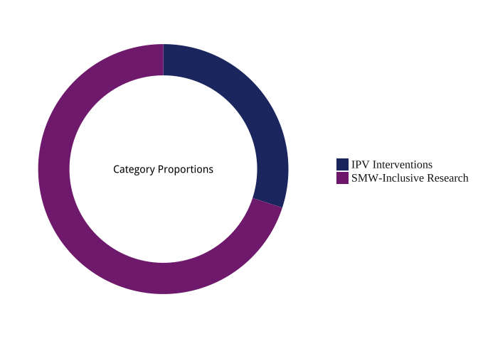

# Publication Titles

##### Number of Publications in Each Research Category per Journal

|  |  |  |
| --- | --- | --- |
|  | IPV Interventions | SMW-Inclusive Research |
| **American Journal of Community Psychology** | 1 | 2 |
| **American Journal of Preventive Medicine** | 1 | - |
| **American Journal of Public Health** | 1 | 2 |
| **Psychology of Women Quarterly** | - | 3 |

## 

## Research Category by Journal & Journal Category

##### $N_{articles}$ in Each Research Category per Journal

|  |  |  |  |
| --- | --- | --- | --- |
|  | IPV Interventions | SMW-Inclusive Research | Total |
| **American Journal of Community Psychology** | 1 | 2 | 3 |
| **American Journal of Preventive Medicine** | 1 | - | 1 |
| **American Journal of Public Health** | 1 | 2 | 3 |
| **Psychology of Women Quarterly** | - | 3 | 3 |

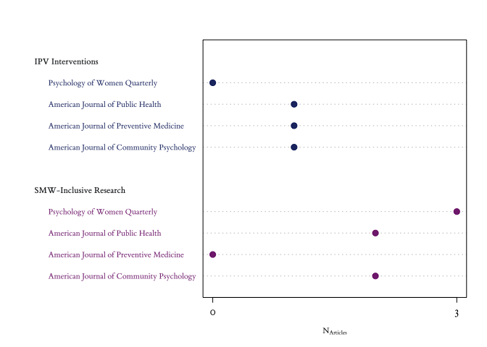

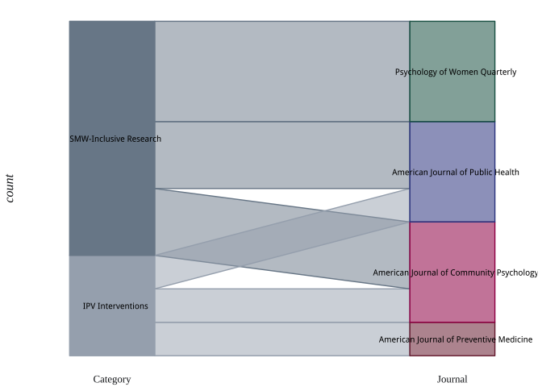

# Research Topics, Sampling Frames, and Methodologies

##### Primary Topics

|  |  |  |  |
| --- | --- | --- | --- |
|  | IPV Interventions | SMW-Inclusive Research | Total |
| **Community Capacity** | - | 1 | 1 |
| **Coordinated Community Response to IPV** | - | 1 | 1 |
| **Help-Seeking** | - | 1 | 1 |
| **Intervention/Prevention (General)** | 3 | - | 3 |
| **IPV Consequences** | - | 1 | 1 |
| **IPV Intervention Program Evaluation** | 3 | - | 3 |
| **IPV Perpetrator Interventions** | 2 | - | 2 |
| **IPV Prevalance** | - | 1 | 1 |
| **IPV Screening** | 1 | - | 1 |
| **IPV Victimization Intervention** | 2 | - | 2 |
| **Measures** | - | 1 | 1 |
| **Outsiders' (general) Perspective** | - | 1 | 1 |
| **Public/Program Policy** | 1 | - | 1 |
| **Risk Factors** | - | 3 | 3 |
| **System Response** | 1 | - | 1 |

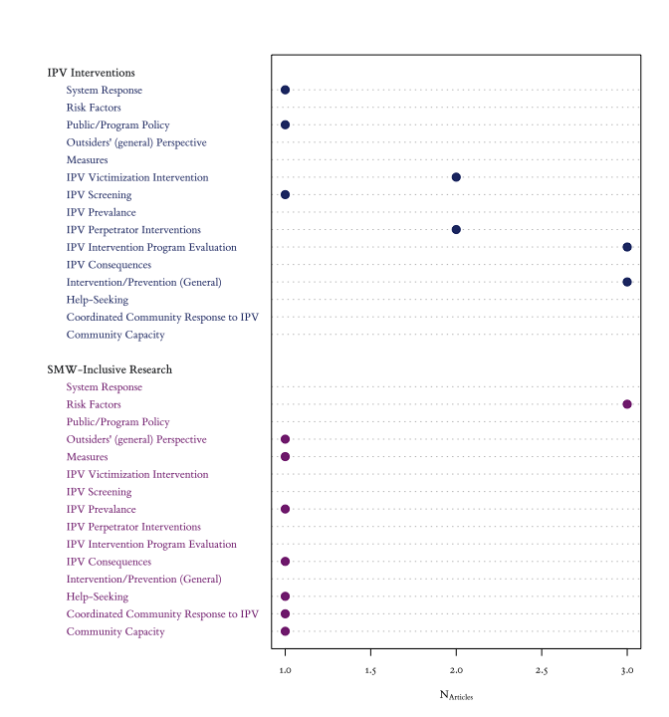

##### Research Designs

|  |  |  |  |
| --- | --- | --- | --- |
|  | IPV Interventions | SMW-Inclusive Research | Total |
| **Cross-Sectional** | - | 5 | 5 |
| **Experimental** | 3 | 1 | 4 |

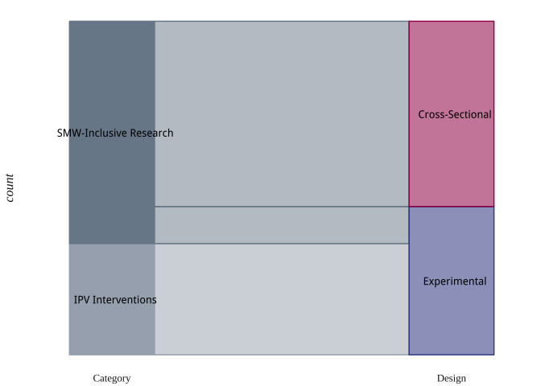

Experimental Research Designs

|  |  |  |  |
| --- | --- | --- | --- |
|  | IPV Interventions | SMW-Inclusive Research | Total |
| **Longitudinal** | 3 | - | 3 |
| **Pre-Test/Post-Test** | - | 1 | 1 |
| **Randomized Control Trial** **(Longitudinal)** | 1 | - | 1 |

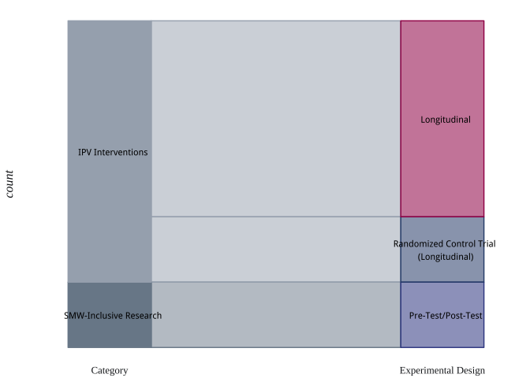

##### Data Collection Methodologies

|  |  |  |  |
| --- | --- | --- | --- |
|  | IPV Interventions | SMW-Inclusive Research | Total |
| **Mixed-Methods** | - | 2 | 2 |
| **QuaLitative Methods** | - | 1 | 1 |
| **QuaNTitative Methods** | 3 | 4 | 7 |

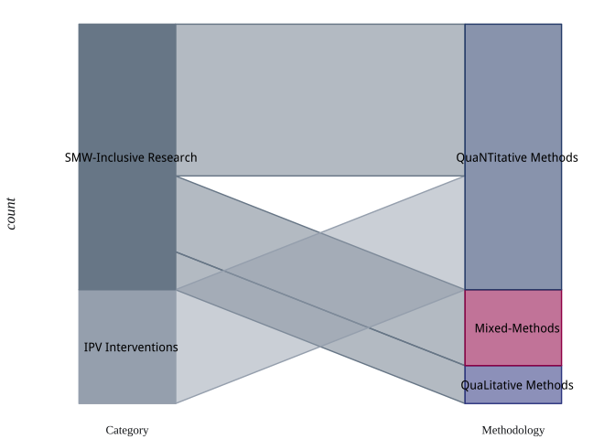

Qua**L**itative Method(s)

|  |  |  |
| --- | --- | --- |
|  | SMW-Inclusive Research | Total |
| **1-on-1 Interviews** | 2 | 2 |
| **Group Interviews** | 1 | 1 |

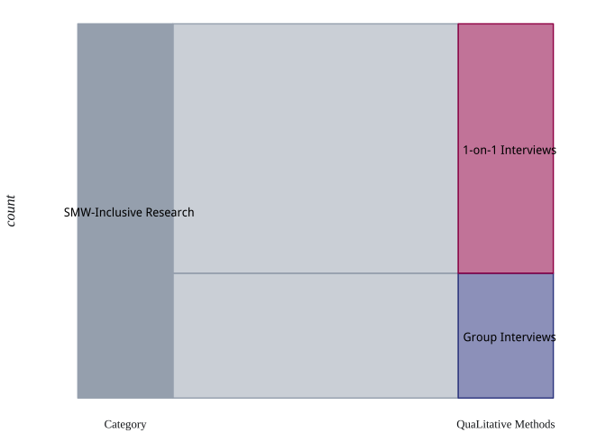

Qua**NT**itative Designs

|  |  |  |  |
| --- | --- | --- | --- |
|  | IPV Interventions | SMW-Inclusive Research | Total |
| **Cross-Sectional Design** | - | 4 | 4 |
| **Experimental Design** | 3 | - | 3 |
| **Longitudinal Design** | 3 | - | 3 |

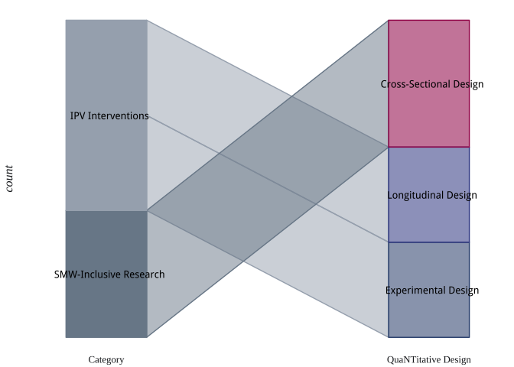

Qua**NT**itative Methods

|  |  |  |  |
| --- | --- | --- | --- |
|  | IPV Interventions | SMW-Inclusive Research | Total |
| **Archival/Secondary Data** | - | 1 | 1 |
| **QuaNTitative Survey** | 6 | 8 | 14 |

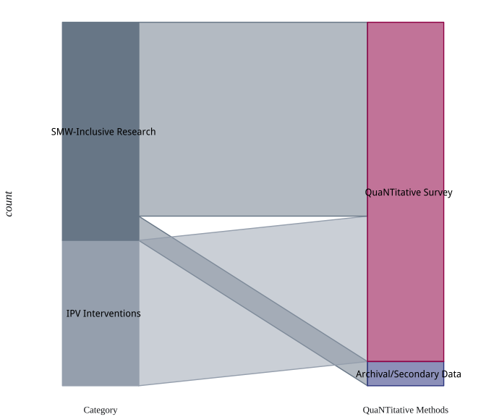

Archival Data Sources

|  |  |  |
| --- | --- | --- |
|  | SMW-Inclusive Research | Total |
| **Government-Sponsored Survey** | 1 | 1 |

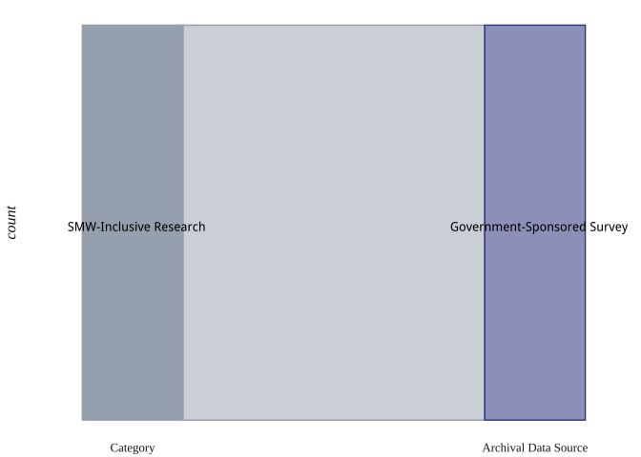

Mixed-Methodological Designs

|  |  |  |
| --- | --- | --- |
|  | SMW-Inclusive Research | Total |
| **Cross-Sectional Design** | 1 | 1 |
| **Experimental Design** | 1 | 1 |
| **Longitudinal Design** | 1 | 1 |
| **Pre-Test/Post-Test Design** | 1 | 1 |

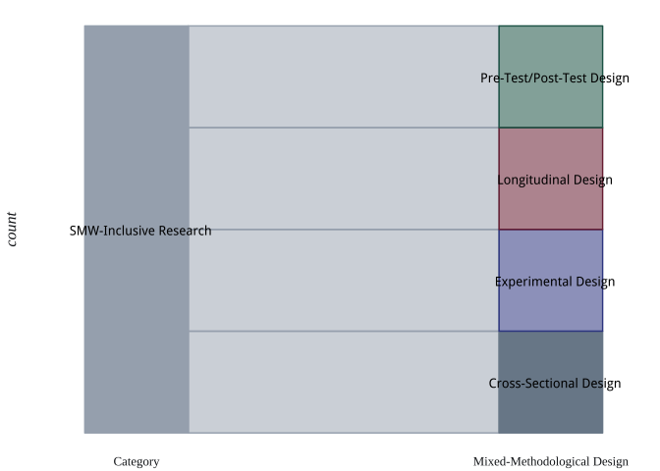

Research Topics

|  |  |  |
| --- | --- | --- |
|  | SMW-Inclusive Research | Total |
| **1-on-1 Interviews** | 2 | 2 |
| **Focus Groups** | 2 | 2 |
| **Group Interviews** | 1 | 1 |
| **QuaLitative Survey** | 2 | 2 |
| **QuaNTitative Survey** | 4 | 4 |

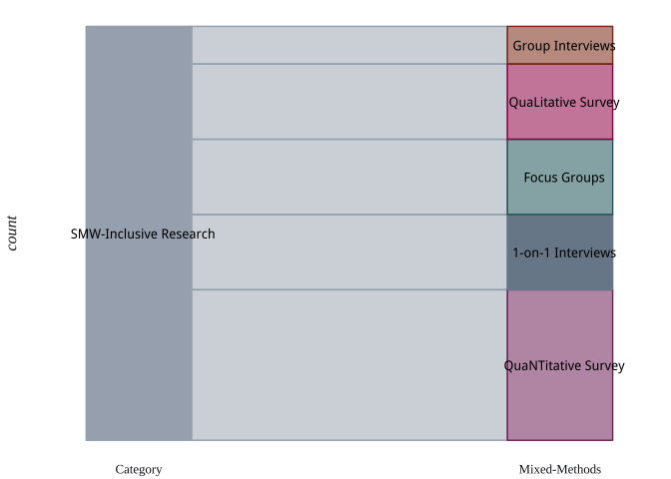

## Target Populations & Sampling Frames

Research Topics

|  |  |  |  |
| --- | --- | --- | --- |
|  | IPV Interventions | SMW-Inclusive Research | Total |
| **College Students** | - | 2 | 2 |
| **Couples** | - | 1 | 1 |
| **Females/Women/Girls** | - | 4 | 4 |
| **IPV Intervention Programs** | 1 | - | 1 |
| **IPV Victims/Survivors** | - | 3 | 3 |
| **Non-IPV Community-Based Practitioners** | 1 | - | 1 |
| **Non-IPV System Entities** | 1 | - | 1 |
| **Parents** | - | 1 | 1 |
| **Sexual Minorities** | - | 2 | 2 |
| **Urban-Specific Populations** | - | 1 | 1 |
| **Youth/Children** | 1 | - | 1 |

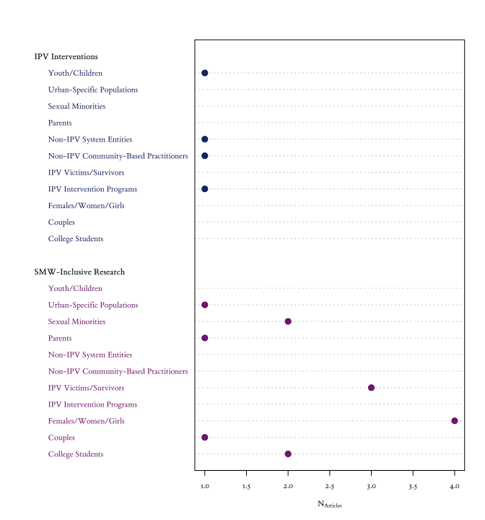

# Appendix C Clinician Rating Form (Edward W Gondolf & Wernik, 2009)

Date:

Subject Name:

Group Leader (initials): Site:

INSTRUCTIONS: Please rate the man named above on each of the listed criteria. Rate him using the 0 to 5 scale below based on your impressions and observations. Return the form immediately to the evaluation contact person. 5 = extremely present; 4 = very present; 3 = somewhat present; 2 = a little present; 1 = very little present; 0 = no opinion, uncertain, not applicable.

_____ attendance: arrives at group session on time; socializes or lingers afterward; contacts program in advance about absence; has legitimate excuse for absences.  
_____ nonviolence: has not recently physically abused partner, children, or others; no apparent threats, intimidation, or manipulation.  
_____ sobriety: attends meeting sober; not high or drunk; no apparent abuse of alcohol or drugs during week; complying to ordered or referred drug and alcohol treatment.  
_____ acceptance: admits that violence and abuse exists; not minimizing, blaming, or excusing the problem; realizes responsibility for abuse; identifies contribution to problems  
_____ using techniques: takes conscious steps to avoid violence; refers to time-outs, self-talk, conflict resolution skills, etc.; does homework assignments or recommendations.  
_____ help seeking: seeks information about alternatives; discusses options with others in the group; calls other participants for help; open to referrals and future support.  
_____ process conscious: lets others speak one at time; acknowledges others’ contributions; asks questions of others without interrogating; heeds direction of counselors.  
_____ actively engaged: attentive body language and nonverbal response; maintains eye contact; speaks with feeling; follows topic of discussion in comments.  
_____ self-disclosure: reveals struggles, feelings, fears, and self-doubts; not withholding or evading issues; not sarcastic or defensive.  
_____ sensitive language: respectful of partner and women in general; nonsexist language and no pejorative slang; checks others who use sexist language.

# References

Allaire, J., Cheng, J., Xie, Y., McPherson, J., Chang, W., Allen, J., … Hyndman, R. (2016). *rmarkdown: Dynamic documents for R*. Retrieved from <https://CRAN.R-project.org/package=rmarkdown>

Anderies, J., Janssen, M., & Ostrom, E. (2004). A framework to analyze the robustness of social-ecological systems from an institutional perspective. *Ecology and Society*, *9*, 18.

Anders, D. (1966). Action research. In S. kemmis & R. McTaggart (Eds.), *The action research reader* (Third Edition, pp. 317–321). Victoria: Deakin University.

Andrews, D., & Bonta, J. (1995). *Level of service inventory–Revised (lsi–R)*. Toronto, Canada: Multi- Health Systems.

Arias, E., Arce, R., & Vilariño, M. (2013). Batterer intervention programmes: A meta-analytic review of effectiveness. *Psychosocial Intervention*, *22*, 153–160.

Arnold, J. B. (2016). *Ggthemes: Extra themes, scales and geoms for ggplot2*. Retrieved from <https://CRAN.R-project.org/package=ggthemes>

Babcock, J., Armenti, N., Cannon, C., Lauve-Moon, K., Buttell, F., Ferreira, R., … others. (2016). Domestic violence perpetrator programs: A proposal for evidence-based standards in the united states. *Partner Abuse*, *7*, 355–460.

Balsam, K. F., & Szymanski, D. (2005). Relationship quality and domestic violence in women’s same-sex relationships: The role of minority stress. *Psychology of Women Quarterly*, *29*, 258–269.

Baral, S., Logie, C., Grosso, A., Wirtz, A., & Beyrer, C. (2013). Modified social ecological model: A tool to guide the assessment of the risks and risk contexts of HIV epidemics. *BMC Public Health*, *13*, 482.

Barner, J. R., & Carney, M. M. (2011). Interventions for intimate partner violence: A historical review. *Journal of Family Violence*, *26*, 235–244.

Beeker, C., Guenther-Grey, C., & Raj, A. (1998). Community empowerment paradigm drift and the primary prevention of HIV/AIDS. *Social Science and Medicine*, *46*, 831–842.

Black, M. C., Basile, K. C., Breiding, M. J., Smith, S. G., Walters, M. L., Merrick, M. T., & Stevens, M. (2011). *National Intimate Partner And Sexual Violence Survey*. Atlanta, GA: Centers for Disease Control and Prevention, National Center for Injury Prevention and Control.

Blosnich, J. R., & Bossarte, R. M. (2009). Comparisons of intimate partner violence among partners in same-sex and opposite-sex relationships in the united states. *American Journal of Public Health*, *99*, 2182–2184.

Boal, A. L., & Mankowski, E. S. (2014). The impact of legislative standards on batterer intervention program practices and characteristics. *American Journal of Community Psychology*, *53*, 218–230.

Boettiger, C. (2015). *knitcitations: Citations for knitr markdown files*. Retrieved from <https://CRAN.R-project.org/package=knitcitations>

Brydon-Miller, M., Greenwood, D., & Maguire, P. (2003). Why action research? *Action Research*, *1*, 9–28.

Burke, L., & Follingstad, D. R. (1999). Violence in lesbian and gay relationships: Theory, prevalence, and correlational factors. *Clinical Psychology Review*, *19*, 487–512.

Cecere, D. J. (1986). The second closet: Battered lesbians. *Naming the Violence: Speaking Out About Lesbian Battering*, 21–31.

Centers for Disease Control and Prevention (CDC), & others. (2015). The Social-Ecological Model: A framework for prevention.

Chandler, D., & Torbert, B. (2003). Transforming inquiry and action interweaving 27 flavors of action research. *Action Research*, *1*, 133–152.

Chang, W. (2014). *Extrafont: Tools for using fonts*. Retrieved from <https://CRAN.R-project.org/package=extrafont>

Charmaz, K. (2006). *Constructing grounded theory: A practical guide through qualitative analysis (introducing qualitative methods series)*. Thousand Oaks, CA: SAGE Publications, Inc.

Cobb, S. (1993). Empowerment and mediation: A narrative perspective. *Negotiation Journal*, *9*, 245–259.

Collins, P. H. (2002). *Black feminist thought: Knowledge, consciousness, and the politics of empowerment*. New York, NY, US: Routledge.

Contrino, K. M., Dermen, K. H., Nochajski, T. H., Wieczorek, W. F., & Navratil, P. K. (2007). Compliance and learning in an intervention program for partner-violent men. *Journal of Interpersonal Violence*, *22*, 1555–1566.

Corbin, J., & Strauss, A. (1990). Basics of qualitative research: Grounded theory procedures and techniques. *Basics of Qualitative Research: Grounded Theory Procedures and Techniques*, *41*.

Creswell, J. W. (2013). *Research design: Qualitative, quantitative, and mixed methods approaches*. Thousand Oaks, CA: SAGE Publications, Inc.

Daroczi, G., & Tsegelskyi, R. (2015). *Pander: An R pandoc writer*. Retrieved from <https://CRAN.R-project.org/package=pander>

Databases, R. S. I. G. on. (2014). *DBI: RDatabase interface*. Retrieved from <https://CRAN.R-project.org/package=DBI>

Durish, P. (2011). Documenting the same sex abuse project, toronto, canada. In J. L. Ristock (Ed.), *Intimate partner violence in LGBTQ lives* (p. 232). New York, NY: Routledge.

Dutton, D. G., & Corvo, K. (2006). Transforming a flawed policy: A call to revive psychology and science in domestic violence research and practice. *Aggression and Violent Behavior*, *11*, 457–483.

Dutton, D. G., & Corvo, K. (2007). The duluth model: A data-impervious paradigm and a failed strategy. *Aggression and Violent Behavior*, *12*, 658–667.

Eckhardt, C. I., Murphy, C. M., Whitaker, D. J., Sprunger, J., Dykstra, R., & Woodard, K. (2013). The effectiveness of intervention programs for perpetrators and victims of intimate partner violence. *Partner Abuse*, *4*, 196–231.

Edelen, M. O., McCaffrey, D. F., Marshall, G. N., & Jaycox, L. H. (2009). Measurement of teen dating violence attitudes an item response theory evaluation of differential item functioning according to gender. *Journal of Interpersonal Violence*, *24*, 1243–1263.

Edwards, K. M., Littleton, H. L., Sylaska, K. M., Crossman, A. L., & Craig, M. (2016). College campus community readiness to address intimate partner violence among lgbtq plus young adults: A conceptual and empirical examination. *American Journal of Community Psychology*, *58*, 16–26.

Espino, S. L. R., & Trickett, E. J. (2008). The spirit of ecological inquiry and intervention research reports: A heuristic elaboration. *American Journal of Community Psychology*, *42*, 60–78.

Feder, L., & Wilson, D. B. (2005). A meta-analytic review of court-mandated batterer intervention programs: Can courts affect abusers’ behavior? *Journal of Experimental Criminology*, *1*, 239–262.

Fine, D. M. (1998). Violence against women act of 1994: The proper federal role in policing domestic violence. *Cornell L. Rev.*, *84*, 252–355.

Fine, M., Torre, M. E., Boudin, K., Bowen, I., Clark, J., Hylton, D., … Rosemarie, A. (2004). Participatory action research: From within and beyond prison bars. *Working Method: Research and Social Justice*, 95–119.

Foshee, V. A., Bauman, K. E., Ennett, S. T., Linder, G. F., Benefield, T., & Suchindran, C. (2004). Assessing the long-term effects of the safe dates program and a booster in preventing and reducing adolescent dating violence victimization and perpetration. *American Journal of Public Health*, *94*, 619–624.

Francois, R. (2014). *Bibtex: Bibtex parser*. Retrieved from <https://CRAN.R-project.org/package=bibtex>

Friedman-Nimz, R., Altman, J., Cain, S., Korn, S., Karger, M. J., Witsch, M., … Weiss, M. (2006). Blending support and social action: The power of a gay-straight alliance and PrideWorks conference. *Prufrock Journal*, *17*, 258–264.

Fryer, D. (2008). Some questions about “the history of community psychology”. *Journal of Community Psychology*, *36*, 572–586.

Gelles, R. J. (2001). Standards for programs for men who batter? Not yet. *Journal of Aggression, Maltreatment & Trauma*, *5*, 11–20.

Gilbert, P. R. (2002). Discourses of female violence and societal gender stereotypes. *Violence Against Women*, *8*, 1271–1300.

Girshick, L. B. (2002). No sugar, no spice: Reflections on research on woman-to-woman sexual violence. *Violence Against Women*, *8*, 1500–1520.

Glass, N., Perrin, N., Hanson, G., Bloom, T., Gardner, E., & Campbell, J. C. (2008). Risk for reassault in abusive female same-sex relationships. *American Journal of Public Health*, *98*, 1021–1027.

Gondolf, E. W. (1999). A comparison of four batterer intervention systems do court referral, program length, and services matter? *Journal of Interpersonal Violence*, *14*, 41–61.

Gondolf, E. W. (2007). Theoretical and research support for the duluth model: A reply to dutton and corvo. *Aggression and Violent Behavior*, *12*, 644–657.

Gondolf, E. W., & Wernik, H. (2009). Clinician ratings of batterer treatment behaviors in predicting reassault. *Journal of Interpersonal Violence*, *24*, 1792–1815.

Greene, J., Caracelli, V., & Graham, W. F. (1989). Toward a conceptual framework for mixed-method evaluation designs. *Educational Evaluation and Policy Analysis*, *11*, 255–274.

Gregory, C., & Erez, E. (2002). The effects of batterer intervention programs the battered women’s perspectives. *Violence Against Women*, *8*, 206–232.

Hammond, N. (1989). Lesbian victims of relationship violence. *Women and Therapy*, *8*, 89–105.

Hart, B. (1986). Lesbian battering: An examination. *Naming the Violence: Speaking Out About Lesbian Battering*, 173–189.

Hart, B. J. (1995, march). Coordinated community approaches to domestic violence. Paper Presented at the Strategic Planning Workshop on Violence Against Women, Washington, DC: National Institute of Justice. Retrieved from <http://www.ncdsv.org/images/Coordinated%20Community%20Approaches%20to%20DV.pdf>

Hassouneh, D., & Glass, N. (2008). The influence of gender role stereotyping on women’s experiences of female same-sex intimate partner violence. *Violence Against Women*, *14*, 310–325.

Heckert, A., & Gondolf, E. W. (2004). Battered women’s perceptions of risk versus risk factors and instruments in predicting repeat reassault. *Journal of Interpersonal Violence*, *19*, 778–800.

Hendricks, B., Werner, T., Shipway, L., & Turinetti, G. J. (2006). Recidivism among spousal abusers: Predictions and program evaluation. *Journal of Interpersonal Violence*, *21*, 703–716.

Huang, R. (2014). *RQDA: R-based qualitative data analysis*. Retrieved from <http://rqda.r-forge.r-project.org/>

Ingram, D., & Franco, S. (2012). NCHS urban-rural classification scheme for counties. In *Vital and health statistics* (Vol. 2). Hyattsville, Maryland: National Center for Health Statistics, Centers for Disease Control; Prevention.

Johnson, B., Onwuegbuzie, A., & Turner, L. A. (2007). Toward a definition of mixed methods research. *Journal of Mixed Methods Research*, *1*, 112–133.

Kelly, J. G., Snowden, L. R., & Munoz, R. F. (1977). Social and community interventions. *Annual Review of Psychology*, *28*, 323–361.

Kelly, J., Azelton, S., Lardon, C., Mock, L., Tandon, D., & Thomas, M. (2004). On community leadership: Stories about collaboration in action research. *American Journal of Community Psychology*, *33*, 205–216.

Kidder, L., & Fine, M. (1987). Qualitative and quantitative methods: When stories converge. *New Directions for Program Evaluation*, *1987*, 57–75.

Kloos, B., & Shah, S. (2009). A social ecological approach to investigating relationships between housing and adaptive functioning for persons with serious mental illness. *American Journal of Community Psychology*, *44*, 316–326.

Lawrence, M. (2015). *CairoDevice: Embeddable cairo graphics device driver*. Retrieved from <https://CRAN.R-project.org/package=cairoDevice>

Lawrence, M., & Temple Lang, D. (2010). RGtk2: A graphical user interface toolkit for R. *Journal of Statistical Software*, *37*, 1–52. Retrieved from <http://www.jstatsoft.org/v37/i08/>

Lawrence, M., & Verzani, J. (2014). *GWidgetsRGtk2: Toolkit implementation of gWidgets for rgtk2*. Retrieved from <https://CRAN.R-project.org/package=gWidgetsRGtk2>

Leech, N. L., & Onwuegbuzie, A. J. (2007). An array of qualitative data analysis tools: A call for data analysis triangulation. *School Psychology Quarterly*, *22*, 557.

LeGates, M. (2001). *In their time: A history of feminism in western society*. New York, NY: Routledge.

Lewis, R. J., Milletich, R. J., Derlega, V. J., & Padilla, M. A. (2014). Sexual minority stressors and psychological aggression in lesbian women’s intimate relationships: The mediating roles of rumination and relationship satisfaction. *Psychology of Women Quarterly*, *38*, 535–550.

Little, B., & Terrance, C. (2010). Perceptions of domestic violence in lesbian relationships: Stereotypes and gender role expectations. *Journal of Homosexuality*, *57*, 429–440.

Lobel, K. (1986). *Naming the violence: Speaking out about lesbian battering*. Seattle, WA, US: Seal Press.

McClennen, J. C. (2005). Domestic violence between same-gender partners recent findings and future research. *Journal of Interpersonal Violence*, *20*, 149–154.

McLaughlin, E., & Rozee, P. D. (2001). Knowledge about heterosexual versus lesbian battering among lesbians. *Women and Therapy*, *23*, 39–58.

Mertens, D., & Wilson, A. T. (2012). *Program evaluation theory and practice: A comprehensive guide*. Guilford Press.

Messinger, A. M. (2011). Invisible victims: Same-sex IPV in the National Violence Against Women Survey. *Journal Of Interpersonal Violence*, *26*, 2228–2243.

Meyer, I. H. (1995). Minority stress and mental health in gay men. *Journal of Health and Social Behavior*, 38–56.

Meyer, I. H. (2003). Prejudice, social stress, and mental health in lesbian, gay, and bisexual populations: Conceptual issues and research evidence. *Psychological Bulletin*, *129*, 674.

Meyer, I. H. (2010). The right comparisons in testing the minority stress hypothesis: Comment on savin-williams, cohen, joyner, and rieger (2010). *Archives of Sexual Behavior*, *39*, 1217–1219.

Meyer, I. H. (2015). Resilience in the study of minority stress and health of sexual and gender minorities. *Psychology of Sexual Orientation and Gender Diversity*, *2*, 209.

Modi, M. N., Palmer, S., & Armstrong, A. (2014). The role of violence against women act in addressing intimate partner violence: A public health issue. *Journal of Women’s Health*, *23*, 253–259.

Morgan, D. (2014). *Integrating qualitative and quantitative methods: A pragmatic approach* (Vol. 16). Thousand Oaks, CA: SAGE Publications, Inc.

Noffke, S. E. (1997). Professional, personal, and political dimensions of action research. *Review of Research in Education*, 305–343.

Onwuegbuzie, A. J., & Weinbaum, R. K. (2017). A framework for using qualitative comparative analysis for the review of the literature. *The Qualitative Report*, *22*, 359–372.

Onwuegbuzie, A. J., Dickinson, W. B., Leech, N. L., & Zoran, A. G. (2009). A qualitative framework for collecting and analyzing data in focus group research. *International Journal of Qualitative Methods*, *8*, 1–21.

Oswald, R. F., Fonseca, C. A., & Hardesty, J. L. (2010). Lesbian mothers’ counseling experiences in the context of intimate partner violence. *Psychology of Women Quarterly*, *34*, 286–296.

Owen, J., & Rogers, P. (1999). *Program evaluation: Forms and approaches*. Thousand Oaks, CA: SAGE Publications, Inc.

Pence, E. (1983). Duluth domestic abuse intervention project, the. *Hamline Rev.*, *6*, 247.

Price, B. J., & Rosenbaum, A. (2009). Batterer intervention programs: A report from the field. *Violence and Victims*, *24*, 757–770.

Prilleltensky, I. (1997). Values, assumptions, and practices: Assessing the moral implications of psychological discourse and action. *American Psychologist*, *52*, 517.

Prilleltensky, I. (2001). Value-based praxis in community psychology: Moving toward social justice and social action. *American Journal of Community Psychology*, *29*, 747–778.

Qiu, Y. (2015). *Showtext: Using fonts more easily in RGraphs*. Retrieved from <https://CRAN.R-project.org/package=showtext>

Qiu, Y., & others. (2015). *Sysfonts: Loading system fonts into R*. Retrieved from <https://CRAN.R-project.org/package=sysfonts>

R Core Team. (2016). *R: A language and environment for statistical computing*. Vienna, Austria: R Foundation for Statistical Computing. Retrieved from <https://www.R-project.org/>

Riger, S. (1993). What’s wrong with empowerment. *American Journal of Community Psychology*, *21*, 279–292.

Ristock, J. L. (2001). Decentering heterosexuality: Responses of feminist counselors to abuse in lesbian relationships. *Women and Therapy*, *23*, 59–72.

Ristock, J. L. (2011). *Intimate partner violence in LGBTQ lives*. New York, NY: Routledge.

Royse, D., Thyer, B., & Padgett, D. (2009). *Program evaluation: An introduction*. Cengage Learning.

Seidman, E. (2012). An emerging action science of social settings. *American Journal of Community Psychology*, *50*, 1–16.

Silvergleid, C. S., & Mankowski, E. S. (2006). How batterer intervention programs work: Participant and facilitator accounts of processes of change. *Journal of Interpersonal Violence*, *21*, 139–159.

Smith, C. (2011). Women who abuse their female intimate partners. In J. L. Ristock (Ed.), *Intimate partner violence in LGBTQ lives* (pp. 131–52). New York, NY: Routledge.

Smith, R. (2017). *Riley: A developing package of r functions for (community-based) psychology research*. Retrieved from <https://github.com/EccRiley/Riley>

Speer, P., & Hughey, J. (1995). Community organizing: An ecological route to empowerment and power. *American Journal of Community Psychology*, *23*, 729–748.

Stokols, D. (1996). Translating social ecological theory into guidelines for community health promotion. *American Journal of Health Promotion*, *10*, 282–298.

Strauss, A., & Corbin, J. (1994). Grounded theory methodology. *Handbook of Qualitative Research*, 273–285.

Sylaska, K. M., & Edwards, K. M. (2015). Disclosure experiences of sexual minority college student victims of intimate partner violence. *American Journal of Community Psychology*, *55*, 326–335.

Tharp, A. T., DeGue, S., Valle, L. A., Brookmeyer, K., Massetti, G., & Matjasko, J. L. (2013). A systematic qualitative review of risk and protective factors for sexual violence perpetration. *Trauma, Violence, and Abuse*, *14*, 133–167.

The Society for Community Research and Action (SCRA). (2017). Other journals relevant to community psychology. Retrieved from <http://www.scra27.org/publications/other-journals-relevant-community-psychology/>

The White House, Office of the Vice President, & Biden, J. (2014). 1 is 2 many: Twenty years fighting violence against women and girls [Official U.S. White House report prepared by the Office of the Vice President to commemorate the 20th Anniversary of the Violence Against Women Act]. Washington, D.C., U.S.: Office of the Vice President, The White House.

Thompson, R. S., Rivara, F. P., Thompson, D. C., Barlow, W. E., Sugg, N. K., Maiuro, R. D., & Rubanowice, D. M. (2000). Identification and management of domestic violence: A randomized trial. *American Journal of Preventive Medicine*, *19*, 253–263.

Tjaden, P., & Thoennes, N. (2000). *Full report of the prevalence, incidence, and consequences of violence against women: Findings from the National Violence against Women Survey: Research report*. Washington, DC: National Institute of Justice.

Tolman, R., & Edleson, J. L. (1995). Intervention for men who batter: A review of research. *Understanding Partner Violence: Prevalence, Causes, Consequences, and Solutions*, *11*, 262–273.

Verzani, J. (2014). *GWidgets: GWidgets API for building toolkit-independent, interactive guis*. Retrieved from <https://CRAN.R-project.org/package=gWidgets>

Visser, M. (2007). The social ecological model as theoretical framework in community psychology. *Community Psychology: Analysis, Context and Action*, 102–116.

Walker, B., Gunderson, L., Kinzig, A., Folke, C., Carpenter, S., & Schultz, L. (2006). A handful of heuristics and some propositions for understanding resilience in social-ecological systems. *Ecology and Society*, *11*, 13.

Walters, M. L., Chen, J., & Breiding, M. J. (2013). *The national intimate partner and sexual violence survey (NISVS): 2010 findings on victimization by sexual orientation*. Atlanta, GA: Centers for Disease Control and Prevention.

Walton-Moss, B., Manganello, J., Frye, V., & Campbell, J. C. (2005). Risk factors for intimate partner violence and associated injury among urban women. *Journal of Community Health*, *30*, 377–389.

Whitaker, P. (2014). Linking community protective factors to intimate partner violence perpetration. *Violence Against Women*, *20*, 1338–1359.

Wickham, H. (2009). *Ggplot2: Elegant graphics for data analysis*. Springer-Verlag New York. Retrieved from <http://ggplot2.org>

Wickham, H. (2011). The split-apply-combine strategy for data analysis. *Journal of Statistical Software*, *40*, 1–29. Retrieved from <http://www.jstatsoft.org/v40/i01/>

Wickham, H. (2016a). *Scales: Scale functions for visualization*. Retrieved from <https://CRAN.R-project.org/package=scales>

Wickham, H. (2016b). *Tidyr: Easily tidy data with spread() and gather() functions*. Retrieved from <https://CRAN.R-project.org/package=tidyr>

Wickham, H., & Chang, W. (2016). *Devtools: Tools to make developing RPackages easier*. Retrieved from <https://CRAN.R-project.org/package=devtools>

Wickham, H., & Francois, R. (2015). *Dplyr: A grammar of data manipulation*. Retrieved from <https://CRAN.R-project.org/package=dplyr>

Wickham, H., James, D. A., & Falcon, S. (2014). *RSQLite: SQLite interface for R*. Retrieved from <https://CRAN.R-project.org/package=RSQLite>

Witte, T. H., Mulla, M. M., & Weaver, A. A. (2015). Perceived social norms for intimate partner violence in proximal and distal groups. *Violence and Victims*, *30*, 691–698.

Xie, Y. (2015). *Dynamic documents with R and knitr* (2nd ed.). Boca Raton, Florida: Chapman; Hall/CRC. Retrieved from <http://yihui.name/knitr/>

Xie, Y., & Allaire, J. (2016). *Tufte: Tufte’s styles for Rmarkdown documents*. Retrieved from <https://CRAN.R-project.org/package=tufte>

Zhu, H. (2016). *KableExtra: Decorate kable output using pipe syntax*. Retrieved from <https://github.com/haozhu233/kableExtra>

1. See Appendix [] for details regarding specific *R* packages used in conducting analyses and presenting this review.
2.