MAP - Bibliography (Bibkeys - CP Only)

Riley M. Smith

24 April 2017

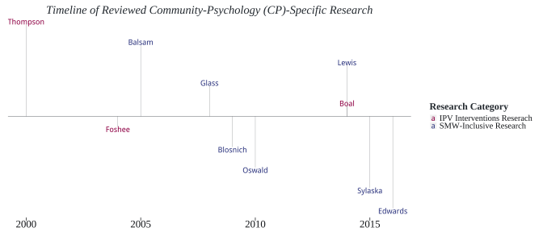

# 

* Boal & Mankowski (2014)
* Foshee et al. (2004)
* R. S. Thompson et al. (2000)

CP-Specific IPV Interventions Research Timeline

|  |  |  |
| --- | --- | --- |
| * Study | * Journal | * Year Published |
| * R. S. Thompson et al. (2000) | * American Journal of Preventive Medicine | * 2000 |
| * Foshee et al. (2004) | * American Journal of Public Health | * 2004 |
| * Boal & Mankowski (2014) | * American Journal of Community Psychology | * 2014 |

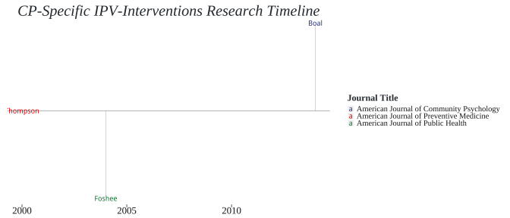

## Research Topics

Primary Topics

|  |  |
| --- | --- |
|  | $N_{Articles}$ |
| * Intervention/Prevention (General) | * 3 |
| * IPV Intervention Program Evaluation | * 3 |
| * IPV Perpetrator Interventions | * 2 |
| * IPV Screening | * 1 |
| * IPV Victimization Intervention | * 2 |
| * Public/Program Policy | * 1 |
| * System Response | * 1 |

Research Topics

|  |  |  |  |  |  |  |  |
| --- | --- | --- | --- | --- | --- | --- | --- |
|  | * 1 | * 2 | * 3 | * 4 | * 5 | * 6 | * 7 |
| * Boal & Mankowski (2014) |  |  |  | $⋅$ | $⋅$ |  | $⋅$ |
| * Foshee et al. (2004) |  |  |  | $⋅$ |  | $⋅$ | $⋅$ |
| * R. S. Thompson et al. (2000) |  |  | $⋅$ |  |  | $⋅$ |  |

*1 = Intervention/Prevention (General)*, *2 = IPV Intervention Program Evaluation*, *3 = IPV Perpetrator Interventions*, *4 = IPV Screening*, *5 = IPV Victimization Intervention*, *6 = Public/Program Policy* and *7 = System Response*

## Target Populations/Sampling Frames

Populations Included

|  |  |
| --- | --- |
|  | $N_{Articles}$ |
| * IPV Intervention Programs | * 1 |
| * Non-IPV Community-Based Practitioners | * 1 |
| * Non-IPV System Entities | * 1 |
| * Youth/Children | * 1 |

|  |  |  |  |  |
| --- | --- | --- | --- | --- |
|  | * 1 | * 2 | * 3 | * 4 |
| * Boal & Mankowski (2014) |  | $⋅$ | $⋅$ | $⋅$ |
| * Foshee et al. (2004) | $⋅$ | $⋅$ | $⋅$ |  |
| * R. S. Thompson et al. (2000) | $⋅$ |  |  | $⋅$ |

*1 = IPV Intervention Programs*, *2 = Non-IPV Community-Based Practitioners*, *3 = Non-IPV System Entities* and *4 = Youth/Children*

## Methodology

Overarching Methodology

|  |  |
| --- | --- |
|  | $N_{Articles}$ |
| * QuaNTitative Methods | * 3 |

|  |  |
| --- | --- |
|  | * 1 |
| * Boal & Mankowski (2014) |  |
| * Foshee et al. (2004) |  |
| * R. S. Thompson et al. (2000) |  |

1 = QuaNTitative Methods

## QuaNTitative Methods

Qua**NT**itative Methods

|  |  |
| --- | --- |
|  | $N_{Articles}$ |
| * QuaNTitative Survey | * 6 |

|  |  |
| --- | --- |
|  | * 1 |
| * Boal & Mankowski (2014) |  |
| * Foshee et al. (2004) |  |
| * R. S. Thompson et al. (2000) |  |

1 = QuaNTitative Survey

# 

* Balsam & Szymanski (2005)
* Blosnich & Bossarte (2009)
* Edwards, Littleton, Sylaska, Crossman, & Craig (2016)
* Glass et al. (2008)
* Lewis, Milletich, Derlega, & Padilla (2014)
* Oswald, Fonseca, & Hardesty (2010)
* Sylaska & Edwards (2015)

SMW-Inclusive Research Timeline

|  |  |  |
| --- | --- | --- |
| * Study | * Journal | * Year Published |
| * Balsam & Szymanski (2005) | * Psychology of Women Quarterly | * 2005 |
| * Glass et al. (2008) | * American Journal of Public Health | * 2008 |
| * Blosnich & Bossarte (2009) | * American Journal of Public Health | * 2009 |
| * Oswald et al. (2010) | * Psychology of Women Quarterly | * 2010 |
| * Lewis et al. (2014) | * Psychology of Women Quarterly | * 2014 |
| * Sylaska & Edwards (2015) | * American Journal of Community Psychology | * 2015 |
| * Edwards et al. (2016) | * American Journal of Community Psychology | * 2016 |

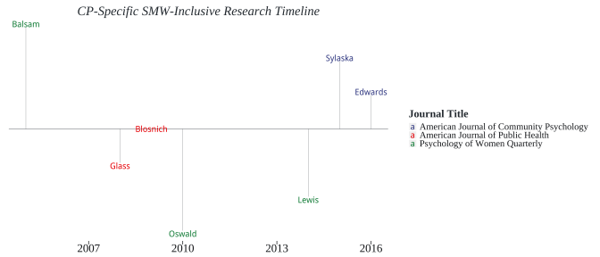

## Research Topics

Primary Topics

|  |  |
| --- | --- |
|  | $N_{Articles}$ |
| * Community Capacity | * 1 |
| * Coordinated Community Response to IPV | * 1 |
| * Help-Seeking | * 1 |
| * IPV Consequences | * 1 |
| * IPV Prevalance | * 1 |
| * Measures | * 1 |
| * Outsiders' (general) Perspective | * 1 |
| * Risk Factors | * 3 |

|  |  |  |  |
| --- | --- | --- | --- |
|  | * AJCP | * AJPH | * PWQ |
| * Community Capacity |  | $⋅$ | $⋅$ |
| * Coordinated Community Response to IPV |  | $⋅$ | $⋅$ |
| * Help-Seeking |  | $⋅$ | $⋅$ |
| * IPV Consequences | $⋅$ |  | $⋅$ |
| * IPV Prevalance | $⋅$ |  | $⋅$ |
| * Measures | $⋅$ |  | $⋅$ |
| * Outsiders' (general) Perspective | $⋅$ | $⋅$ |  |
| * Risk Factors | $⋅$ |  |  |

*AJCP = American Journal of Community Psychology*, *AJPH = American Journal of Public Health* and *PWQ = Psychology of Women Quarterly*

|  |  |  |  |  |  |  |  |  |
| --- | --- | --- | --- | --- | --- | --- | --- | --- |
|  | * 1 | * 2 | * 3 | * 4 | * 5 | * 6 | * 7 | * 8 |
| * Balsam & Szymanski (2005) | $⋅$ | $⋅$ | $⋅$ | $⋅$ | $⋅$ | $⋅$ | $⋅$ |  |
| * Blosnich & Bossarte (2009) | $⋅$ | $⋅$ | $⋅$ |  |  | $⋅$ | $⋅$ | $⋅$ |
| * Edwards et al. (2016) |  |  | $⋅$ | $⋅$ | $⋅$ | $⋅$ | $⋅$ | $⋅$ |
| * Glass et al. (2008) | $⋅$ | $⋅$ | $⋅$ | $⋅$ | $⋅$ |  | $⋅$ |  |
| * Lewis et al. (2014) | $⋅$ | $⋅$ | $⋅$ | $⋅$ | $⋅$ | $⋅$ | $⋅$ |  |
| * Oswald et al. (2010) | $⋅$ | $⋅$ | $⋅$ | $⋅$ | $⋅$ | $⋅$ |  | $⋅$ |
| * Sylaska & Edwards (2015) | $⋅$ | $⋅$ |  | $⋅$ | $⋅$ | $⋅$ | $⋅$ | $⋅$ |

*1 = Community Capacity*, *2 = Coordinated Community Response to IPV* , *3 = Help-Seeking*, *4 = IPV Consequences*, *5 = IPV Prevalance*, *6 = Measures*, *7 = Outsiders' (general) Perspective* and *8 = Risk Factors*

## Target Populations/Sampling Frames

Populations Included

|  |  |
| --- | --- |
|  | $N_{Articles}$ |
| * College Students | * 2 |
| * Couples | * 1 |
| * Females/Women/Girls | * 4 |
| * IPV Victims/Survivors | * 3 |
| * Parents | * 1 |
| * Sexual Minorities | * 2 |
| * Urban-Specific Populations | * 1 |

|  |  |  |  |  |  |  |  |
| --- | --- | --- | --- | --- | --- | --- | --- |
|  | * 1 | * 2 | * 3 | * 4 | * 5 | * 6 | * 7 |
| * Balsam & Szymanski (2005) | $⋅$ | $⋅$ |  | $⋅$ | $⋅$ | $⋅$ | $⋅$ |
| * Blosnich & Bossarte (2009) | $⋅$ | $⋅$ | $⋅$ |  | $⋅$ |  |  |
| * Edwards et al. (2016) |  | $⋅$ | $⋅$ | $⋅$ | $⋅$ | $⋅$ | $⋅$ |
| * Glass et al. (2008) | $⋅$ |  |  |  | $⋅$ | $⋅$ | $⋅$ |
| * Lewis et al. (2014) | $⋅$ | $⋅$ |  | $⋅$ | $⋅$ | $⋅$ | $⋅$ |
| * Oswald et al. (2010) | $⋅$ | $⋅$ |  | $⋅$ |  | $⋅$ | $⋅$ |
| * Sylaska & Edwards (2015) |  | $⋅$ | $⋅$ |  | $⋅$ |  | $⋅$ |

*1 = College Students*, *2 = Couples*, *3 = Females/Women/Girls*, *4 = IPV Victims/Survivors*, *5 = Parents*, *6 = Sexual Minorities* and *7 = Urban-Specific Populations*

## Methodology

Overarching Methodology

|  |  |
| --- | --- |
|  | $N_{Articles}$ |
| * Mixed-Methods | * 2 |
| * QuaLitative Methods | * 1 |
| * QuaNTitative Methods | * 4 |

|  |  |  |  |
| --- | --- | --- | --- |
|  | * 1 | * 2 | * 3 |
| * Balsam & Szymanski (2005) | $⋅$ | $⋅$ |  |
| * Blosnich & Bossarte (2009) | $⋅$ | $⋅$ |  |
| * Edwards et al. (2016) | $⋅$ | $⋅$ |  |
| * Glass et al. (2008) |  | $⋅$ | $⋅$ |
| * Lewis et al. (2014) | $⋅$ | $⋅$ |  |
| * Oswald et al. (2010) | $⋅$ |  | $⋅$ |
| * Sylaska & Edwards (2015) |  | $⋅$ | $⋅$ |

*1 = Mixed-Methods*, *2 = QuaLitative Methods* and *3 = QuaNTitative Methods*

## QuaNTitative Methods

Qua**NT**itative Methods

|  |  |
| --- | --- |
|  | $N_{Articles}$ |
| * Archival/Secondary Data | * 1 |
| * QuaNTitative Survey | * 8 |

|  |  |  |
| --- | --- | --- |
|  | * 1 | * 2 |
| * Balsam & Szymanski (2005) | $⋅$ |  |
| * Blosnich & Bossarte (2009) |  |  |
| * Edwards et al. (2016) | $⋅$ |  |
| * Lewis et al. (2014) | $⋅$ |  |

*1 = Archival/Secondary Data* and *2 = QuaNTitative Survey*

## Mixed-Methods

Mixed-Methods

|  |  |
| --- | --- |
|  | $N_{Articles}$ |
| * 1-on-1 Interviews | * 2 |
| * Focus Groups | * 2 |
| * Group Interviews | * 1 |
| * QuaLitative Survey | * 2 |
| * QuaNTitative Survey | * 4 |

|  |  |  |  |  |  |  |
| --- | --- | --- | --- | --- | --- | --- |
|  | * 1 | * 2 | * 3 | * 4 | * 5 | * 6 |
| * Glass et al. (2008) |  |  |  | $⋅$ |  | $⋅$ |
| * Sylaska & Edwards (2015) | $⋅$ | $⋅$ | $⋅$ |  |  | $⋅$ |

*1 = 1-on-1 Interviews*, *2 = Focus Groups*, *3 = Group Interviews*, *4 = QuaLitative Survey*, *5 = QuaNTitative Survey* and *6 = 1-on-1 Interviews*

# References

Balsam, K. F., & Szymanski, D. (2005). Relationship quality and domestic violence in women’s same-sex relationships: The role of minority stress. *Psychology of Women Quarterly*, *29*, 258–269.

Blosnich, J. R., & Bossarte, R. M. (2009). Comparisons of intimate partner violence among partners in same-sex and opposite-sex relationships in the united states. *American Journal of Public Health*, *99*, 2182–2184.

Boal, A. L., & Mankowski, E. S. (2014). The impact of legislative standards on batterer intervention program practices and characteristics. *American Journal of Community Psychology*, *53*, 218–230.

Edwards, K. M., Littleton, H. L., Sylaska, K. M., Crossman, A. L., & Craig, M. (2016). College campus community readiness to address intimate partner violence among lgbtq plus young adults: A conceptual and empirical examination. *American Journal of Community Psychology*, *58*, 16–26.

Foshee, V. A., Bauman, K. E., Ennett, S. T., Linder, G. F., Benefield, T., & Suchindran, C. (2004). Assessing the long-term effects of the safe dates program and a booster in preventing and reducing adolescent dating violence victimization and perpetration. *American Journal of Public Health*, *94*, 619–624.

Glass, N., Perrin, N., Hanson, G., Bloom, T., Gardner, E., & Campbell, J. C. (2008). Risk for reassault in abusive female same-sex relationships. *American Journal of Public Health*, *98*, 1021–1027.

Lewis, R. J., Milletich, R. J., Derlega, V. J., & Padilla, M. A. (2014). Sexual minority stressors and psychological aggression in lesbian women’s intimate relationships: The mediating roles of rumination and relationship satisfaction. *Psychology of Women Quarterly*, *38*, 535–550.

Oswald, R. F., Fonseca, C. A., & Hardesty, J. L. (2010). Lesbian mothers’ counseling experiences in the context of intimate partner violence. *Psychology of Women Quarterly*, *34*, 286–296.

Sylaska, K. M., & Edwards, K. M. (2015). Disclosure experiences of sexual minority college student victims of intimate partner violence. *American Journal of Community Psychology*, *55*, 326–335.

Thompson, R. S., Rivara, F. P., Thompson, D. C., Barlow, W. E., Sugg, N. K., Maiuro, R. D., & Rubanowice, D. M. (2000). Identification and management of domestic violence: A randomized trial. *American Journal of Preventive Medicine*, *19*, 253–263.