What qualifies as community psychology related research

Riley M. Smith

07 May 2017

The process of conducting the community-psychology-focused systematic review of empirical research related to IPV and sexual minority women was arduous to say the least. Community-psychology is overwhelmingly more multi-disciplinary than most social scientific, and especially psychological, research fields. At multiple junctures throughout the article selection and review process, the author was careful to maintain detailed records regarding each decision made in determining which research articles to include and exclude in the formal review (see Figure 1), as well as the rationale underlying those decisions. A potentially useful by-product

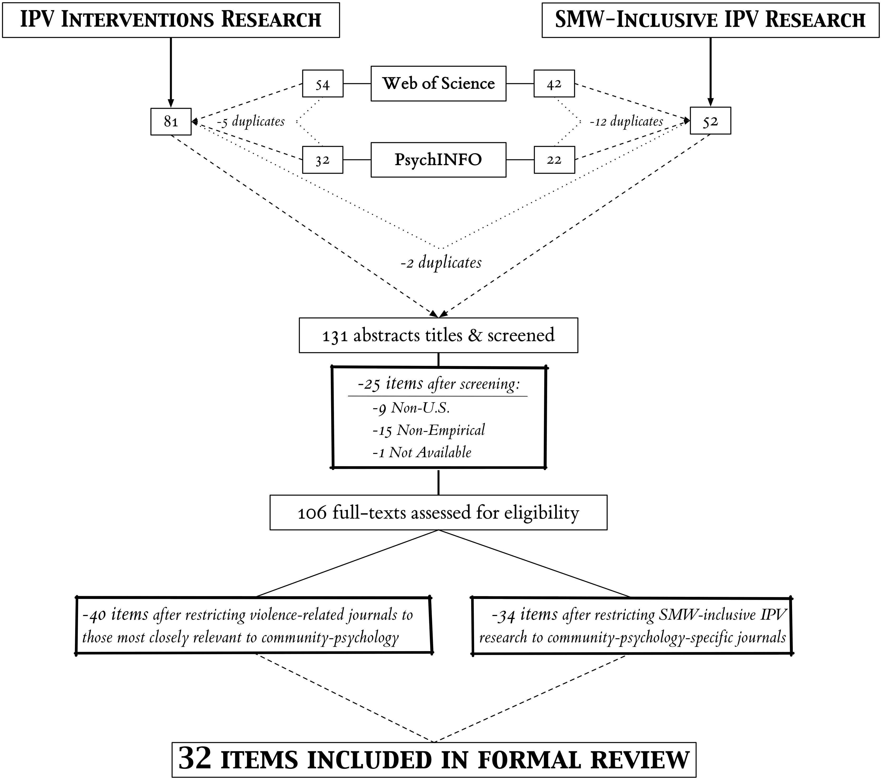

Figure 1: