MAP - Bibliography (CP-Only)

Riley M. Smith

24 April 2017

# Community Psychology Publications

Community-psychology journals included in database searches:

* Action Research
* American Journal of Community Psychology
* American Journal of Health Promotion
* American Journal of Orthopsychiatry
* American Journal of Preventive Medicine
* American Journal of Public Health
* Australian Community Psychologist
* Community Development
* Community Development Journal
* Community Mental Health Journal
* Community Psychology in Global Perspective
* Cultural Diversity and Ethnic Minority Psychology
* Global Journal of Community Psychology Practice
* Health Education and Behavior
* Health Promotion Practice
* Journal of Applied Social Psychology
* Journal of Community and Applied Social Psychology
* Journal of Community Practice
* Journal of Community Psychology
* Journal of Health and Social Behavior
* Journal of Prevention and Intervention
* Journal of Primary Prevention
* Journal of Rural Community Psychology
* Journal of Social Issues
* Journal of Community Psychology
* Psychiatric Rehabilitation Journal
* Psychology of Women Quarterly
* Social Science and Medicine
* the Community Psychologist
* Transcultural Psychiatry
* Progress in Community Health Partnerships

# Results of Systematic Database Searches:

## General Research Categories

|  |  |
| --- | --- |
| * Category | * N |
| * IPV Interventions | * 3 |
| * SMW-Inclusive Research | * 7 |

##### Binomial Test of the Difference in Search Category Proportions

|  |  |  |  |  |  |  |
| --- | --- | --- | --- | --- | --- | --- |
| alternative | null.value | parameter | estimate | statistic | p.value | CI |
| two.sided | 0.5 | 1 | 0.3 | 1.6 | 0.206 | 0.11, 0.6 |

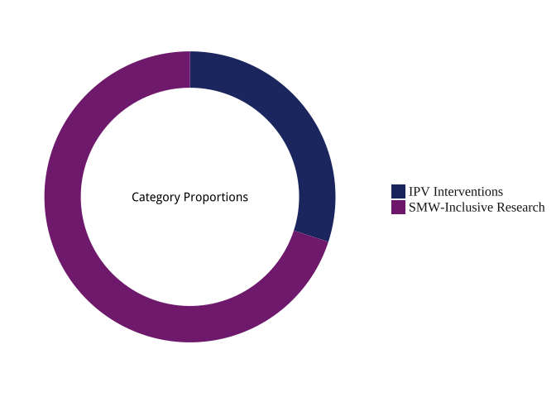

# Publication Titles

##### Number of Publications in Each Research Category per Journal

|  |  |  |
| --- | --- | --- |
|  | IPV Interventions | SMW-Inclusive Research |
| **American Journal of Community Psychology** | 1 | 2 |
| **American Journal of Preventive Medicine** | 1 | - |
| **American Journal of Public Health** | 1 | 2 |
| **Psychology of Women Quarterly** | - | 3 |

## 

## Research Category by Journal & Journal Category

##### $N_{articles}$ in Each Research Category per Journal

|  |  |  |  |
| --- | --- | --- | --- |
|  | IPV Interventions | SMW-Inclusive Research | Total |
| **American Journal of Community Psychology** | 1 | 2 | 3 |
| **American Journal of Preventive Medicine** | 1 | - | 1 |
| **American Journal of Public Health** | 1 | 2 | 3 |
| **Psychology of Women Quarterly** | - | 3 | 3 |

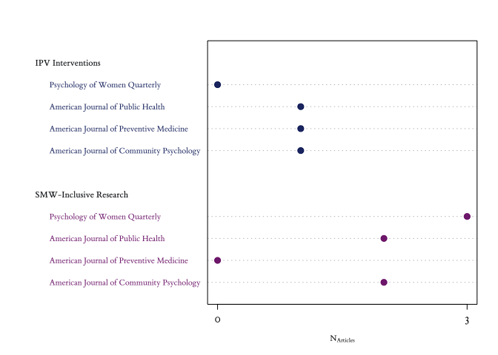

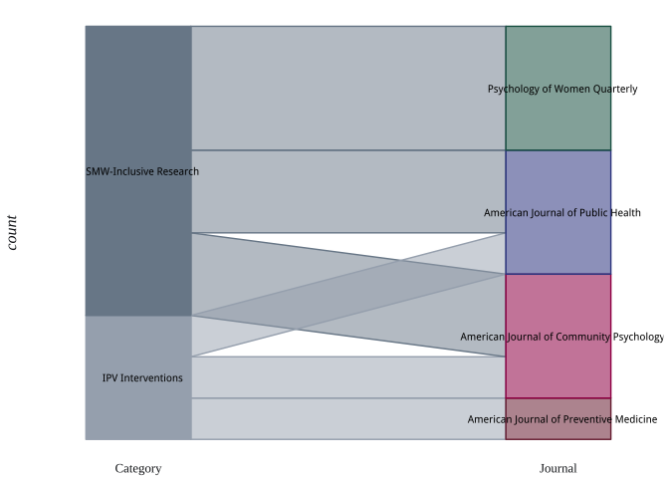

# Research Topics, Sampling Frames, and Methodologies

##### Primary Topics

|  |  |  |  |
| --- | --- | --- | --- |
|  | IPV Interventions | SMW-Inclusive Research | Total |
| **Community Capacity** | - | 1 | 1 |
| **Coordinated Community Response to IPV** | - | 1 | 1 |
| **Help-Seeking** | - | 1 | 1 |
| **Intervention/Prevention (General)** | 3 | - | 3 |
| **IPV Consequences** | - | 1 | 1 |
| **IPV Intervention Program Evaluation** | 3 | - | 3 |
| **IPV Perpetrator Interventions** | 2 | - | 2 |
| **IPV Prevalance** | - | 1 | 1 |
| **IPV Screening** | 1 | - | 1 |
| **IPV Victimization Intervention** | 2 | - | 2 |
| **Measures** | - | 1 | 1 |
| **Outsiders' (general) Perspective** | - | 1 | 1 |
| **Public/Program Policy** | 1 | - | 1 |
| **Risk Factors** | - | 3 | 3 |
| **System Response** | 1 | - | 1 |

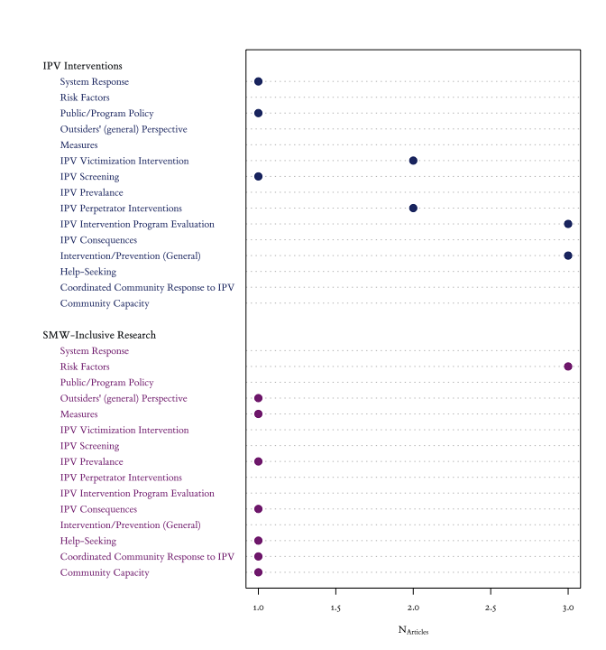

##### Research Designs

|  |  |  |  |
| --- | --- | --- | --- |
|  | IPV Interventions | SMW-Inclusive Research | Total |
| **Cross-Sectional** | - | 5 | 5 |
| **Experimental** | 3 | 1 | 4 |

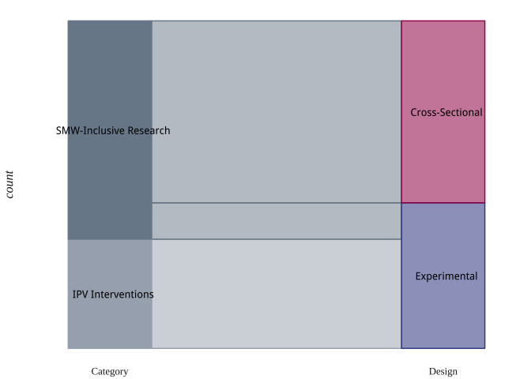

Experimental Research Designs

|  |  |  |  |
| --- | --- | --- | --- |
|  | IPV Interventions | SMW-Inclusive Research | Total |
| **Longitudinal** | 3 | - | 3 |
| **Pre-Test/Post-Test** | - | 1 | 1 |
| **Randomized Control Trial** **(Longitudinal)** | 1 | - | 1 |

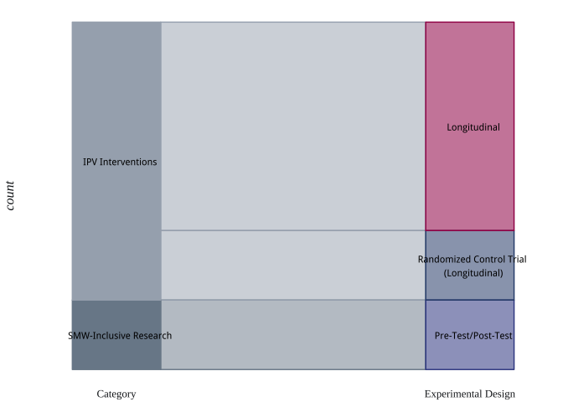

##### Data Collection Methodologies

|  |  |  |  |
| --- | --- | --- | --- |
|  | IPV Interventions | SMW-Inclusive Research | Total |
| **Mixed-Methods** | - | 2 | 2 |
| **QuaLitative Methods** | - | 1 | 1 |
| **QuaNTitative Methods** | 3 | 4 | 7 |

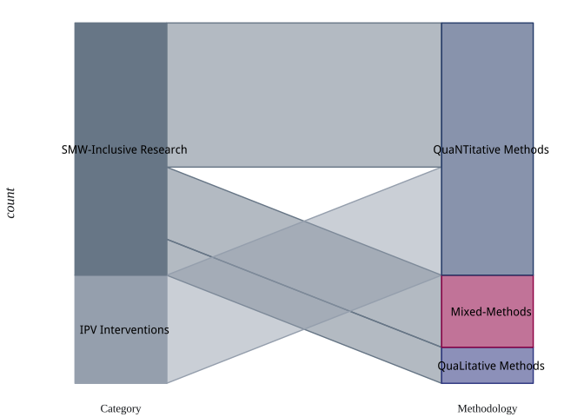

Qua**L**itative Method(s)

|  |  |  |
| --- | --- | --- |
|  | SMW-Inclusive Research | Total |
| **1-on-1 Interviews** | 2 | 2 |
| **Group Interviews** | 1 | 1 |

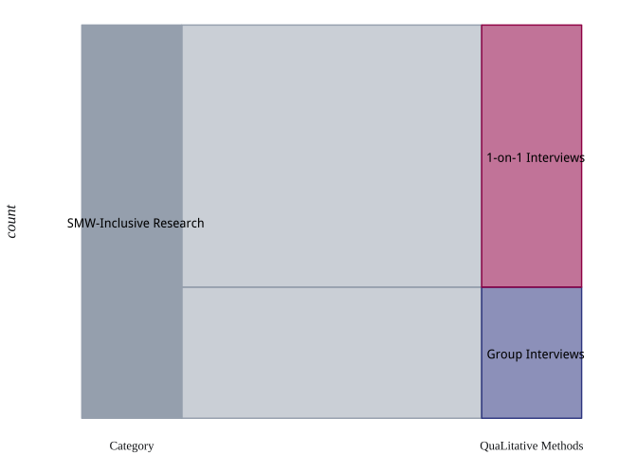

Qua**NT**itative Designs

|  |  |  |  |
| --- | --- | --- | --- |
|  | IPV Interventions | SMW-Inclusive Research | Total |
| **Cross-Sectional Design** | - | 4 | 4 |
| **Experimental Design** | 3 | - | 3 |
| **Longitudinal Design** | 3 | - | 3 |

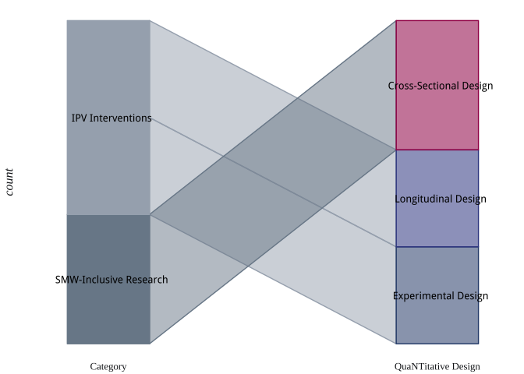

Qua**NT**itative Methods

|  |  |  |  |
| --- | --- | --- | --- |
|  | IPV Interventions | SMW-Inclusive Research | Total |
| **Archival/Secondary Data** | - | 1 | 1 |
| **QuaNTitative Survey** | 6 | 8 | 14 |

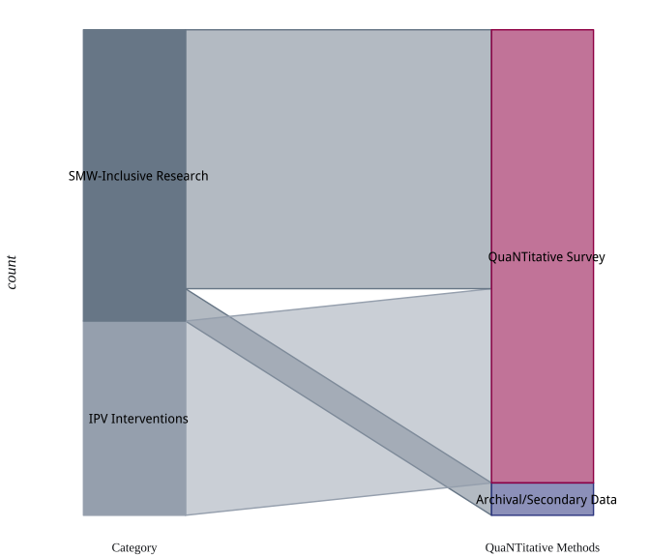

Archival Data Sources

|  |  |  |
| --- | --- | --- |
|  | SMW-Inclusive Research | Total |
| **Government-Sponsored Survey** | 1 | 1 |

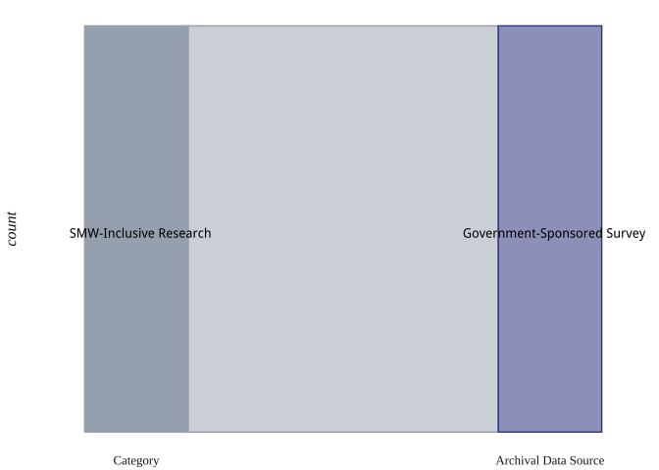

Mixed-Methodological Designs

|  |  |  |
| --- | --- | --- |
|  | SMW-Inclusive Research | Total |
| **Cross-Sectional Design** | 1 | 1 |
| **Experimental Design** | 1 | 1 |
| **Longitudinal Design** | 1 | 1 |
| **Pre-Test/Post-Test Design** | 1 | 1 |

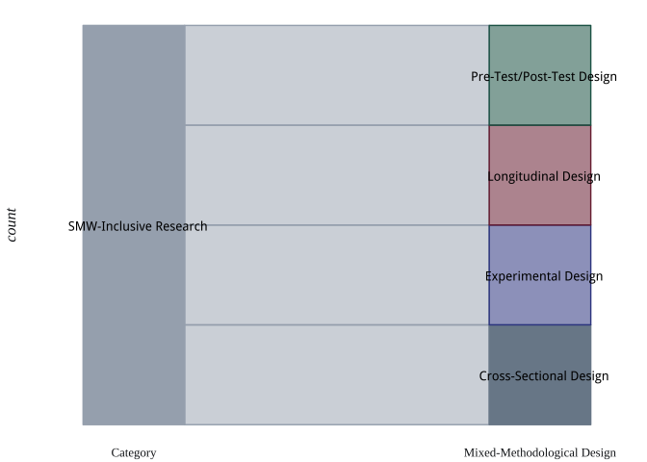

Research Topics

|  |  |  |
| --- | --- | --- |
|  | SMW-Inclusive Research | Total |
| **1-on-1 Interviews** | 2 | 2 |
| **Focus Groups** | 2 | 2 |
| **Group Interviews** | 1 | 1 |
| **QuaLitative Survey** | 2 | 2 |
| **QuaNTitative Survey** | 4 | 4 |

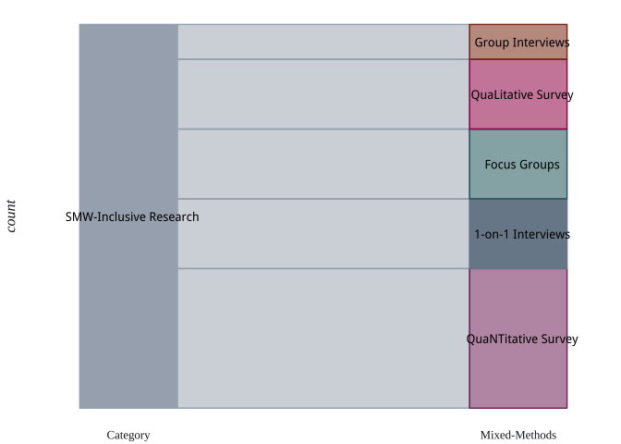

## Target Populations & Sampling Frames

Research Topics

|  |  |  |  |
| --- | --- | --- | --- |
|  | IPV Interventions | SMW-Inclusive Research | Total |
| **College Students** | - | 2 | 2 |
| **Couples** | - | 1 | 1 |
| **Females/Women/Girls** | - | 4 | 4 |
| **IPV Intervention Programs** | 1 | - | 1 |
| **IPV Victims/Survivors** | - | 3 | 3 |
| **Non-IPV Community-Based Practitioners** | 1 | - | 1 |
| **Non-IPV System Entities** | 1 | - | 1 |
| **Parents** | - | 1 | 1 |
| **Sexual Minorities** | - | 2 | 2 |
| **Urban-Specific Populations** | - | 1 | 1 |
| **Youth/Children** | 1 | - | 1 |

