- Creating and Renaming Files/Directories
- Create a directory named test_dir using mkdir.
srinivas@SrinivasSwaroop:~/Projects/assign_1$ mkdir test_dir
- Inside test_dir, create an empty file called example.txt.
srinivas@SrinivasSwaroop:~/Projects/assign_1$ cd test_dir
srinivas@SrinivasSwaroop:~/Projects/assign_1/test_dir$ touch example.txt
- Rename example.txt to renamed_example.txt using mv.
srinivas@SrinivasSwaroop:~/Projects/assign_1/test_dir$ mv example.txt renamed_example.txt
ScreenShots:
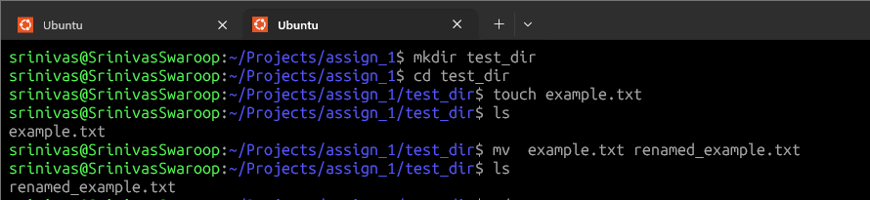
- Viewing File Contents
- Use cat to display the contents of /etc/passwd.
srinivas@SrinivasSwaroop:/$ cat /etc/passwd
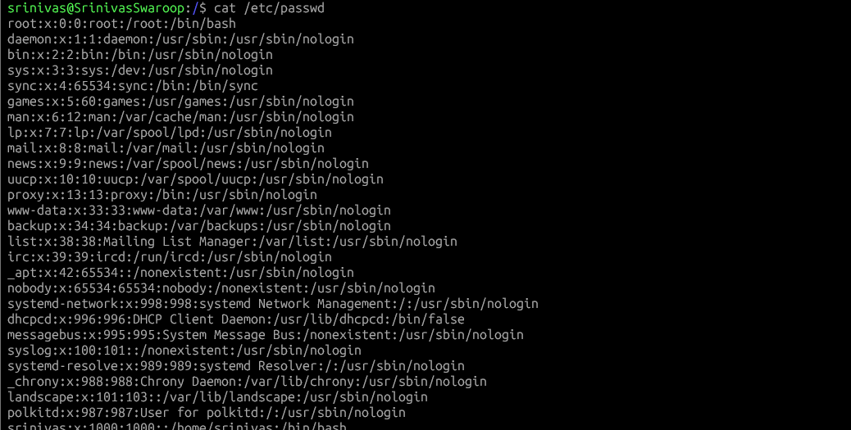

- Display only the first 5 lines of /etc/passwd using head.
srinivas@SrinivasSwaroop:/$ head -5 /etc/passwd
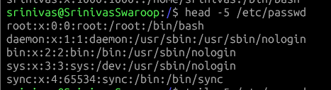
- Display only the last 5 lines of /etc/passwd using tail.
srinivas@SrinivasSwaroop:/$ tail -5 /etc/passwd
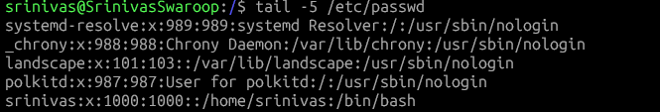

- Searching for Patterns
Use grep to find all lines containing the word “root” in /etc/passwd.
srinivas@SrinivasSwaroop:/$ cat /etc/passwd | grep root

- Zipping and Unzipping
Compress the test_dir directory into a file named test_dir.zip using zip.
srinivas@SrinivasSwaroop:~/Projects/assign_1$ zip -r test_dir.zip test_dir
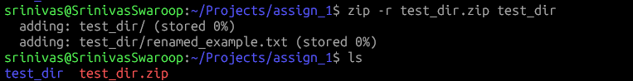

Unzip test_dir.zip into a new directory named unzipped_dir.
srinivas@SrinivasSwaroop:~/Projects/assign_1$ unzip test_dir.zip -d unzipped_dir
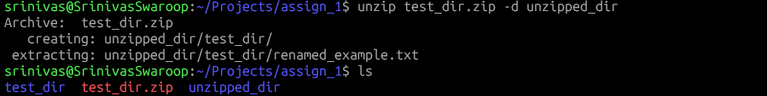
- Downloading Files
Use wget to download a file from a URL (e.g.,https://example.com/sample.txt).
srinivas@SrinivasSwaroop:~/Projects/assign_1$ wget https://example.com/sample.txt
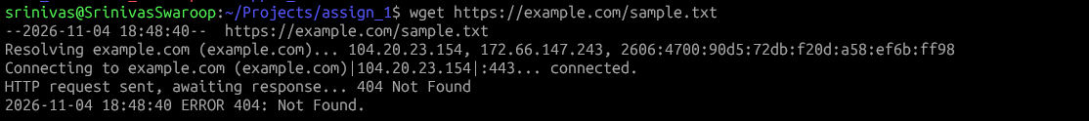
Note: (404) as file was no available/found
6. Changing Permissions
Create a file named secure.txt and change its permissions to read-only for everyone using chmod.
srinivas@SrinivasSwaroop:~/Projects/assign_1/test_dir$ touch secure.txt
srinivas@SrinivasSwaroop:~/Projects/assign_1/test_dir$ chmod 444 secure.txt
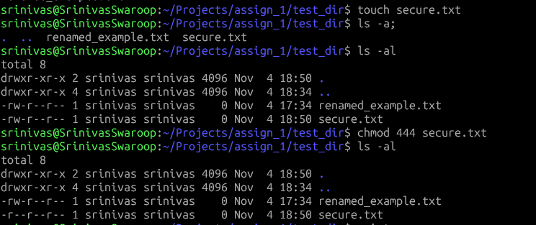

7. Working with Environment Variables
Use export to set a new environment variable called MY_VAR with the value “Hello, Linux!”.
srinivas@SrinivasSwaroop:~/Projects/assign_1/test_dir$ export MY_VAR="Hello Linux!"


