Assignment-2(GIT)

By-Aneesh Kumar

**1.How can you initialize a repository in Git? Write Command.**

**Ans:** We can initialize a git repository by the command

**git init <repo name>;**

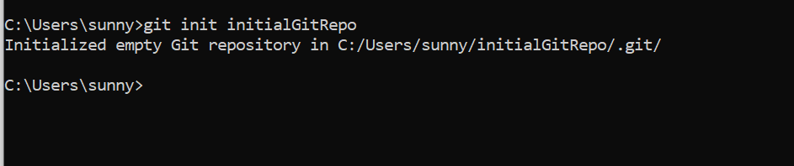

**2.Create repository named - Employee . After that create branch named - Employee_Detail .**

**Ans:** Basically these are the steps to create a new repository and add any file to it

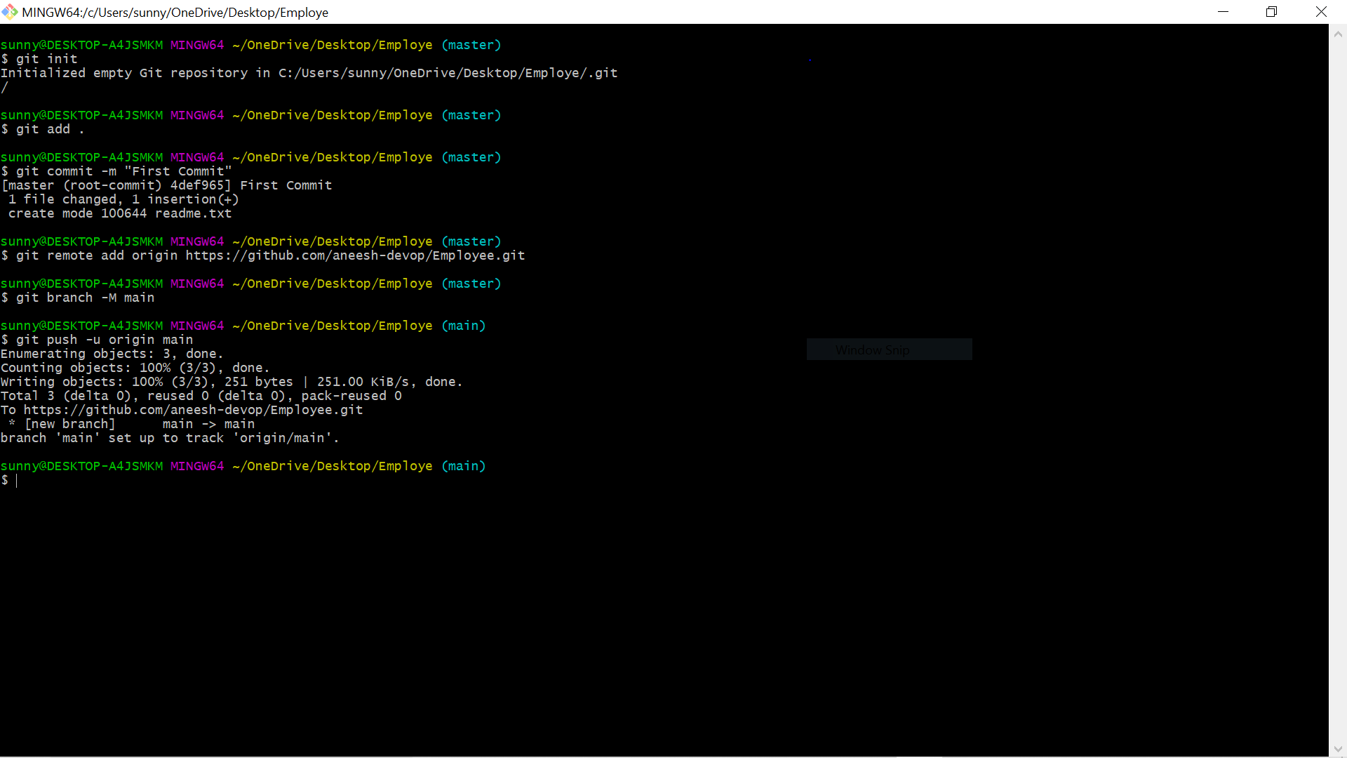

After git commit we go to our Github account on browser and create a new repo and add our files to it by git remote and git push commands.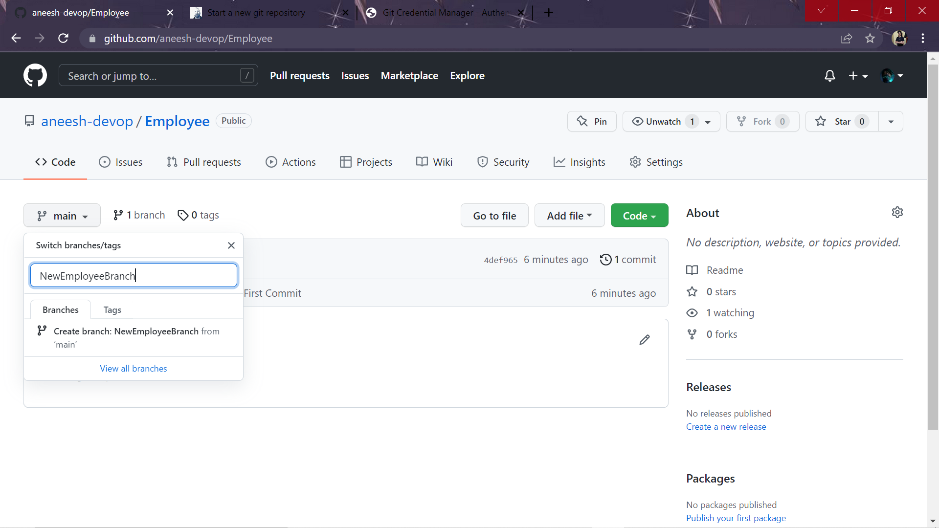

After creating a git repo we go to main option at right side of browser window and create a new branch named NewEmployeeBranch.

**3. In Employee repository check the status and later commit new file or folder in it.**

**Ans:** Before adding new file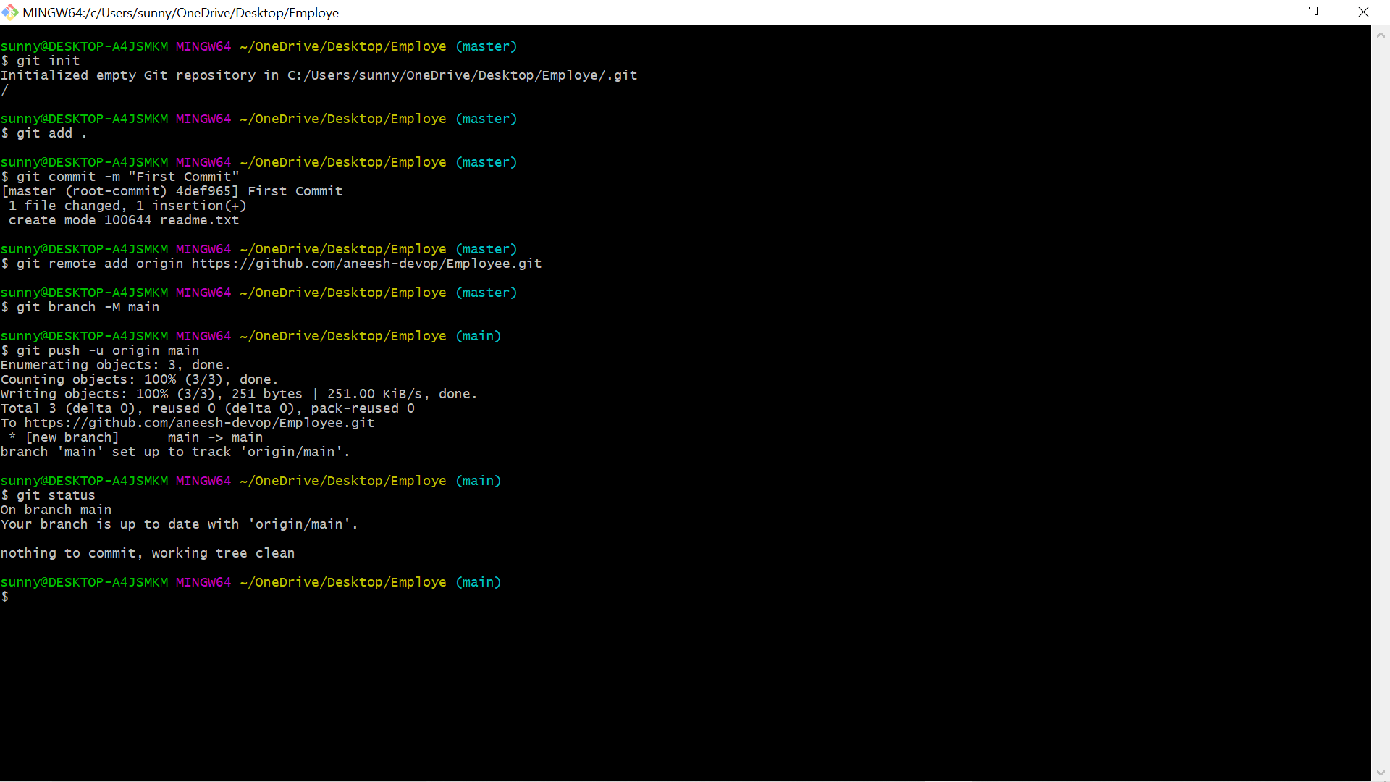

After adding new file

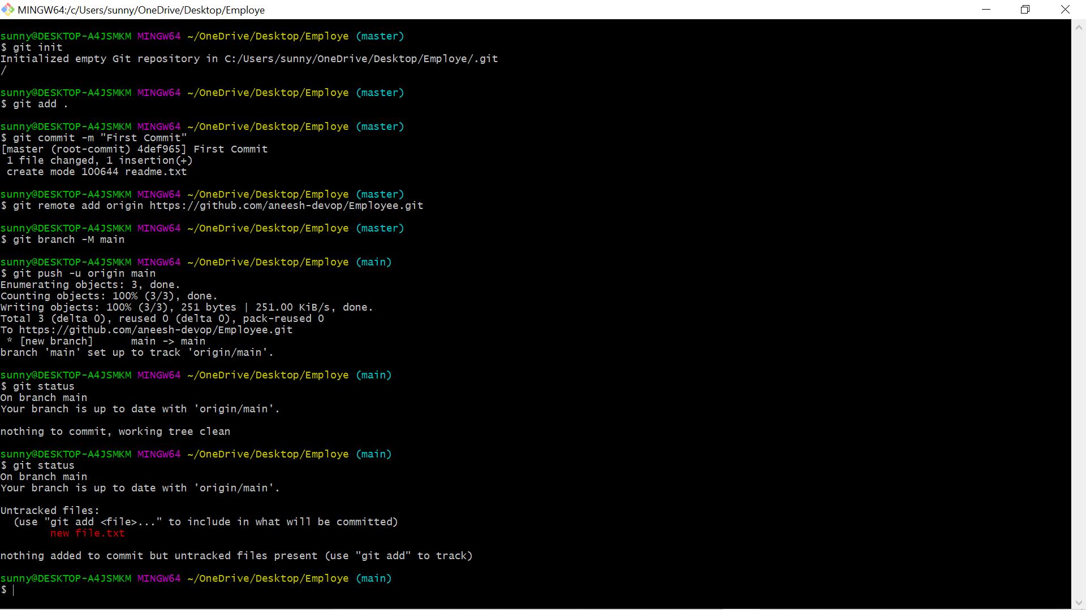

Pushed the new file on github

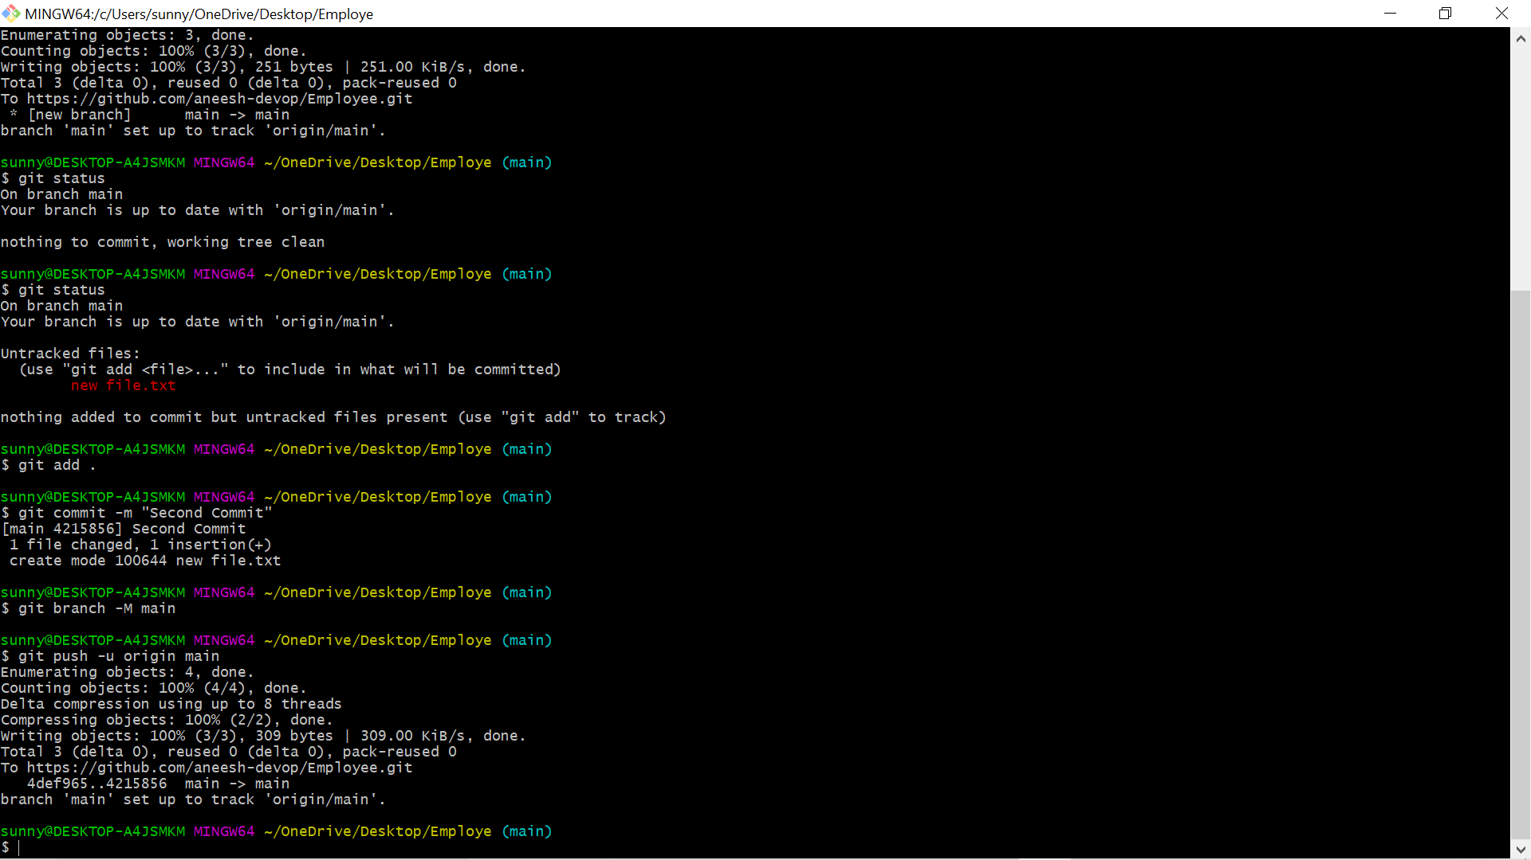

**4.Merge two branch in Employee respository .**

**Ans:**

So basically for merging we give pull request and then the user of main bracnch reviews and merges it

