Here’s the **indexed structure** for the **Synnergyze Framework**, based on the domains, modules, and their functionalities:

**Indexed Structure**

**1. Core Hub: brand.synnergyze.com**

• **Primary Index**: CoreHubIndex

• Fields:

• UserID (Primary Key)

• Role (Admin, Manager, Employee)

• ModuleAccess (Array of accessible modules)

• LastLoginTimestamp

• APIAccessKey

• **Use Cases**:

• Authenticate users and manage access control.

• Monitor API usage across all modules.

**2. Subdomains and Modules**

**a. Woven Supply: woven.synnergyze.com**

• **Primary Index**: VendorIndex

• Fields:

• VendorID (Primary Key)

• LicenseID (Foreign Key)

• PerformanceScore

• ComplianceStatus

• ProcurementValue

• **Workflow Index**: ProcurementWorkflowIndex

• Fields:

• WorkflowID (Primary Key)

• VendorID (Foreign Key)

• TaskName

• Timestamp

• CompletionStatus

• **Use Cases**:

• Track vendor performance and procurement workflows.

• Ensure compliance and timely task completion.

**b. Commune Connect: commune.synnergyze.com**

• **Primary Index**: CollaborationIndex

• Fields:

• TeamID (Primary Key)

• UserID (Foreign Key)

• TaskID (Foreign Key)

• Deadline

• CompletionStatus

• **Activity Log Index**: ActivityLogIndex

• Fields:

• LogID (Primary Key)

• TeamID (Foreign Key)

• ActionPerformed

• Timestamp

• **Use Cases**:

• Monitor team collaboration and task progress.

• Log user activity for compliance and productivity tracking.

**c. Last Smile: lastmile.synnergyze.com**

• **Primary Index**: LogisticsIndex

• Fields:

• FleetID (Primary Key)

• DeliveryID (Foreign Key)

• RouteEfficiency

• SustainabilityScore

• FleetStatus

• **Delivery Workflow Index**: DeliveryWorkflowIndex

• Fields:

• WorkflowID (Primary Key)

• FleetID (Foreign Key)

• TaskName

• Timestamp

• CompletionStatus

• **Use Cases**:

• Optimize fleet routes and track delivery progress.

• Ensure sustainability metrics are met.

**d. Sync Up: apps.synnergyze.com**

• **Primary Index**: AppMarketplaceIndex

• Fields:

• AppID (Primary Key)

• LicenseID (Foreign Key)

• UserRatings

• UsageFrequency

• APIKey

• **App Performance Index**: AppPerformanceIndex

• Fields:

• MetricID (Primary Key)

• AppID (Foreign Key)

• KPI

• Value

• Timestamp

• **Use Cases**:

• Track app usage and performance.

• Recommend apps based on user activity.

**e. OMS: oms.synnergyze.com**

• **Primary Index**: OrderIndex

• Fields:

• OrderID (Primary Key)

• LicenseID (Foreign Key)

• OrderStatus

• TotalValue

• Timestamp

• **Inventory Index**: InventoryIndex

• Fields:

• SKU (Primary Key)

• StockLevel

• ReorderPoint

• LastUpdated

• **Use Cases**:

• Manage B2B/B2C orders and track inventory levels.

• Automate reorder triggers for low stock.

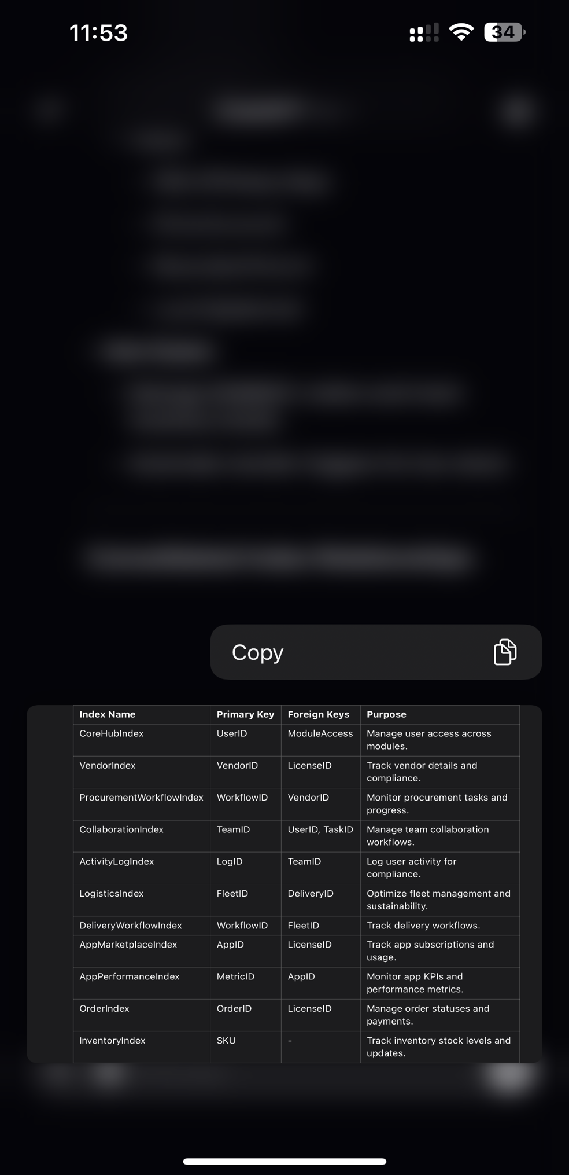

The codification logic for storing data in the **Synnergyze Framework** should ensure efficient organization, retrieval, and scalability. Below is a detailed **codification logic framework**:

**1. Hierarchical Key Structure**

The codification logic uses a hierarchical structure to group data by modules, users, workflows, and indices. This structure ensures that data relationships are preserved and can be efficiently queried.

**2. Key Components of Codification**

**2.1 License Keys**

• **Logic**:

• Each license is assigned a unique identifier based on its module, user, and creation date.

• Format: L-{ModuleCode}-{UserID}-{YYYYMMDD}

• Example:

• License for Woven Supply, User ID 12345, created on 2024-12-01: L-WS-12345-20241201

**2.2 Workflow IDs**

• **Logic**:

• Each workflow is assigned an ID based on its parent license and task sequence.

• Format: W-{LicenseID}-{TaskCode}

• Example:

• Workflow for license L-WS-12345-20241201 for procurement: W-L-WS-12345-20241201-PROC

**2.3 User IDs**

• **Logic**:

• Users are assigned unique IDs based on their organization, role, and registration sequence.

• Format: U-{OrgCode}-{RoleCode}-{SequenceNumber}

• Example:

• User in Org “VOI” with role Manager: U-VOI-MGR-001

**2.4 Vendor and Product Codes**

• **Logic**:

• Vendors and products are codified based on categories, regions, and unique sequences.

• Vendor Format: V-{RegionCode}-{CategoryCode}-{VendorID}

• Product Format: P-{CategoryCode}-{SKU}-{BatchNumber}

• Examples:

• Vendor in Asia for fabric: V-AS-FAB-123

• Product: P-FAB-SKU123-B001

**2.5 Index Data Codification**

• Each index type has a codification pattern to map data effectively:

**Index Type** **Key Format** **Example**

CoreHubIndex CH-{UserID}-{ModuleCode} CH-12345-WS

VendorIndex VI-{VendorID}-{LicenseID} VI-V-AS-FAB-123-L-WS-12345-20241201

ProcurementWorkflowIndex PW-{WorkflowID} PW-W-L-WS-12345-20241201-PROC

CollaborationIndex CI-{TeamID}-{TaskID} CI-T-001-TASK001

LogisticsIndex LI-{FleetID}-{DeliveryID} LI-F-001-DLV001

OrderIndex OI-{OrderID} OI-ORD12345

InventoryIndex II-{SKU}-{LocationCode} II-SKU123-WH001

**3. Codification Logic for Data Storage**

**3.1 Logical Segmentation**

Data is stored in logical segments based on the module and index type.

**Segment** **Purpose** **Data Example**

Licenses Stores all active/inactive licenses. L-WS-12345-20241201

Workflows Tracks tasks and processes. W-L-WS-12345-20241201-PROC

Users Maintains user details. U-VOI-MGR-001

Vendors Stores vendor information. V-AS-FAB-123

Products Stores product-related data. P-FAB-SKU123-B001

Orders Tracks orders and statuses. OI-ORD12345

Inventory Tracks inventory data. II-SKU123-WH001

**3.2 Data Storage in Index Tables**

**Index Name** **Key Field** **Primary Storage Field**

CoreHubIndex LicenseID User permissions and roles.

ProcurementWorkflowIndex WorkflowID Workflow completion status.

CollaborationIndex TaskID Collaboration activities.

LogisticsIndex DeliveryID Delivery and fleet data.

OrderIndex OrderID Order status and payments.

InventoryIndex SKU Stock levels and locations.

**4. Query Optimization with Codification**

**License-Based Query:**

• **Purpose**: Fetch workflows for a specific license.

• **Query**:

SELECT *

FROM ProcurementWorkflowIndex

WHERE LicenseID = 'L-WS-12345-20241201';

**Vendor-Based Query:**

• **Purpose**: Retrieve vendor performance metrics.

• **Query**:

SELECT *

FROM VendorIndex

WHERE VendorID = 'V-AS-FAB-123';

**Order-Based Query:**

• **Purpose**: Get order details for a specific SKU.

• **Query**:

SELECT *

FROM OrderIndex

WHERE SKU = 'SKU123';

**5. Scalability**

The codification logic supports:

1. **Multi-Module Operations**: Unique IDs for tasks across modules.

2. **Regional Scaling**: Region-based segmentation for vendors and inventory.

3. **Optimized Retrieval**: Hierarchical indexing reduces lookup times.

Consolidated Flow and Structure for Synnergyze Framework

Based on the uploaded documents, here’s a comprehensive summary integrating the process documentation, domain structure, and functional flow for Synnergyze. This outlines how the framework serves various stakeholders like brands, retailers, wholesalers, and end users.

Synnergyze Domain Layers

1. Core Hub:

• Domain: brand.synnergyze.com

• Acts as the centralized governance system, managing all user access, APIs, and data flows.

• Features:

• Secure authentication.

• Unified dashboards for all modules.

• Role-based access control.

2. Subdomains and Modules:

• Woven Supply: woven.synnergyze.com

• Vendor management, procurement tracking, and AI-driven sourcing recommendations.

• Commune Connect: commune.synnergyze.com

• Collaboration tools, task automation, and workflow integration.

• Last Smile: lastmile.synnergyze.com

• Logistics and delivery tracking, fleet optimization.

• Sync Up (App Marketplace): apps.synnergyze.com

• Third-party integrations, SaaS subscriptions, and additional tools.

• OMS (Order Management System): oms.synnergyze.com

• Handles B2B/B2C orders, inventory updates, and payment tracking.

Workflow from Documentation (OMS Integration)

Key Processes:

1. Brand Registration:

• Self-service or assisted KYC for onboarding brands.

• Registration is validated by admin teams through the platform.

2. Order Management:

• Brands log in to oms.synnergyze.com to view products.

• Orders (POs) are placed, confirmed by admin/marketing teams, and processed.

3. Inventory Integration:

• Inventory is uploaded via ERP or Excel templates to OMS.

• Picking, packing, and shipping workflows are triggered.

4. Delivery & Payment:

• Real-time tracking for shipments with updates from logistics providers.

• Payment options: Direct gateway or credit lines via NBFC integration.

5. Reporting & Logs:

• Sales, pending orders, payments, and delivery statuses are logged.

• Secure access logs ensure data confidentiality.

Stakeholder Flow Chart

Primary Entities:

• Tributaries: Influencers, consultants, resellers, and external entities driving traffic to the brand.

• Pier-to-Pier Connections: Links between marketplaces, buyers, and product listings.

• End Users: Final customers interacting with the brand’s products/services.

Flow Segments:

1. Main River (Core Data Flow):

• Governance, CRM, OMS, and central dashboards.

2. River Delta (Functional Segregation):

• Woven Supply: Vendor and supply chain.

• Last Smile: Delivery and logistics.

• Sync Up: Integrations and app management.

3. Flood Plains (Corporate Operations):

• Data segregation, governance, and analytics for brands.

• Centralized control at the corporate office level.

Skeleton for Brand Implementation

Key Layers:

1. Core Layer: Governance, compliance, and centralized reporting.

2. Operational Layer:

• OMS for order management.

• ERP for production and inventory control.

3. Customer Engagement Layer:

• CRM for loyalty and customer behavior analytics.

• Marketing automation for campaigns.

Environment Setup:

• Development: For testing and staging integrations.

• Production: Live system for all users.

• Analytics: Dashboards and reporting for decision-making.

Next Steps:

Would you like:

1. A refined visualization (flow chart) of this structure?

2. A detailed API integration strategy for modules like OMS and logistics?

3. Customized workflows for specific stakeholders like brands or end users?

Let me know how to proceed!

For **managed services**, a service log book should track all activities related to IT, infrastructure, or service support tasks. It can serve as a record for ongoing monitoring, maintenance, incident response, updates, and upgrades. Here’s how to structure a **Managed Services Log Book**:

**Structure for a Managed Services Log Book**

**1. General Information**

• **Client Information**: Name, contact, address.

• **Service Provider Information**: Name, contact, service agreement details.

• **Agreement Details**:

• Contract Start/End Date.

• SLA (Service Level Agreement) specifics (e.g., response time, resolution time).

• **Asset/Service Description**:

• Systems under management (e.g., servers, networks, applications, or devices).

• Asset details (serial numbers, IP addresses, configurations).

**2. Service Activity Entries (Repeating Section)**

Each entry records a specific activity or ticket and should include:

**Field** **Description**

**Date and Time** Date and time of service or issue occurrence.

**Service Type** E.g., Monitoring, Maintenance, Incident, Update, Backup, etc.

**Request/Ticket ID** Unique identifier for the task or incident.

**Issue Description/Details** Details of the issue or service performed.

**Resolution Details** Description of the steps taken to resolve or complete the task.

**Duration** Time taken to resolve or complete the task.

**Technician** Name of the technician or team responsible for the task.

**Status** E.g., Completed, In Progress, Escalated.

**Follow-Up Actions** Recommended next steps or scheduled maintenance.

**Client Confirmation** Notes or signature confirming client satisfaction or acknowledgment of service.

**3. Monthly/Quarterly Summary**

• **Service Metrics**:

• Total incidents resolved.

• Uptime percentages.

• Average response/resolution time.

• **Performance Against SLA**: Highlight SLA compliance or breaches.

• **Trends**: Repeated issues or service areas needing improvement.

• **Next Steps**: Recommendations for future improvements or upgrades.

**Example Entry**

**Date** **Request ID** **Service Type** **Details** **Resolution** **Tech** **Status** **Follow-Up**

2024-12-26 #MS12345 Incident Response Server down due to unexpected power loss. Restarted server, verified integrity. John Doe Completed Schedule UPS replacement.

**Tools for Managing a Managed Services Log Book**

1. **Physical/Digital Log Books**:

• Use a standard template in Excel, Google Sheets, or Word.

2. **Professional Tools**:

• **Service Desk Software** (e.g., Zendesk, ServiceNow, Jira).

• **ITSM Platforms** for incident and problem tracking.

3. **Client Portals**:

• Provide client access to logs for transparency.

**Recommendations**

• **Automation**: Set up alerts and auto-updated logs for recurring maintenance (e.g., backups, monitoring reports).

• **Visualization**: Include charts for SLA performance, ticket volumes, and incident trends in summaries.

• **Reports**: Generate PDF summaries monthly for stakeholders or audits.

Would you like me to create a customized template or set up a digital spreadsheet for this log book? Or do you need guidance on implementing it in software like Excel or ITSM tools? Let me know!