\*\*Document Title: Transforming Supply Chain Finance - Case Study\*\*

\*\*Introduction:\*\*

In this case study, we'll explore how the [Company Name] platform facilitates a seamless supply chain finance model. The key parties involved are:

- \*\*Distributor:\*\* Synnergyze

- \*\*Buyer:\*\* VJRIPL (VOI and SLUB labels)

- \*\*Manufacturer:\*\* Scott’s Garments

- \*\*Financier:\*\* Dollar

- \*\*Buying Agent:\*\* [Company Name]

\*\*Roles of Each Party:\*\*

1. \*\*Distributor (Synnergyze):\*\*

- Acts as a distribution intermediary.

- Receives goods from the manufacturer and facilitates transactions with the buyer.

- Bills the buyer and manages financial transactions.

2. \*\*Buyer (VJRIPL - VOI and SLUB):\*\*

- Places Purchase Orders (PO) for final goods cost.

- Has a 45-day window to repay after the invoice date.

- Engages with the platform as a buyer and benefits from streamlined transactions.

3. \*\*Manufacturer (Scott’s Garments):\*\*

- Produces goods and provides a prototype for approval.

- Confirms that raw materials will take 3 weeks of processing.

- Requires Cash on Delivery (COD) for raw material processing.

4. \*\*Financier (Dollar):\*\*

- Provides financing services.

- Manages the financial transactions between Synnergyze and VJRIPL.

5. \*\*Buying Agent ([Company Name]):\*\*

- Markets the platform and onboards brands as buying agents.

- Facilitates collaborations between brands and the platform.

- Acts as a liaison between brands and the platform.

\*\*Scenario: Prototype Approval and Raw Material Processing:\*\*

1. \*\*Buyer's Actions (VJRIPL):\*\*

- Likes the prototype provided by Scott’s Garments.

- Raises a PO on the final goods cost using the [Company Name] platform.

2. \*\*Manufacturer's Actions (Scott’s Garments):\*\*

- Confirms that raw materials will take 3 weeks of processing.

- Requests Cash on Delivery (COD) for the raw material processing.

3. \*\*Distributor's Role (Synnergyze):\*\*

- Receives the PO and facilitates the transaction.

- Coordinates with Dollar for financing and manages the payment to the manufacturer.

- Ensures the timely delivery of goods.

4. \*\*Financier's Role (Dollar):\*\*

- Provides financing services to facilitate the transaction.

- Manages the financial aspects between Synnergyze and VJRIPL.

\*\*Appendix: Tables\*\*

1. \*\*Roles and Responsibilities Table:\*\*

- Lists the key parties (Distributor, Buyer, Manufacturer, Financier, Buying Agent) and their respective roles.

2. \*\*Transaction Flow Table:\*\*

- Outlines the step-by-step flow of transactions from PO to payment, involving all parties.

3. \*\*Payment Terms Table:\*\*

- Details the payment terms, including the 45-day window for the buyer.

4. \*\*Raw Material Processing Table:\*\*

- Describes the specific actions and responsibilities related to the manufacturer's raw material processing.

These tables provide a comprehensive overview of the roles, transactions, payment terms, and specific actions involved in the described scenario.

:

1) \*\*Buyer (Inox):\*\* Issues a Purchase Order (PO) to the Manufacturer (Supplier) specifying the sanctioned amount, and provides a bank guarantee of the same value.

2) \*\*Manufacturer (Supplier):\*\* Raises an invoice to the Financier (Shapos) based on the sanctioned amount, with the invoice and Eway Bill billed to Shapos but shipped to Moglix. Moglix's GST is attached for the ship-to address.

3) \*\*Financier (Shapos):\*\* Bills Moglix based on the interest amount agreed upon.

4) \*\*Buyer (Inox):\*\* Requires the Purchase Order from Moglix for the amount Moglix will bill to Inox and also asks for a bank guarantee. A security post-dated cheque is needed for the sanctioned limit.

5) \*\*Moglix:\*\* Bills Inox (Buyer) once the Purchase Order is received.

6) \*\*All Documents:\*\* Inox ensures all necessary documents (Invoices, Eway Bills, PO, Security Cheque) are in place.

7) \*\*Financier (Moglix):\*\* Releases the payment to the Manufacturer (Supplier) within 3 working days once all documents are verified.

This process ensures compliance with the customer's requirement for the seller to be a licensed manufacturer.

Certainly, let's define the roles of each individual party in a smaller business scenario:

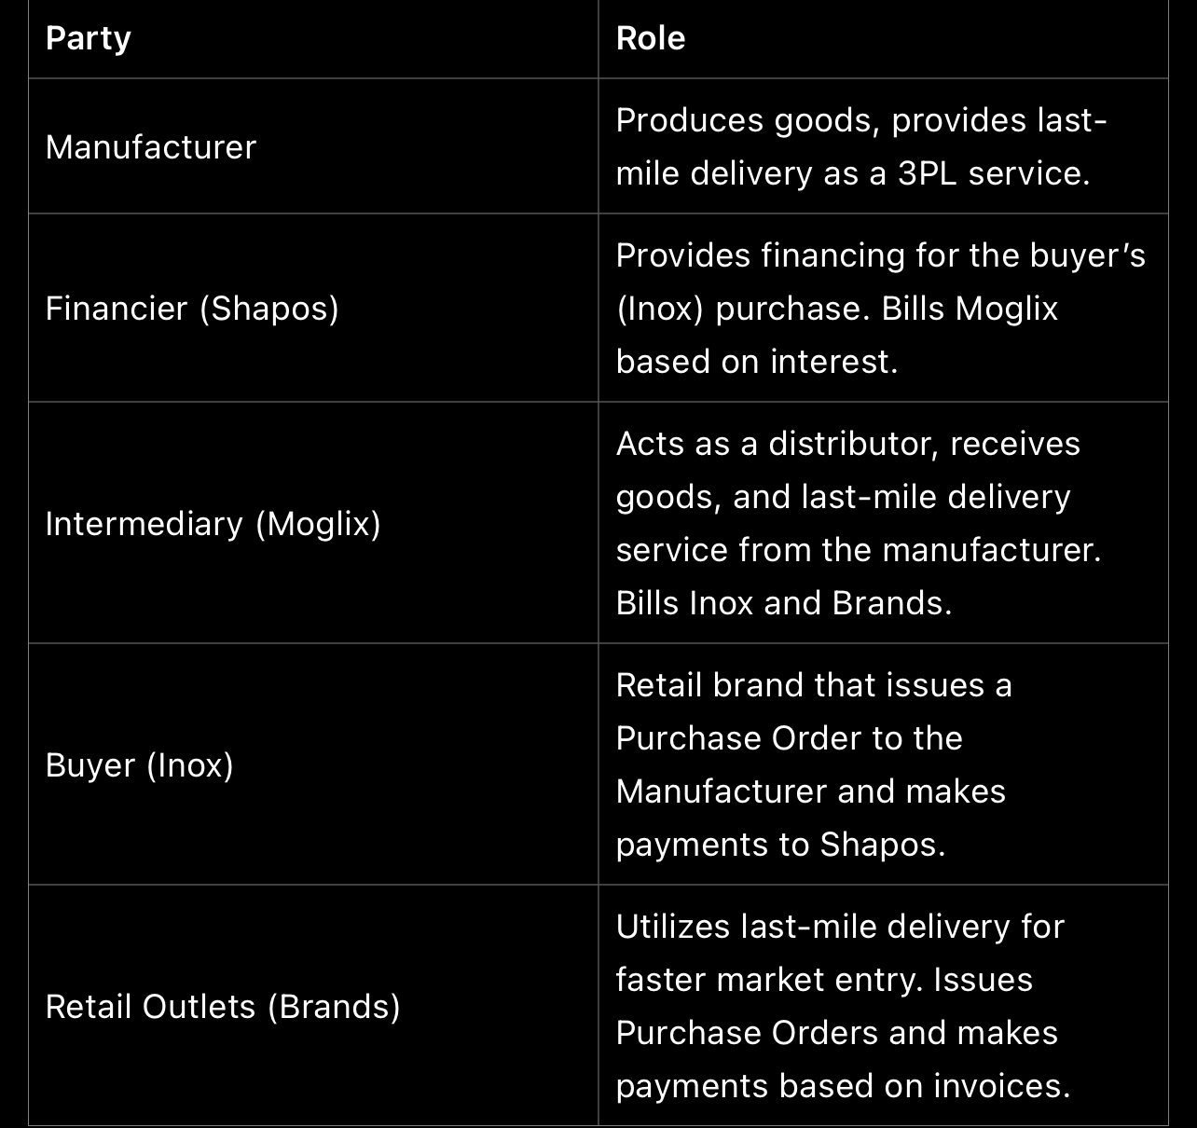

In this smaller business scenario, each party has a specific role within the supply chain. The Manufacturer produces goods and provides services, the Financier facilitates financing, the Intermediary manages distribution, the Buyer places orders, and the Retail Outlets utilize last-mile delivery services for retailing. This setup is designed for a more streamlined and efficient business

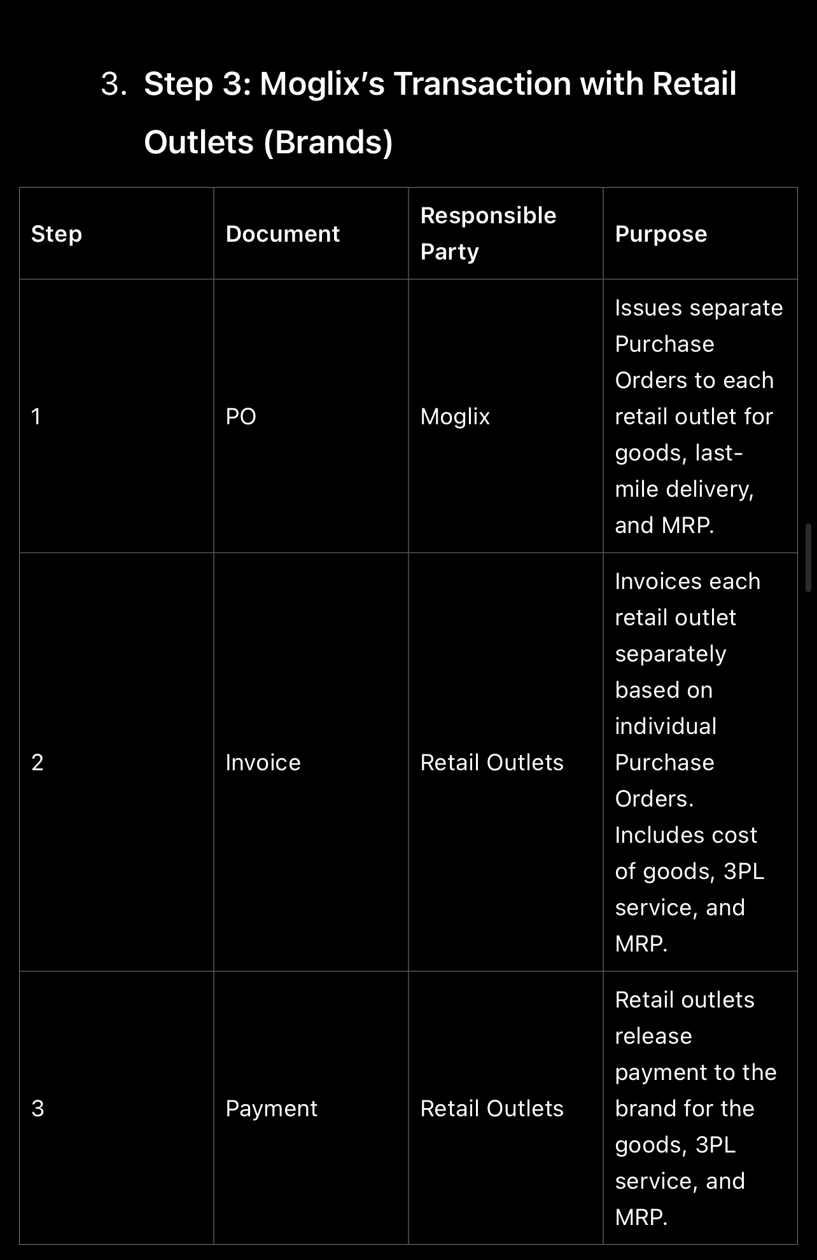 operation.

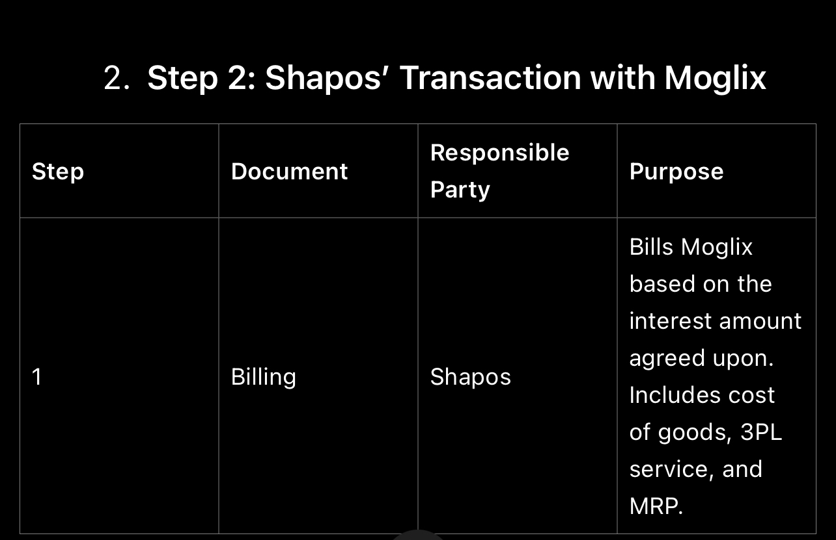

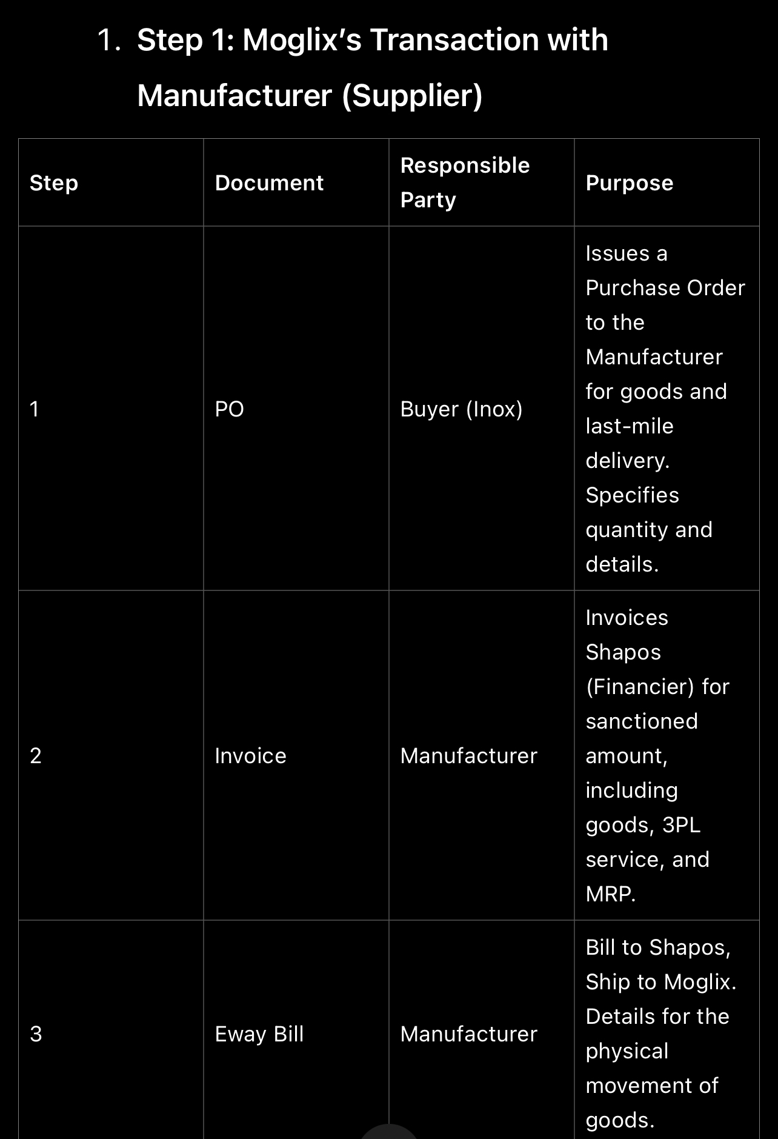

Explanation:

1. Supplier Invoice:

• Document: Purchase Order (PO) from Buyer.

• Responsible Party: Supplier or Manufacturer.

• Purpose: Billing the buyer for the delivered goods and services.

2. Financier Invoice:

• Document: Invoice from Supplier.

• Responsible Party: Financier (e.g., Shapos).

• Purpose: Charging the buyer for financing services provided.

3. Intermediary Invoice:

• Document: Billing from Financier.

• Responsible Party: Intermediary (e.g., Synnergyze).

• Purpose: Invoicing the buyer for distribution services provided.

4. Buyer Invoice:

• Document: Purchase Order (PO) from Buyer to Supplier.

• Responsible Party: Buyer (e.g., VJRIPL).

• Purpose: Billing the retail outlets for the goods ordered.

5. Retail Outlet Invoice:

• Document: Invoice from Buyer.

• Responsible Party: Retail Outlets (e.g., VOI, SLUB).

• Purpose: Charging end customers for the purchased goods.

Each type of taxed invoice serves a specific purpose in the supply chain and financial transactions, ensuring transparency and accountability at each stage.

