Dev Ops Lab 2

GitHub Link: https://github.com/Ech01ng/DevOps

Initial Commit + 2nd commit
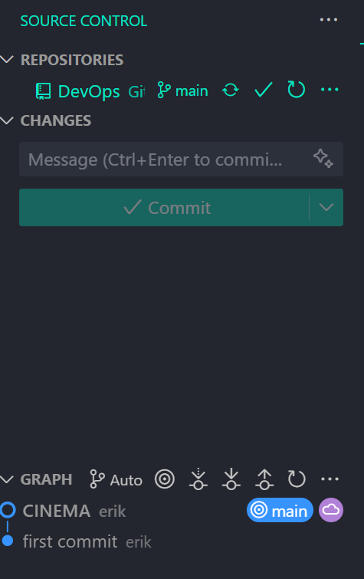

Main GitHub Page
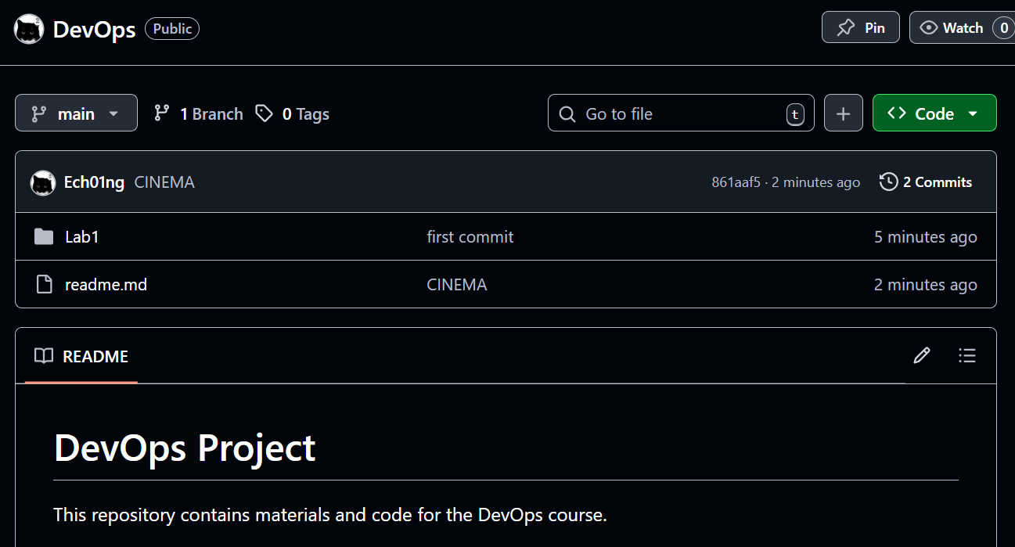

Git Log
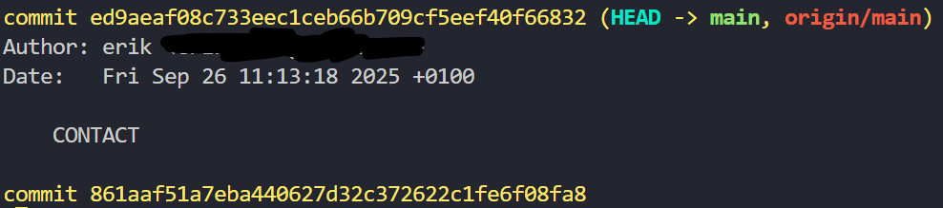

Git Diff
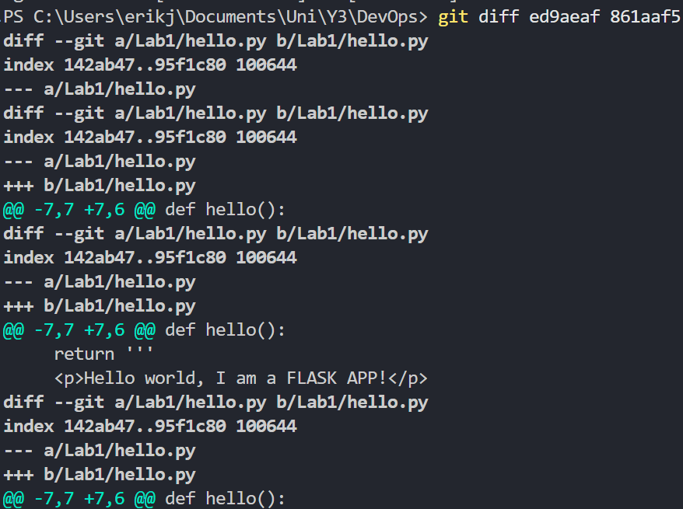

Fast Forward Merge
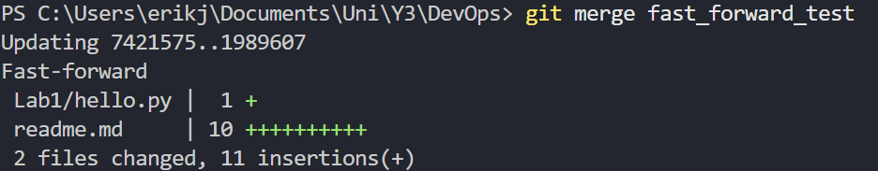

Forking
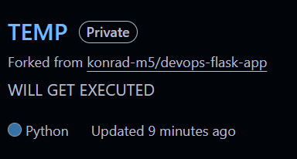

Added link to python on forked script

