|  |
| --- |
| Chukong Technologies |
| Cocos3D Getting Started |
| PC-Android |

|  |
| --- |
| Cocos3D Team |

Contens

1 Preparations 0

2 Create cocos3d-x project 1

3 Compile Android project 1

3.1 Configuration environment variable 1

3.2 Compile lib file 1

3.3 Generate apk file 2

3.4 Run 4

# Preparation

* Software：

1. Windows (In this case,we use Windows7 64 bit)
2. Jdk(In this case,jdk-7u3-windows-x64 and install to the default path)

Download:

<http://www.oracle.com/technetwork/java/javase/downloads/jdk7-downloads-1880260.html>

1. Jre (In this case, we use Jre -7u51-windows-x64)

Download: <http://www.oracle.com/technetwork/java/javase/downloads/jre7-downloads-1880261.html>

1. Ant (In this case, we use apache-ant-1.9.3 and unzip it at D:\)

Download: <https://ant.apache.org>

1. Python (In this case, we use python2.7.5 and install at C:\)

Download：<http://www.python.org/download/releases/2.7.5/>

1. Adt-bundle (In this case, we use adt-bundle-windows-x86_64-20131030 and unzip it at D:\)

Download：[http://developer.android.com/sdk/index.html#download](http://developer.android.com/sdk/index.html" \l "download)

1. NDK (In this case, we use android-ndk-r9b-windows-x86_64 and unzip it at D:\)

Download：<https://developer.android.com/tools/sdk/ndk/index.html>

* install Git (In this case we use git version 1.7.10-preview20120409)

Download: <http://git-scm.com/download/win>

Note：This step we suggest you choice third option shown below

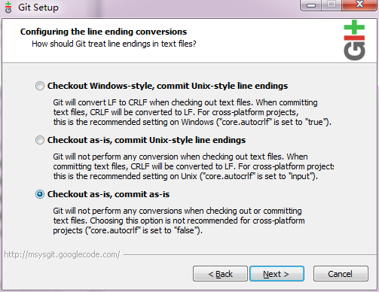

* Get cocos3d-x source from GitHub：<https://github.com/cocos2d/cocos3d-x> (in this case, we put the source into E:\)

# Create cocos3d-x project

Run windows command line and navigate to “cocos3d-x\tools\project-creator”

Input "create_project.py -project fishjoy -package com.chukong.fishjoy"

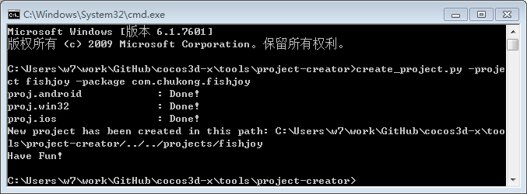

Finally, the newly created project will be located in “cocos3d-x\projects”

# Compile Android project



## Configuration environment variable

In this case, my environment variable as below:

ANDROID_SDK  D:\adt-bundle-windows\sdk

NDK_ROOT D:\android-ndk-r9b

JAVA_HOME C:\Program Files\Java\jdk1.7.0_03

Add C:\apache-ant-1.9.3\bin to Path tail.

## Compile lib file

1. Run windows command line,navigate to build\ directory,and run ”android-build.py –p 19 –b release”



The output as follows:

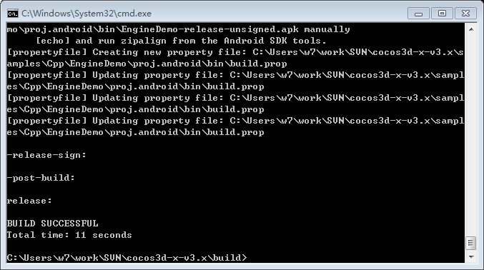

Finally ,the apk package will be generated at ”proj.android\bin”