|  |  |
| --- | --- |
| UT Austin – Astronomy Silicon Diffractive Optics Group | |
| To: | Sungho Lee, Weisong Wang, Dan Jaffe |
| From: | Michael Gully-Santiago |
| CC: | IGRINS team |
| Date: | 2/3/2011 |
| Re: | CA-1 blaze angle |
| Comments: | This document summarizes the blaze angle measurements of CA1, the IGRINS prototype immersion grating. I measure the blaze angle as **d=71.63 +/- 0.20°** (which has Dd=0.736**°)**, and agrees with **d=*R3***to within the errors. |

The IGRINS grating is intended to be *R3*, so tan-1(d)=3, and d=71.565°. We control the blaze angle by cutting the Si boule with respect to the Silicon crystal planes. The figure on the below right is copied from *Marsh et al. 2007*; the triangle is sketched for an *R3* geometry on the left. Here, *b=*d=71.565°, and C is the optically active surface.

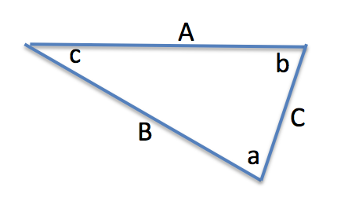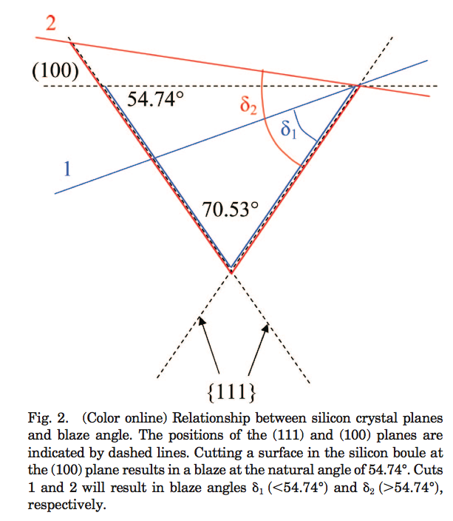

There are two ways for b to differ minutely from *R3.*

First, the finite anisotropic wet etch ratio of silicon produces a small increase, Dd in the groove apex (angle *a* in the above left). For an infinite anisotropic etch ratio, *a=*70.53° is defined by the Si crystal structure planes. Weisong Wang and others experimentally measured an anisotropic ratio of 50-100, and a=70.53°+2Dd with Dd=0.8°, and Dd defined in Figure 5 from Marsh et al. 2007 (copied on the next page for convenience).

Second, the Si boule could be cut imprecisely. In that case, the red line marked 2 in the figure in the above right produces and angle b=d which is too small or large. The specification on the angle from the vendor is +/- 0.04°, which is very small, so we are confident that the boule cutting is not our biggest problem. We anticipated the anisotropic etch angle when requesting the Si boule cut angle, so our final device would be R3 after cutting and etching.

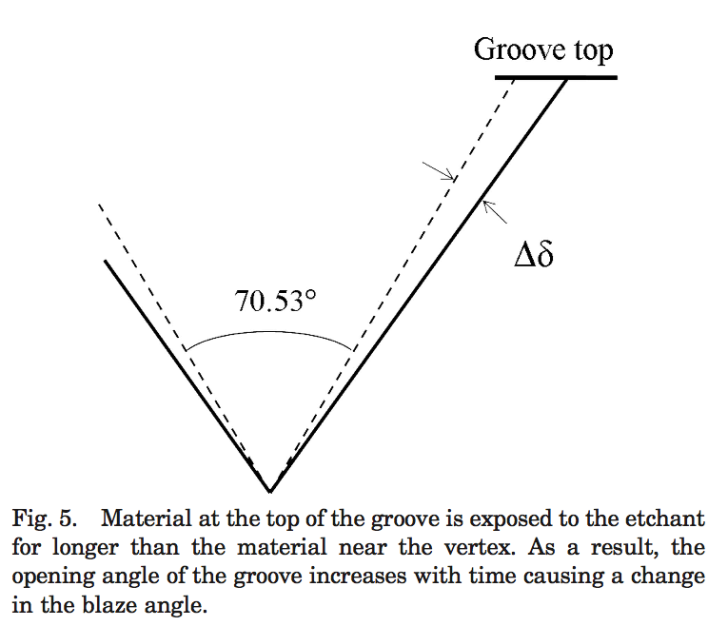

In mid December, 2010, I coarsely measured the blaze angle by counting the orders from zero to the blaze. I found that order 82 is the brightest order in Littrow reflection measurements employing lambda=632.8nm HeNe laser. That measurement placed the blaze angle firmly in the range 72.6 > d > 70.5, since otherwise orders 83 or 81 would be brightest.

On February 3, 2011, I measured the relative intensities of the orders surrounding the blaze. The relative intensities of these orders are sensitive to the blaze angle. I constructed a scalar blazed grating model, which included the Littrow geometry of the measurements, and the foreshortening of the optically active surface (*C* in Figure 1), for cases when the groove facet is shadowed by the groove top. The best agreement of model and observation occurs for **d=71.63 +/- 0.20°** (which has Dd=0.736**°)**. **These measurements are consistent with d=R3=71.57°,** (which has Dd=0.800**°)**

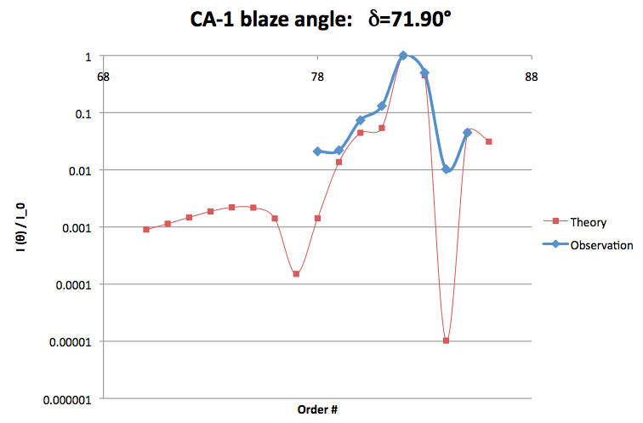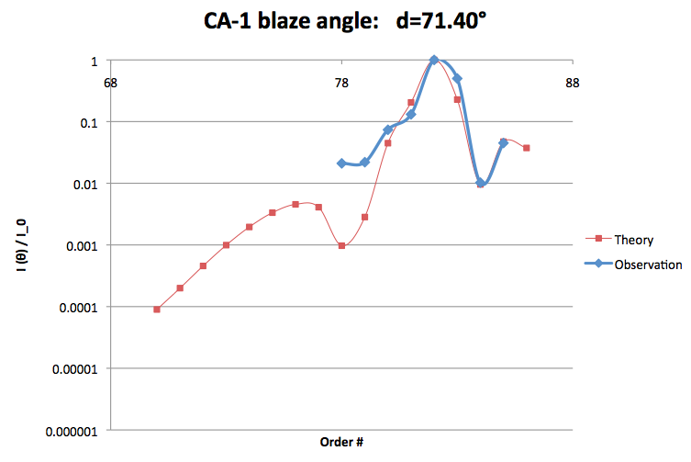

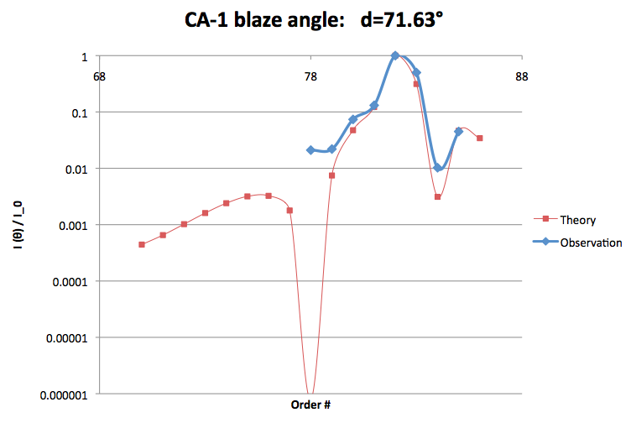

**Supplement: d=*R3***

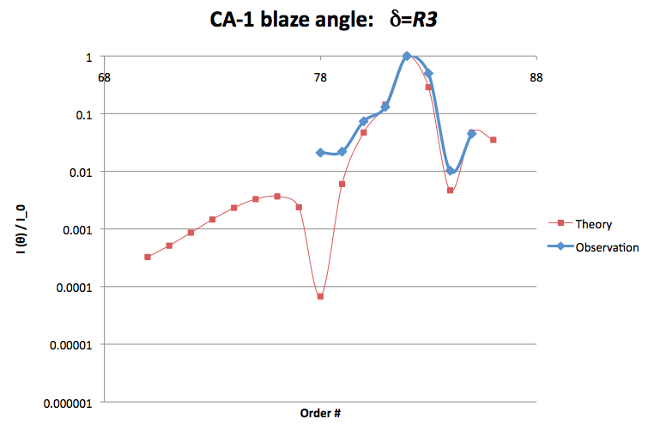

**Supplement: Example of disagreement in models and observations for extreme blaze angles.**