MANDEGAR | AUGUST 2026 / v1.0

WORKING MASTER
Award-Level Digital Experience
  - Creative direction, visual system, motion language, interaction model, production workflow and code-generator reference.
A light, cinematic, looped exhibition world in which Mandegar activates space, media, interaction and memory.
ایده‌های خوب، خاطره‌های ماندگار می‌سازند.
WONDER | INNOVATION | LUXURY | EXPERIENCE

Status of this document
This is a deliberately editable master. It locks the creative north star and experience architecture while keeping art style details, copy density, crowd representation and some technical choices open for visual prototyping. The goal is controlled evolution, not premature certainty.

00 / CREATIVE DIRECTION

How to use this master
This document separates what is fixed, what can be tuned, and what must be validated through generated keyframes and prototypes.
Decision class | Meaning
LOCKED | The core promise, target feeling, exhibition-world concept, loop structure, light/premium direction, central hero zone, activation order, real-media timing and award-level ambition.
FLEXIBLE | Exact color bursts, final typography, amount of copy, camera timing, human/particle representation, loader visual, sound design and scene duration.
OPEN TO TEST | Signature object treatment, visual style precision within semi-realistic stylized realism, mobile quality tier, WebGPU use, exact project-media transitions and AI-data visual form.
RULE | No decision becomes expensive to change unless it has passed a keyframe review, motion animatic and performance prototype.

Document map
01 Project ambition and positioning | 09 Loading, sound and loop | 17 Image-generation plan
02 Creative north star | 10 Content and multilingual copy | 18 Code-generator handoff rules
03 Reference DNA | 11 Homepage versus inner pages | 19 Acceptance criteria
04 Core world and spatial architecture | 12 CMS boundaries | 20 Decision register
05 Homepage experience arc | 13 Mobile and adaptive performance | Appendix A Reference moodboard
06 Visual art direction | 14 3D production pipeline | Appendix B Technical references
07 Motion language | 15 Technology and libraries
08 Interaction and interface | 16 Prototype and approval workflow

01 / CREATIVE DIRECTION

Project ambition and positioning
Mandegar’s website is not a brochure with decorative effects. It is a live demonstration of the experiences Mandegar can create for clients.
Business role  Mandegar delivers full event and exhibition production from concept to execution: strategy, creative direction, spatial design, technical production, content, interactive experiences, games, photo booths, installation, operation and post-event evaluation. | Market position  Iran-first and internationally ready. The site must appeal to corporate brands, luxury brands, exhibition organizers, government organizations and partner agencies, without claiming international delivery history that does not yet exist.

Primary memory  “These people are innovative, open-minded and perfect for a luxury brand that wants something extraordinary.” | Future capability  AI-enhanced event intelligence is shown as a developing capability: extracting structured event data and turning it into summaries, engagement patterns and recommendations.

Award-level ambition
The benchmark is not “a good agency site.” The benchmark is a cohesive digital art direction with distinctive composition, effortless scroll, memorable transitions, responsive interaction, strong performance and a clear original idea. The website itself must be portfolio evidence.

Success is felt before it is explained
Within three seconds, the visitor should feel wonder and recognize a premium event/exhibition world.
Within the first journey beat, the visitor should understand that Mandegar makes quiet spaces come alive.
By the full reveal, the visitor should see production, media and interaction as one designed system.
By the project-proof phase, the visitor should trust that the vision is supported by real work.
At the final invitation, contact should feel like the natural continuation of the experience.

02 / CREATIVE DIRECTION

Creative north star
A calm, pale tech expo becomes alive as Mandegar activates light, screens, media, interaction, color and audience energy.
Core concept statement
Mandegar transforms an elegant but inactive exhibition space into the most magnetic and memorable zone in the event. Light becomes structure; structure becomes experience; experience becomes memory; memory becomes measurable value.
First emotion | Wonder and innovation.
Brand character | Luxury + technology + art.
World type | Indoor tech expo, followed by luxury exhibition, futuristic premium event and immersive art-fair influence.
Representation | Recognizable and client-friendly, but art-directed enough to feel unique.
Visual style | Semi-realistic cinematic stylized realism.
Base palette | Light architectural whites and soft grays.
Activation palette | Occasional controlled full-color bursts.
Main payoff | The entire Mandegar zone lights up in one spectacular emotional reveal.
Experience structure | One continuous camera journey that also forms a complete loop.

The first three seconds
Frame 0  A very short elegant loader, rooted in the same ring-and-light language as the experience. It must show real loading progress and never impose a fake delay. | Frame 1  The camera is already moving gently into a bright indoor exhibition hall. Most of the environment is pale and quiet; a distant Mandegar zone has the smallest hint of life.

Hook  A first light trail moves through the hall toward the hero zone. One LED surface wakes, establishing cause and curiosity immediately. | Promise  The visitor instantly sees an event world, not an abstract technology demo. The mystery is what Mandegar will make happen next.

03 / CREATIVE DIRECTION

Reference DNA — borrow principles, never forms
The references define quality, pacing and feeling. They are not templates to clone.
Reference | What Mandegar learns
Lacoste Members Play | Calm light palette, refined composition, delightful buttons, interaction polish and motion that feels effortless. Use: tactile micro-interactions, premium spacing, smooth responsive transitions. Avoid: copying visual motifs or product identity.
Noomo Showcase | Camera travel through space, spatial depth and controlled movement. Use: deliberate camera path and scene reveals. Avoid: making movement the concept by itself.
Ciao Energy | Strong core idea, integrated render and lighting, smooth scroll-to-animation relationship. Use: one clear metaphor and continuous timing. Avoid: unrelated effects between sections.
IGLOO | Loop structure, loading as part of the experience, bold color, playful transitions, unusual camera movement and high visual confidence. Use: cohesive world-building and return-to-start logic. Avoid: cloning its objects, colors or layout.
Corn Revolution | Interactive typography, playful scroll, strong 3D presence and confident art direction. Use: text that participates in the scene and unexpected but controlled interaction. Avoid: humor or surrealism that conflicts with Mandegar’s luxury positioning.
Originality rule
Every borrowed principle must be translated through Mandegar’s own business truth: a premium event zone that activates and attracts people. If an effect cannot be explained through that idea, it does not belong.

04 / CREATIVE DIRECTION

Core world and spatial architecture
One hero Mandegar zone sits inside a spacious indoor exhibition hall, with clearly readable but secondary modules attached around it.
Hero architecture | A rounded, modular hybrid expo island combining pavilion, stage, immersive booth and event zone.
Primary anchor | A suspended circular lighting ring / halo over the center. It is quiet at first and becomes the emotional heart of the full reveal.
Central stage | Balanced between architectural presence, media display and show/performance function.
Media system | Large LED wall, curved screen and additional media surfaces integrated into the architecture.
Attached modules | Photo booth, custom game station, touch table, immersive display, audience-engagement pocket and branded entrance/signage.
Audience representation | Subtle abstract figures at first; more activity later. Prefer particles, shadows, point clusters or stylized translucent traces over heavy realistic 3D people.
Material character | Matte architectural surfaces with minimal translucent and metallic accents only where functionally useful.
Scene density | Very minimal and clean. Every object must have narrative or production meaning.
Spatial hierarchy  The hero zone must remain readable from every key camera angle. Attached zones support the story but never compete with the central ring, stage and media surfaces. | Buildability  Although stylized, the architecture should feel physically plausible enough that a client can imagine Mandegar producing it in the real world.

Modularity  Model the world as replaceable GLB modules so the ring, stage, media walls, booths and audience elements can be redesigned independently. | Loop geometry  The camera path and hall composition must permit a seamless transition from the final invitation back to the arrival view without a visible reset.

05 / CREATIVE DIRECTION

Homepage experience arc
The journey is calm and easy, not short for the sake of being short. Duration follows the experience, but every beat must justify its scroll distance.
# | Phase | Visual state | Motion / interaction | Purpose
0 | Loader | A thin ring, spark or sequence of waking segments; minimal and immediate. | Real progress drives the loader; transition opens into the hall. | Build anticipation without hiding slowness.
1 | Arrival | Wide indoor expo, pale and quiet; Mandegar zone visible ahead. | Slow floating camera entry; side navigation remains available. | Immediate recognition + curiosity.
2 | Discovery | Light trails lead toward the hero island; halo and first screen hint at life. | Camera approaches; subtle pointer parallax; first text beat. | Establish Mandegar as the source of activation.
3 | Activation | Screens wake one by one; media walls, booths and signage begin responding. | Scroll controls rhythmic activations; micro-pauses create anticipation. | Show the full service ecosystem coming online.
4 | Full reveal | Ring, stage, screens, color and audience energy activate together. | One dramatic camera reveal and controlled full-color burst. | The main emotional wow moment.
5 | Real proof | Real Mandegar projects appear inside LED walls and curved media surfaces. | Media transitions, subtle interaction and 3 featured projects. | Convert wonder into trust.
6 | Intelligence | Event activity becomes data lines, nodes and diagrammatic insights. | Particles and signals reorganize into clear data forms. | Introduce AI/event intelligence honestly.
7 | Invitation + loop | The energy condenses, contact CTA appears, then the scene returns to the arrival state. | Pause for CTA; loop transition reuses the ring/light language. | Turn emotion into action and complete the art piece.

05A / CREATIVE DIRECTION

Experience detail — arrival through full reveal
The first half must prove that the space, motion and interaction are one system rather than static content over a canvas.
0 — Loader  A minimal ring or segmented line represents actual asset progress. A small pulse travels around it; segments can wake like future LED screens. At completion, the ring expands or aligns with the suspended halo in the hall. Loader target: visible instantly, no fake 0–100 animation. | 1 — Arrival  The camera glides into a bright indoor expo at eye-level or slightly elevated. The hall is elegant and largely desaturated. Side navigation allows exit at any time. Copy is minimal: one quiet statement, not a wall of text.

2 — Discovery  A light trail becomes the guide. The ring is recognized; a single LED screen wakes. Small secondary modules become legible through controlled lighting, not labels everywhere. | 3 — Activation  Screens wake one by one in a deliberate rhythm. Then media walls, interactive modules, signage and abstract audience signals activate. Each response should have a different but related motion signature.

4 — Full reveal  The ring energizes, the entire zone lights up, and a controlled full-spectrum burst moves through the architecture. The camera makes one dramatic reveal—never a constant orbit. This is the moment that should be captured in award submissions and hero video. | Text choreography  Each phase uses at most one short statement. Text enters, contributes, and leaves. It never remains as a static editorial layer across multiple scene states.

Activation order — locked
Light trails → LED screens → media walls → interactive booths → signage/branding → audience movement → total-zone reveal.

05B / CREATIVE DIRECTION

Experience detail — proof, intelligence and loop
The second half shows real capability, future value and a satisfying return to the beginning.
5 — Real project proof  Three featured projects appear only after the zone is fully active. Media is integrated into actual LED/curved screen geometry, not placed as floating generic cards. The active project may move from scene surface to a clean full-frame view and back. | Project interaction  Scroll selects the narrative project; pointer/touch adds subtle depth or reveals metadata. A separate Projects page holds the full archive and filters.

6 — Event intelligence  Visitor signals, booth activity, games and media interactions become nodes and lines. The scene shifts from cinematic space to a clearer diagrammatic language while preserving the same color and ring geometry. | AI positioning  Show engagement patterns, summaries, feedback and future recommendations as a developing capability. Avoid product-dashboard claims or invented results.

7 — Invitation  The data and color resolve into a calm final composition. The message invites the visitor to imagine the next event together. Primary action: Start a Project; sales call and WhatsApp are immediate options. | Complete loop  After a readable pause, the ring/light system folds back into the arrival state. The loop should feel intentional and optional—not trap the user or hijack navigation.

Provisional Persian anchor lines
ایده‌های خوب، خاطره‌های ماندگار می‌سازند. | Good ideas create lasting memories.
رویداد بعدی خود را تصور کنید. | Imagine your next event.
تجربه را زنده می‌کنیم. | We bring the experience to life.
داده‌های رویداد، بینش برای آینده. | Event data, insight for what comes next.
بیایید رویداد بعدی شما را با هم تصور کنیم. | Let’s imagine your next event together.

06 / CREATIVE DIRECTION

Visual art direction
Recognizable premium realism, art-directed through composition, materials, light and controlled color rather than abstraction for abstraction’s sake.
Dimension | Direction
Style family | Semi-realistic cinematic stylized realism.
Composition | Minimal, spatial, architectural and editorial. Large negative space around one clear focal action.
Surfaces | Matte architectural whites and grays. Very limited glass/translucency. Fine metallic details only as accents.
Lighting | Controlled exhibition lighting: clean white base, soft pools of illumination, strong but selective activation moments.
Color behavior | The world is mostly pale. Full color appears in short, high-value bursts around screens, light trails and the full reveal.
Typography | Clean modern type with occasional large statements. Persian is designed as primary, not treated as translated English.
Branding | Subtle and premium. Mandegar naming appears through spatial signage, screen content and interface, not large repeated logos.
People | Abstract and lightweight: point-cloud silhouettes, soft particle figures, translucent motion traces, shadows or 2.5D cutouts. Final choice follows generated concept art and performance tests.
Warm White  #F7F7F4  base | Soft Fog  #E8EBEA  surface | Charcoal  #16191D  type | Cobalt  #225CFF  core signal | Cyan  #50C7FF  light | Magenta  #D95CFF  burst | Amber  #FFB54A  burst
Color rule
Cobalt is the persistent Mandegar signal. Cyan, magenta, amber and other colors appear as controlled event energy—never as a constant rainbow skin.

07 / CREATIVE DIRECTION

Motion language
Smoothness is not a plugin. It is the combined result of pacing, camera choreography, easing, rendering stability, input response and visual continuity.
Camera grammar  Slow and floating most of the time. Use a few deliberate dramatic moves: the entrance alignment, full reveal, project-media approach and final loop return. Avoid continuous orbiting and mouse-driven spinning. | Scroll rhythm  Scroll should feel calm, easy and responsive. Use long breathing zones, short activation beats, small moments of settle, and one major reveal. Not every property should be mechanically scrubbed.

Transition families  Light-path continuation; architectural assembly; screen wake; media-surface expansion; particle reorganization; ring alignment; controlled color wash. Reuse these families so the whole site feels authored by one system. | Easing  Prioritize smooth ease-in/out and physical settle. Reserve sharper acceleration for screen wakes and the total-zone activation. No bounce unless a playful interactive module specifically justifies it.

Typography motion  Short statements enter through depth, mask or light reveal; remain still long enough to read; then dissolve or move with the scene. Avoid generic fade-up on every section. | Buttons  Apple-like subtle: small magnetic response, micro-depth, animated border/arrow, precise focus state and immediate touch feedback. No oversized glow or noisy hover particles.

Interaction response  Pointer adds local parallax and surface response. Touch receives the same core visual beats without depending on hover. | Frame ownership  Each animated property must have one owner. Do not let GSAP, Theatre.js and R3F state fight over the same camera/object transform.

Motion review rule
A motion prototype is approved only when viewed as a screen recording at normal speed on desktop and a real phone—not from code, timelines or individual screenshots.

08 / CREATIVE DIRECTION

Interaction and interface
The user is free to explore, skip or leave the cinematic journey at any time. The experience must feel inviting, never controlling.
Primary input | Native vertical scroll mapped to the experience timeline.
Pointer | Subtle parallax, local light response and media depth only.
Touch | The same narrative and wow beats; no feature depends on hover.
Side navigation | Persistent minimal side controls link to Projects, Services, About and Contact at any time.
Progress | A quiet phase indicator may communicate position without turning the experience into slides.
CTA | Start a Project opens a compact contact layer or route with sales call, WhatsApp and general contact.
Language | Persian default; English and Arabic accessible from a minimal language control. Persian and Arabic use full RTL behavior.
Sound | Muted by default. A clear “Enable sound” control activates subtle ambient and interaction audio only after user input.
Accessibility | Keyboard access, visible focus, reduced-motion mode, semantic DOM content, no-WebGL fallback and readable contrast remain mandatory.
UI presence  Interface chrome should be extremely light: brand, side navigation, language, sound and progress. The scene remains the main interface. | No hidden content  All essential company information and contact paths remain available without completing the journey, enabling SEO, accessibility and impatient visitors.

09 / CREATIVE DIRECTION

Loader, optional sound and complete loop
The beginning and end are part of the same artwork. Loading must be fast, truthful and visually connected to the hero ring.
Loader concept  A small cobalt signal travels around a thin segmented ring. Segments wake in response to real asset progress. At completion, the ring scales or aligns into the suspended exhibition halo, revealing the hall. | Fast-entry strategy  Render HTML, typography and loader immediately. Load the arrival scene first; progressively stream later modules, media and high-quality textures. Never wait for all project videos before entering.

Sound palette  Optional ambient hall tone, soft electrical pulses as screens wake, a restrained low-frequency reveal, and delicate interface cues. No autoplay; no essential information in sound. | Loop transition  At the end, data points and project light condense into the ring signal. Camera and environment return to the arrival pose while the CTA remains readable long enough before the loop restarts.

Loop controls  Loop may continue visually, but scrolling/navigation remains normal. Provide a replay or return-to-start affordance if needed after testing. | Test variables  Loader form, exact reveal sound, loop duration and CTA pause remain flexible until keyframes and animatic are approved.

10 / CREATIVE DIRECTION

Content and multilingual copy
The homepage communicates through image and motion first. Copy is short, precise and editable; inner pages carry detail.
Persian | Primary/default language, fully art-directed for RTL composition and native reading rhythm.
English | International positioning and partner/business development.
Arabic | Gulf-region readiness, full RTL, no claims of completed international work.
Homepage density | Start with one short statement per phase as the baseline. Test fewer or slightly richer beats against visual clarity.
Project proof | Three featured projects in the journey; full archive and filters on Projects.
Claims | No invented metrics, client names, international projects, AI product maturity or legal statements.
Editorial principle | Every line must either orient, explain capability, create emotion or invite action.
Editable copy without breakable layout
CMS fields must define character guidance and preview warnings. Large statement slots, supporting line slots and CTA slots are controlled—not unlimited rich text that can destroy composition.

11 / CREATIVE DIRECTION

Homepage versus inner pages
The homepage is the award-level experience piece. Inner pages are refined, fast editorial tools that convert interest into trust and contact.
Homepage | Persistent 3D/2.5D exhibition journey, looped camera path, real project media, interaction, AI/data transition and final invitation.
Projects archive | Fast CMS-driven grid/list, filters, strong thumbnails, subtle hover motion and excellent mobile usability.
Project detail | Editorial case study: context, challenge, approach, scope, services, media, results, credits and related work.
Services | Clear capability structure: events, exhibitions, content, interactive experiences, games, photo booths, technology, production and future intelligence.
About | Positioning, philosophy, team and production approach.
Contact | Immediate sales phone, WhatsApp, general inquiries, minimal optional form and location/social details.
Legal | Localized, editable and approved privacy/terms/media-rights content.
Shared identity  Inner pages use the same palette, typography, buttons, light trails and media treatment, but do not reproduce the heavy homepage scene. | Shared quality  Static does not mean dead. Use restrained page transitions, image reveals, cursor/touch feedback and excellent typography—while prioritizing speed and clarity.

12 / CREATIVE DIRECTION

CMS boundaries and editability
Content must be easy to change, while the cinematic structure remains protected from accidental editorial breakage.
CMS-managed | Projects, categories, services, project media, homepage statements, featured-project selection/order, AI wording, CTAs, contacts, clients, social links, SEO and all three languages.
Code/scene-managed | Core phase order, camera architecture, ring/zone scene graph, activation sequence, transitions, performance tiers and interaction logic.
Developer-configurable | Design tokens, phase timing, camera keyframes, object visibility, media slots, color-burst intensity, quality thresholds and feature flags.
Protected editor model | Use controlled homepage slots rather than arbitrary drag-and-drop blocks. Editors can swap content without changing the journey’s logic.
Preview | Sanity preview must show localized copy and selected media inside the real composition before publication.
Replaceability | All final brand colors, typefaces, logo assets and contact details must be replaceable without architectural rewrite.
Core editability architecture
Externalize visual constants into design tokens, scene configuration, Theatre/animation state, CMS references and quality profiles. Avoid magic numbers scattered across components.

13 / CREATIVE DIRECTION

Mobile and adaptive performance
Mobile should feel like the same artwork—not a separate lesser website—but it must adapt complexity, camera framing and asset quality intelligently.
One experience, adaptive execution  Use one narrative, one content model and one scene architecture. Adapt camera path, visible modules, particles, texture resolution, DPR and video quality by aspect ratio and capability. Avoid maintaining two unrelated sites. | Mobile priority  Most visitors may arrive on phones. Design keyframes for portrait early, verify thumb-friendly navigation, and make the full reveal readable without tiny distant geometry.

Progressive scene  Entry loads the hall, hero zone silhouette, ring and first screen. Attached zones, project media and AI elements stream later. The experience begins before the full asset set is ready. | Fallbacks  Reduced motion, Save-Data and no-WebGL modes preserve the same story using stills, short video, SVG and DOM—not generic placeholder pages.

Budget / rule | Initial target
Critical loader/UI transfer | Target under 250–350 KB compressed before heavy 3D/media chunks.
Arrival scene transfer | Target under 1.5 MB mobile / 2.5 MB desktop after compression.
Total core GLB scene | Starting target under 5 MB mobile / 8 MB desktop, loaded progressively.
Texture policy | KTX2/WebP/AVIF, power-of-two only when required, conservative resolution, no unused maps.
Video policy | Poster first; no autoplay download for off-screen media; 720p mobile and 1080p desktop variants where justified.
Rendering | Capped DPR, minimal real-time shadows, baked lighting, instancing, merged static meshes and on-demand rendering when the scene is idle.
Frame goal | Aim for stable 60 fps on representative modern devices; gracefully reduce quality before falling below a usable 30–45 fps range.
Measurement | Profile on real iOS Safari and Android Chrome with realistic media and throttled networks before visual lock.

14 / CREATIVE DIRECTION

3D production pipeline — 3ds Max to GLB
The scene should be art-directed in 3ds Max, exported as modular GLB assets, then optimized reproducibly for the web.
Authoring tool | 3ds Max.
Export format | GLB/glTF through the Real-Time Exporter using glTF-compatible materials.
Scene scale | Meters, consistent scale, centered logical pivots, transforms reset/frozen before export.
Module naming | hall_, hero_, ring_, stage_, led_, booth_, photo_, game_, touch_, signage_, audience_, fxAnchor_.
Hierarchy | Separate logical modules for independent loading, replacement, LOD and animation.
Materials | Small reusable PBR material set; avoid unique heavy materials for every object.
Lighting | Bake static contribution where possible. Export light anchors or metadata, but recreate runtime lights intentionally.
Media surfaces | Named meshes with clean UVs and known aspect ratios for video/image textures.
Animation | Use model animation only where it belongs to the asset. Camera and main scene choreography remain external and editable.
Optimization | Inspect and process with glTF Transform; prune, deduplicate, simplify selectively, apply Meshopt/Draco as tested, and compress textures.
3ds Max delivery checklist  Clean topology, sensible segment counts on rounded forms, no hidden geometry, no unused materials, no giant textures, correct normals/tangents, preserved pivots and a reference screenshot for expected appearance. | Web delivery checklist  GLB file size recorded, draw calls inspected, texture memory estimated, mobile LOD verified, media surfaces tested, color space correct, and visual comparison approved against the 3ds Max render.

15 / CREATIVE DIRECTION

Technology and libraries
Use a production-ready React/WebGL stack, but treat tools as means to achieve the approved art direction—not as the source of the concept.
Tool | Role and constraint
Next.js App Router + TypeScript | Routing, server-rendered editorial pages, localized layouts, SEO, image/media delivery and deployment structure.
React Three Fiber + Three.js | Persistent scene graph and integration of 3D with React.
Drei | useGLTF/useKTX2, loaders, staging helpers, instances/merged geometry and other tested R3F abstractions.
GSAP + ScrollTrigger | Primary mapping of native scroll progress to DOM, scene phases, transitions and media states.
Lenis | Optional smooth-scroll layer. Use only when real-device tests show improved feel without harming accessibility, touch or browser behavior.
Theatre.js + @theatre/r3f | Recommended authoring tool for camera, light and object choreography during visual development. Let GSAP drive sequence position or use Theatre as the property owner—never both on the same property. Run on one RAF loop.
Sanity Studio | Structured multilingual content, featured projects, contacts, SEO and protected homepage slots.
glTF Transform CLI | Reproducible GLB inspection, pruning, deduplication, geometry compression and texture optimization.
Playwright | Functional, accessibility and visual-regression checks for keyframes, routes and responsive states.
Lighthouse CI + real-device profiling | Performance guardrails; synthetic tests are not a substitute for iOS/Android review.
Optional WebGPU path | Three.js WebGPURenderer can fall back to WebGL2, but WebGPU must remain an enhancement until the project’s device matrix and effects are proven. Do not make award ambition depend on an experimental-only path.
Recommended animation ownership
Best starting architecture: Theatre.js authors the 3D camera/light/object sequence; GSAP/ScrollTrigger maps scroll progress to Theatre sequence position and controls DOM/media transitions. A single RAF loop keeps R3F, GSAP, Lenis and Theatre synchronized.

16 / CREATIVE DIRECTION

Prototype and approval workflow
The project should remain editable because some decisions can only be judged when seen in context. Iteration is a feature of the process, not a failure of planning.
Gate | Deliverable
1. Creative lock | Approve this concept, spatial system and emotional arc. Do not code final visuals yet.
2. Keyframe generation | Generate desktop and portrait images for loader, arrival, activation steps, full reveal, project proof, intelligence and loop.
3. Style selection | Choose material realism, crowd representation, color-burst character, typography and ring design from visual comparisons.
4. Motion animatic | Create a low-cost video/animatic from keyframes defining camera path, timing, screen wakes, reveal and loop.
5. Technical spike | Prototype only the hall, ring, one screen, one light trail and the loop on representative phones.
6. Asset production | Build modular 3ds Max assets and optimize them through the GLB pipeline.
7. Experience build | Implement phases sequentially. Each phase must pass visual, motion and performance review before the next.
8. Content integration | Add three real projects, trilingual copy, contact data and CMS preview.
9. Polish and awards | Tune easing, sound, micro-interactions, fallback modes, page transitions and submission capture.
Change-friendly implementation  Scene phase values, camera paths, timing, colors, media slots and quality rules must be centralized. A changed decision should alter configuration or one module—not trigger a rewrite. | Review artifact per gate  Every gate produces something visible: keyframe, storyboard, animatic, browser build or real-device recording. Textual “done” reports are not acceptance evidence.

17 / CREATIVE DIRECTION

Image-generation plan
The next deliverable is a comprehensive visual package that leaves the code generator very little room to invent the design.
ID | Image | Purpose
A1 | Visual world board | Hall architecture, matte materials, controlled white lighting, rounded modular geometry.
A2 | Hero-zone design board | Ring, stage, LED wall, curved screen and attached modules from 3–4 angles.
A3 | Color activation board | Pale base plus controlled cobalt/full-spectrum burst alternatives.
A4 | Audience style board | Particle silhouettes, point clouds, shadows, translucent figures and 2.5D cutouts.
K0 | Loader | Progress ring and transition into the hall.
K1 | Arrival wide | Camera entering the quiet tech expo.
K2 | Discovery | First light trail and one waking screen.
K3a–K3d | Activation sequence | Screens wake one by one; media walls, booths, signage and audience follow.
K4a–K4c | Full reveal | Before, peak color/light, and settled premium final state.
K5a–K5c | Real project proof | Three real projects integrated into LED walls and a clean media transition.
K6a–K6c | Intelligence | Signals become data, diagram view, and insight composition.
K7a–K7c | Invitation and loop | Final CTA, energy condensation and return to arrival.
M1–M8 | Portrait/mobile keyframes | Same core phases composed for mobile, not cropped desktop frames.
UI1 | Interface board | Navigation, language, sound, progress, buttons and contact layer.
T1 | Typography board | Persian-first title scales, English/Arabic pairing and interactive text treatment.
Image prompt rule
Every image prompt must state that it is a keyframe from the same continuous world, include the previous approved keyframe as a reference, and specify camera position, active modules, lighting state, color level, audience level and UI/text presence.

18 / CREATIVE DIRECTION

Code-generator handoff rules
The generator receives this document, the approved image pack, motion animatic, real project media and GLB modules. It must implement, not reinterpret.
Inspect the existing repository, but do not treat current visuals as approved merely because architecture or tests exist.
Reproduce approved keyframes at named scroll checkpoints before adding intermediate effects.
Use a persistent main scene and explicit phase state machine/configuration.
Integrate DOM text and real media with the scene; do not overlay permanent editorial sections on a decorative canvas.
Centralize design tokens, scene timing, camera data, media slots and quality profiles.
Build the loader and arrival phase first; validate on mobile before expanding the scene.
Implement the activation order exactly unless a reviewed visual test changes it.
Use three real featured projects in scene; keep the full archive on inner pages.
Preserve semantic DOM, keyboard access, reduced motion and no-WebGL content parity.
Do not declare completion based on installed libraries, passing tests or existence of scene states. Completion is visual match, motion quality and real-device performance.
Required progress report
For each milestone: files changed, browser URL, exact phase implemented, reference keyframes matched, assets still temporary, performance measurement, desktop recording and mobile recording.

19 / CREATIVE DIRECTION

Acceptance criteria and award readiness
The result must be judged as an experience, a brand tool and a production website at the same time.
Criterion | Pass condition
Concept clarity | A first-time visitor understands that Mandegar activates complete events and exhibitions without reading a service list.
First-three-second hook | The hall, camera movement, light trail and first screen create immediate wonder.
Cohesion | Visuals, motion, text, buttons, loading, media and loop feel from one authored world.
Main reveal | The total-zone activation is spectacular, emotional and smooth on target desktop and mobile devices.
Project proof | Real work is integrated into the scene clearly and remains editable through CMS selection.
Interaction | Scroll is smooth and responsive; pointer/touch effects are subtle and purposeful.
Loop | The ending returns to the start without an obvious reset or broken scroll state.
Mobile | Portrait composition preserves the same story and wow moment with adaptive complexity.
Performance | Fast useful first frame, progressive loading, stable frame pacing and no unnecessary media download.
Accessibility | Keyboard, reduced motion, semantic content, contrast, captions and fallback mode pass manual and automated review.
Originality | No section looks like a direct copy of a reference website.
Editorial use | Projects, translations, contacts and homepage content can change without breaking the cinematic structure.
Award package | Clean hero recording, mobile recording, case study narrative, process visuals and technical-performance evidence are available.

20 / CREATIVE DIRECTION

Decision register
This register keeps the project decisive without pretending every artistic choice is final before visual testing.
Status | Decision
LOCKED — Brand feeling | Wonder, innovation, luxury-ready, open-minded and unique.
LOCKED — Core world | Bright indoor tech expo with one hero Mandegar zone and secondary attached modules.
LOCKED — Spatial language | Rounded + modular; matte architectural surfaces; suspended ring.
LOCKED — Journey | Loader → arrival → discovery → activation → full reveal → real proof → intelligence → invitation → complete loop.
LOCKED — Activation | Trails → screens → media walls → booths → branding → audience → full reveal.
LOCKED — Media timing | Three real projects appear after full activation, integrated into LED surfaces.
LOCKED — Interface | Subtle Apple-like UI, side navigation, Persian default, optional sound.
FLEXIBLE — Duration | As long as the experience needs while remaining calm, easy and free of filler.
FLEXIBLE — Copy density | Start minimal; validate through keyframes and readability tests.
FLEXIBLE — Color burst | Controlled full-spectrum alternatives will be selected from generated images.
OPEN — People style | Particles, point clouds, shadows, translucent traces or another lightweight stylization.
OPEN — Loader form | Ring/segment concept is preferred but must be designed through image and motion tests.
OPEN — Runtime renderer | WebGL2 baseline; WebGPU only if capability and performance testing justify it.
OPEN — Animation authoring | Recommended Theatre.js + GSAP ownership model; final decision after technical spike.
RULE — Changeability | No visual decision may be hardcoded across the project. Tokens, scene config, modules and content slots must support iteration.

A / CREATIVE DIRECTION

Reference moodboard — IGLOO screenshots supplied by the user
These images communicate color confidence, looped-world feeling, interactive UI, visual continuity and camera-led experience. They are inspiration only and must not be copied.
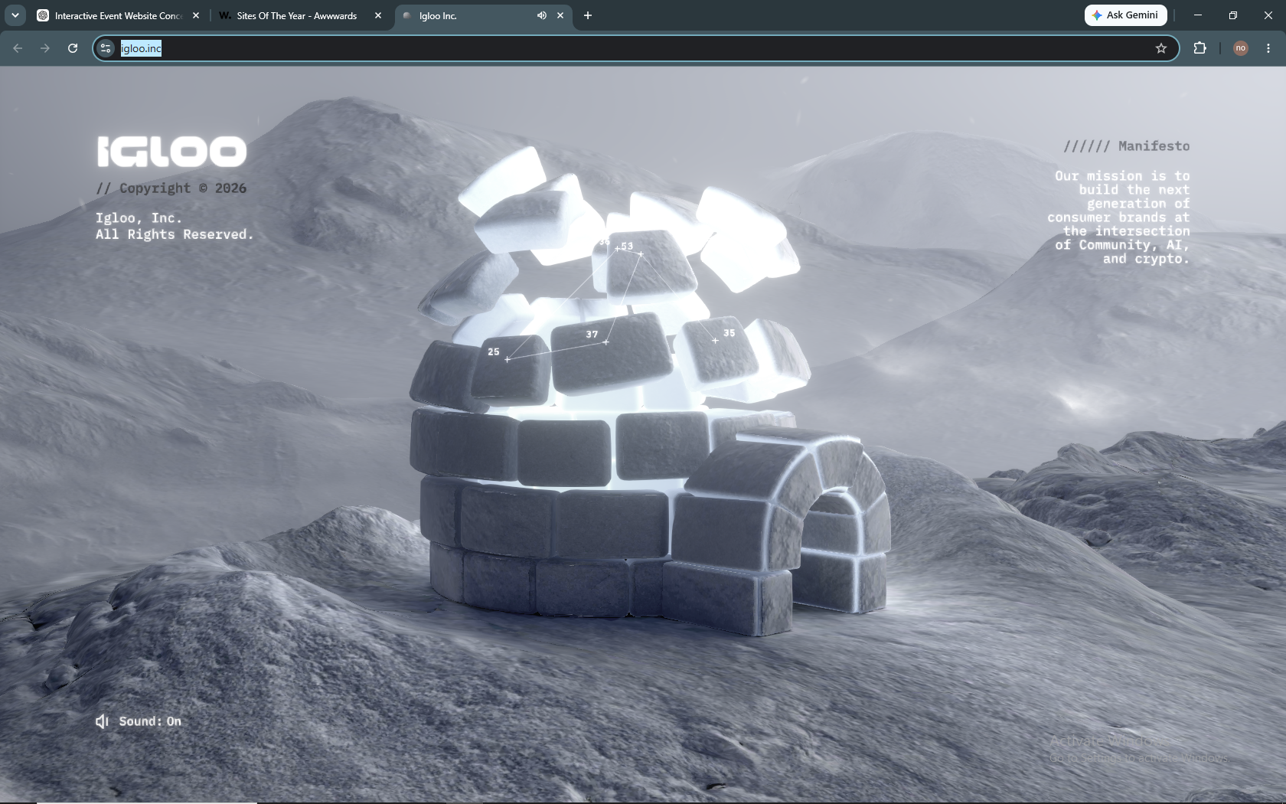 | 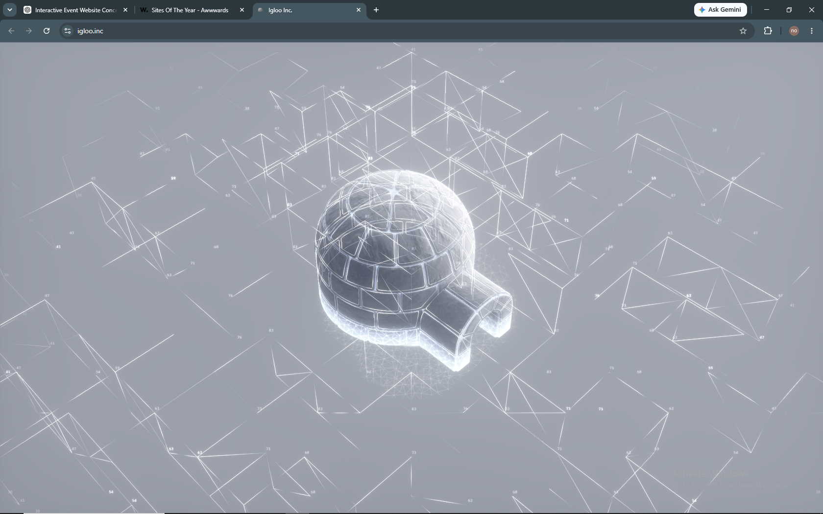

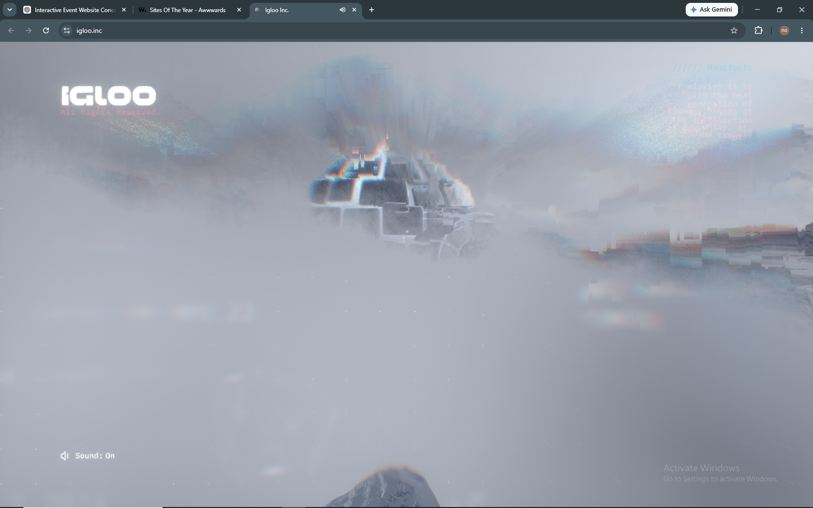 | 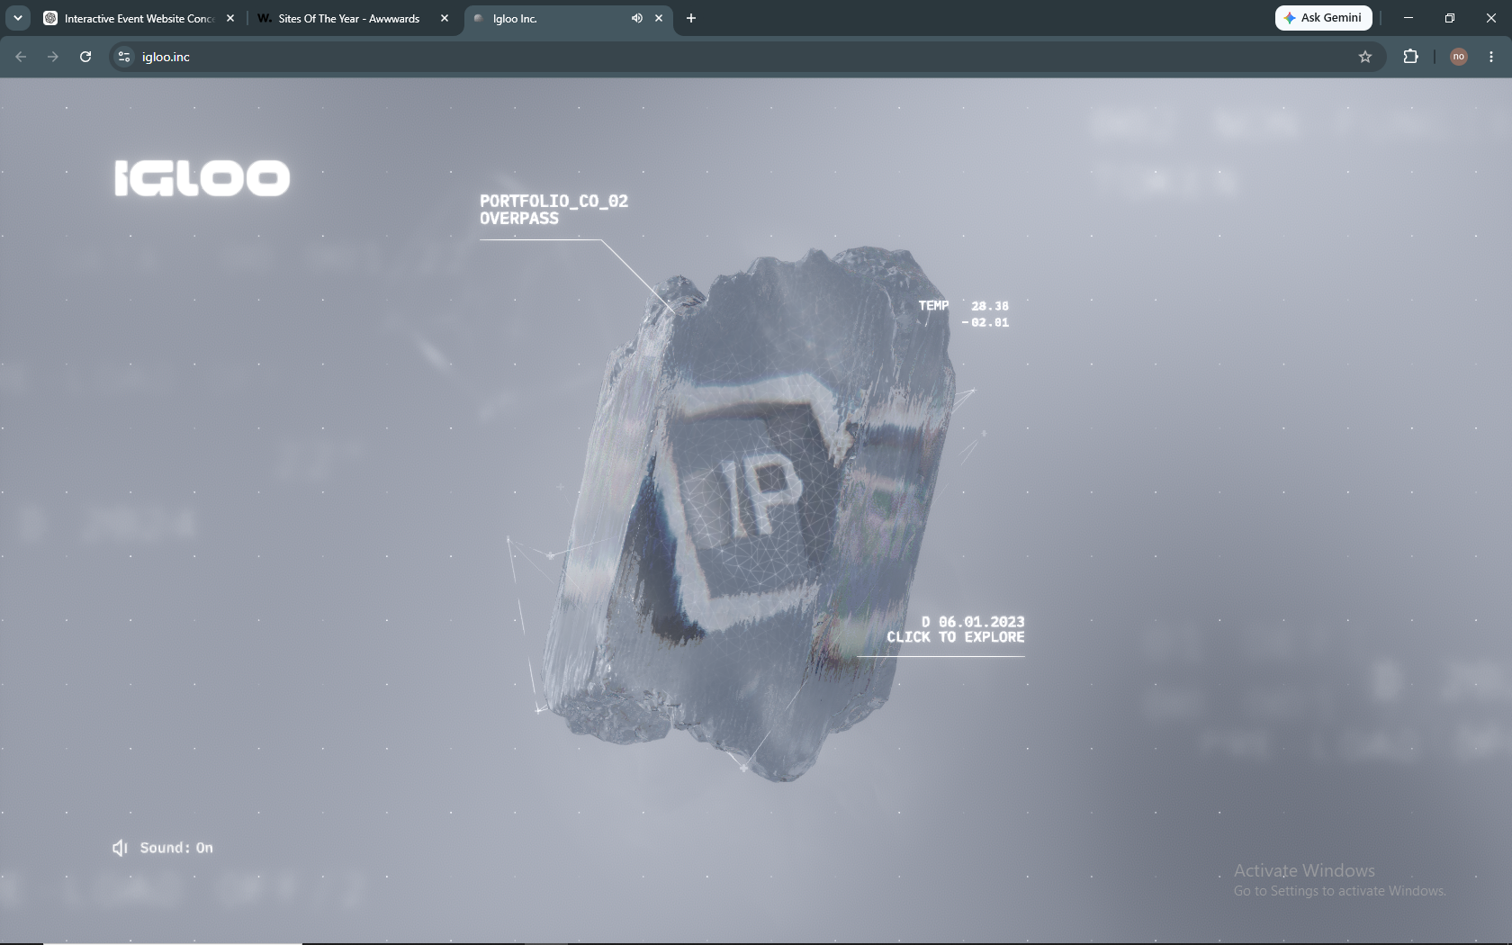

Reference qualities: confident color, art-directed camera, scene-as-interface, continuous world and polished interaction.

A2 / CREATIVE DIRECTION

Reference moodboard — interaction and continuity
The useful lesson is the level of visual authorship: every screen, label, transition and movement participates in one world.
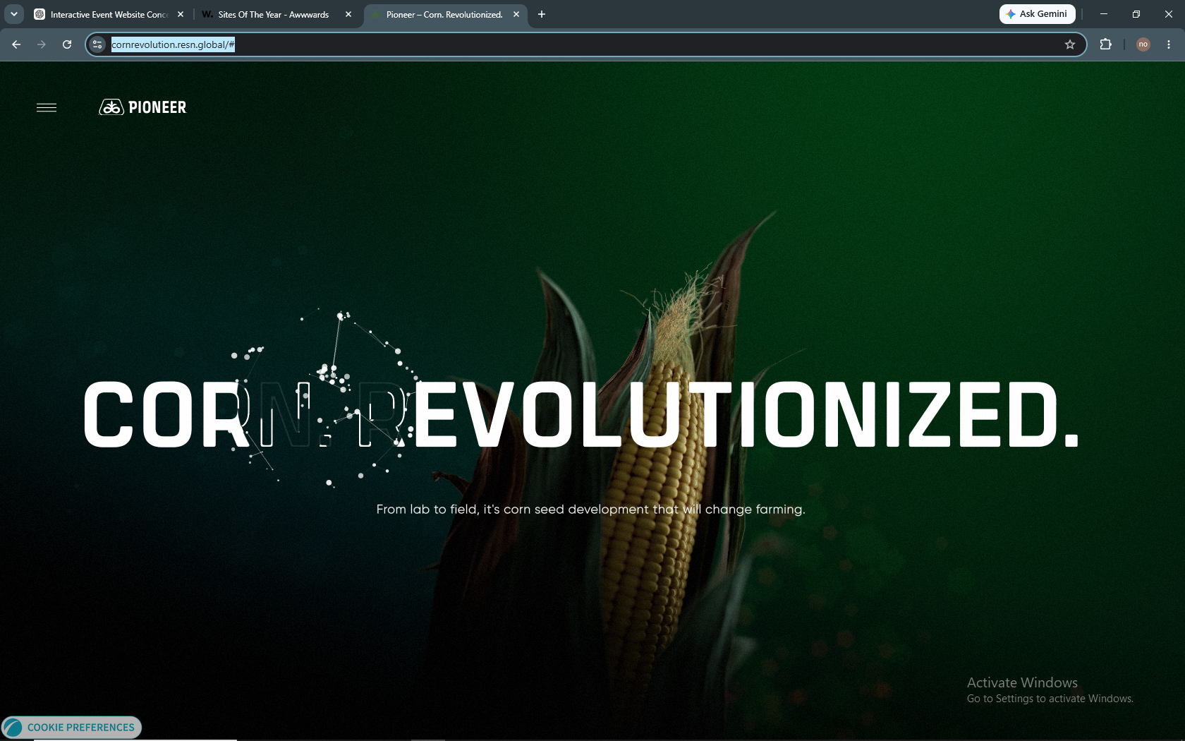 | 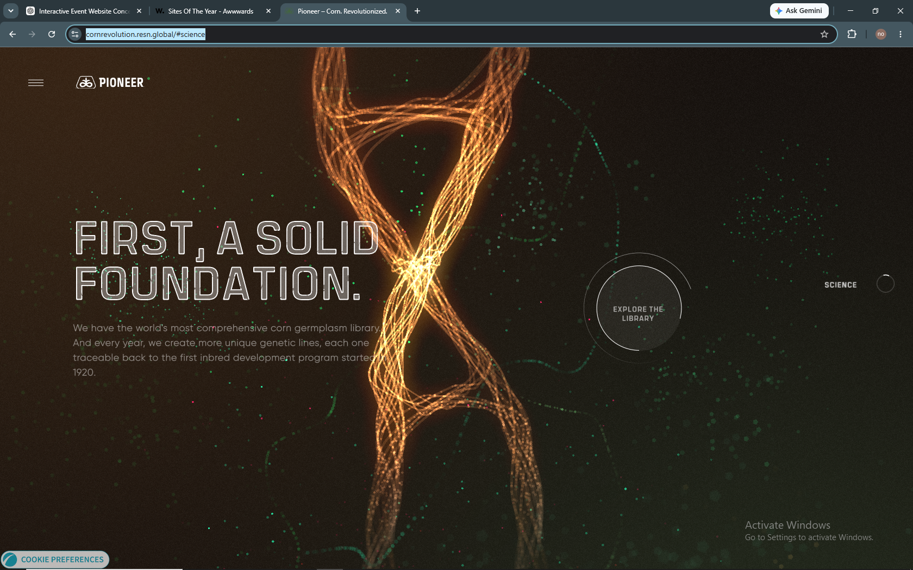

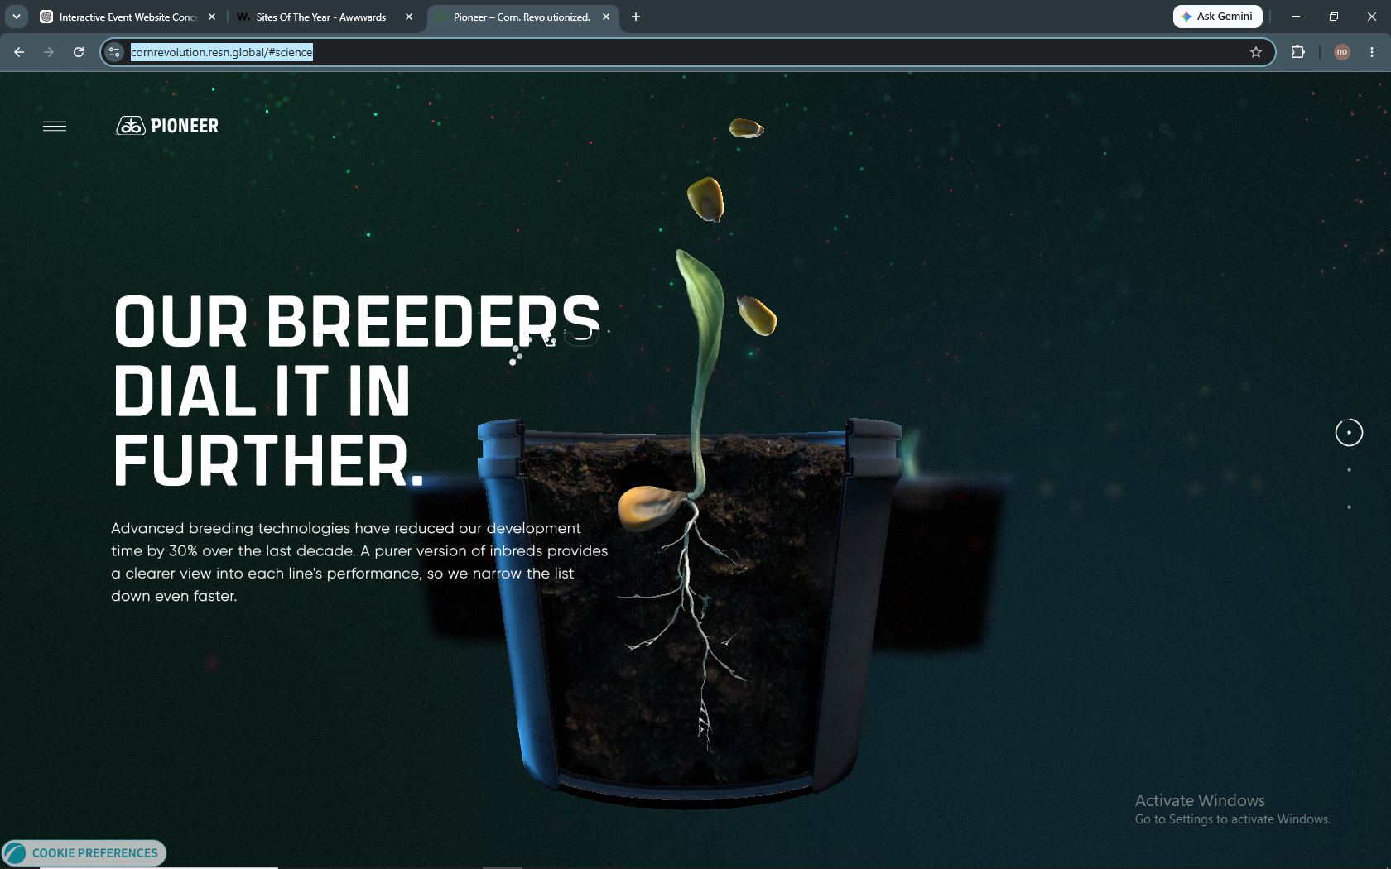

Do not reproduce these forms. Translate the quality bar through Mandegar’s exhibition activation concept.

B / CREATIVE DIRECTION

Technical references
Primary documentation supporting the recommended production approach. Library versions must be pinned to stable releases during implementation.
React Three Fiber — performance scaling: official documentation
React Three Fiber — performance pitfalls: official documentation
Drei — useGLTF: official documentation
Drei — KTX2 textures: official documentation
Drei — merged meshes / instancing: official documentation
GSAP ScrollTrigger: official documentation
Lenis: official documentation
Theatre.js with React Three Fiber: official documentation
Theatre.js sequences: official documentation
Theatre.js advanced / single RAF loop: official documentation
Next.js App Router internationalization: official documentation
Sanity localization: official documentation
glTF Transform: official documentation
Autodesk 3ds Max — glTF export: official documentation
Three.js WebGPURenderer: official documentation
Playwright visual comparisons: official documentation
Technical note: use WebGL2 as the safe baseline. WebGPU may be evaluated as a progressive enhancement after the target device matrix is tested.

MANDAGAR / NEXT GATE
Next deliverable
  - Generate the complete visual keyframe package defined in Section 17, then approve a motion animatic before further full-production coding.
The guiding principle
Do not ask code to discover the art direction. Approve the idea, images and motion first; then ask code to reproduce them faithfully, performantly and accessibly.
This master is designed to evolve. When a visual test proves a decision wrong, update the decision register, keyframes and configuration—without losing the creative north star.

