**MODULE 1: Management Studio**

**Exercise 1: Creating a link**

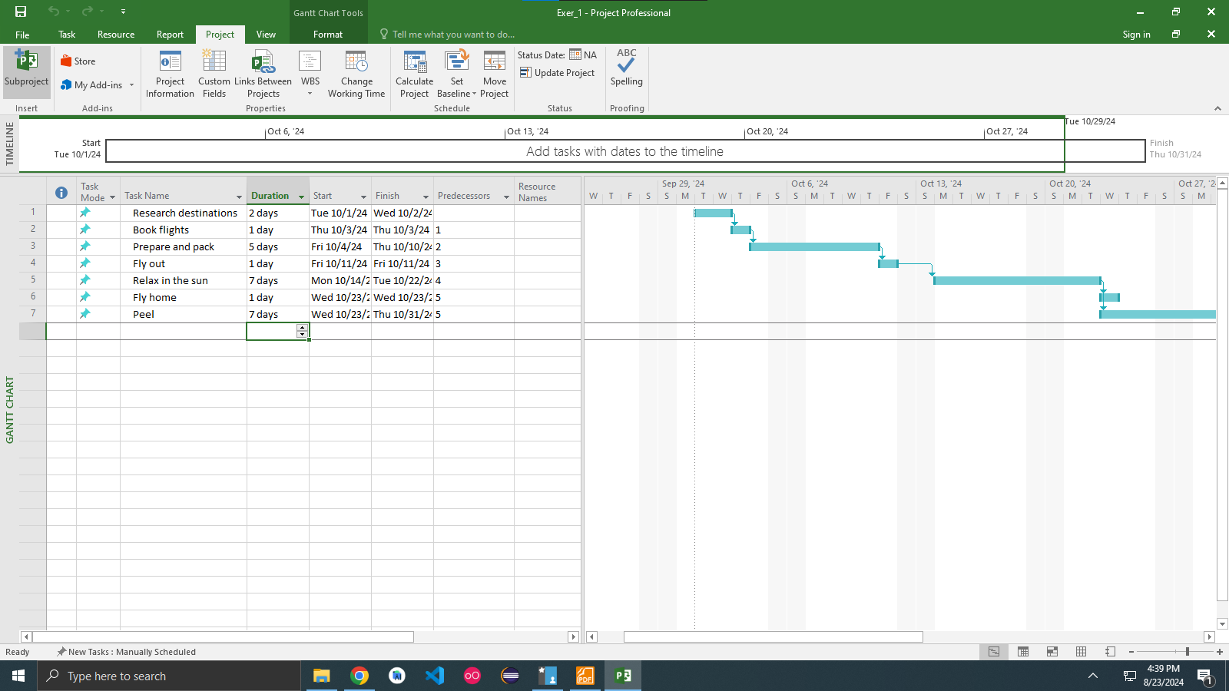

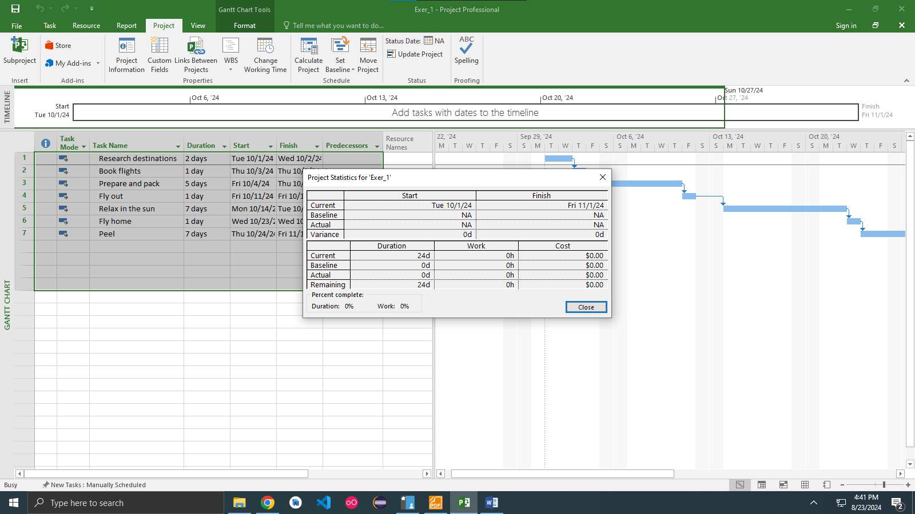

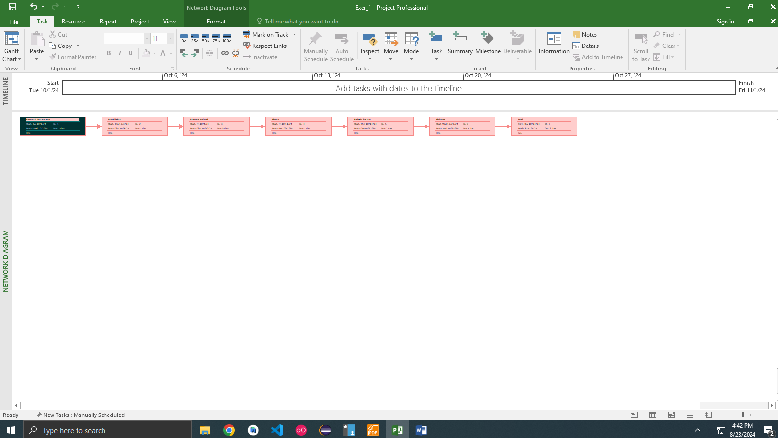

**Exercise 2. Setting duration**

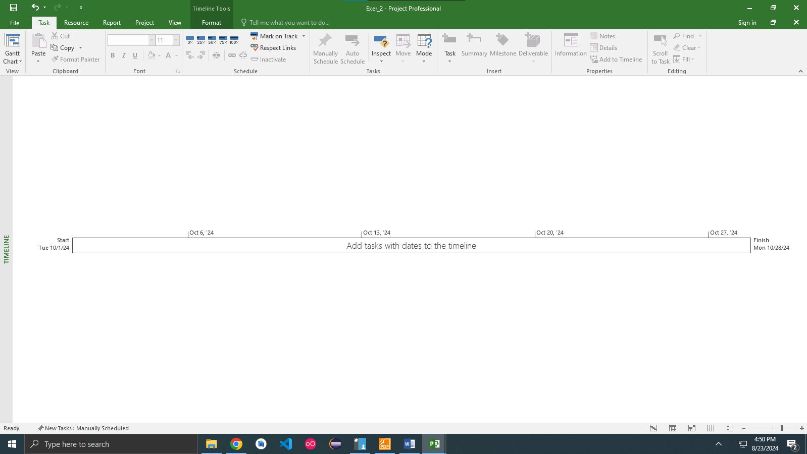

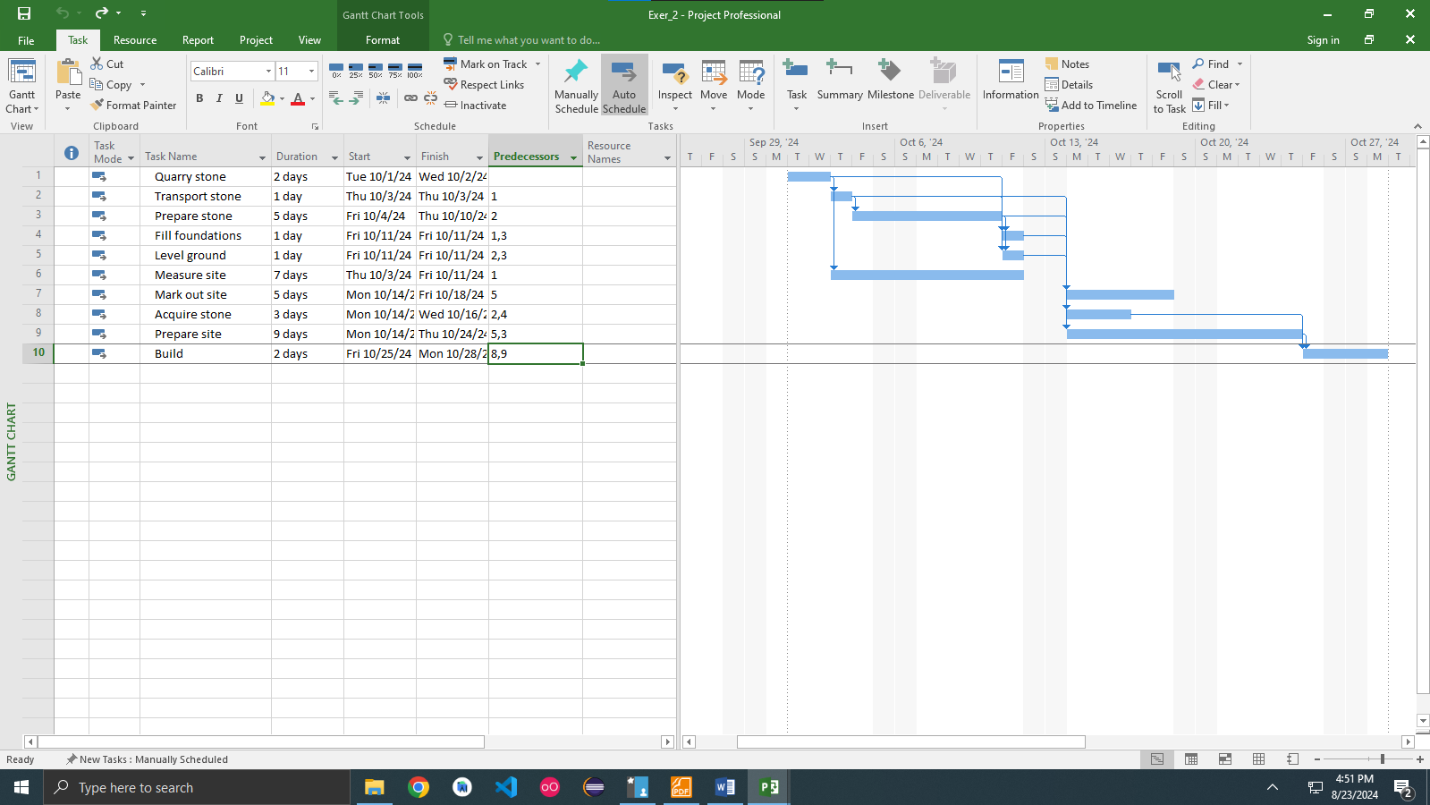

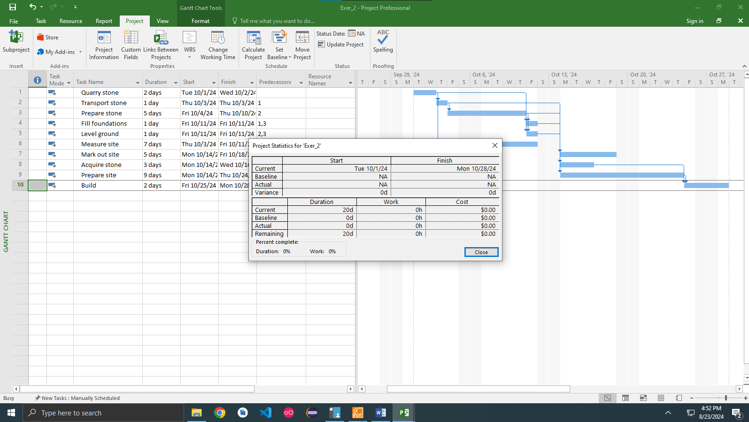

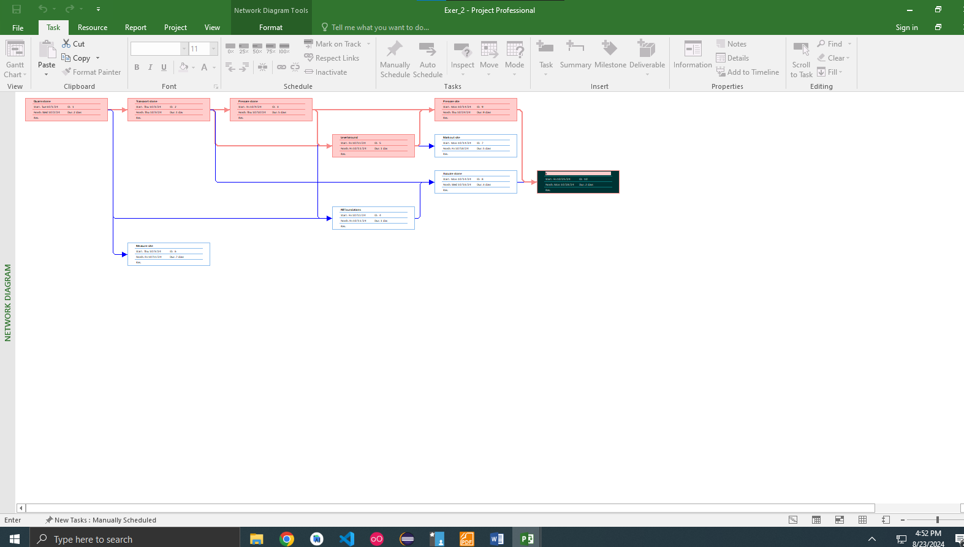

**Exercise 3. Creating phases**

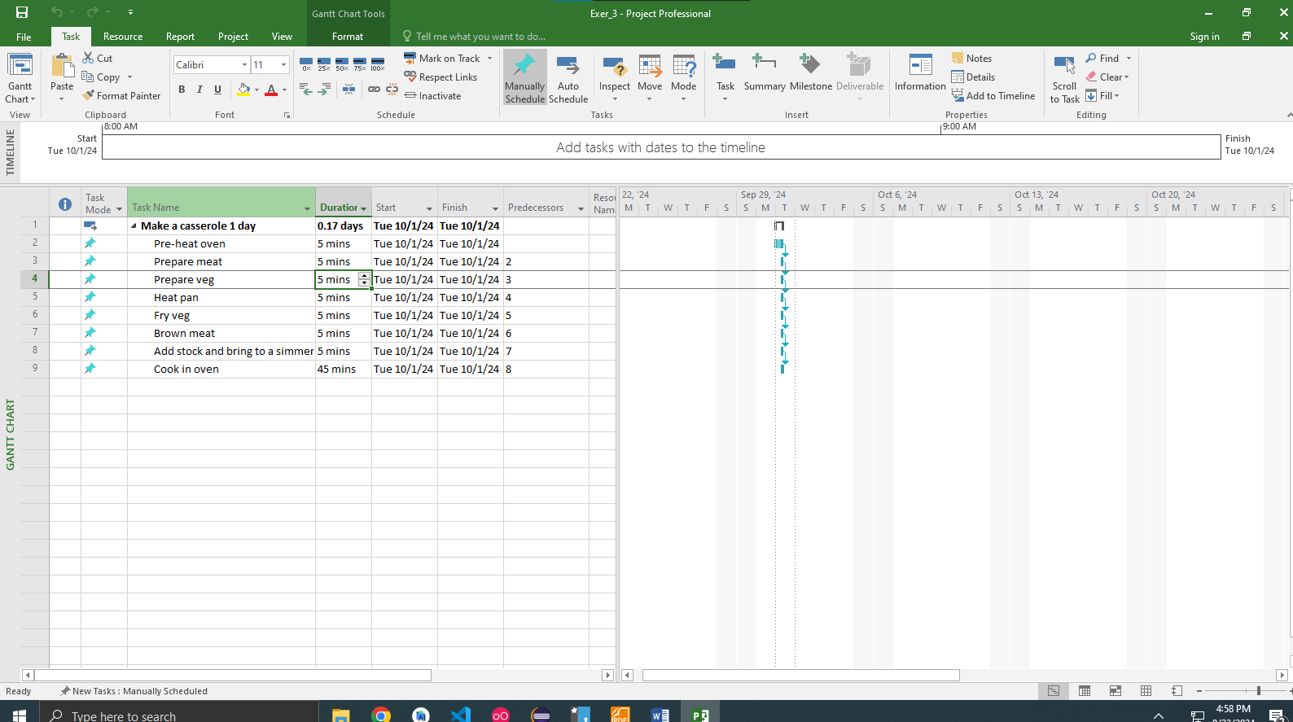

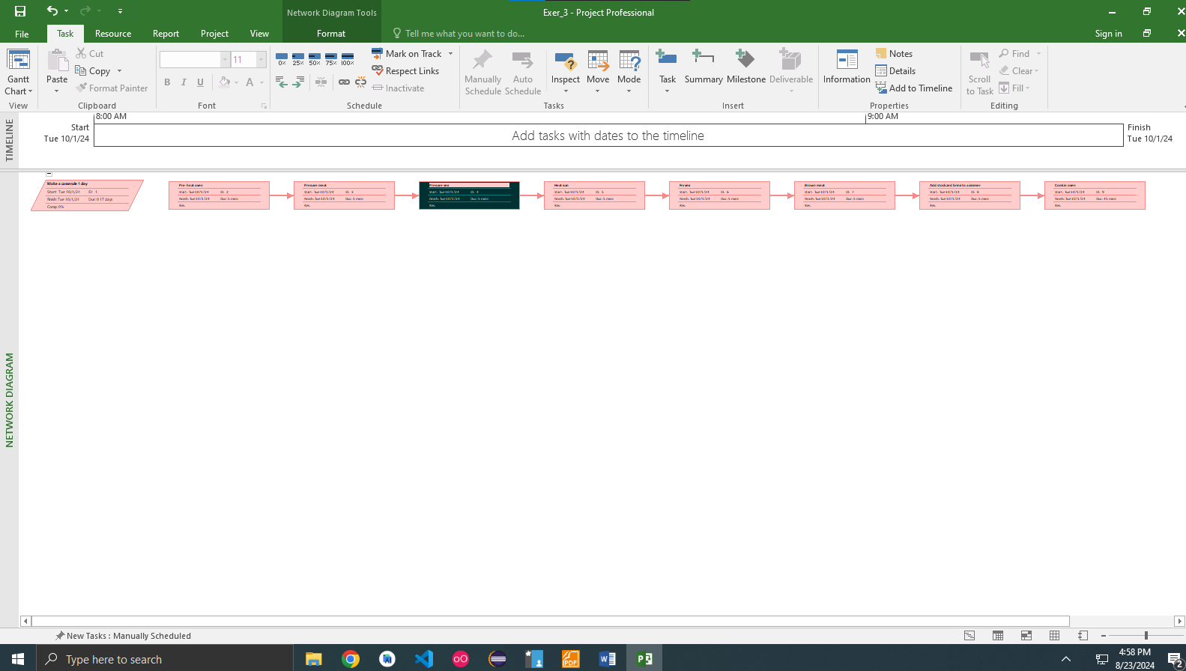

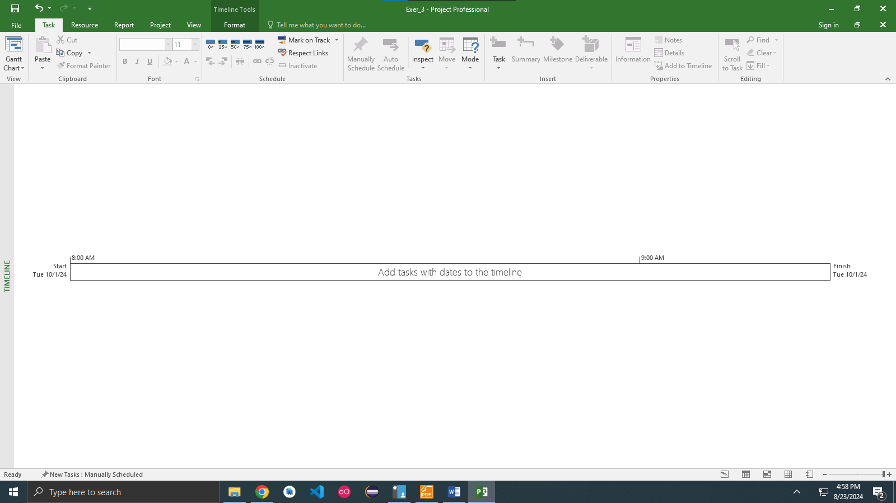

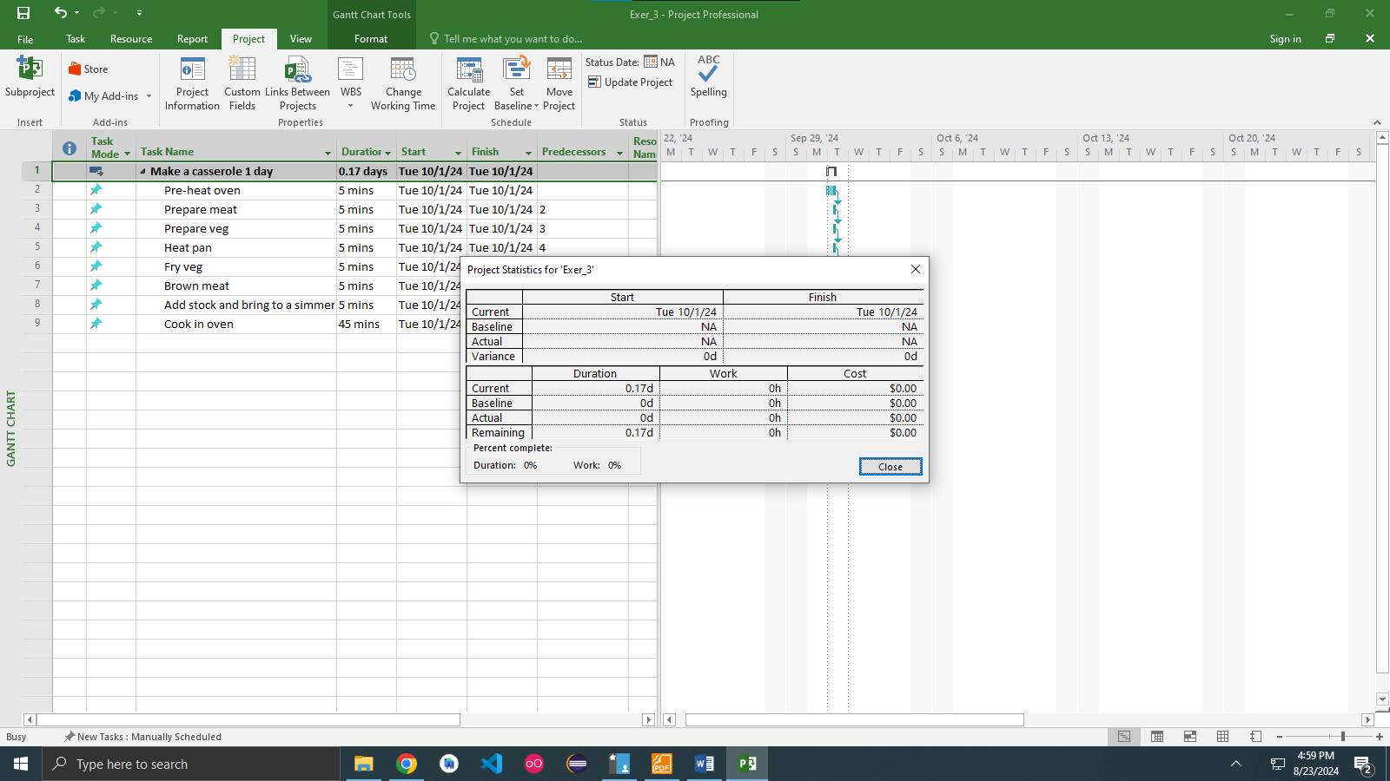

**Exercise 4. Noah – Linking**

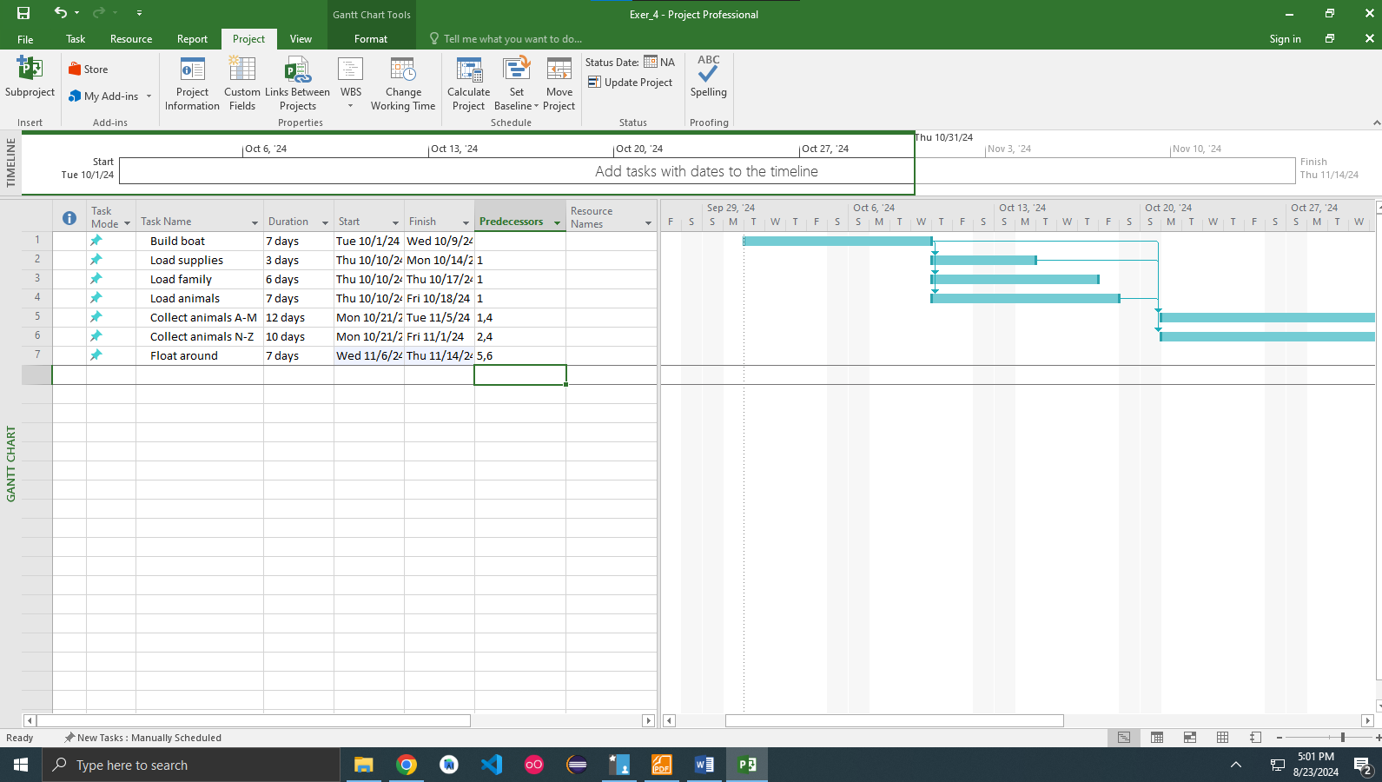

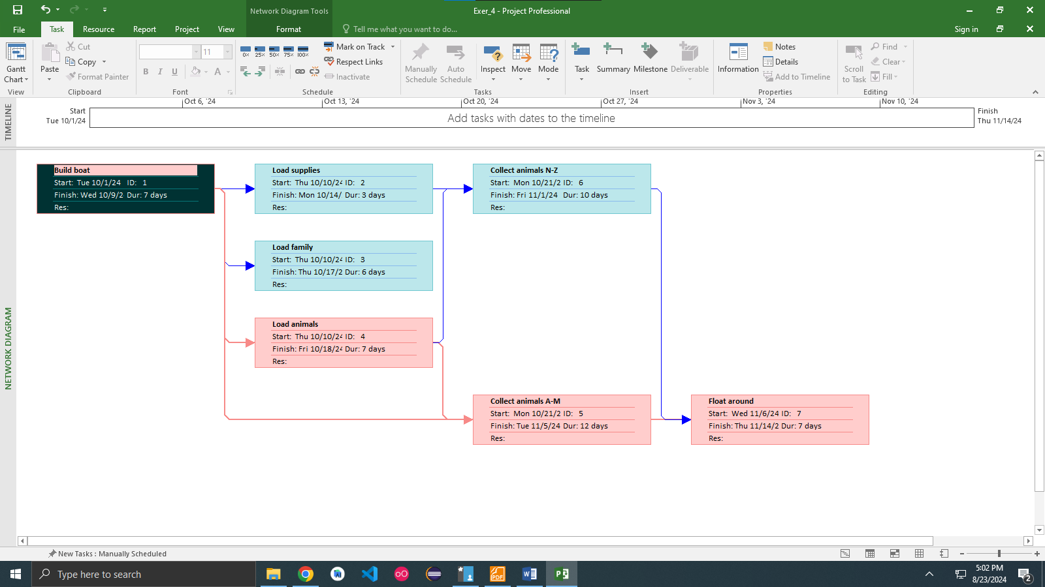

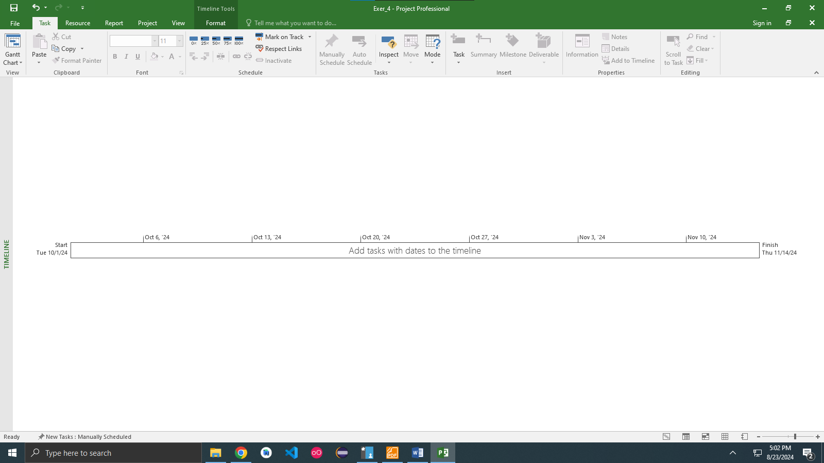

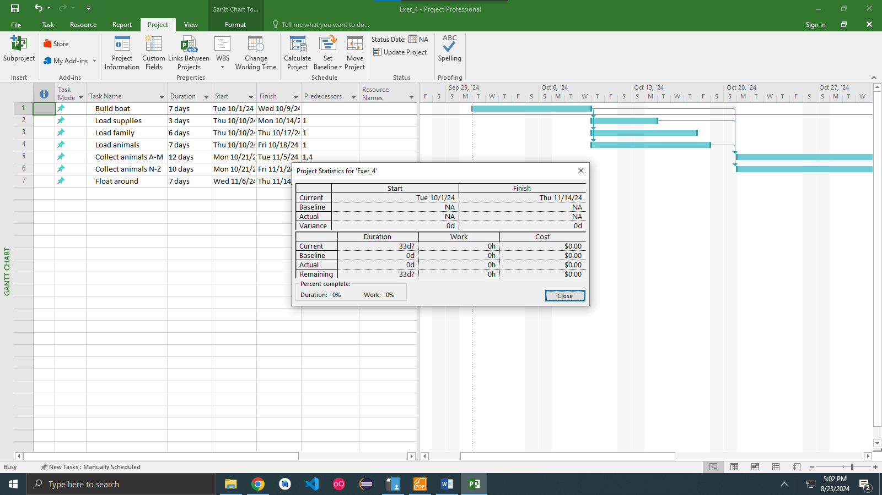

**Exercise 5. Pyramid - Multi level grouping**

**Exercise 6. Creating a plan for Staff Training**

**Exercise 7. Recurring tasks**

