**MODULE 3: Working with Tasks**

**Exercise 1. Changing Working Time (Start Date 1/11/2024)**

* **Display the Project Information.**

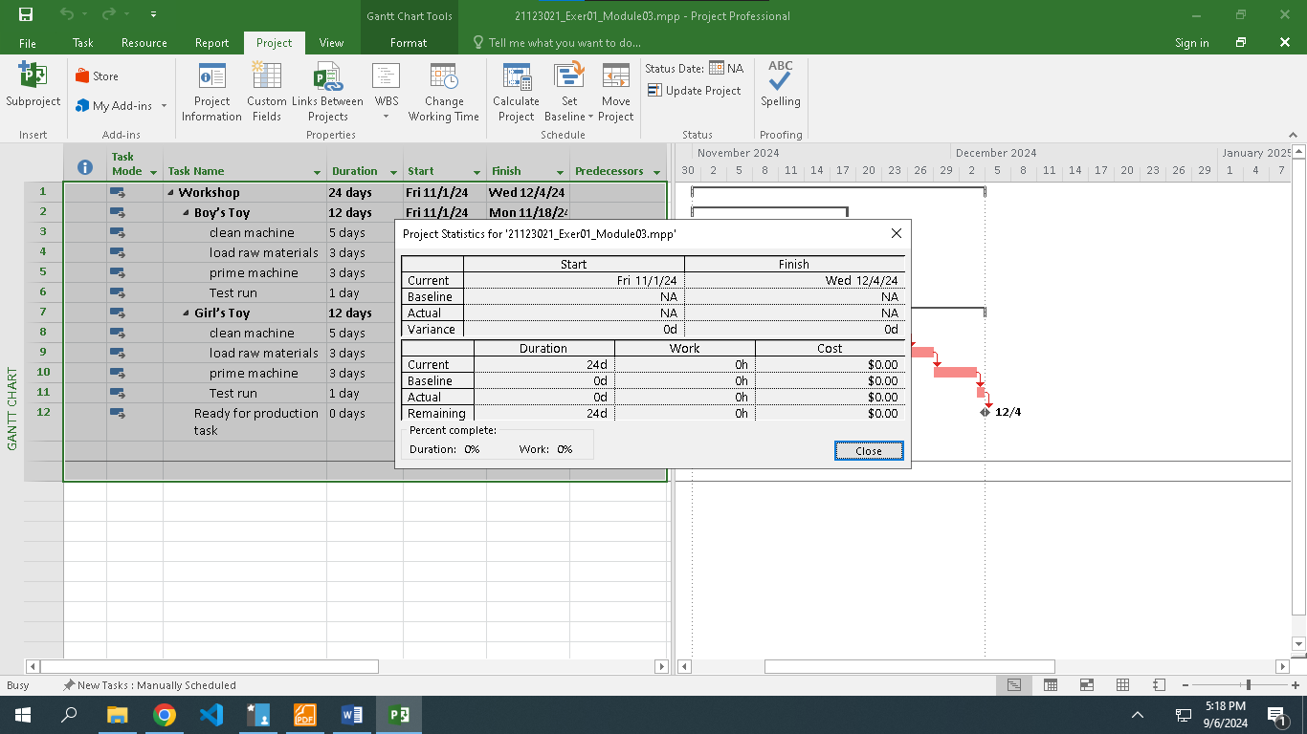

* View Project Timeline

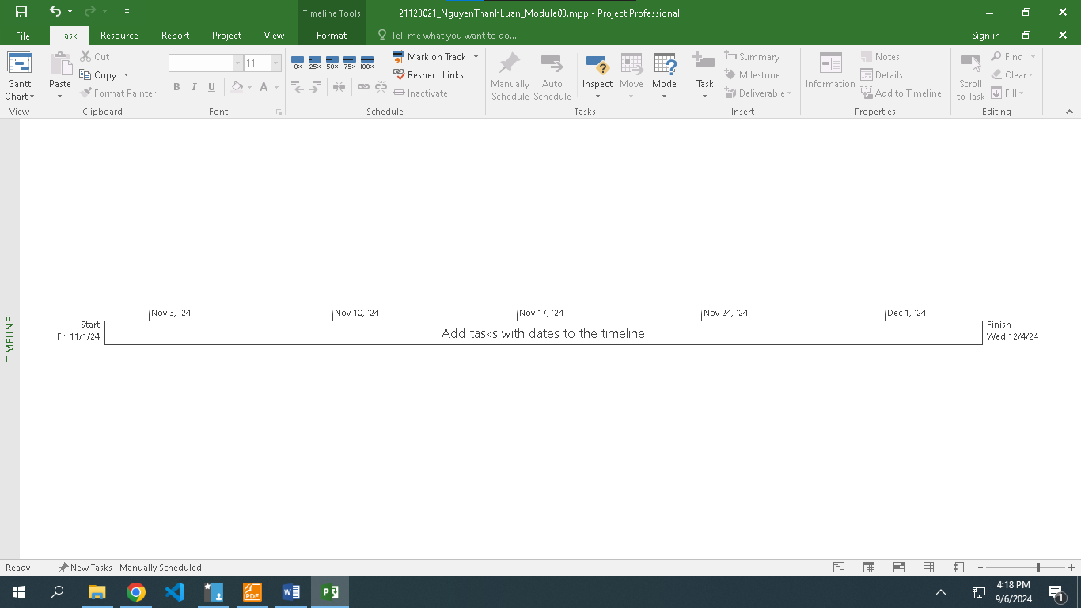

* Gantt Chart

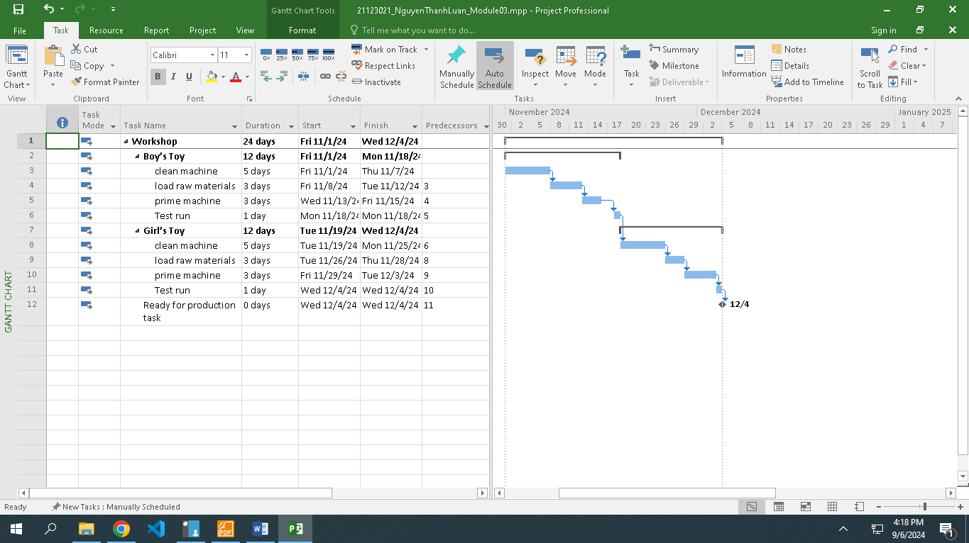

* view CP

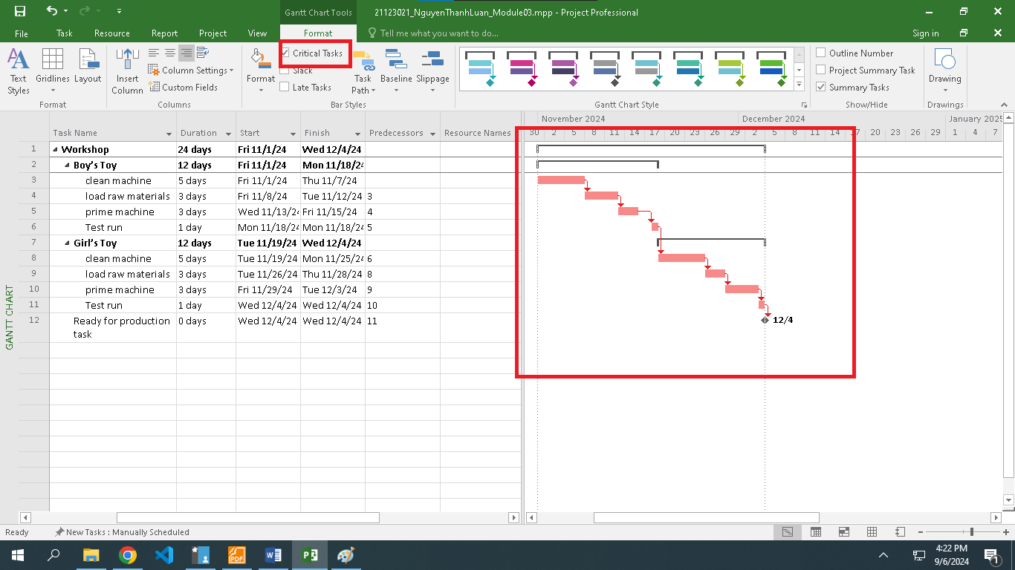

* Total Slack

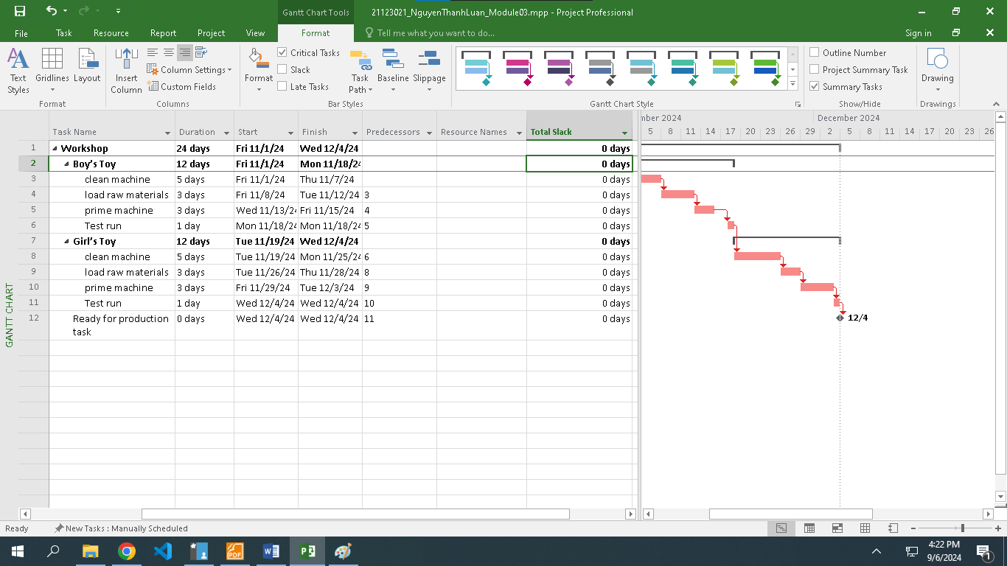

**Exercise 2. Changing Working Time (Start Date 1/11/2024)**

* Create the summary task is Buy a shop that contains all tasks in the project
* Establish the duration of Wait for a decision task is 7 days.

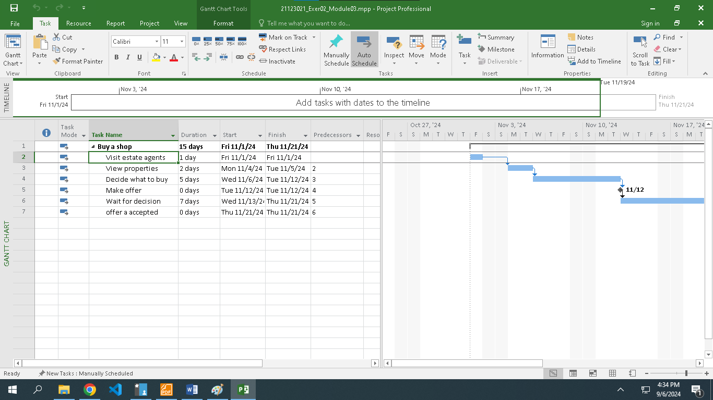

* Change the duration of View properties task to 7 days.

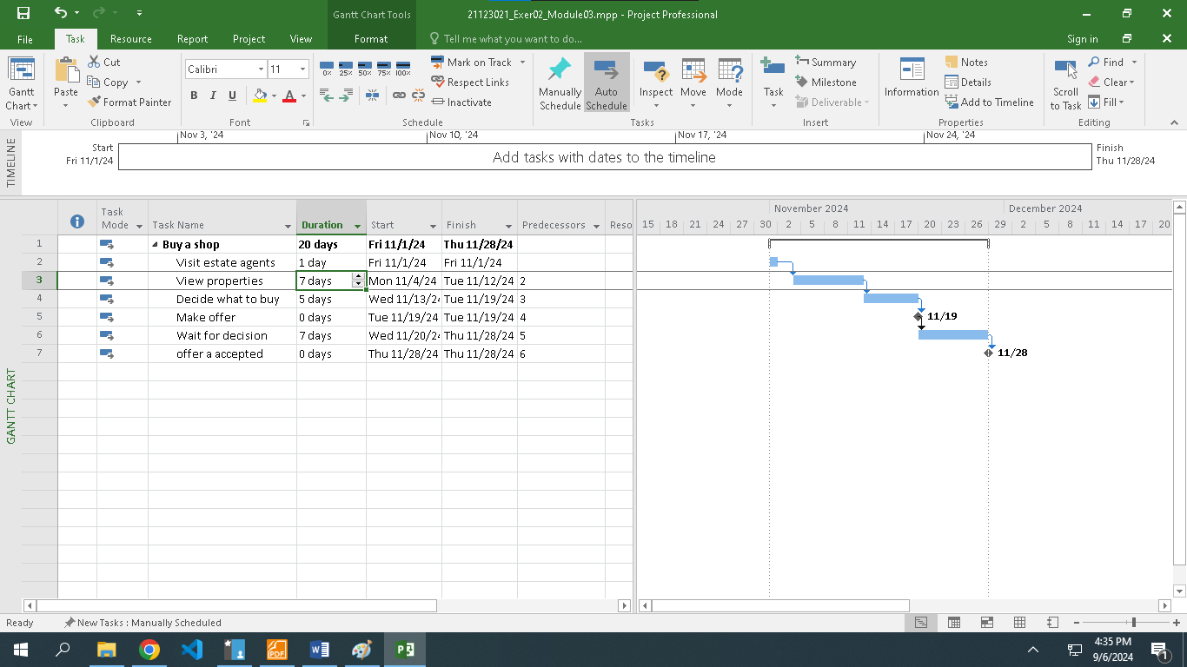

* **Display the Project Information.**

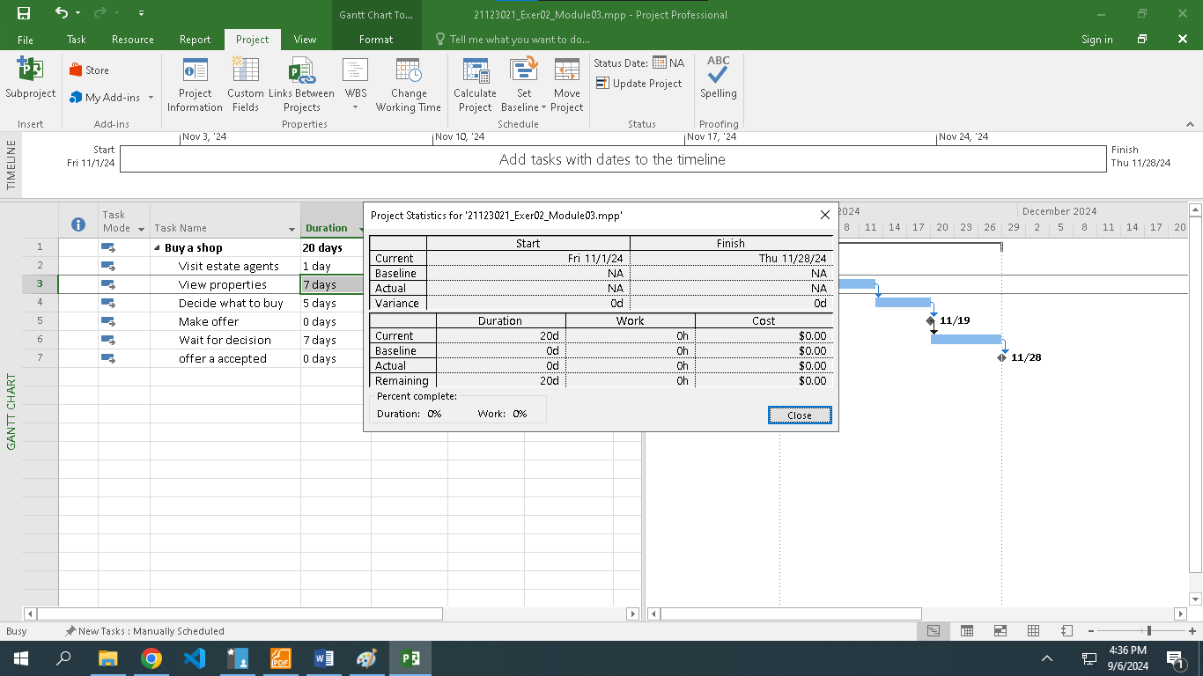

* View Project Timeline

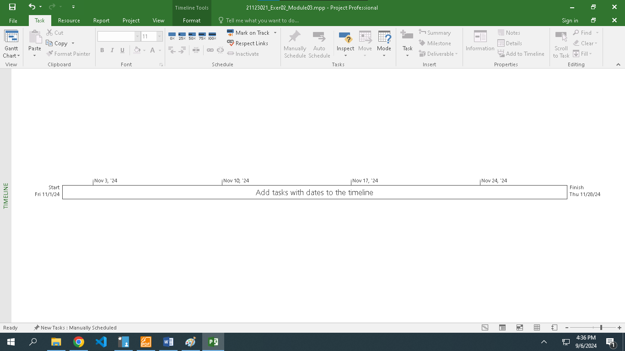

* Gantt Chart

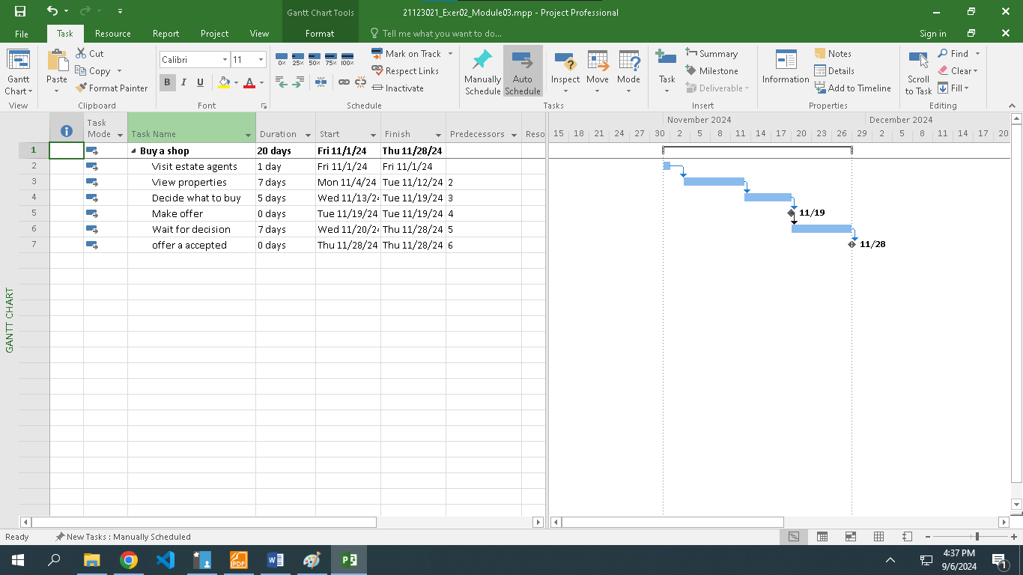

* view CP

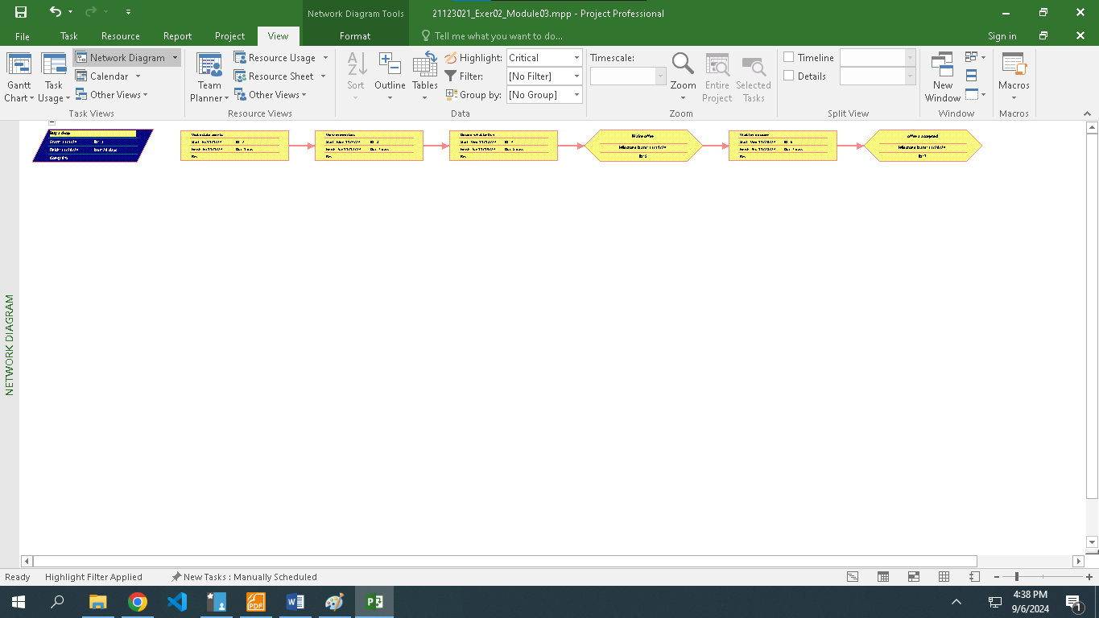

* Total Slack

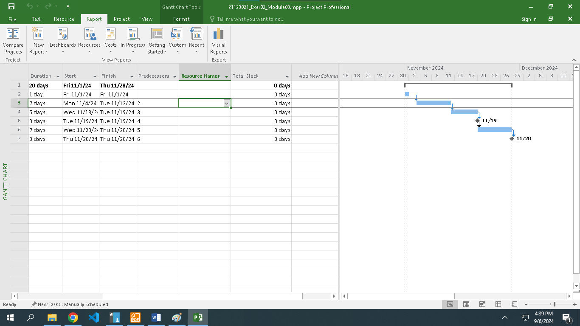

**Exercise 3. Scheduling – Task dependencies**

* Create the list of tasks to model this processing (Start date: 10/10/2024)
* Create the summary tasks for series tasks below

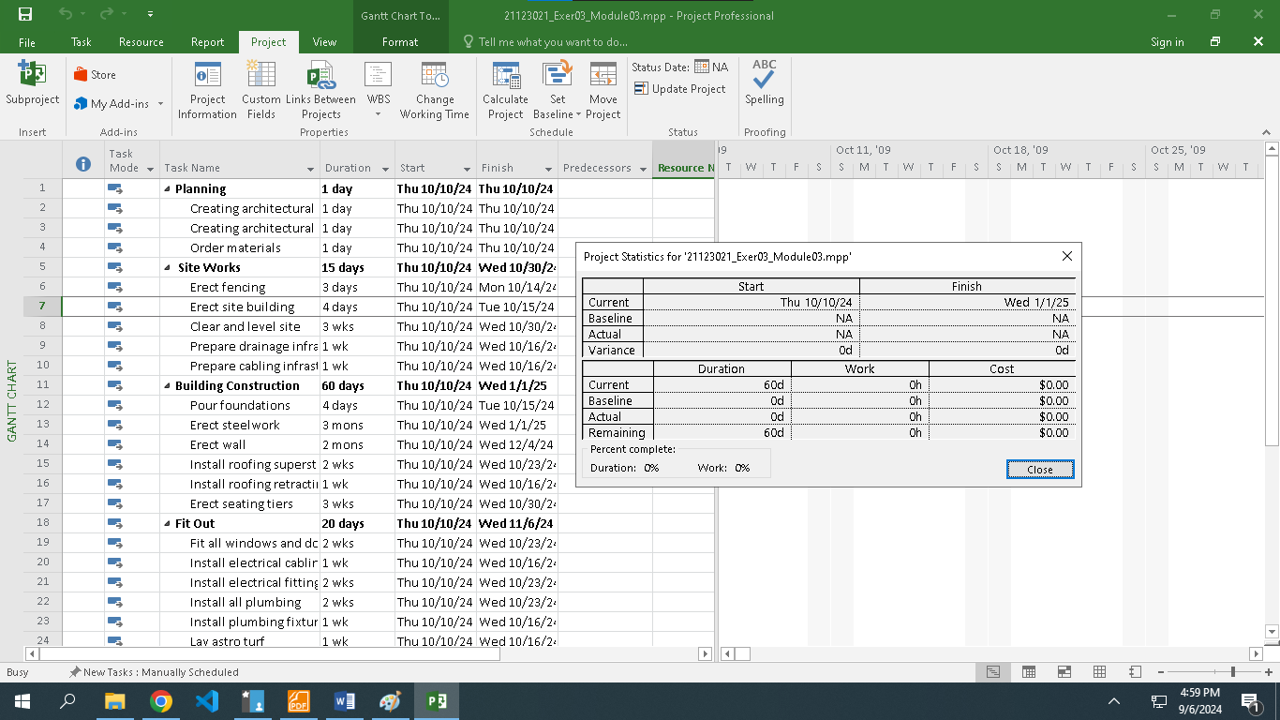

* Create the milestones for this project below:

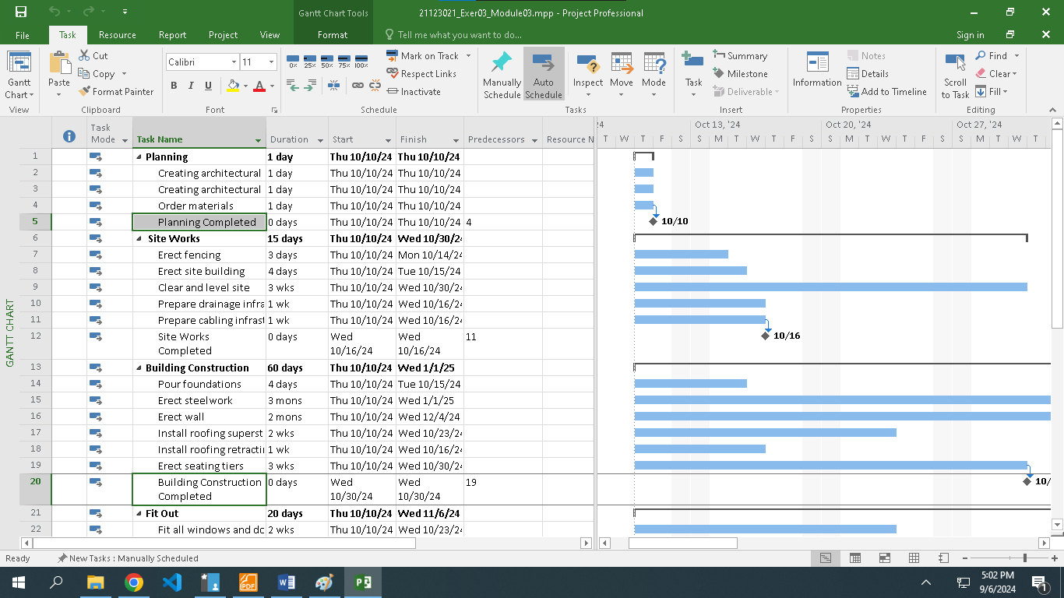

* Creating Dependencies in Task Entry

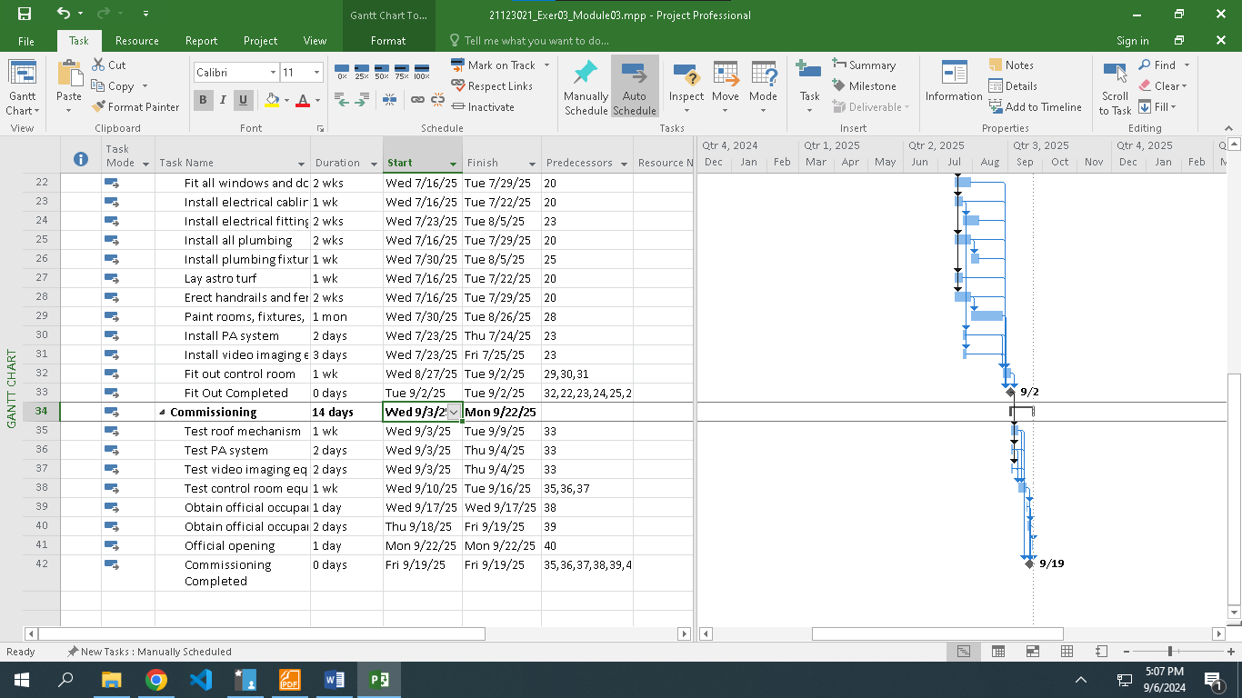

* ***Display the Project Information***

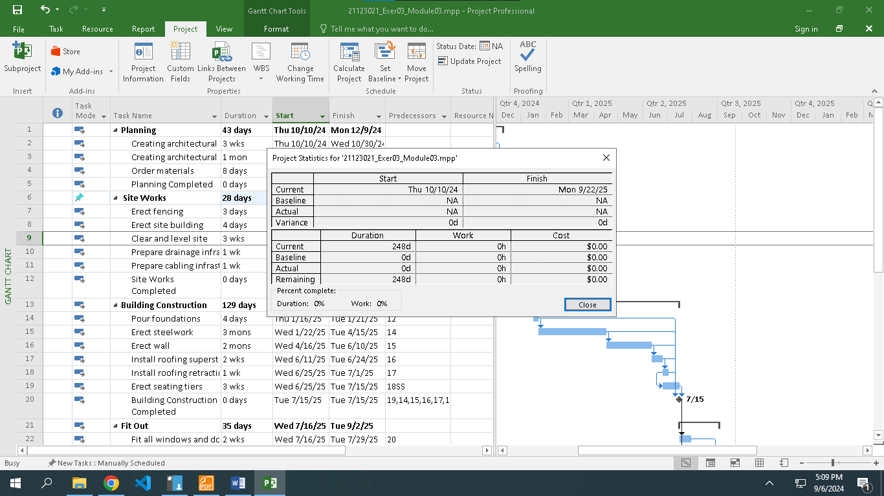

* View the project in Gantt Chart and define CP and Project Slack

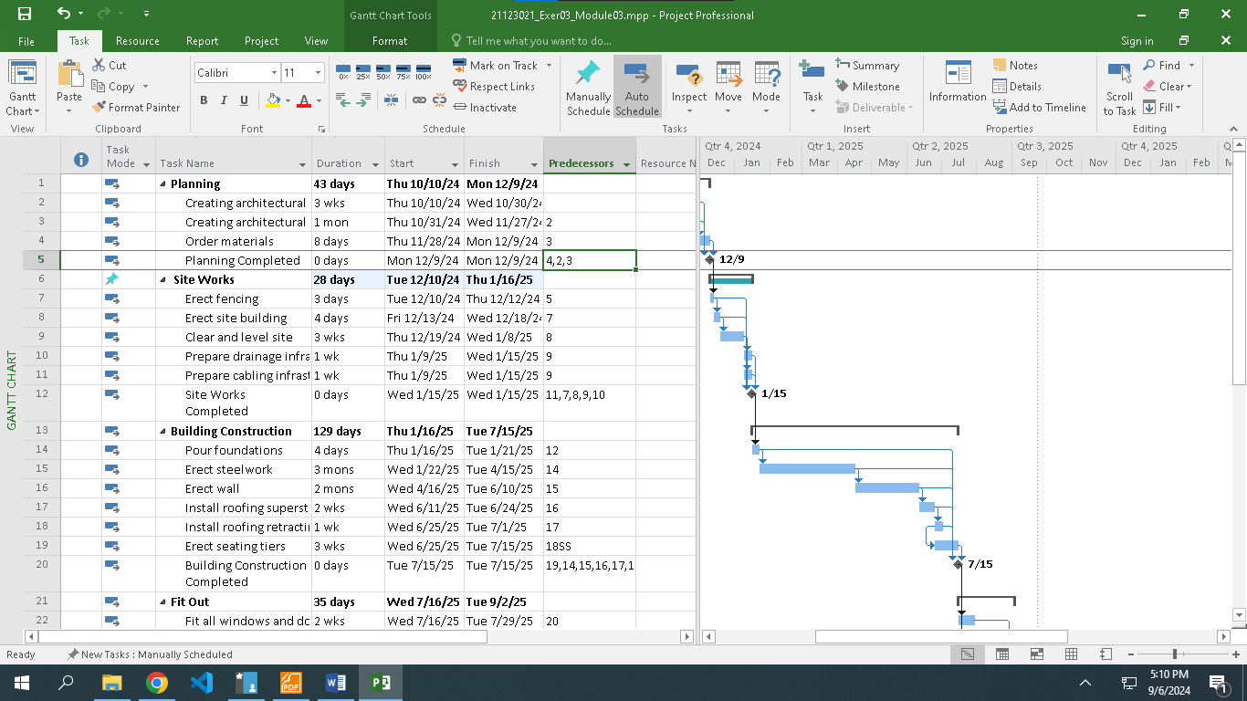

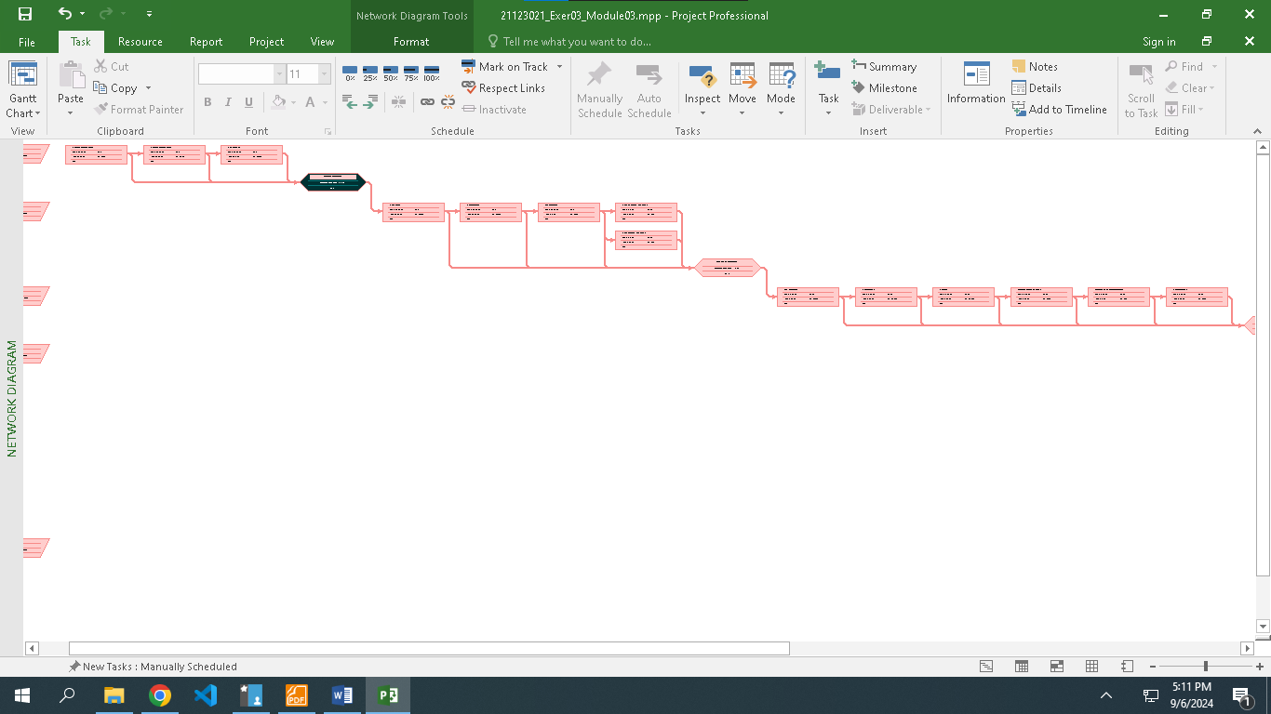

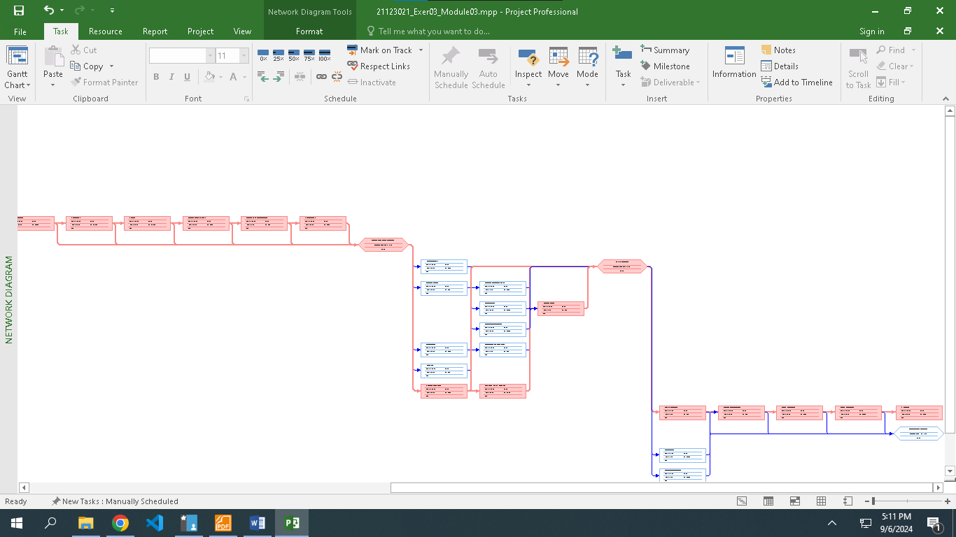

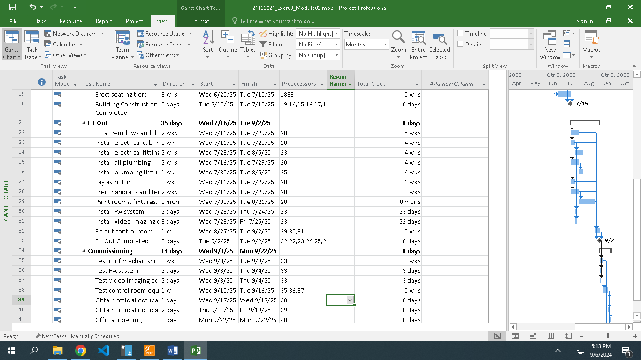

* Choose Gantt Chart Format tab → check on Critical Tasks in Bar Styles.

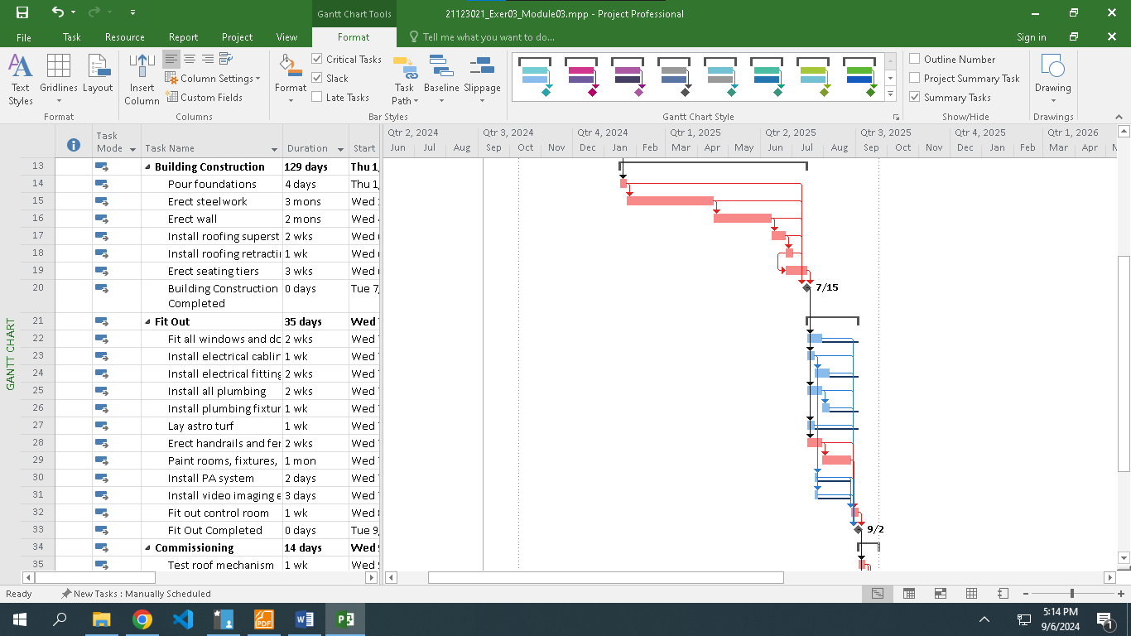

* On the table data Add column Late Start, Late Finish, Total Slack

