**MODULE 4: Assigning the Resource for a Project**

**Exercise 1. Entering work resource**

* **Project information**

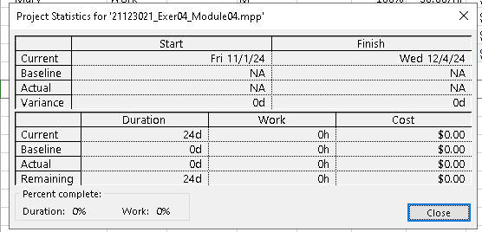

* **Resource Sheet**

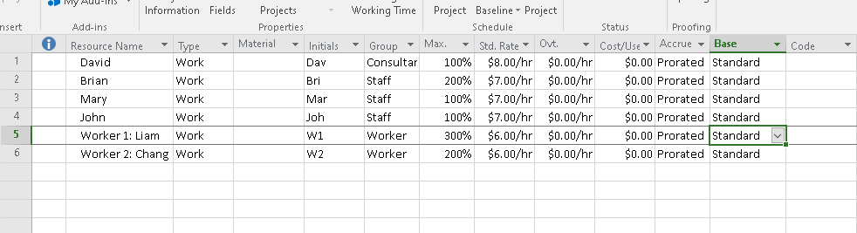

* **Gant chart**

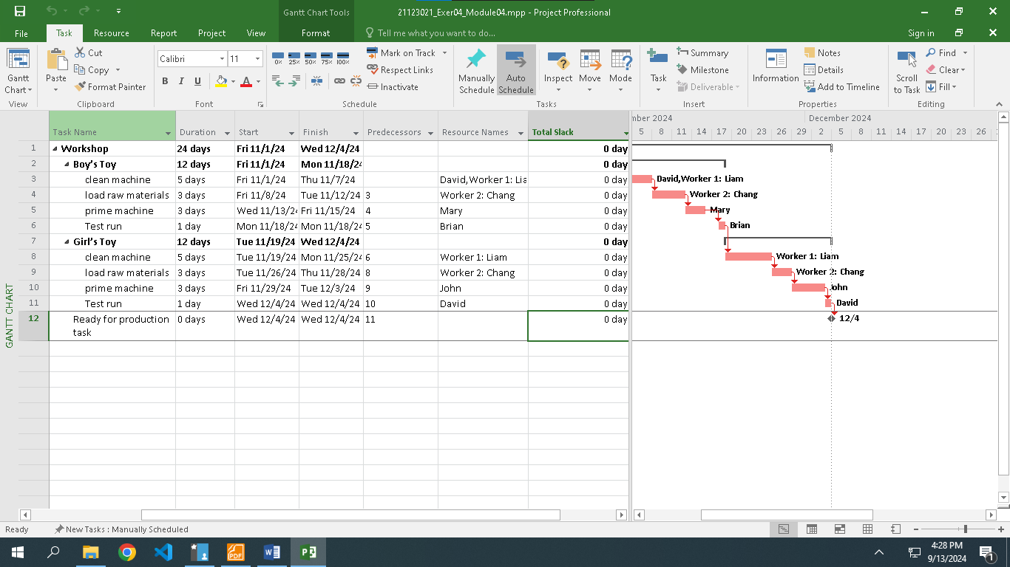

* **Project Information**

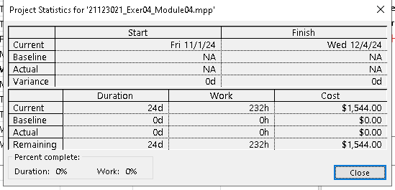

**Exercise 2. Entering work resource**

* **Project information**

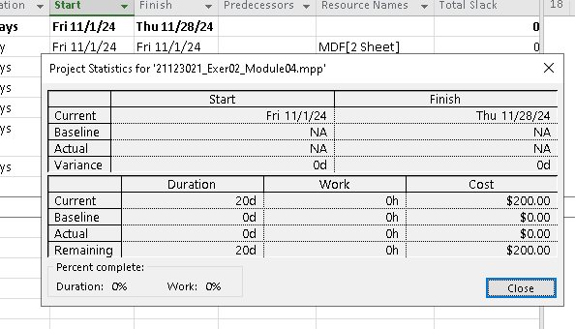

* **Resource Sheet**

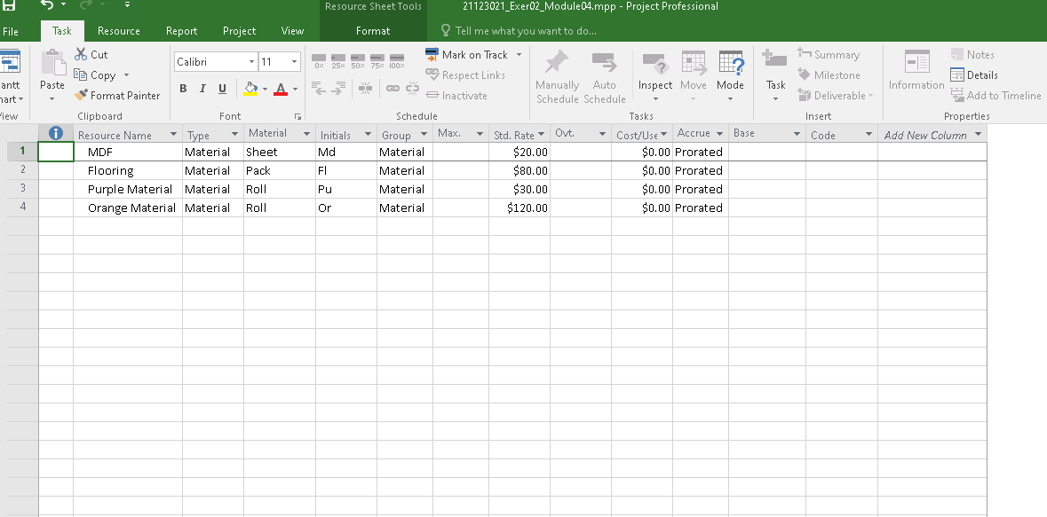

* **Gant Chart**

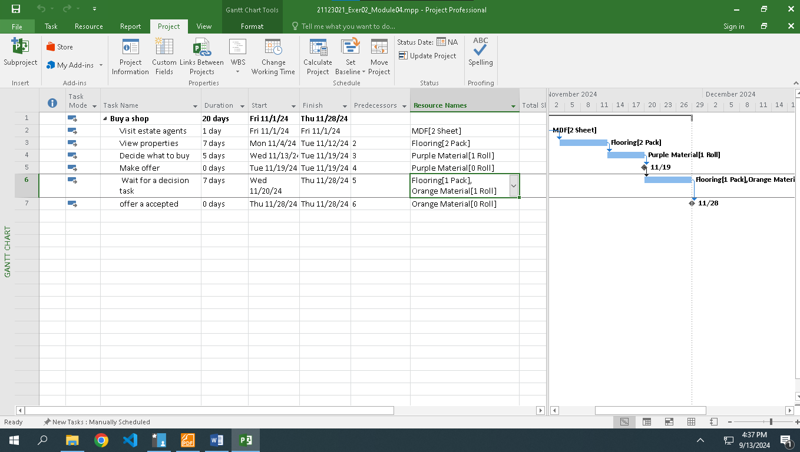

* **Project information**

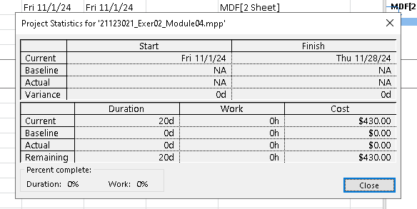

**Exercise 3. Entering work resource**

* **Project information**

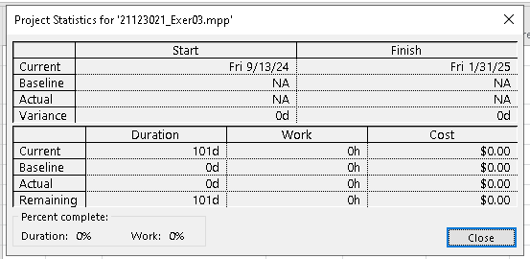

* **Resource Sheet**

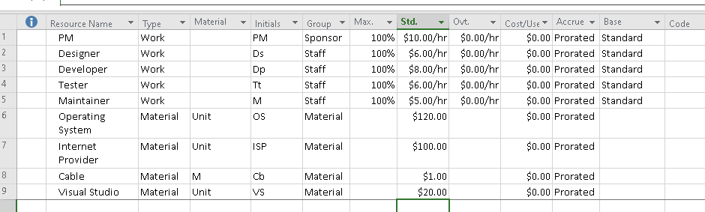

* **Gant Chart**

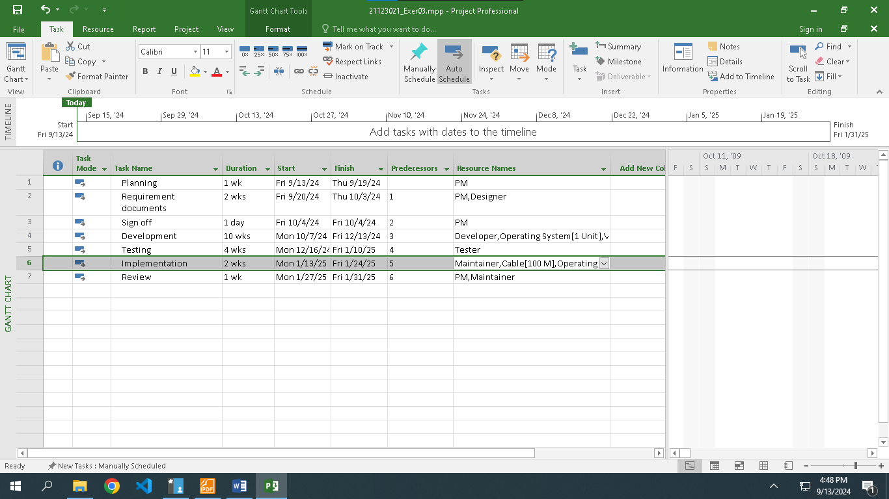

* **Project information**

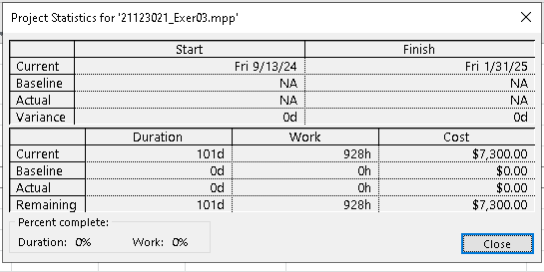

**Exercise 4. Entering work resource**

* **Project information**

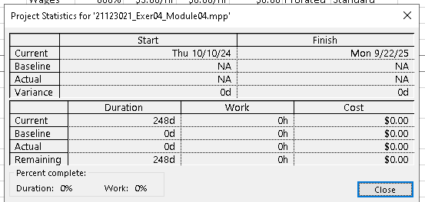

* **Resource Sheet**

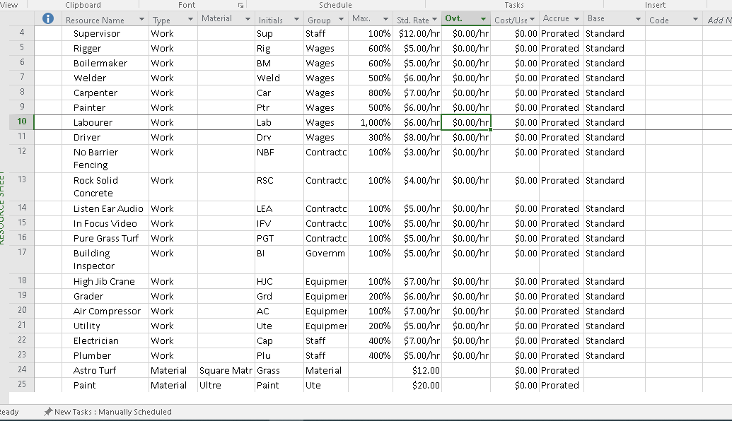

* **Gant Chart**

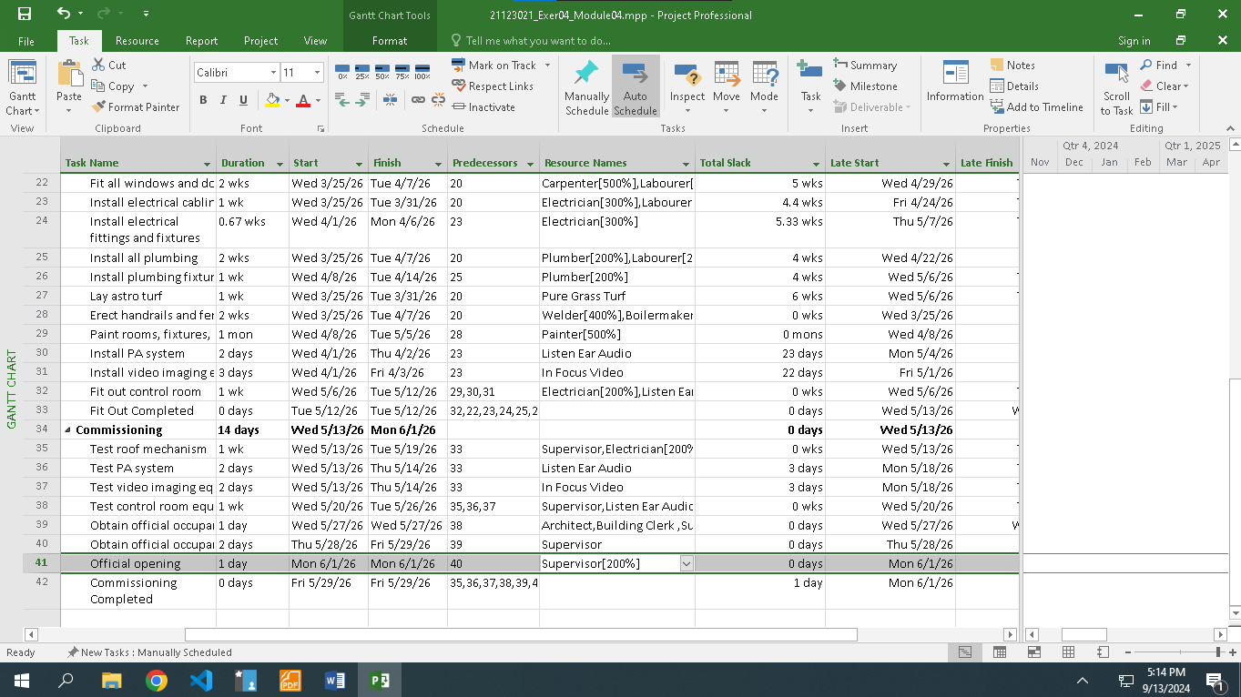

* **Project information**

**Exercise 5. Capture the Project Information before and after assigning the resource.- Project information**

* **Resource Sheet**

* **Gant Chart**

* **Project information**

