***MODULE 5: COST, CONSTRAINS, DEADLINE for TASKs***

Exercise 1. Entering Cost

* **Project information before**

* **Resource Sheet**

* **Gant chart**

* **Project information after**

* Project information of after 5 days

Exercise 2.

* Information Project before

* **Resource Sheet**

* **Gant chart**

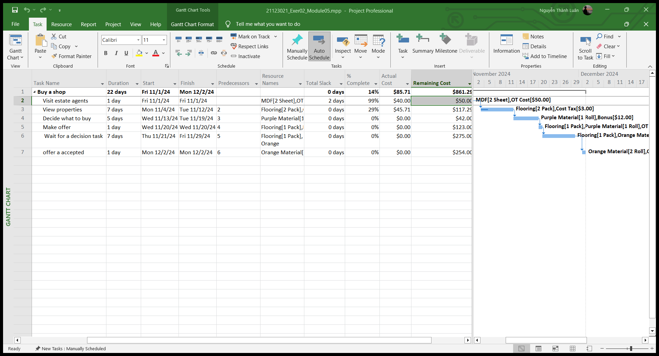

* **Information Project after**

* **Information Project after update 3 days**

**Exercise 3.**

* **Information Project**

* **Resources Sheet**

* **Gant Chart**

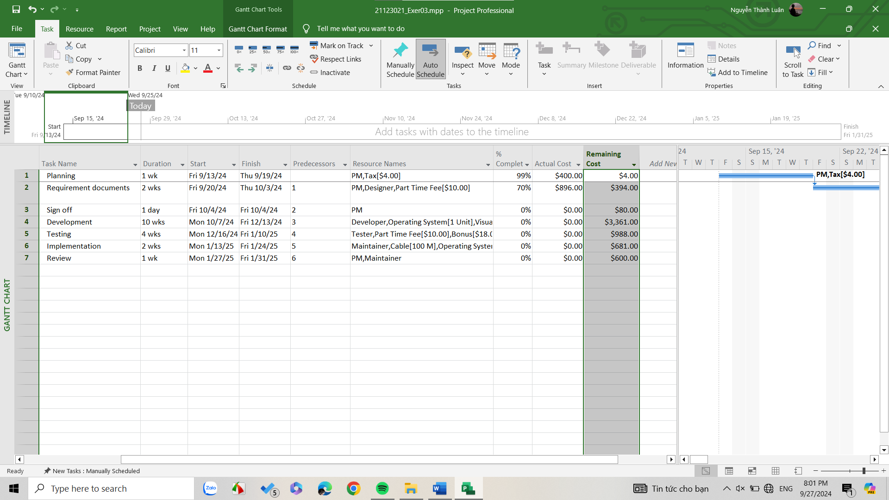

* **Information Project after**

* **Information Project after 2 weeks**
* **A screenshot of a computer

  Description automatically generated**

**Exercise 4.**

* **Information project**

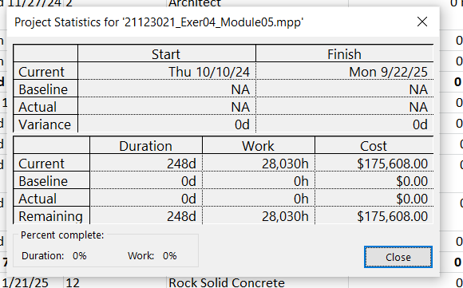

* **Resouce sheet**

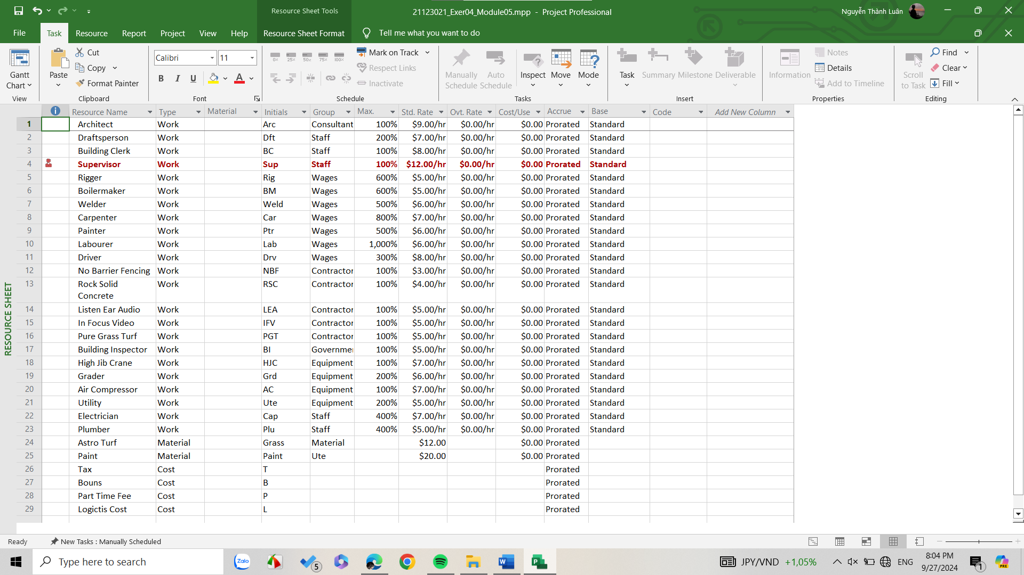

* **Gant chart**

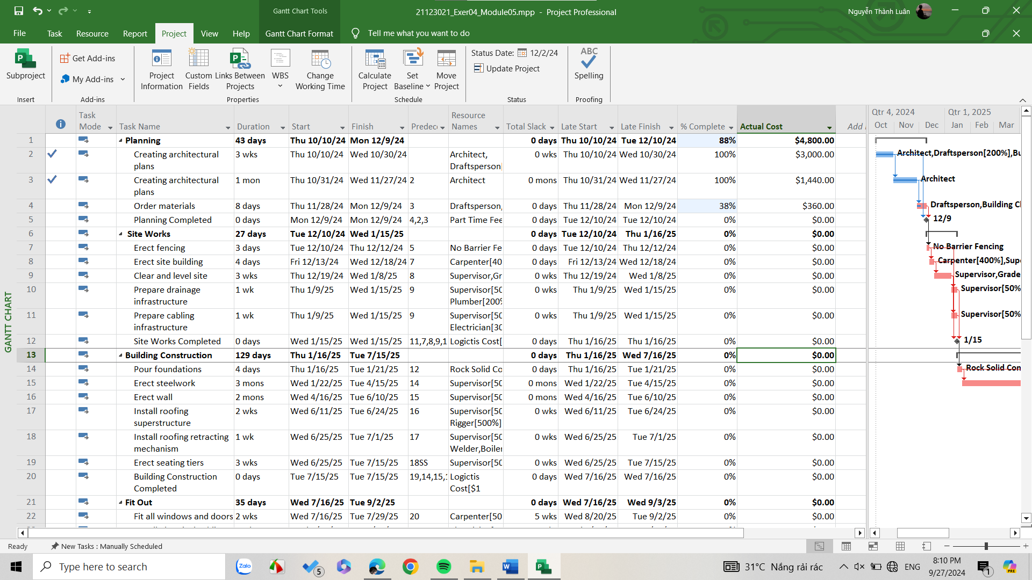

* **Information project after 1 month**

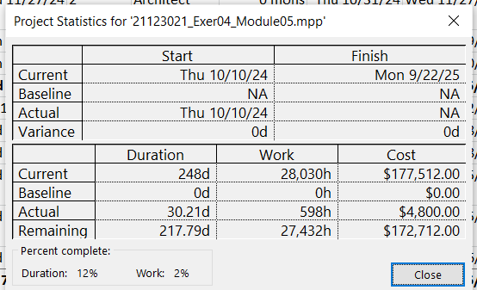

* **Update Project after 4,5 month? Cost of Project?**
  + **4 month**

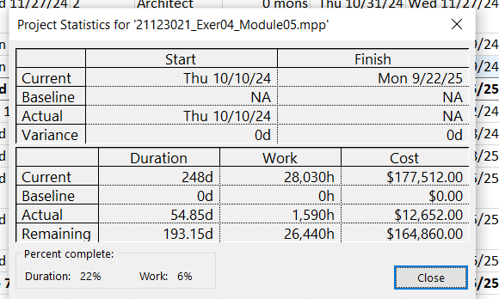

* + **5 month**

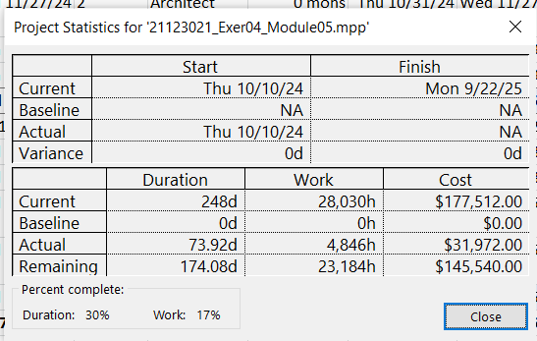

* **6 month**

