ssf2ud-writeup

alex jack

2025-01-14

## METHODS

To ascertain relationships between step_length, selection and landscape configuration we simulated telemetry data for an agent across a 100 by 100 domain of continuous habitat (ranging from 0 to 1; Figure 1).

### Landscape

To smooth the landscape we first padded the 100 by 100 domain by two times the smoothing factor on each side with cells side from the opposite side of the domain. We then utilized the smoothing function *focal* from the R-package *terra* to take the average of the cells within a square moving window with size of the smoothing factor Hijmans (2024). For example with a smoothing factor of 3, 6 columns or rows of cells from the opposite side were attached to the corresponding side. These cells were then averaged over a square with of size 3 (i.e., an area of 9 $units^{2}$). After smoothing the domain was cropped back to it’s original size by removing the padded values.

### Movement

For a given cell, $c$, the agent was programmed to only move to a cells within one cell of $c$ in the rook’s case (i.e., only those cells that shared more than one point with cell $c$) or stay in the same cell. The likelihood of the agent moving from a cell $c$ to any of it’s neighbors or to stay in the same cell is given by Equation 1.

$$p\left(c_{n}\right) = e^{−p+θ\left(c_{n}\right)} \left(1\right)$$

Equation 1 gives the transition probability between the cell $c$ and a neighboring cell $c_{n}$. This is given by the exponential of the sum of the movement penalty $p$ (n.b., for the case of staying in the same cell $p=0$) and the preference of the agent $θ$ for the neighboring cell $c_{n}$. The values $p$ and $θ$ were scholastically updated throughout the simulation to examine relationships between movement penalty ($p$), and preference $θ$.

Since we wanted to simulate movement on a torus we utilized a mixture modular arithmetic and subtraction to ensure that if the agent left the original 100 by 100 domain that it ended it’s step back inside the domain. For example if the agent started at position [1,1] we would add or subtract the size of the domain (depending upon whether the step was smaller or larger than allowed within the domain) to project the agent back in (Figure 3).

### Modelling

To retrieve the downstream selection coefficient for a given habitat type $t$ the function $fit_{i}ssf$ from the R-package AMT Signer et al. (2019). Coefficients were then taken from the fit model and new datasets were generated using the function $mvnorm$ from the R-packages MASS Venables and Ripley (2002). These new $beta$ values were then used to generate new shape and scale parameters from AMT using the function $update_{s}l_{d}istr$.

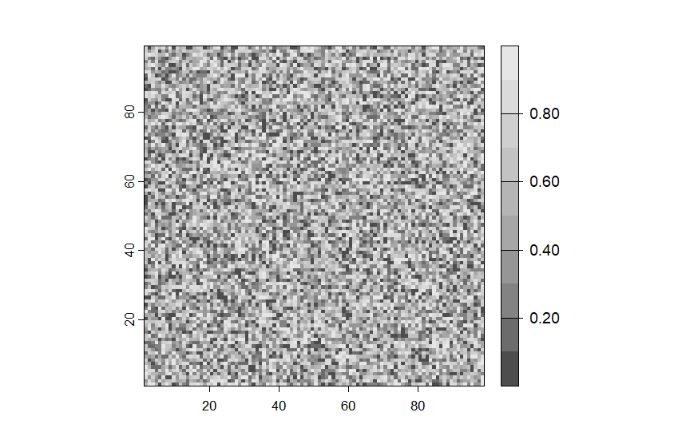

Figure 1. An image of an unsmoothed 100 by 100 domain.

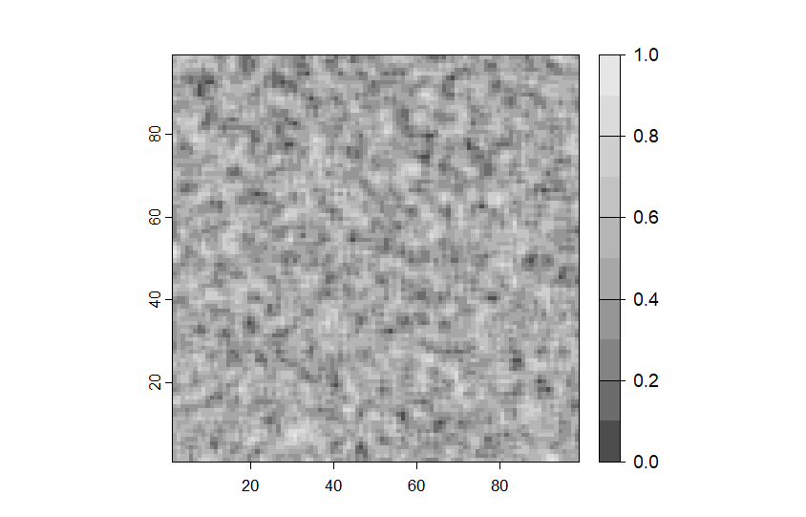

Figure 2. An image of a 100 by 100 domain smoothed by a factor of 3.

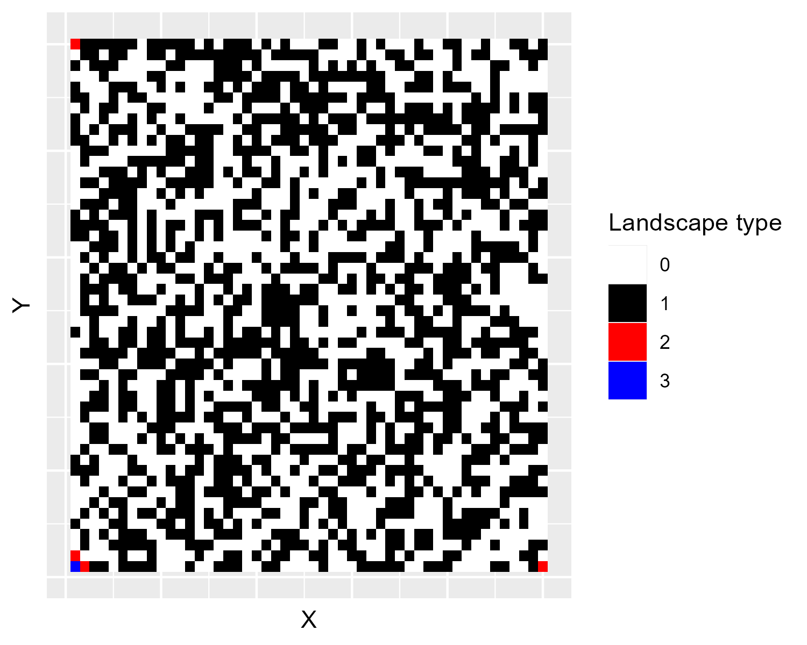

Figure 3. An image of an 100 by 100 domain with possible steps (red) the agent could take from the first cell (blue).

Hijmans, R. 2024. [_terra: Spatial Data Analysis_.](https://CRAN.R-project.org/package=terra)

Signer, J., J. R. Fieberg, and T. Avgar. 2019. Animal movement tools (amt): R package for managing tracking data and conducting habitat selection analyses. Ecology and Evolution 9:880–890.

Venables, W. N., and B. D. Ripley. 2002. Modern Applied Statistics with S. Fourth edition. Springer, New York.