Due Thurs/8-Oct-2026
Homework Instructions:
- Develop, solve and document your solution:
  - MATLAB notebook (.mlx file), as demonstrated in class AND/OR,
  - Python Jupyter notebook (.pynb) AND/OR,
  - Handwritten solution on paper.
- Scan/Print your MATLAB/Python notebook code/results as a pdf file. Make sure your results are exposed (printed out) for evaluation of your MATLAB/Python code.
- Append your MATLAB/Python notebook solution after the problem description and result summary with the following filename: me5634_f26_hw4_LastName_FirstName. Please append the files in the following order:
    - me5634 homework description and result summary,
    - scanned/printed MATLAB/Python/hand solution,
- Upload the single appended solution file to Canvas for the grading.
  - Add your homework solution to the homework description as a single .pdf file for upload.
Note:
- Logic, formulas and calculations leading to answers must be documented.
- Any points or lines used from graphs must be marked and labeled, for example, stress concentrations figures.
- Numerical answers should have sufficient significant figures, and correct units are required for full credit.
- I believe there is merit in developing an engineering solution so you can revisit and learn from your work. It is also possible that you may revise your solution to apply a “best practice”, correct a solution, or prepare for an exam.
Honor Code Instructions:
- The Virginia Tech Honor Code is being applied to this homework assignment.
- Use of AI is not allowed on this homework assignment.
- There is merit in working and learning together. You may discuss the problems with other students in class; however, you are responsible for your own work.
- Copying someone’s solution is NOT acceptable, it is a violation of the Honor Code.
- Please sign/date the Honor Code Pledge on this page and in your MATLAB/Python notebook:
Virginia Tech Honor Code Pledge:
On my honor, I have completed the work on this homework assignment in compliance with the honor code instructions. I have neither given nor received unauthorized assistance with this homework:

___________________________________________.

The figure shows the ½-in by 1-in rectangular steel bar to be welded to fixed supports. Welding is performed by TIG with settings at 10 volts and 35 amps. TIG welding process efficiency is known, η = 60%. The heat flux per unit area for the TIG welding process is q_{x Weld} = η*V*I/in² = 716.55 (BTU/hr)/in². The ambient temperature in the shop is 75°F.
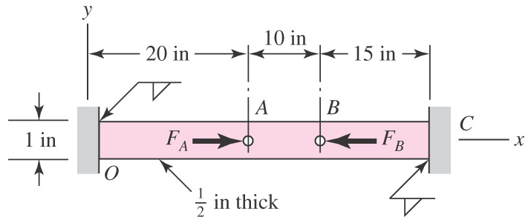
Figure 1: Welded bar structure.
The rectangular bar material is UNS G10350 Cold-Drawn steel, E = 30.0 Mpsi, ν = 0.292, S_{y} = 67 kpsi, S_{ut} = 80 kpsi and thermal conductivity k_{x} = 2.83 (BTU/hr)/(in-°F). The free convection coefficient between the steel bar and the shop air is estimated to be h_{BarAir} = 0.0122 (BTU/hr)/(in²-°F). The right end of the bar, Point C, has a temperature of 80°F.
Using the temperature distribution solution from the combined Conduction/Convection model, determine the deflection strain and stress distribution in the welded bar developed from fabrication, i.e. welding the left end of the bar, at Point O. During fabrication, the right end of the bar, Point C, is clamped in a fixture.
Use the 1D bar element and the results of the hw3 9-element (10-node) heat conduction/convection thermal model.
Use a 1-D linear 1D bar element for the structural model.
  - Using the Partitioned Matrix form of the Direct Stiffness Method, assemble the global equations,].
  - Assemble each element:
  - Develop, document the element nodal coordinates
  - Develop, document the element length
  - Develop, document the arrange the element assembly vector
  - Develop, document the stiffness matrix: 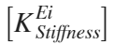
  - Develop, document the thermal equivalent joint loads: 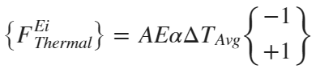
  - Assemble, document the global stiffness matrix, 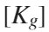.
  - Assemble, document the global load vector, 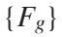.
  - Document the prescribed displacement boundary conditions, 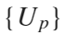
  - Compute the unknown nodal displacements, 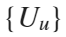.
  - Compute the reaction forces, 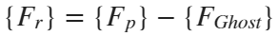.
  - Post-Process each Element:
  - Compute the total strain in each element: 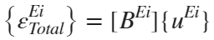.
  - Compute the thermal strain in each element: 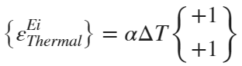
  - Compute the elastic strain in each element: 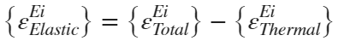.
  - Compute the elastic stress in each element: 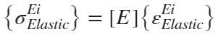.
Plot field variables vs. Bar Length for both the MATLAB and Abaqus solutions below on the same plot, i.e. 2 curves on the same plot.
Temperature vs. bar length,
axial displacement vs. bar length,
total axial strain vs. bar length,
thermal axial strain vs. bar length
elastic axial strain vs. bar length
elastic axial stress vs. bar length
- (10) MATLAB 9-Element Solution (see example code from class):
- Solution (see example code from class): Using a uniform mesh, a mesh with equal length elements, of 10 nodes, 9 elements, with nodal coordinates, x = linspace(0, 45, 10)
- Export the thermal solution from hw3:
- save('TNi.dat','TNi','-ascii'); % export the nodal temp from variable TNi to file TNi.dat
- Import the thermal solution from hw3:
- TNi = load('TNi.dat', '-ascii'); % import the nodal temp from file TNi.dat into variable TNi
- Summarize the field variable results in MATLAB Tables:
  - Nodal solution: axial nodal displacement and nodal force results, 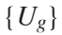, .
  - Elemental solution: axial strains and stresses,
________ / 10
- (10) Abaqus Solution:
- Starting with the uniform mesh of 9 elements, 10 nodes in the Abaqus hw3 model.
- Import the thermal solution for hw3 using the predefined field.
- Attach a screenshot of the following structural response.
  - loads and BCs,
  - Temperature (NT11) Distribution from thermal solution.
  - Nodal displacement, U1.
  - Thermal Strain, THE11, and Elastic Strain, EE11.
  - Elastic Stress, S11.
________ / 10

Figure 2: Welded bar finite element model (a) structural loads & BCs, (b) nodal temperature, NT11.
Figure 3: Welded Bar finite element model (a) axial displacement, U1, (b) thermal strain, THE11.
Figure 4: Welded Bar finite element model (a) elastic strain, EE11, (b) elastic stress, S11.

