mysql> create database Students;

mysql> use Students;

mysql> CREATE TABLE Student(
-> Sno CHAR(7),
-> Sname NCHAR(5),
-> Ssex NCHAR(1),
-> Sage TINYINT,
-> Sdept NVARCHAR(20)
-> );

mysql> insert into Student(Sno,Sname,Ssex,Sage,Sdept)
-> values('0611101','李勇','男','21','计算机系'),
-> ('0611102','刘晨','男','20','计算机系'),
-> ('0611103','王敏','女','20','计算机系'),
-> ('0611104','张小红','女','19','计算机系'),
->('0621101','张立','男','20','信息管理系'),
-> ('0621102','吴宾','女','19','信息管理系'),
-> ('0621103','张海','男','20','信息管理系'),
-> ('0631101','钱小平','女','21','通信工程系'),
-> ('0631102','王大力','男','20','通信工程系'),
-> ('0631103','张珊珊','女','19','通信工程系');

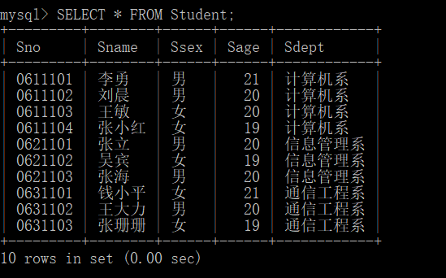

mysql> CREATE TABLE Course(
-> Cno CHAR(7),
-> Cname NVARCHAR(20),
-> Credit TINYINT,
-> Semster TINYINT
-> );

mysql> insert into Course(Cno,Cname,Credit,Semster)
-> values('C001','高等数学','4','1'),
-> ('C002','大学英语','3','1'),
-> ('C003','大学英语','3','2'),
-> ('C004','计算机文化学','2','2'),
-> ('C005','VB','2','3')，
-> ('C006','数据库基础','4','5')，
-> ('C007','数据结构','4','4'),
-> ('C008','计算机网络','4','4');

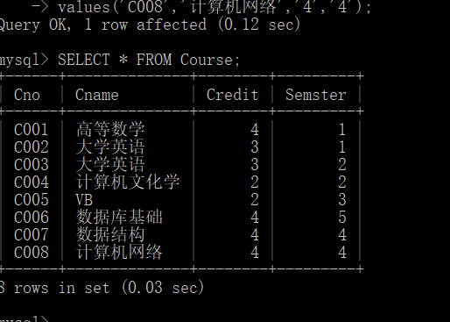

mysql> CREATE TABLE SC(
-> Sno CHAR(7),
-> Cno CHAR(6),
-> Grade TINYINT
-> );

mysql> insert into SC(Sno,Cno,Grade)
-> values('0611101','C001','96'),
-> ('0611101','C002','80'),
-> ('0611101','C003','84'),
-> ('0611101','C005','62'),
-> ('0611102','C001','92'),
-> ('0611102','C002','90'),
-> ('0611102','C004','84'),
-> ('0621101','C001','76'),
-> ('0621101','C004','85'),
-> ('0621101','C005','73');

