1.

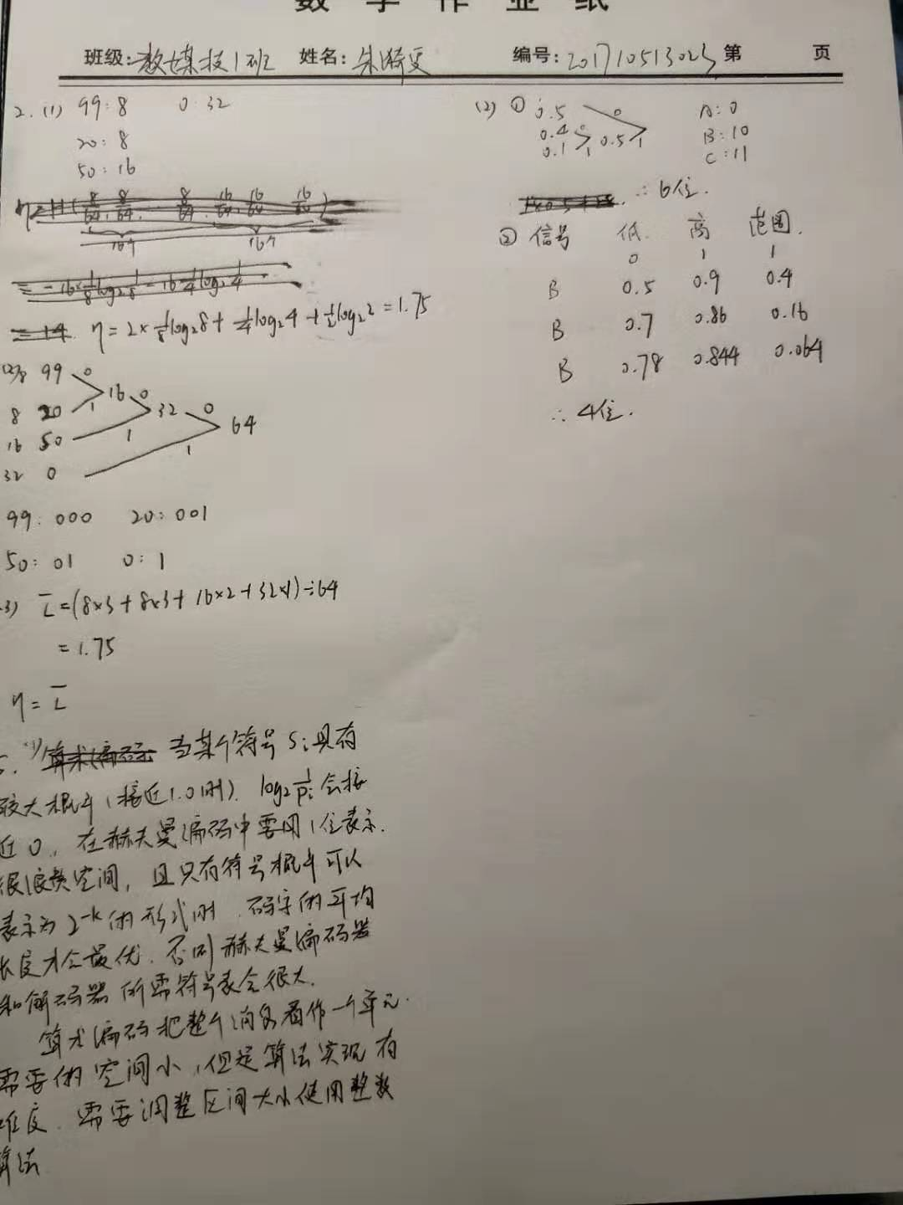

2.#include<stdio.h>

#include<iostream>

#include<string.h>

char string[30];

int n;

int find(char s)

{

int temp = -1;

for (int i = 0; i < 30; i++)

{

if (string[i] == s)

temp = i+1;

}

return temp;

}

void int()

{

string[0] = "a";

string[1] = "b";

string[2] = "c";

for (int i = 3; i < 30; i++)

{

string[i] = "";

}

}

void code(char str)

{

int();

char temp[2];

temp[0] = string[0];

temp[1] = '\0';

char w = temp;

int i = 0;

int j = 3;

cout << "编码为：";

for (i = 0; i < 30; i++)

{

char t[2];

t[0] = string[i];

t[1] = '\0';

char k = t;

if (k == "")

{

cout << "" << find(w);

break;

}

if (find(w + k) > -1)

{

w = w + k;

i++;

}

else {

cout << "" << find(w);

char wk = w + k;

string[j++] = wk;

w = k;

i++;

}

}

cout << endl;

}

void decode(int c[])

{

int pw;

int cw;

cw = c[0];

int j = 2;

cout << "译码为：";

cout << string[cw - 1];

for (int i = 0; i < n - 1; i++)

{

pw = cw;

cw = c[i + 1];

if (cw <= j + 1)

{

cout << string[cw - 1];

char t[2];

t[0] = string[cw - 1][0];

t[1] = '\0';

char k = t;

j++;

string[j] = string[pw - 1] + k;

}

else

{

char t[2];

t[0] = string[cw - 1][0];

t[1] = '\0';

char k = t;

j++;

string[j] = string[pw - 1] + k;

cout << string[cw - 1];

}

}

cout << endl;

for (i = 0; i < j + 1; i++)

{

cout << setw(45) << i + 1 << setw(12) << string[i] << endl;

}

coue << endl;

}

void main()

{

char str;

while (1)

{

char character;

cin >> character;

code(character);

char character2;

character2= code(character);

decode(character2);

}

}