**Story Idea for Tech Demo: Title – Rooms**

This document details an idea of a story for the tech demo, with a description of what happens on each route and at each node. Pictures of which route or node is being discussed will be included.

A route is being discussed when the title looks *Like this:* and a node is being discussed when the title looks **Like this:** .

*Down corridor alone:*

In this route, our first character wakes up in a bedroom. We show the player that they are playing a first person game and that they can interact with the environment, by pressing a button to open the bedroom door. We may also show that the characters are being watched, by including a camera in the corner of the room, looking in. Having opened the door to the bedroom, the player is presented with a bland corridor with another door with a button at the end. When the player presses the button, the door opens and they are introduced to the two other characters. At this point, once the player has time to see the characters, the character select screen is displayed and the player must choose a character to enter the conversation with.

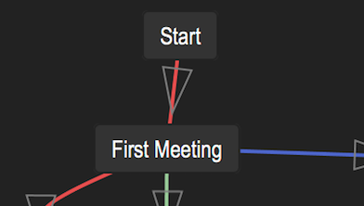

**First Meeting:**

Here the concept of dialog options is introduced. The three characters have a conversation. The player must choose which character to participate as. Char1 is bold and independent, quick to speak and can be blunt. Char2 is more thoughtful, considers what they say before they say it. Char3 is the most conciliatory of the three, and thrives in the company of the others/doesn’t want to be alone. This makes it sadder when they are the only character that has to be separated for the majority of the game and the only one that can die. At the end of the conversation (details of which can be found in Convo1), whatever is said, the lights all go out and the characters are separated. We then get the second character select screen to decide whom to follow.

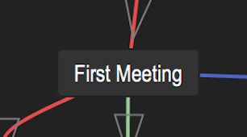

*Parkour room:*

Here we attempt to introduce the concept of choice in a rather unsubtle manner. There are two doors. You can only go through one. We also have the fun opportunity for jokes like “We hoped you picked the **right** choice” when the correct door to go through is the door on the right. If the player picks the right door, they survive and end up in a character select screen. If they pick the left door, they get dropped into a pit and with a slow fade to black they die. No more Char3.

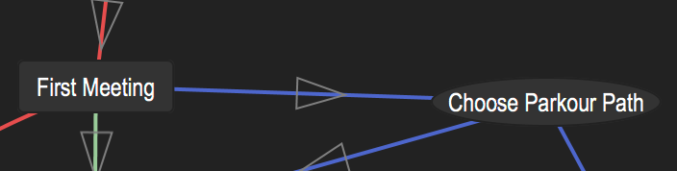

*See puzzle first time:*

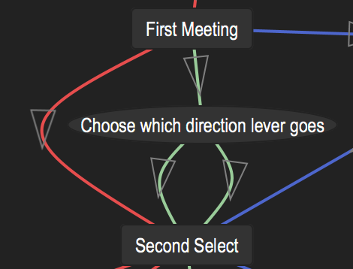Here Char1 is introduced to the crate puzzle. There are two pressure plates and three doors, one that we entered through which locks behind us, one that is open, and one that is clearly connected to the puzzle but has no handle. Behind this door is a second door also connected to the puzzle with no handle, and behind that a third door that does have a handle. The pressure plate not in front of the door operates the first door, and the pressure plate directly in front of the first door operates the second door behind it, so we can see the second door opening and closing, but can’t get through it before it closes. There is one box in the room. The puzzle is not solvable yet, so all we can do is investigate the puzzle, and then go through the only open door.

*Lever pull affects door:*



In this section, Char2 is presented with a lever that can be pulled either left or right. There are signs above the lever with the words “Send Left” and “Send Right”, and on each sign is a green and red light. When the lever is to the left the green light on the “Send Left” sign is lit while the red light on the “Send Right” sign is lit, and vice versa when the lever is to the right. This choice will later affect which door is open for Char1. The choice node is only actually entered when the player leaves the room and continues, so that the lever cannot be changed again.