ASSIGNMENT-3: LOOPS

1. Write a C program which accepts a number n and prints
a. all integers divisible by n between 1 and 100 where value of n is provided by the user.
b. all prime numbers between 1 and n.
c. all prime factors of n.
d. octal equivalent of n
e. sum of digits.
f. factorial of n.
g. reverse of n.
Code:-
#include <stdio.h>
int main()
{
int m,n;
printf("Enter a number: ");
scanf("%d",&n);
printf("The numbers b/w 1 and 100 divisible by %d are ",n);
for (int i=1; i<101; i++)
if (i%n==0)
printf("%d ",i);
printf("\n");
printf("The prime numbers between 1 and %d are",n);
int dum;
for (int j=2; j<=n; j++){
dum=1;
for (int k=2; k<j;k++)
if (j%k==0)
dum=0;
if (dum)
printf("%d ",j);
}
printf("\n");
printf("The prime factors of %d are",n);
for (int l=2;l<=n;l++){
if (n%l==0){
dum=1;
for (int k=2; k<l;k++)
if (l%k==0)
dum=0;
if (dum)
printf("%d ",l);
}
}
printf("\n");
printf("Octal equivalent : %o\n",n);
m=n;
int sum=0;
while (m>0){
sum=sum+(m%10);
m=m/10;
}
printf("Sum of digits %d\n",sum);
int fact=1;
for (int i=1;i<=n;i++){
fact*=i;
}
printf("Factorial is %d\n",fact);
m=n;
int rev=0;
while (m>0){
rev=rev*10+(m%10);
m=m/10;
}
printf("The reverse of %d is %d\n",n,rev);
return 0;
}
Output:-
Enter a number: 12
The numbers b/w 1 and 100 divisible by 12 are 12 24 36 48 60 72 84 96
The prime numbers between 1 and 12 are2 3 5 7 11
The prime factors of 12 are2 3
Octal equivalent : 14
Sum of digits 3
Factorial is 479001600
The reverse of 12 is 21

2. Write a C program to find out the sum of the following series.
a. S=1+2+3+4+ ... +n
b. S=1.2+2.3+3.4+4.5+ ... +n.(n+1)
c. S=1!+2!+3!+4!+ ... +n!
d. S = 1@ + 2@ + 3@ + 4@ + … + n@
where, n@ is the sum of all factors of n. Example: 6@ = 1+2+3+6 = 12
Code:-
#include <stdio.h>
int main()
{
int n,sum=0;
printf("Enter the value of n ");
scanf("%d",&n);
for (int i=1;i<=n;i++)
sum+=i;
printf("Sum: %d\n",sum);

int sum1=0;
for (int j=1;j<=n;j++)
sum1+=j*(j+1);
printf("Sum of cons digit: %d\n",sum1);

int fact=1,sum2=0;
for (int i=1;i<=n;i++){
fact*=i;
sum2+=fact;
}
printf("Sum of factorials: %d\n",sum2);

int sum4,sum3=0;
for (int i=1;i<=n;i++){
sum4=0;
for (int j=1;j<=i;j++){
if (i%j==0)
sum4+=j;
}

sum3+=sum4;

}
printf("Sum of @s is %d\n",sum3);

return 0;
}
Output:-
Enter the value of n 5
Sum: 15
Sum of cons digit: 70
Sum of factorials: 153
Sum of @s is 21

3. Write a program to generate all combinations of digit 1, 2 and 3 using a for loop.
Code:-
#include <stdio.h>
int main()
{
int a[9]={0};
for (int i=100;i<=999;i++){
int a[9]={0};
int j=i;
while (j>0){
a[j%10]+=1;
j=j/10;
}
if (a[1]==1 & a[2]==1 & a[3]==1)
printf("%d\n",i);
}
return 0;
}
Output:-
123
132
213
231
312
321

4. Write a menu driven program to accept a number in any Number System [from Binary, Decimal, Octal, and Hex] and convert and display the same in any other amongst these.
Code:-
#include<stdio.h>
int main(){
int n=0,a[50],c,b[50];
int in,op;
printf("Enter input base binary(b),octal(o),decimal(d),hexadecimal(x):");
while ((in=getchar()) != EOF && in !='\n'){
printf("Enter the number:");
switch(in){
case 'b':
scanf("%d",&c);
unsigned int z=0;
while(c){
b[z]=(c%10);
c=c/10;
z++;
if ((c&1 !=0) && (c&1 !=1)){
printf("%d",c);
printf("!ERROR!\n");
return 0;
}
}
for (int g=z-1;g>=0;g--){
n+=b[g];n=n<<1;
}
n=n>>1;break;
case 'o' : scanf("%o",&n);c=n;break;
case 'd' : scanf("%d",&n);break;
case 'x' : scanf("%x",&n);break;
default : printf("invalid choice");return 0;break;
}
}
printf("Enter output base binary(b),octal(o),decimal(d),hexadecimal(x):");
while ((op=getchar()) != EOF && op !='\n'){
switch(op){
case 'b' :;
int i=0;
while(n){
a[i]=n&1;
n=n>>1;
i++;
}
for (int j=i-1;j>-1;j--){
printf("%d",a[j]);
}
break;
case 'o' : printf("%o",n); break; case 'd' : printf("%d",n); break; case 'x' : printf("%x",n); break;
default : printf("invalid choice"); break;
}
}
printf("\n");
return 0;
}
Output:-
Enter input base binary(b),octal(o),decimal(d),hexadecimal(x):b
Enter the number:1011
Enter output base binary(b),octal(o),decimal(d),hexadecimal(x):d
11
Enter input base binary(b),octal(o),decimal(d),hexadecimal(x):o
Enter the number:177
Enter output base binary(b),octal(o),decimal(d),hexadecimal(x):x
7f

5. Write a program named SINE to find the sine of an angle. The angle and its unit (degree, radian or grade) should be provided as command line arguments. For the units, short forms as d/D (for degree), r/R (for radian) or g/G (for grade) may be used. The program should use the series

for evaluation. Take care of negative angles and angles in all the quadrants.
Code:-
#include<stdio.h>
#include<math.h>
int main(){
float n,res=0;
char m;
printf("Enter the value of the angle and unit(d/r) :");
scanf("%f %c",&n,&m);
if (m=='d')
n=n*(3.14/180);
int j=0,fact=1;
for (int i=1;i<10;i+=2){
res+= (pow(-1,j) * pow(n,i))/fact;
j++;
fact=fact*(i+1)*(i+2);
}
printf("Result is %f\n",res);
return 0;
}
Output:-
Enter the value of the angle and unit(d/r) :30 d
Result is 0.499770
Enter the value of the angle and unit(d/r) :1 r
Result is 0.841471

6. Write a C program to print the first n numbers of the Fibonacci sequence. The Fibonacci
sequence is constructed by adding the last two numbers of the sequence so far to get the next number in the sequence. The first and second numbers of the sequence are defined as 0 and 1. We get: 0, 1, 1, 2, 3, 5, 8, 13, 21…
Code:-
#include<stdio.h>
int main(){
int n,a=0,b=1,temp;
printf("Enter the value of n:");
scanf("%d",&n);
printf("0,");
for (int i=0;i<n-1;i++){
printf("%d,",b);
temp=b;
b=a+b;
a=temp;
}
return 0;
}
Output:-
Enter the value of n:9
0,1,1,2,3,5,8,13,21,

7. Write a program to print out all Armstrong numbers between 1 and 500. If the sum of cubes of each digit of the number is equal to the number itself, then the number is called an Armstrong number.
For example, 153 =
Code:-
#include<stdio.h>
#include<math.h>
int main(){
int sum=0;
for (int i=1;i<501;i++){
sum=0;
int c=i;
while(c){
sum+=pow((c%10),3);
c=c/10;

}
if (sum==i){
printf("%d\n",i);
}
}
return 0;
}
Output:-
1
153
370
371
407

8. Write a C program which prints the first 10 happy numbers. If you iterate the process (assume
maximum 100 iterations) of summing the squares of the decimal digits of a number and if the
process terminates in 1, then the original number is called a Happy number. For example 7 is a
happy number as 7 → 49 → 97 → 130 → 10 → 1.
Code:-
#include<stdio.h>
#include<math.h>
int main(){
int i=0;
int k=0;
while (i<10){
k++;
int c=k;
for (int j=0;j<100;j++){
int sum=0;
while(c){
sum+=pow((c%10),2);
c=c/10;
}
c=sum;
if (sum==1){
printf("Happy Number is %d\n",k);
i++;
break;
}
}
}
return 0;
}
Output:-
Happy Number is 1
Happy Number is 7
Happy Number is 10
Happy Number is 13
Happy Number is 19
Happy Number is 23
Happy Number is 28
Happy Number is 31
Happy Number is 32
Happy Number is 44

9. An important property of square numbers: If a natural number is a square number, then it has
to be the sum of Successive Odd Numbers starting from 1.
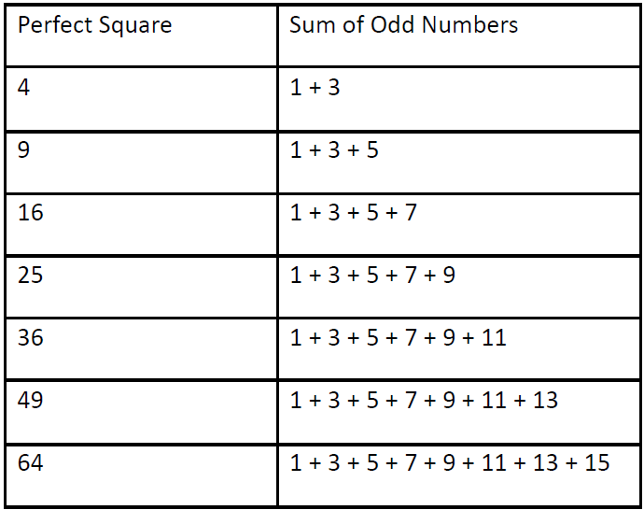
For example:
Now using this property, find the square root of any perfect square.
Code:-
#include<stdio.h>
int main(){
printf("Enter a number ");
int n;
scanf("%d",&n);
int i=1,temp=3,sum=1;
while (1){
if (sum==n){
printf("%d\n",i);
break;
}
else if(sum>n){
printf("Number is not a perfect square");
break;
}
sum+=temp;
temp+=2;
i+=1;
}
return 0;
}
Output:-
Enter a number 64
8
Enter a number 13
Number is not a perfect square
10. Write a C program that prints the following patterns for the input of n=4. The value of n is input by the user.
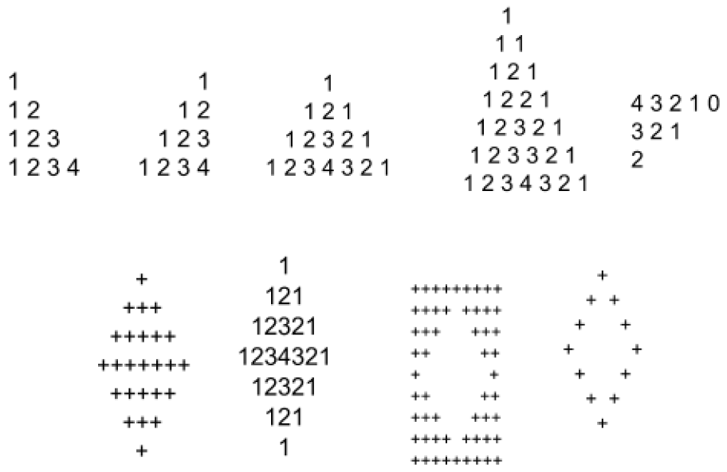
Pattern 1:
Code:-
#include<stdio.h>
int main(){
int n;
scanf("%d",&n);
for (int i=1;i<=n;i++){
for (int j=1;j<=i;j++){
printf("%d ",j);
}
printf("\n");
}
return 0;
}
Output:-
4
1
1 2
1 2 3
1 2 3 4

Pattern 2:
Code:
#include <stdio.h>
int main(){
int n;
scanf("%d",&n);
for (int i=1;i<=n;i++){
for (int j=1;j<=n-i;j++)
printf(" ");
for (int k=1;k<=i;k++)
printf("%d",k);
printf("\n");
}
return 0;
}
Output:
4
1
12
123
1234

Pattern 3:
Code:
#include<stdio.h>
int main(){
int n,temp1,temp2;
scanf("%d",&n);
for (int i=1;i<=n;i++){
for (int j=1;j<=n-i;j++)
printf(" ");
for (int k=1;k<=i;k++){
printf("%d",k);
temp1=k;
}
for (int l=temp1-1;l>0;l--)
printf("%d",l);
printf("\n");
}
return 0;
}
Output:
4
1
121
12321
1234321

Pattern 4:
Code:
#include<stdio.h>
int main(){
int temp1,temp2;
int n;
scanf("%d",&n);
n=n+1;
int m=1+(n-2)*2;
for (int i=1;i<=m;i++){
for (int j=1;j<=m-i;j++)
printf(" ");
if (i%2!=0){
for (int k=1;k<=(i+1)/2;k++){
printf("%d ",k);
temp1=k;
}
for (int l=temp1-1;l>0;l--)
printf("%d ",l);
}
else {
for (int a=1;a<=i/2;a++){
printf("%d ",a);
temp2=a;
}
for (int b=temp2;b>0;b--)
printf("%d ",b);
}
printf("\n");
}
return 0;
}
Output:
4
1
1 1
1 2 1
1 2 2 1
1 2 3 2 1
1 2 3 3 2 1
1 2 3 4 3 2 1

Pattern 5:
Code:
#include<stdio.h>
int main(){
int n;
scanf("%d",&n);
int j=n+1;
while (j>0){
for (int i=0;i<j;i++)
printf("%d ",n-i);
n-=1;
j-=2;
printf("\n");
}
return 0;
}
Output:
4
4 3 2 1 0
3 2 1
2

Pattern 6:
Code:
#include<stdio.h>
int main(){
int n;
scanf("%d",&n);
int temp1,temp2;
for (int i=0;i<n;i++){
for (int j=0;j<n-i-1;j++)
printf(" ");
for (int k=0;k<=i;k++){
printf("+");
temp1=k;
}
for (int l=temp1-1;l>=0;l--)
printf("+");
printf("\n");
}
for (int a=0;a<n-1;a++){
for (int b=0;b<=a;b++)
printf(" ");
for (int c=0;c<n-a-1;c++){
printf("+");
temp2=c;
}
for (int d=temp2-1;d>=0;d--)
printf("+");
printf("\n");
}
return 0;
}
Output:
4
+
+++
+++++
+++++++
+++++
+++
+

Pattern 7:
Code:
#include<stdio.h>
int main(){
int n,temp1,temp2;
scanf("%d",&n);
for (int i=1;i<=n;i++){
for (int j=1;j<=n-i;j++)
printf(" ");
for (int k=1;k<=i;k++){
printf("%d",k);
temp1=k;
}
for (int l=temp1-1;l>0;l--)
printf("%d",l);
printf("\n");
}
for (int i=n-1;i>0;i--){
for(int j=n-i;j>0;j--)
printf(" ");
for (int k=1;k<=i;k++){
printf("%d",k);
temp2=k;
}
for (int l=temp2-1;l>0;l--)
printf("%d",l);
printf("\n");
}

return 0;
}
Output:
4
1
121
12321
1234321
12321
121
1

Pattern 8:
Code:
#include <stdio.h>
int main()
{
int n;
scanf("%d",&n);
int a=n, b=n;
for (int i=0;i<n+1;i++){
for (int j=0;j<2*n+1;j++){
if (j>a && j<b)
printf(" ");
else
printf("+");
}
a-=1;
b+=1;
printf("\n");
}
a++;
b--;
for (int i=0;i<n+1;i++){
for (int j=0;j<2*n+1;j++){
if (j>a && j<b)
printf(" ");
else
printf("+");
}
a+=1;
b-=1;
printf("\n");
}
return 0;
}

Output:
4
+++++++++
++++ ++++
+++ +++
++ ++
+ +
+ +
++ ++
+++ +++
++++ ++++
+++++++++
Pattern 9:
Code:
#include <stdio.h>
int main()
{
int n;
scanf("%d",&n);
int a=n, b=n;
for (int i=0;i<n;i++){
for (int j=0;j<2*n+1;j++){
if (j==a || j==b)
printf("+");
else
printf(" ");
}
a-=1;
b+=1;
printf("\n");
}
a++;
b--;
a++;
b--;
for (int i=1;i<n;i++){
for (int j=0;j<2*n+1;j++){
if (j==a || j==b)
printf("+");
else
printf(" ");
}
a+=1;
b-=1;
printf("\n");
}
return 0;
}
Output:
4
+
+ +
+ +
+ +
+ +
+ +
+

