MAR31c

The MAR31c is a portable music player with clock and input based on an AVR microcontroller.

Parts list

<https://detail.tmall.com/item.htm?id=536177311143>

<https://detail.tmall.com/item.htm?id=563596251820>

<https://detail.tmall.com/item.htm?id=14601487966>

<https://detail.tmall.com/item.htm?id=555380054234>

<https://detail.tmall.com/item.htm?id=17952641393>

<https://detail.tmall.com/item.htm?id=21123656085>

<https://item.taobao.com/item.htm?id=529059737540>

<https://detail.tmall.com/item.htm?id=533054527075>

<https://detail.tmall.com/item.htm?id=41210227078>

<https://detail.tmall.com/item.htm?id=45823224665>

<https://item.taobao.com/item.htm?id=35014299078>

<https://item.taobao.com/item.htm?id=521729293708>

<https://detail.tmall.com/item.htm?id=536471530768>

<https://detail.tmall.com/item.htm?id=14768953772>

M3

[https://detail.tmall.com/item.htm?id=13866722304](https://detail.tmall.com/item.htm?id=13866722304&_u=m3oj6mk0c361)

M3

Uses Arduino pro mini 5v/16mhz as controller

Pinout schematic

18650 Battery TP4056

+ B+

- B-

Voltage regulator

In+ OUT+

In- OUT-

Arduino pro mini

OUT+ RAW

OUT- GND

Nokia 5110 LCD display

Vcc VCC

Gnd GND

CLK 8

DIN 9

DC 10

RST 11

CS 12

BL 13

Rotary encoder

+ VCC

GND GND

SW A1

CLK 2

DT 3

DS1307

+ VCC

- GND

SDA A4

SCL A5

DFPlayer mini (pin numbers go from top left in counter-clockwise from 1)

1. VCC
2. 5
3. 4

7 GND

16 A2

Resistors 3.5mm Headphone jack

6 220ohm Left

8 220ohm Right

GND 1kohm GND

DFPlayer SDcard file arrangement

Libraries list

ds1307(custom library based on RTClib)

<http://www.rinkydinkelectronics.com/library.php?id=47>

<https://www.pjrc.com/teensy/td_libs_Encoder.html>

<https://github.com/DFRobot/DFRobotDFPlayerMini>

<https://github.com/adafruit/Adafruit-GFX-Library>

and other libraries that comes with the IDE

Reference photos

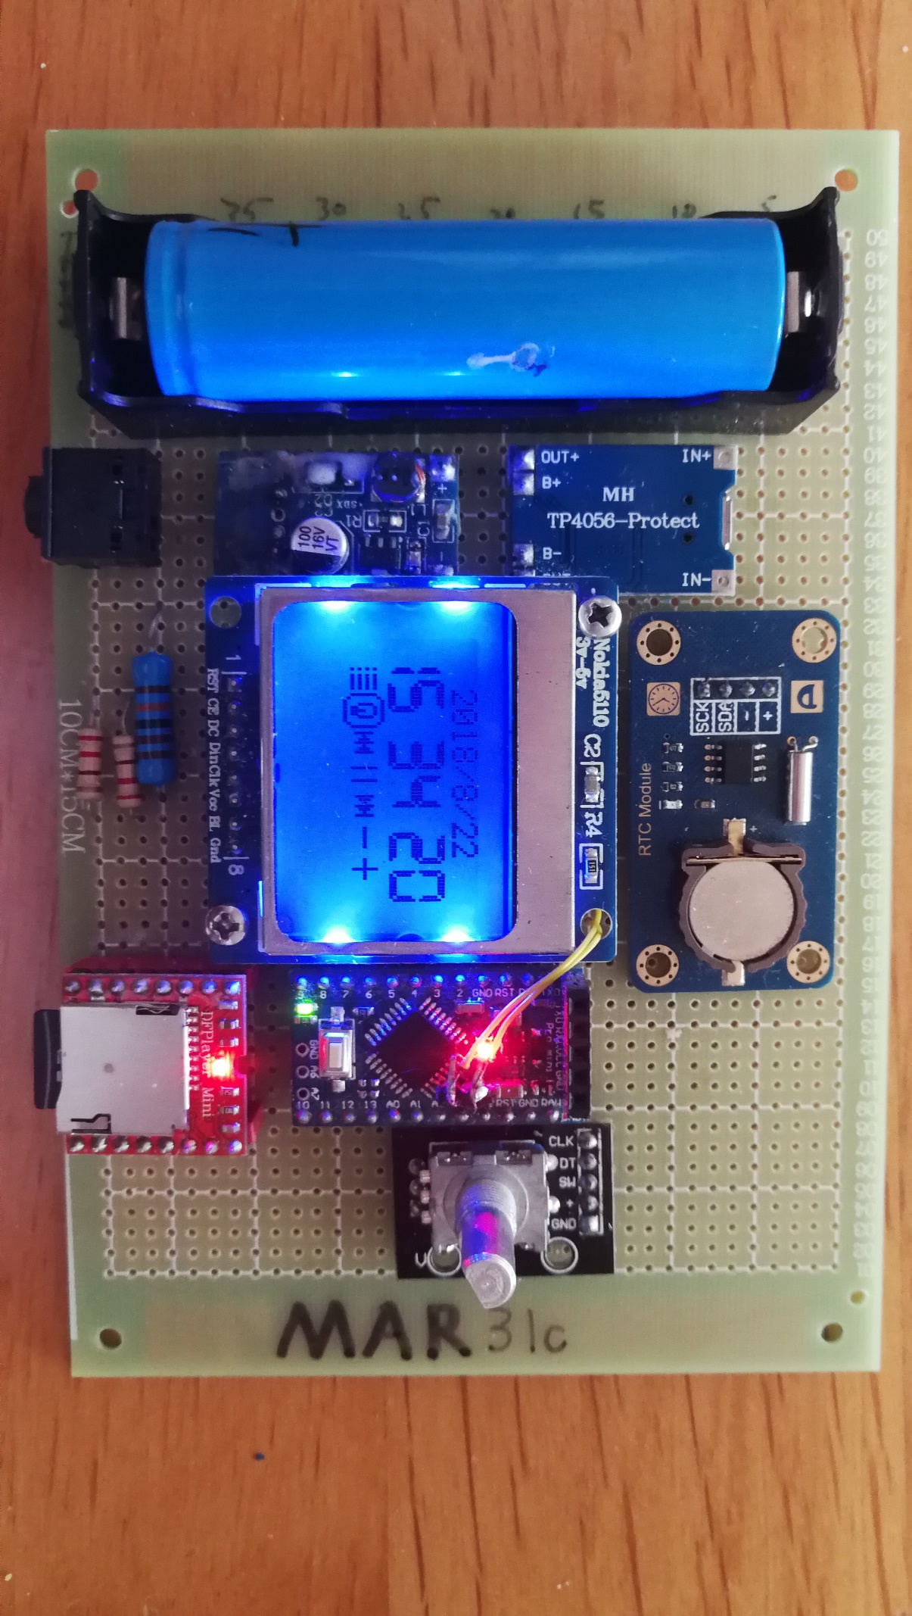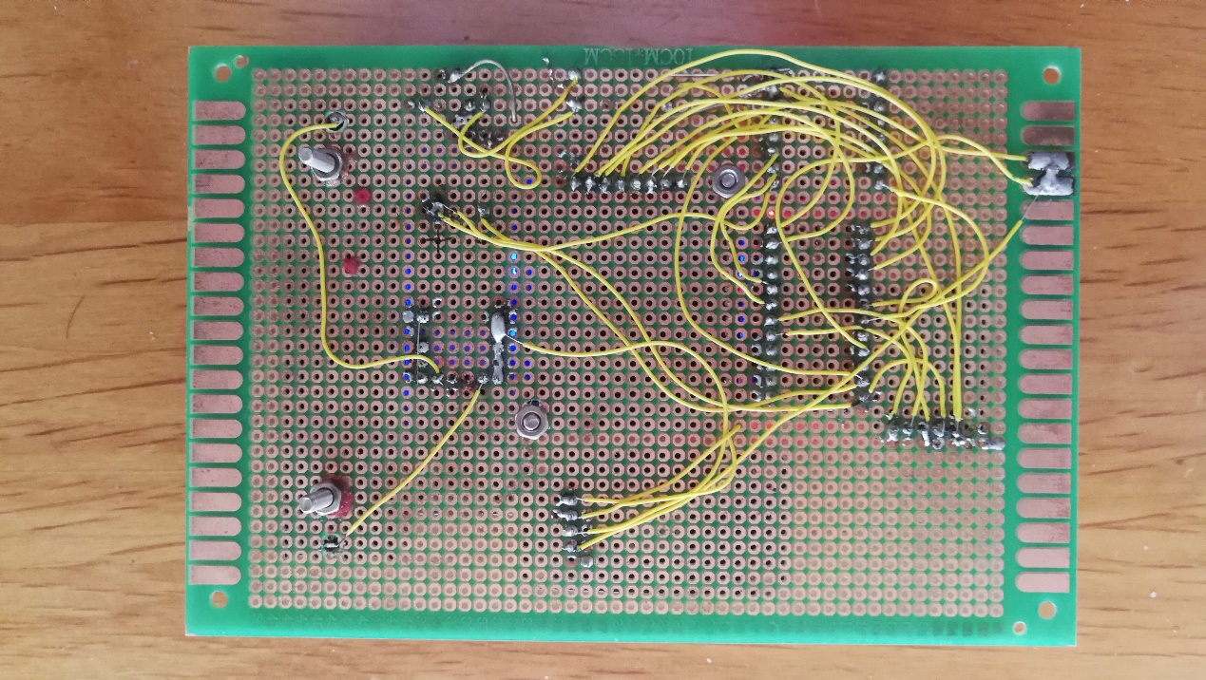

Mp3 player playlist management

Functions

Mp3 player

Clock

Alarm with music ringtone

Lockdown (passcode = 0118999881999119725)

This concludes the MAR31c project datasheet.

Datasheet updated 2018/8/25

Copyright Xiachuan Xu aka. Non-GUI Coder / Non-GUI Programmer

xxc13924018000@gmail.com