# Readme:

Chenran Gong

I have implemented both Level 1 and Level2:

## Level 1:

The SOCJenaLevel1 project implemented the requirements in level 1. User input the data on the console according to the prompt and the load data into RDF through Jena. At last, user can input a publication name to query detailed information about the publication. As following:

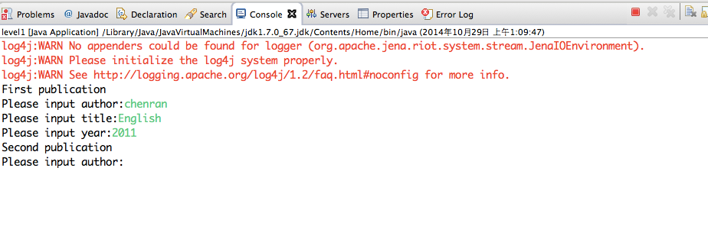

And the RDF shows below:

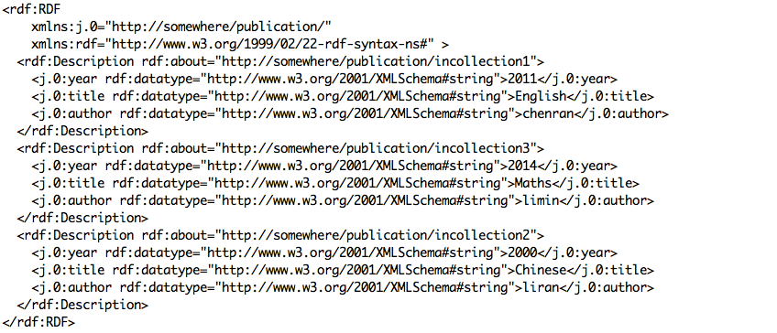

Then query a publication name:

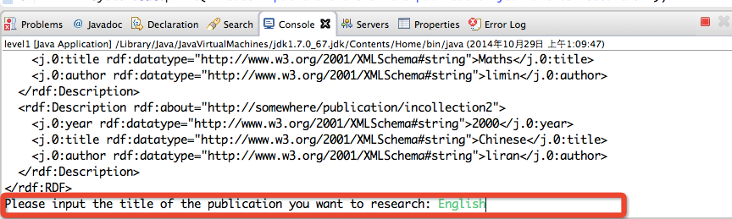

It shows the query results:

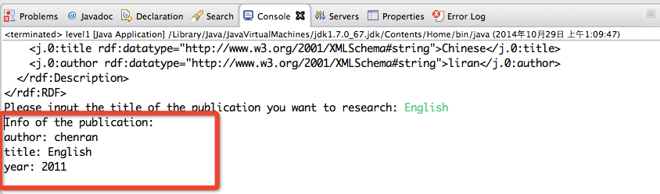

## Level 2:

The XMLtoRDF project implemented the requirements in level 2.

First the DOMParser parse the XML file and then load data to RDF through Jena and generate a RDF file in XMLtoRDF project.

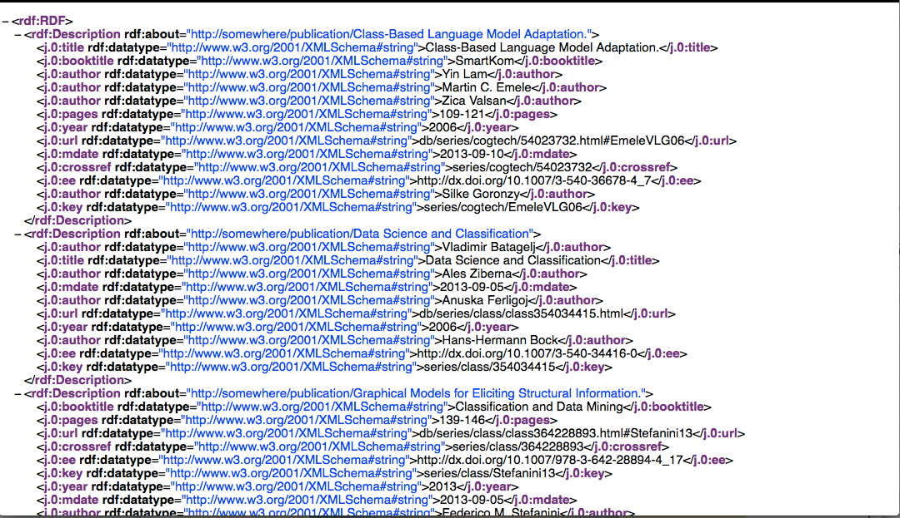

Moreover, I also implemented a web interface to do some simple queries.

Input an author name, as below:

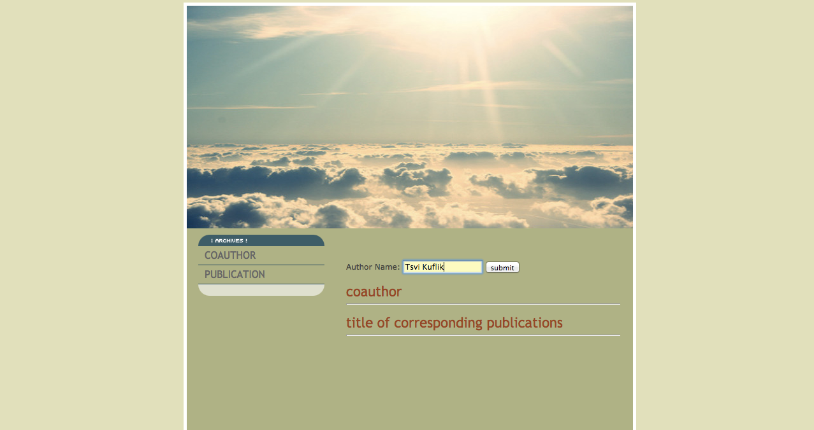

And provide all of the co-authors together with the corresponding publication information. As following:

