Web Service QoS workflow-Selection using JGAP
Chenran Gong

- Class design
Below are the classes to represent SC and S in the flows.
They are in the relationship of composition.
WebServiceCluster
WebService
Below are the classes calculating the most fitted workflow.
QosWebTest
QosWebFitnessFunction
- Evolution steps
In QosWebTest class, JGAP class Chromesome is used. By transferring 3 variable genes, the chromesome could evolve to different composition of web workflow for evaluate.
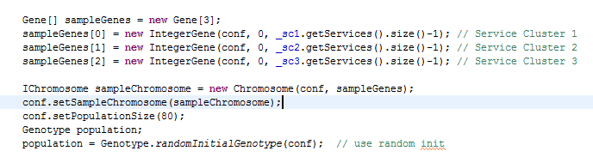

After particular times of evolution, those value compositions will be calculated and it make possible to find the best solution in fitness class.
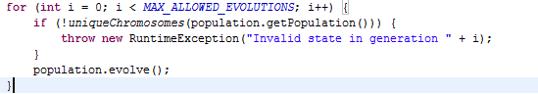

- QoSWebFitnessFunction design
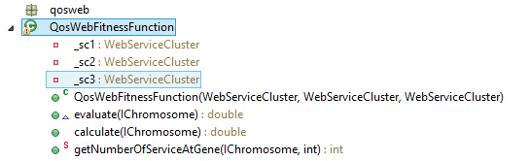
In this class, I implement the way to measure the QoS value of particular composition.
The major logic is calculate () method.

The final fitness will be summed by 4 parameters with their weights:
cost*.35 + time*.30 + reliability *.30 + availability

- Running Result
After running for 200 times, the result is like below:
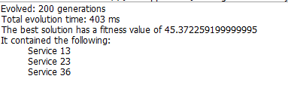
Which means S13 – S23 – S36 will be the best solution on this measurement.

