Managing Datasets: UNIX 101

- How do you connect to our class server?
  - Using MobaXterm for Windows 10.
  - Connect to the UT Houston VPN, and ssh to IP 129.106.2.94
    - Username is eschwartz
    - Default pw is UT@Houston. Changed on first login

- What is your username?
  - eschwartz

- Draw a diagram that shows the public folder (/home/public/) in relation to your home directory and include the commands to go from one to another. What are the commands you would use to create a “Lab1” subfolder in your home directory and copy “pheno.txt” and “geno.txt” to your Lab1 directory from the public folder?
  - 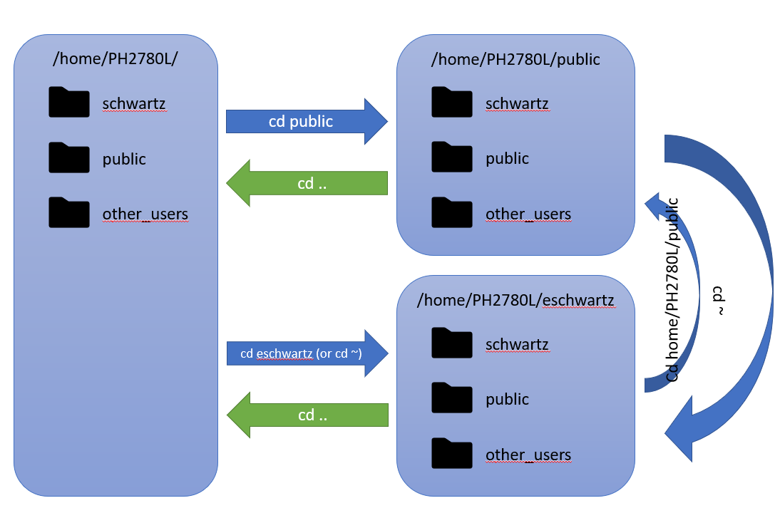
  - To create Lab1 in eschwartz:
    - cd home/PH2780L/eschwartz
    - mkdir Lab1
  - To copy pheno.txt and geno.txt from home/PH2780L/
    - cp home/PH2780L/public/Lab1/pheno.txt home/PH2780L/eschwartz/Lab1/pheno.txt
    - cp home/PH2780L/public/Lab1/geno.txt home/PH2780L/eschwartz/Lab1/geno.txt

- How do you move files from the server to your local computer and vice versa?
  - Using scp
    - scp <source location> <target location>
    - From server to local: scp ~/myFile.txt C:/PH2870L/Lab1/myfile.txt
    - From local to server: scp C:/PH2870L/Lab1/myfile.txt ~/myFile.txt
  - Using MobaXterm
    - Use Upload / Download icons:
      - Upload to current folder:
      - Download selected files:

Managing Datasets: R 101

- What R function do you use to set an R working directory?
  - setwd(“path/to/mydir”)

- How do you check the number of individuals and variable in an R data frame?
  - To find number of individuals, use nrow(df), where df is the data frame in question.
  - To find number of variables, use ncol(df).

- What is the mean age in the merged dataset? What is the proportion of smokers in the merged dataset?
  - Age: mean is 41.38
  - Smokers: proportion of smokers (current or previous) is 0.314. Assumed that entries with no indication (“ “) are neither smokers or non-smokers.

- How do you export an R dataset?
  - With R-Studio: Click the icon in the Environment tab.

