LD & Haplotypes

- How many individuals are there? Is it pedigree data? How many SNPs are there? Which chromosome are SNPs on? How is missing data coded?
  - Individuals: There are 1000 individuals (number of rows in the .ped file)
  - Pedigree data: Columns V1 and V2 are equal in each of the 1000 individuals (unique family ID, unique individual ID). This is not a pedigree because there are no relationships between individuals.
  - SNPs: There are 1940 SNPs, based on the .map file.
  - SNP location: All SNPs are located on chromosome 16.
  - Missing data: Missing data in the .ped file is coded as “0 0” in the genotype.

Evaluating LD
- What is the full name of the CETP gene? What are the start and stop positions? How big is the gene (kb)? How many genotyped common SNPs are in CETP shown on the Genome Brower (i.e., tens, hundreds, or thousands)?
  - Full name: Homo sapiens cholesteryl ester transfer protein (CETP).
  - Start and Stop: chr16:56961950-56983845.
  - Size: 21,896 bp.
  - Common SNPs: Common SNPs for this gene are in the hundreds, based on dbSNP Release 155.

- How many SNPs in CETP are included in our map file?
  - Based on the .map file, there are 9 SNPs that exist for the CETP gene.

- Is there LD among any of our SNPs in CETP? How do you calculate pairwise LD for all SNPs?
  - There is some LD between the 9 SNPs found in the lab2 file. The SNPs and their associated MAF values are shown below. They are generated with the command plink --noweb --file cetp --freq --out cetp_freq. 3 SNPs exhibit a MAF of zero and are excluded from the analysis.
CHR SNP A1 A2 MAF NCHROBS
16 rs7197148 T C 0.03103 1998
16 rs7185970 A G 0.07093 1988
16 rs7186316 0 G 0 2000
16 rs17241126 T C 0.08342 1954
16 rs34696101 T C 0.05305 1998
16 rs41486544 0 T 0 2000
16 rs7189961 0 T 0 2000
16 rs8048037 A G 0.06231 1974
- rs3743565 A G 0.2298 1976

  - To determine pairwise LD, we can use the command plink --noweb --file cetp --r2 --ld-window-r2 0 --out cetp_LD_gt0. This will establish the filter threshold for R² at 0 and perform pairwise analysis across all remaining SNPs. The results are shown below. Only one pairwise comparison exceeds a threshold of 0.2, between rs8048037 and rs3743565.

CHR_A BP_A SNP_A CHR_B BP_B SNP_B R2
16 56962005 rs7197148 16 56964065 rs7185970 0.00489348
16 56962005 rs7197148 16 56971665 rs17241126 1.50547e-05
16 56962005 rs7197148 16 56978817 rs34696101 0.00228491
16 56962005 rs7197148 16 56982469 rs8048037 0.0004205
16 56962005 rs7197148 16 56983683 rs3743565 0.00432976
16 56964065 rs7185970 16 56971665 rs17241126 0.0154805
16 56964065 rs7185970 16 56978817 rs34696101 0.00613227
16 56964065 rs7185970 16 56982469 rs8048037 0.0603878
16 56964065 rs7185970 16 56983683 rs3743565 0.109977
16 56971665 rs17241126 16 56978817 rs34696101 0.00769019
16 56971665 rs17241126 16 56982469 rs8048037 0.0065353
16 56971665 rs17241126 16 56983683 rs3743565 0.0247579
16 56978817 rs34696101 16 56982469 rs8048037 0.00348799
16 56978817 rs34696101 16 56983683 rs3743565 0.143313
16 56982469 rs8048037 16 56983683 rs3743565 0.216174

Estimating Haplotypes

- Analyze the frequency of haplotypes constructed with the following SNPs.
  - rs289715 and rs289742
    - Results are as follows below. The TG haplotype appears with the highest frequency at 0.87:

LOCUS HAPLOTYPE F
H1 AC 0.1163
H1 TC 0.01213
H1 TG 0.868
    - Note that the combination type of AG is missing, likely because the two SNPs do not feature the A and G alleles.
  - rs4783962 and rs289715
    - Results are as follows below. The CT haplotype appears with the highest frequency at 0.66:

LOCUS HAPLOTYPE F
H2 TA 0.01416
H2 CA 0.1081
H2 TT 0.2133
H2 CT 0.6645

Quantitative Traits and Heritability

- What do the summary statistics tell you about these traits?
  - Traits 2, 3, 4, and 5 would be considered quantitative, while traits 1, 6, and 7 are qualitative.

 | Male |  | Female
 | Mean | S.D. | Mean | S.D.
Age | 39.9 | 23.5 | 42.8 | 22.9
Trait2 | 116.2 | 18.3 | 117.8 | 22.2
Trait3 | 70.2 | 11.9 | 69.0 | 10.1
Trait4 | 110.5 | 70.9 | 100.5 | 51.1
Trait5 | 309.0 | 124.0 | 290.3 | 132.4
Covar1 | 24.9 | 5.4 | 24.6 | 5.6

  - Age: Lower mean age for men than women, wider distribution for men than women.
  - Trait2: Higher mean and distribution for women than men.
  - Trait3: Higher mean and distribution for men than women.
  - Trait4: Higher mean and distribution for men than women.
  - Trait5: Higher mean for men, higher distribution for women
  - Covar1: Very similar mean and distribution for men and women.
 | Male | Female
N/A | 115 | 41
Current Smoker | 76 | 78
Former Smoker | 238 | 130
Never Smoked | 509 | 634

  - Not reported: Greater number of men than women.
  - Current smoker: Similar numbers for men and women.
  - Former smoker: Greater number of men than women.
  - Never smoked: Greater number of women than men.

 |  | Male | Female
Trait 1 | 1 | 337 | 358
Trait 1 | 2 | 92 | 129

  - 1: Greater number of females than males.
  - 2: Greater number of females than males.

 |  | Male | Female
Trait 6 | 1 | 358 | 319
Trait 6 | 2 | 273 | 231

  - 1: Greater number of males than females.
  - 2: Greater number of males than females.

 |  | Male | Female
Trait 7 | 1 | 318 | 323
Trait 7 | 2 | 262 | 224

  - 1: Greater number of females than males.
  - 2: Greater number of males than females.

- What other statistics might be appropriate to report for this dataset?
  - In conjunction with the histogram on continuous variables, a Q-Q plot can be used to further investigate the normality of the sample distribution. These are included below and show varying levels of deviation at the tails. In addition to mean and standard deviation, median and IQR may be more appropriate for non-normally distributed variables, especially if they do not respond to transformations. If hypothesis testing is desired, Chi-squared or t-testing could be used, based on whether the trait was continuous or categorical.
  - Age
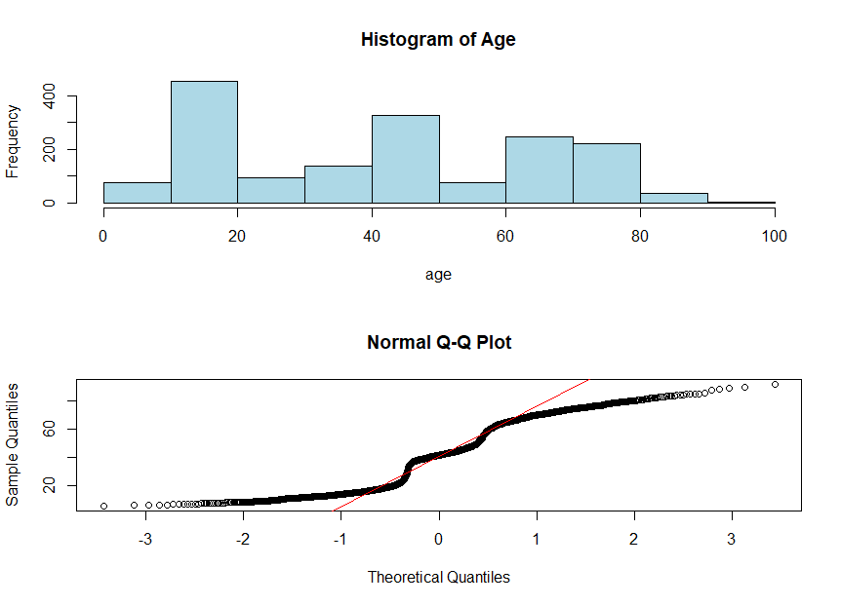
  - Trait2
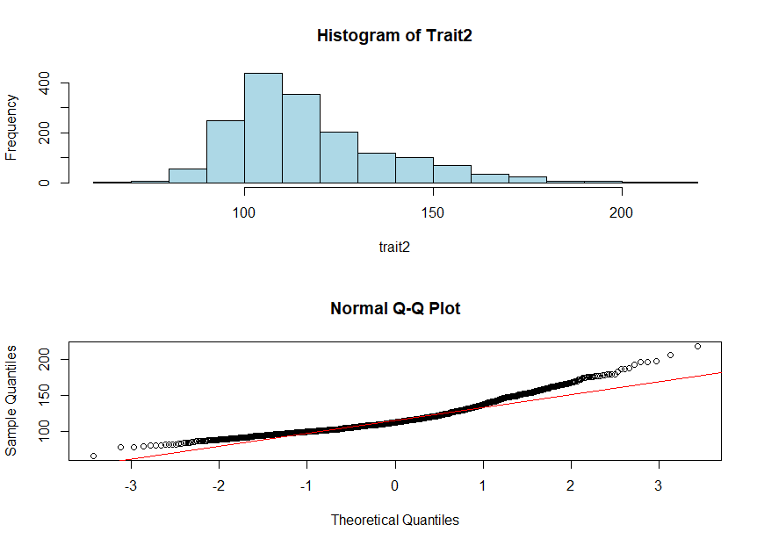
  - Trait3
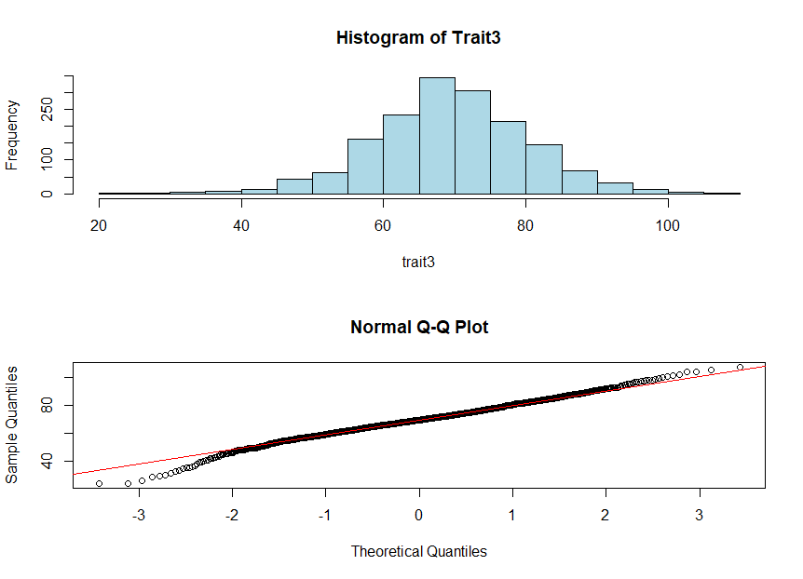

  - Trait4
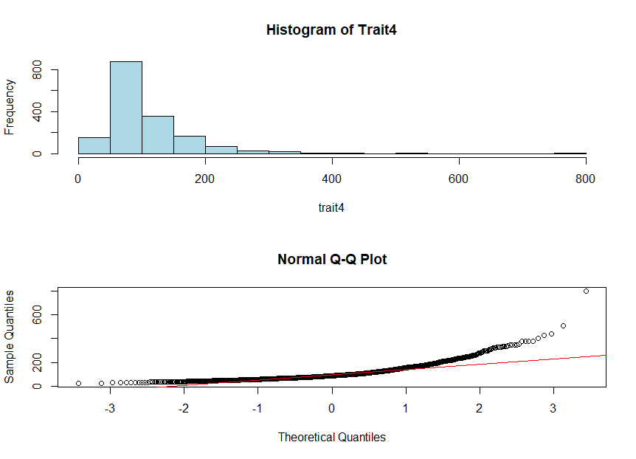
  - Trait5
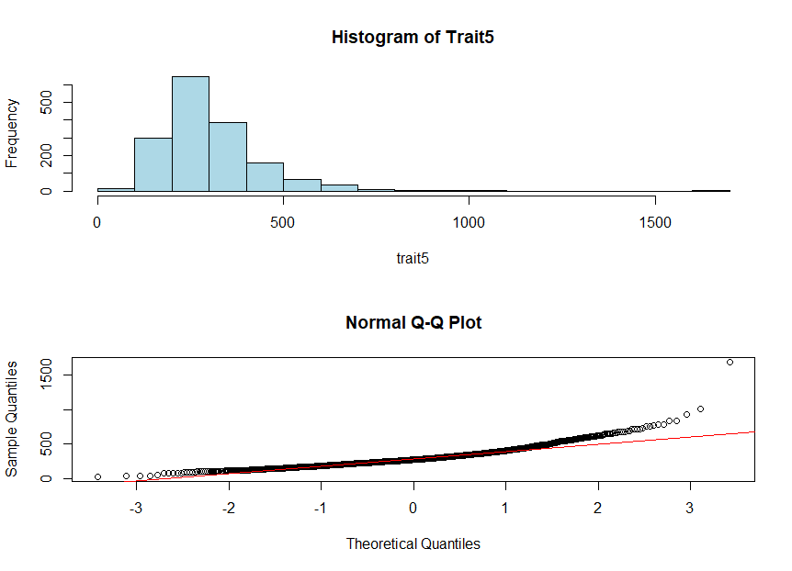
  - Covar1

- Which quantitative traits are NOT normally distributed? Are they improved by log transformation?
  - The following traits are NOT normally distributed: trait2, trait4, trait5, and covar1. These all demonstrate significant right skew, distorting the normal distribution.
  - Log distribution transformations of these variables are shown below:
    - Log(trait2). Significant improvement, approaching normal distribution
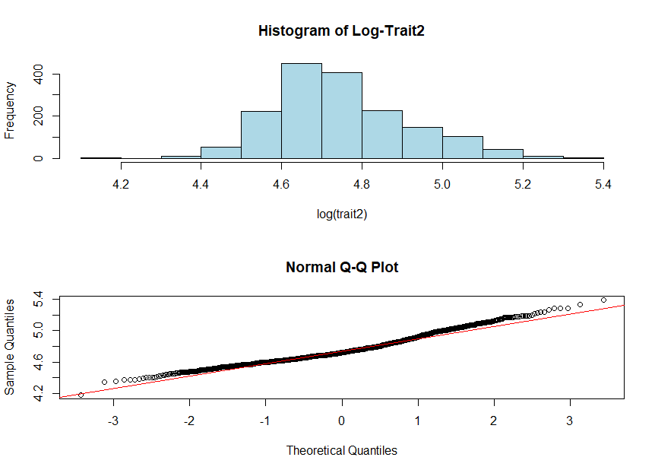
    - Log(trait4). Significant improvement, though the tails still show mild deviation from normality.
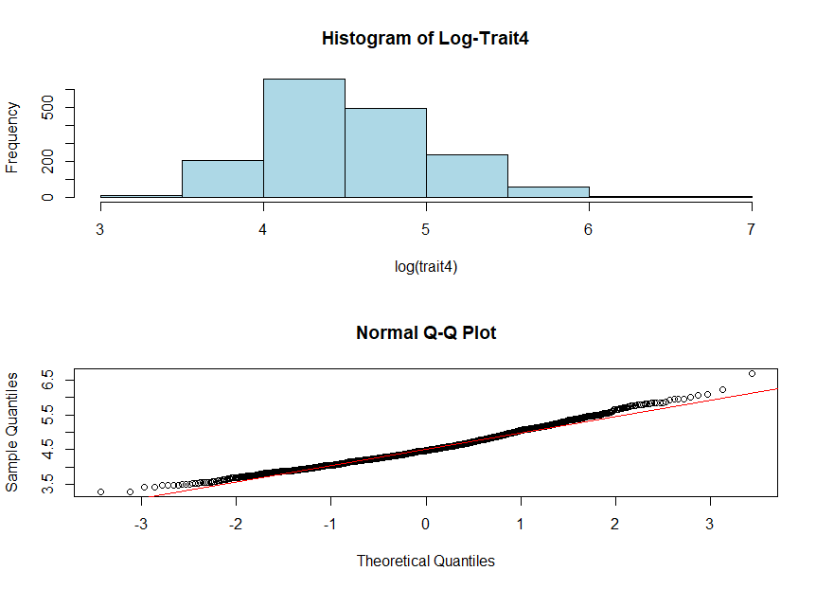

    - Log(trait5). Performance is worse on the left of the distribution and improved on the right. Log transformation is not sufficient to call this distribution normal.
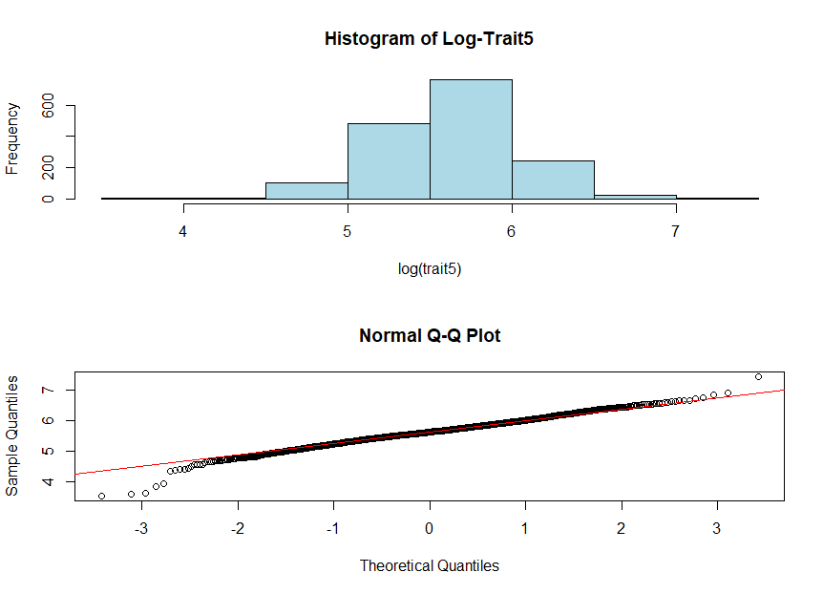

    - Log(covar1). Still demonstrates ample right skewness, but with marked improvement from the untransformed data.
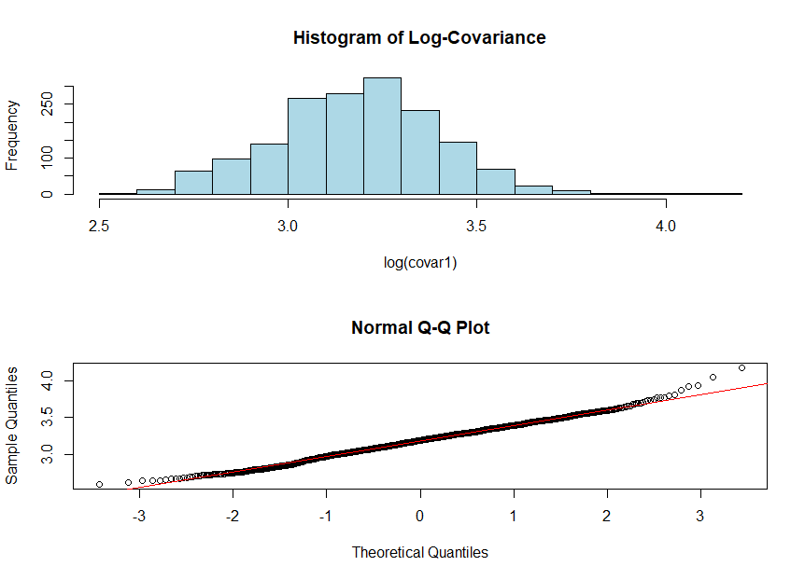

- What is the estimated heritability of trait4 and covar1?
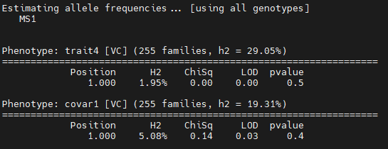
  - Heritability of trait4 is 29%, while the heritability of MS1 is only 1.95%
  - Heritability of covar1 is 19.3%, while the heritability of MS1 is only 5%

- What is the estimated heritability of log-transformed trait4 and covar1?
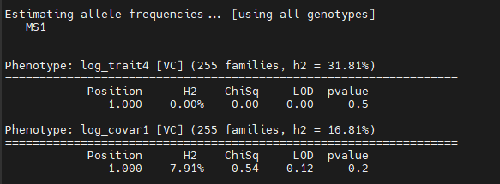

  - Heritability of log_trait4 is 31.8%, while the heritability of MS1 is 0%
  - Heritability of covar1 is 16.8%, while the heritability of MS1 is only 7.9%

