Quantitative Traits and Heritability

- What do the summary statistics tell you about these traits?
  - Traits 2, 3, 4, and 5 would be considered quantitative, while traits 1, 6, and 7 are qualitative.

 | Male |  | Female
 | Mean | S.D. | Mean | S.D.
Age | 39.9 | 23.5 | 42.8 | 22.9
Trait2 | 116.2 | 18.3 | 117.8 | 22.2
Trait3 | 70.2 | 11.9 | 69.0 | 10.1
Trait4 | 110.5 | 70.9 | 100.5 | 51.1
Trait5 | 309.0 | 124.0 | 290.3 | 132.4
Covar1 | 24.9 | 5.4 | 24.6 | 5.6

  - Age: Lower mean age for men than women, wider distribution for men than women.
  - Trait2: Higher mean and distribution for women than men.
  - Trait3: Higher mean and distribution for men than women.
  - Trait4: Higher mean and distribution for men than women.
  - Trait5: Higher mean for men, higher distribution for women
  - Covar1: Very similar mean and distribution for men and women.
 | Male | Female
N/A | 115 | 41
Current Smoker | 76 | 78
Former Smoker | 238 | 130
Never Smoked | 509 | 634

  - Not reported: Greater number of men than women.
  - Current smoker: Similar numbers for men and women.
  - Former smoker: Greater number of men than women.
  - Never smoked: Greater number of women than men.

 |  | Male | Female
Trait 1 | 1 | 337 | 358
Trait 1 | 2 | 92 | 129

  - 1: Greater number of females than males.
  - 2: Greater number of females than males.

 |  | Male | Female
Trait 6 | 1 | 358 | 319
Trait 6 | 2 | 273 | 231

  - 1: Greater number of males than females.
  - 2: Greater number of males than females.

 |  | Male | Female
Trait 7 | 1 | 318 | 323
Trait 7 | 2 | 262 | 224

  - 1: Greater number of females than males.
  - 2: Greater number of males than females.

- What other statistics might be appropriate to report for this dataset?
  - In conjunction with the histogram on continuous variables, a Q-Q plot can be used to further investigate the normality of the sample distribution. These are included below and show varying levels of deviation at the tails. In addition to mean and standard deviation, median and IQR may be more appropriate for non-normally distributed variables, especially if they do not respond to transformations. If hypothesis testing is desired, Chi-squared or t-testing could be used, based on whether the trait was continuous or categorical.
  - Age
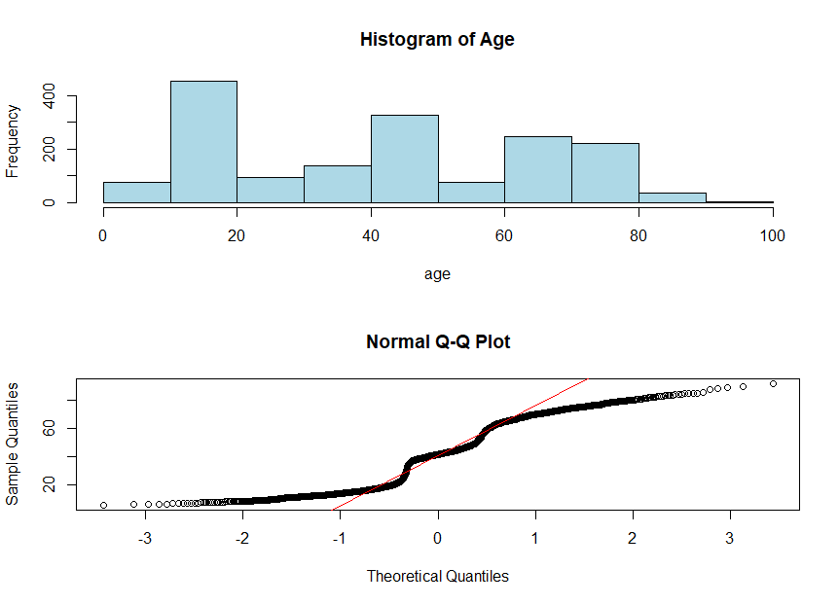
  - Trait2
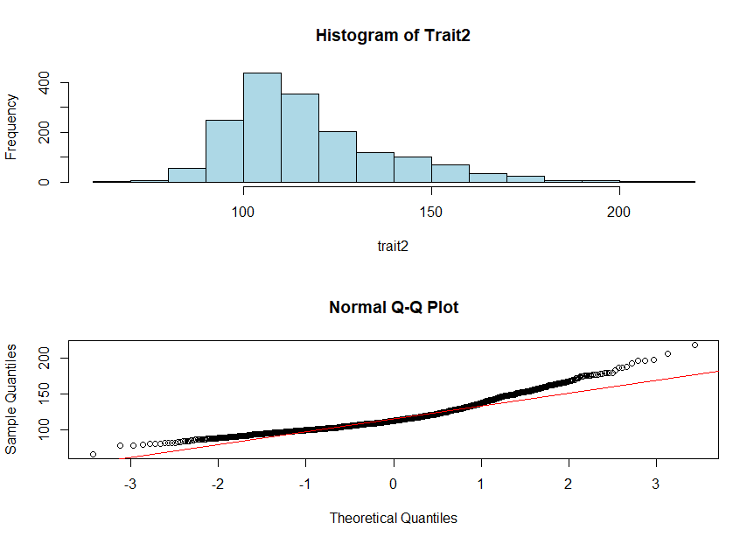
  - Trait3
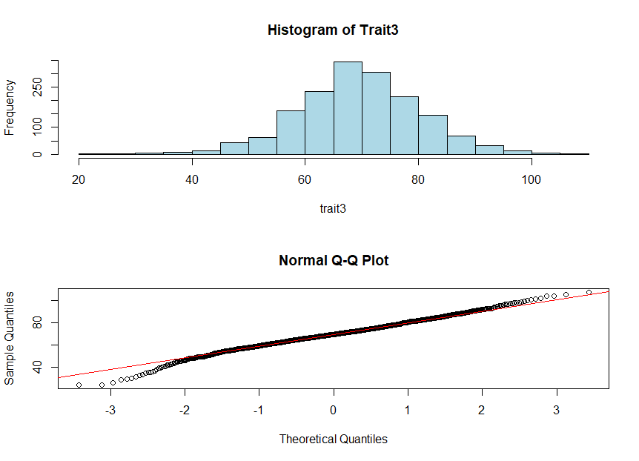

  - Trait4
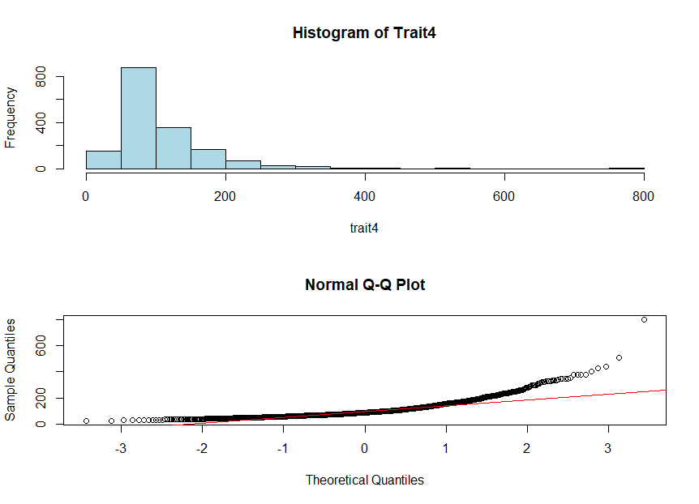
  - Trait5
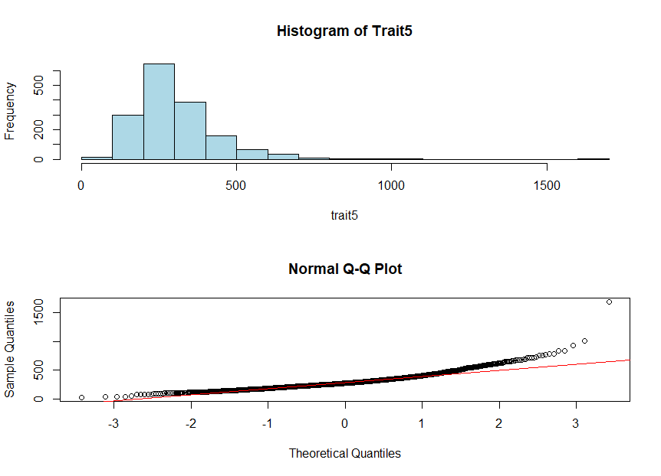
  - Covar1

- Which quantitative traits are NOT normally distributed? Are they improved by log transformation?
  - The following traits are NOT normally distributed: trait2, trait4, trait5, and covar1. These all demonstrate significant right skew, distorting the normal distribution.
  - Log distribution transformations of these variables are shown below:
    - Log(trait2). Significant improvement, approaching normal distribution
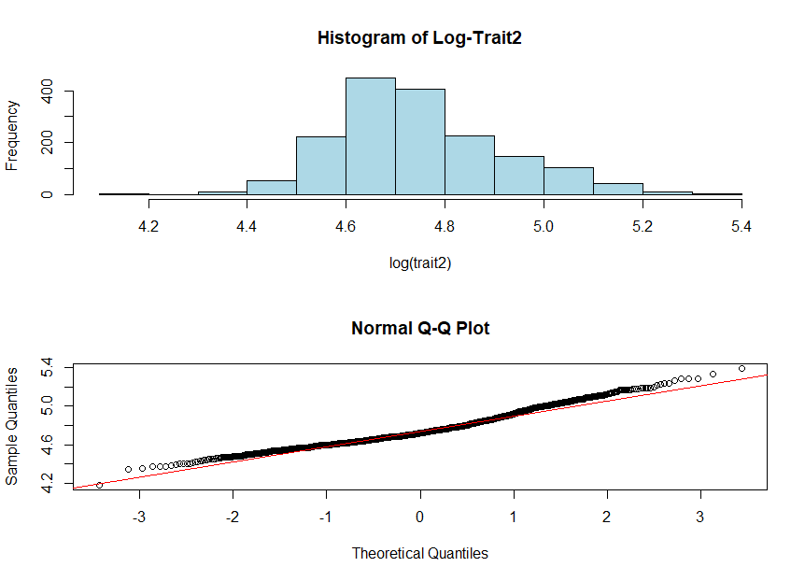
    - Log(trait4). Significant improvement, though the tails still show mild deviation from normality.
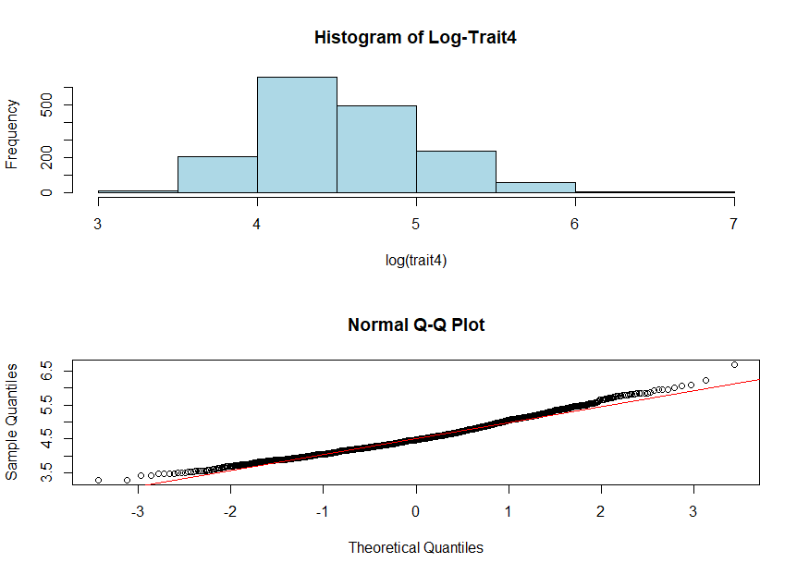

    - Log(trait5). Performance is worse on the left of the distribution and improved on the right. Log transformation is not sufficient to call this distribution normal.
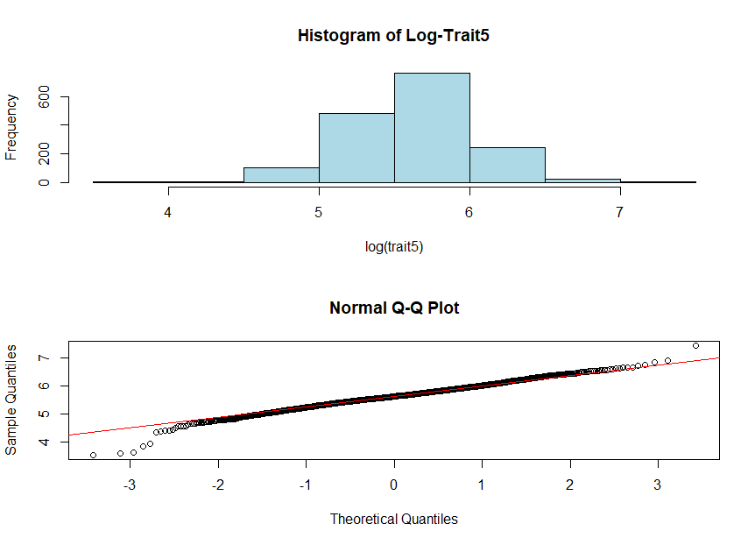

    - Log(covar1). Still demonstrates ample right skewness, but with marked improvement from the untransformed data.
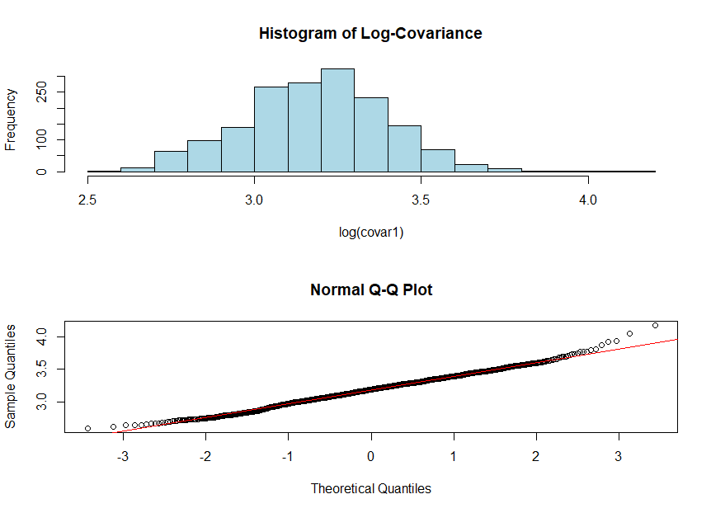

- What is the estimated heritability of trait4 and covar1?
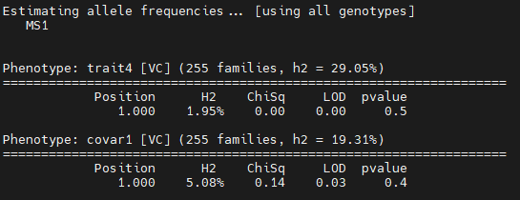
  - Heritability of trait4 is 29%, while the heritability of MS1 is only 1.95%
  - Heritability of covar1 is 19.3%, while the heritability of MS1 is only 5%

- What is the estimated heritability of log-transformed trait4 and covar1?
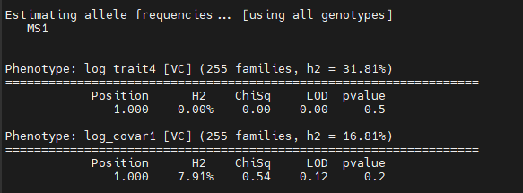

  - Heritability of log_trait4 is 31.8%, while the heritability of MS1 is 0%
  - Heritability of covar1 is 16.8%, while the heritability of MS1 is only 7.9%

