Quantitative Linkage Analysis Questions

Preparing files for analysis

- Using pedstats, verify that MERLIN is interpreting the input files correctly. Confirm the number of:
  - Pedigrees: 255
  - Number of individuals (how many founders and nonfounders?): 1821
    - Founders: 864
    - Non-founders: 957
  - Average family size: 7.14
  - Average number of generations: 2.83
  - Also verify the mean for trait 5: 299.562
    - Founders only: 320.938
  - Marker with the lowest heterozygosity: ms2, 69.8%
  - Marker with the highest heterozygosity: ms1, 76.8%

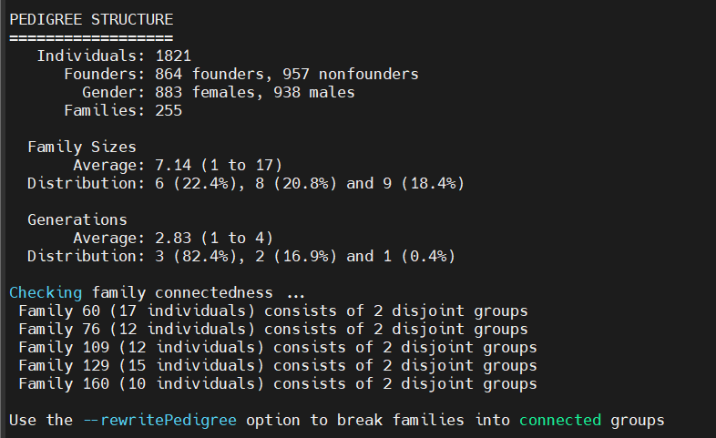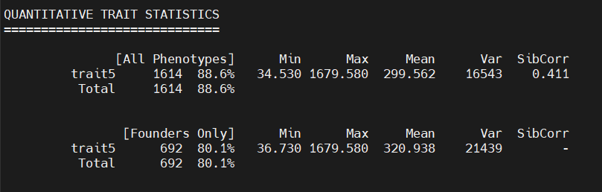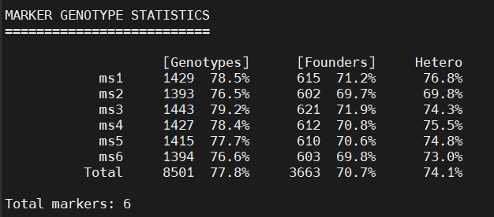

Variance Components Linkage Analysis (Merlin)
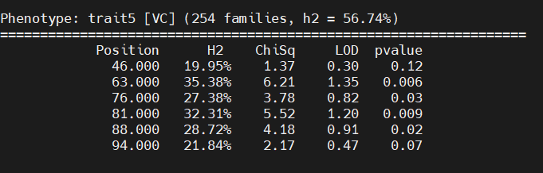
- How many pedigrees were informative for the analysis?
  - 254 families
  - What is the heritability of trait5: 56.74%
  - Is there evidence for linkage in this region of chromosome 10?
    - See position 63.0, this highest LOD score. Even so, this score is below the presumptive threshold of 2 for linkage, suggesting insufficient evidence to claim linkage. Though the p-value is < 0.05, the threshold for this kind of analysis is higher than this. Overall, there is insufficient evidence to claim linkage.
- At which marker is the LOD score the highest for:
  - The singlepoint analysis?
    - For ms2, at position 63.0 cM
  - The multipoint analysis?
    - For ms2, between 65.0 and 66.0 cM
  - How do the singlepoint and multipoint plots compare?
    - Singlepoint appears like a piecewise function, with disjunctions at the cM positions provided. Plots provided below.
    - Multipoint analysis demonstrates a similar, although smoother, function.
    - Both demonstrate disjunctions near 77.0 cM and 81.0 cM.

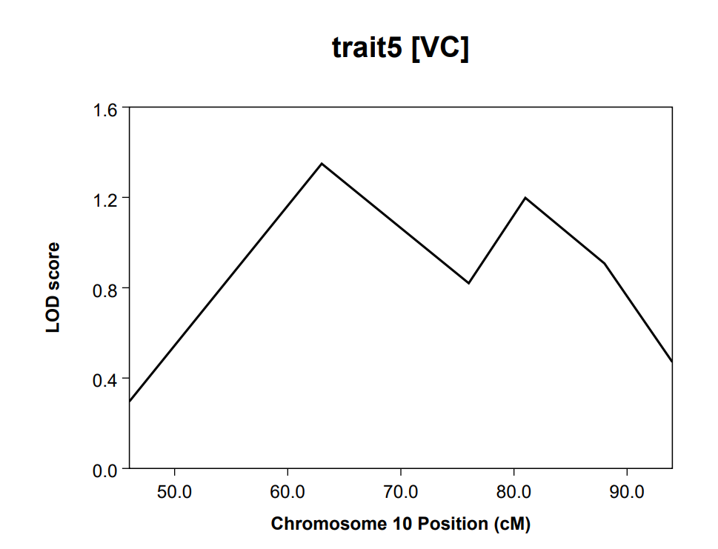 | 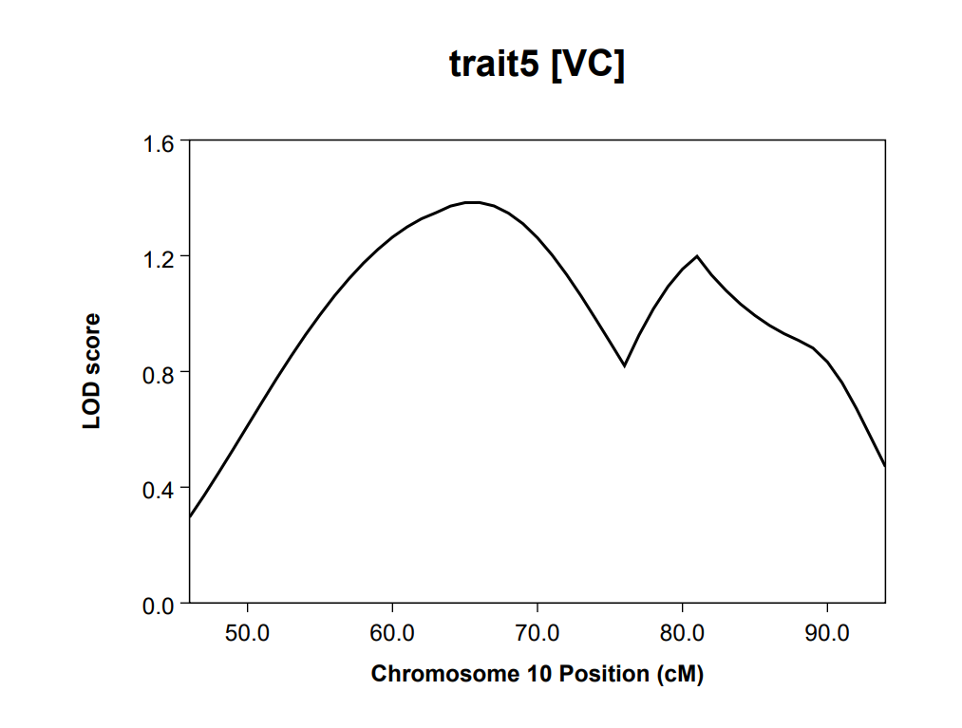
Singlepoint Plot | Multipoint Plot

- How do the plots of adjusted and unadjusted multipoint linkage for trait5 compare? Does the highest evidence for linkage appear in the same cM position?
  - It appears that the linkage analysis was influenced by the two covariates (age and covar1).
  - Overall, LOD and p-value scores are lower than those found in the singlepoint and multipoint analysis.
  - Max LOD score appears at 63.0 cM (1.05), like both the singlepoint and multipoint analysis.

Analyzing data using R: Preparing the files

- What is the rare homozygous genotype for each of the five SNPs? What is the range of the rare homozygous genotype frequency across generations?

SNP | Rare homozygous genotype | Frequency range
SNP1 | AA | 0.184 – 0.220
SNP2 | GG | 0.200 – 0.221
SNP3 | GG | 0.000 – 0.040
SNP4 | AA | 0.000 – 0.005
SNP5 | GG | 0.000 – 0.129

- For each SNP, detail how the genotypes were recorded as an additive effect of the rare allele.

Recoding | 2 (Counts) | 1 (Counts) | 0 (Counts)
SNP1 | AA (280) | AG (694) | GG (436)
SNP2 | GG (315) | AG (750) | AA (430)
SNP3 | GG (40) | CG (376) | CC (1009)
SNP4 | AA (4) | AG (275) | GG (860)

- How many cases and how many controls are in the dataset for traits 6 and 7 in each generation? Are you statistically powered for a case-control study (alpha=0.05)?

Hint: http://zzz.bwh.harvard.edu/gpc/ (assumptions: disease prevalence of 30%, f(A)=0.2, additive coding with the heterozygous risk ratio =1.5, perfect LD with the disease allele with the same frequency as the marker allele, using the smallest sample size you get in the table below)

 | GP |  | Parent |  | Child
Trait | Cases | Controls | Cases | Controls | Cases | Controls
6 | 161 | 168 | 153 | 157 | 189 | 196
7 | 155 | 155 | 149 | 149 | 181 | 181

Using the statistical parameters outlined above, and the most conservative estimate with minimum sample size (i.e., parents, trait 7 N = 149), statistical power is equal to 0.8638. This suggests that there is an 86.38% likelihood of detecting a statistically significant result.

Genetic Association Studies (Cross-Sectional)

Analyzing quantitative data using R: ANOVA

- Is there a significant difference in means of logtrait5 across each genotype class in each dataset (i.e., by generation)? Did each dataset meet the assumption of the equality of variances?
  - For grandparents, there was a significant difference in means of log_trait5, but not for parents or children. Each dataset met the assumption of equal variance, based on the Bartlett test (see table below).

Generation | P-value Significant? | Equal Variances?
Child | 0.423, no. | p-value = 0.4485, equal variance.
GP | 0.0186, yes. | p-value = 0.1821, equal variance.
Parent | 0.158, no. | p-value = 0.5644, equal variance.

- How does ANOVA compare to the lm output?
  - Grandparents
    - ANOVA: P-value = 0.0186
    - LM: P-value = 0.0186
    - Models agree. Reject the null. There is sufficient evidence to suggest that the mean of logtrait5 is different for at least one genotype group among grandparents.
  - Parents
    - ANOVA: P-value = 0.158
    - LM: P-value = 0.158
    - Models agree. Fail to reject the null. There is insufficient evidence to conclude that the mean of logtrait5 is different for genotype groups among parents.
  - Children
    - ANOVA: P-value = 0.423
    - LM: P-value = 0.423
    - Models agree. Fail to reject the null. There is insufficient evidence to conclude that the mean of logtrait5 is different for genotype groups among children.

Genetic Association Studies (Case-Control)

Analyzing qualitative data using R: Chi-square test

- Is there evidence for a significant association between SNP4 and trait7?
  - Grandparents
    - Table:

 | AA | AG | GG
0 | 2 | 35 | 61
1 | 0 | 27 | 73

    - Chi-squared = 4.0871, df = 2, p-value = 0.1296
      - Insufficient statistical evidence to suggest an association.
    - Fisher’s exact: p-value = 0.1163
      - Insufficient statistical evidence to suggest an association.
  - Parents
    - Table:

 | AA | AG | GG
0 | 0 | 20 | 83
1 | 0 | 25 | 79

    - Chi-squared = cannot be computed due to the 0 AA value.
      - Cannot conclude based on Chi-squared.
    - Fisher’s exact: p-value = 0.5009
      - Insufficient statistical evidence to suggest an association.
  - Children
    - Table:

 | AA | AG | GG
0 | 0 | 27 | 97
1 | 1 | 22 | 107

    - Chi-squared = 1.8597, df = 2, p-value = 0.3946
      - Insufficient statistical evidence to suggest an association.
    - Fisher’s exact: p-value = 0.3853
      - Insufficient statistical evidence to suggest an association.
- In the tables, did any cells contain less than 5 individuals? How does this affect the test? What test of association is appropriate for small sample sizes and sparse tables? Run this test and compare the results to the chi-square test.

  - Grandparents: AA has less than 5, Fisher’s exact must be used.
  - Parents: AA has no observations, Fisher’s exact must be used.
  - Children: AA has 1 observation, Fisher’s exact must be used.
  - All of Fisher’s exact tests suggest that there is insufficient statistical evidence to suggest significant associations.

Analyzing qualitative data using R: Logistic regression

- Test for the association between SNP3 and trait7 in the GP generation. Use additive coding for SNP3. How do the results from the logistic regression model compare with the results from a chi-square test?

  - 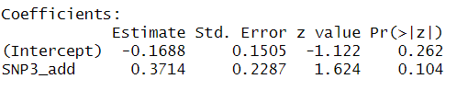

    - Coefficient for additive coding of SNP is > 0.05, suggesting that there is insufficient evidence to conclude an association among the GP generation.

  - 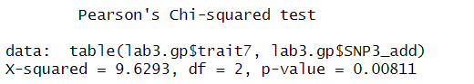

    - P-value is significant in comparison between trait7 and the additive coding of SNP3. It is 0.008, which is < 0.05. There is sufficient evidence to suggest an association.

  - Results comparison: Chi-squared test uses 2 degrees of freedom (i.e. is the distribution of trait7 the same in all 3 genotypes), while the logit model only tests the additive effect of SNP3.

- Do the results change for different genotypic models for SNP3?

  - Logistic

    - Recessive model

      - 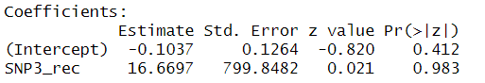

        - Not significant.
    - Dominant model

      - 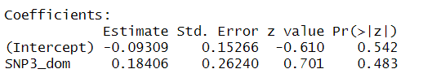
        - Not significant
  - Chi-squared

    - Recessive model

      - 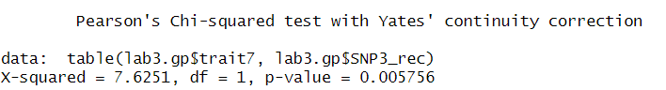
        - Significant result. The p-value is < 0.05. There is sufficient evidence to suggest a deviation from expected values in the recessive model.

    - Dominant model

      - 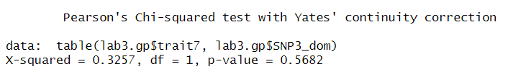
        - Not significant.

- Is there a difference in the association between SNP3 (additive model) and trait7 after adjusting for covariates age, sex, and covar1, in the GP generation?

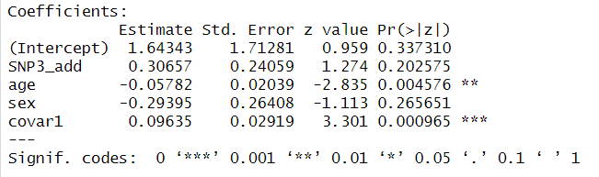
  - Additive effect of SNP3 is not found to be significant to the association; however, both age and covar1 were found to have a statistical association with trait7.

  - Odds ratio for adjusted model: 1.359. Individuals carrying SNP3 are ~1.4 times more likely to carry the trait.

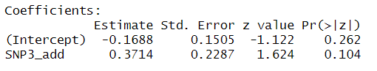
  - Odds ratio for unadjusted model: 1.45

  - Using the 10% rule (1.450 – 1.39) / 1.450, or ~6.7%, we can conclude that age, sex, and covar1 are not confounders to the association between trait7 and SNP3 (even though there is association found between age and covar1).

