Analyzing data using R: Preparing the files

- What is the rare homozygous genotype for each of the five SNPs? What is the range of the rare homozygous genotype frequency across generations?

SNP | Rare homozygous genotype | Frequency range
SNP1 | AA | 0.184 – 0.220
SNP2 | GG | 0.200 – 0.221
SNP3 | GG | 0.000 – 0.040
SNP4 | AA | 0.000 – 0.005
SNP5 | GG | 0.000 – 0.129

- For each SNP, detail how the genotypes were recoded as an additive effect of the rare allele.

Recoding | 2 (Counts) | 1 (Counts) | 0 (Counts)
SNP1 | AA (280) | AG (694) | GG (436)
SNP2 | GG (315) | AG (750) | AA (430)
SNP3 | GG (40) | CG (376) | CC (1009)
SNP4 | AA (4) | AG (275) | GG (860)

- How many cases and how many controls are in the dataset for traits 6 and 7 in each generation? Are you statistically powered for a case-control study (alpha=0.05)?
Hint: http://zzz.bwh.harvard.edu/gpc/ (assumptions: disease prevalence of 30%, f(A)=0.2, additive coding with the heterozygous risk ratio =1.5, perfect LD with the disease allele with the same frequency as the marker allele, using the smallest sample size you get in the table below)

 | GP |  | Parent |  | Child
Trait | Cases | Controls | Cases | Controls | Cases | Controls
6 | 161 | 168 | 153 | 157 | 189 | 196
7 | 155 | 155 | 149 | 149 | 181 | 181

Using the statistical parameters outlined above, and the most conversative estimate with minimum sample size (i.e. parents, trait 7 N = 149), statistical power is equal to
0.8638. We can conclude this case-control study is statistically powered.

enetic Association Studies (Cross-Sectional)

Analyzing quantitative data using R: ANOVA

- Is there a significant difference in means of logtrait5 across each genotype class in each dataset (i.e., by generation)? Did each dataset meet the assumption of equality of the variances?
  - For grandparents, there was a significant difference in means of log_trait5, but not for parents or children.
  - Each dataset met the assumption of equal variance, based on the Bartlett test.
  - See table below.

Generation | P-value Significant? | Equal Variances?
Child | 0.423, no. | p-value = 0.4485, equal variance.
GP | 0.0186, yes. | p-value = 0.1821, equal variance.
Parent | 0.158, no. | p-value = 0.5644, equal variance.

- How does anova compare to the lm output?
  - Grandparents
    - ANOVA: P-value = 0.0186
    - LM: P-value = 0.0186
    - Models agree, SNP3 is significantly different for grandparents.
  - Parents
    - ANOVA: P-value = 0.158
    - LM: P-value = 0.158
    - Models agree, SNP3 is not significantly different for parents.
  - Children
    - ANOVA: P-value = 0.0.423
    - LM: P-value = 0.423
    - Models agree, SNP3 is not significantly different for children.

Genetic Association Studies (Case-Control)

Analyzing qualitative data using R: Chi-square test
- Is there evidence for a significant association between SNP4 and trait7?
  - Grandparents
    - Table:
 | AA | AG | GG
--- | ---- | ---- | ----
0 | 2 | 35 | 61
1 | 0 | 27 | 73
    - Chi-squared = 4.0871, df = 2, p-value = 0.1296
      - No significant association.
    - Fisher exact: p-value = 0.1163
      - No significant association.
  - Parents
    - Table:
 | AA | AG | GG
--- | ---- | ---- | ----
0 | 0 | 20 | 83
1 | 0 | 25 | 79
    - Chi-squared = Cannot be computed due to 0 AA value.
      - Cannot conclude based on Chi-squared.
    - Fisher exact: p-value = 0.5009
      - No significant association.
  - Children
    - Table:
 | AA | AG | GG
--- | ---- | ---- | ----
0 | 0 | 27 | 97
1 | 1 | 22 | 107
    - Chi-squared = 1.8597, df = 2, p-value = 0.3946
      - No significant association.
    - Fisher exact: p-value = 0.3853
      - No significant association.

- In the tables, did any cells contain less than 5 individuals? How does this affect the test? What test of association is appropriate for small sample sizes and sparse tables? Run this test and compare the results to the chi-square test.
  - See previous problem
  - Grandparents: AA has less than 5, Fisher exact must be used.
  - Parents: AA has no observations, Fisher exact must be used.
  - Children: AA has 1 observation, Fisher exact must be used.
  - All Fisher exact tests determine that no significant associations can be concluded.

Analyzing qualitative data using R: Logistic regression
- Test for the association between SNP3 and trait7 in the GP generation. Use additive coding for SNP3. How do the results from the logistic regression model compare with the results from a chi-square test?
  - 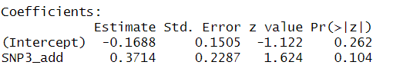
    - Coefficient for additive coding for SNP is not significant (< 0.05) for the GP generation.
  - 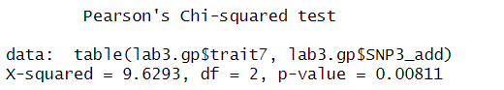
    - P-value is significant in comparison between trait7 and the additive coding of SNP3
    - Chi-squared test is a 2 degree of freedom test (i.e. is the distribution of trait7 the same in all 3 genotypes), while the logit model only tests the additive effect of SNP3.

- Do the results change for different genotypic models for SNP3?
  - Logistic
    - Recessive model
      - 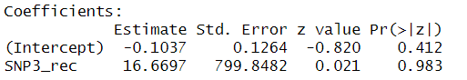
      - Not significant.
    - Dominant model
      - 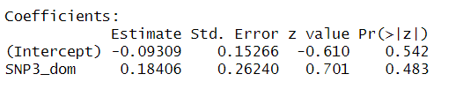
      - Not significant
  - Chi-squared
    - Recessive model
      - 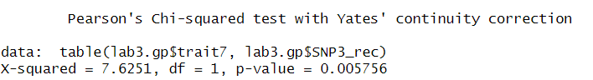
      - Significant result, values deviate from expected for the recessive model
    - Dominant model
      - 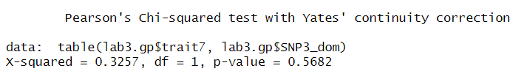
      - Not significant.

- Is there a difference in the association between SNP3 (additive model) and trait7 after adjusting for covariates age, sex and covar1, in the GP generation?
  - 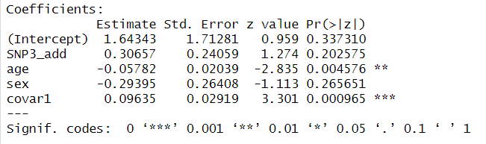
  - Additive effect of SNP3 is not found to be significant to the association; however, both age and covar1 were found to have statistical association to trait7.
  - Odds ratio for adjusted model: 1.359. Individuals carrying SNP3 are ~1.4 times more likely to carry the trait.
  - 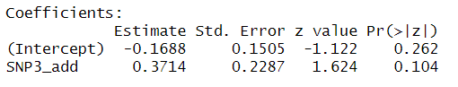
  - Odds ratio for unadjusted model: 1.450
  - Using the 10% rule (1.450 – 1.39) / 1.450, or ~6.7%, we can conclude that age, sex, and covar1 are not confounders to the association between trait7 and SNP3 (even though there is association found between age and covar1).

