GWAS using PLINK

- How many SNPs are there in the map file? Which chromosome are they on? How many individuals are there in the ped file?
  - There are 1940 SNPs in the map file.
  - They are on Chromosome 16.
  - There are 1000 individuals in the ped file.
- What is the highest individual missing rate?
  - The highest individual missing rate, from individual A01866, is 0.03608.
- Which SNP has the highest missing rate? How many SNPs have a missing rate > 10%?
  - SNP rs8044753 has the highest missing rate, at 13.5%.
  - In total, 5 SNPs have a rate greater than 10%.

- What is the minimum minor allele frequency of SNPs in the dataset? (Note: monomorphic markers should be excluded.) How many markers fail HWE (p <=0.0001)?
  - The minimum MAF of SNPs in this data set is 0.0005.
  - 7 markers in total failed the HWE test with p-values <= 0.0001.
- What is the format of the PLINK phenotype file?
  - FAMILY_ID | INDIVIDUAL_ID | PHENOTYPE

- What is the format of the PLINK covariate file? How do you code Males? Females?
  - FAMILY_ID | INDIVIDUAL_ID | GENDER | AGE
  - Males: 1
  - Females: 2

- What SNP has the smallest p-value?
  - SNP rs247617, with p-value = 2.92e-07

- What is the location of the top SNP and where does it lie on the genome?
  - Rs274617 lies at 56956804 on Chromosome 16.
  - It lies between the HERPUD1 and CETP genes.

- How many SNPs are there in the top SNP ± 150kb regional plot? There are 85 SNPs in the 150kb regional plot. Please see below.

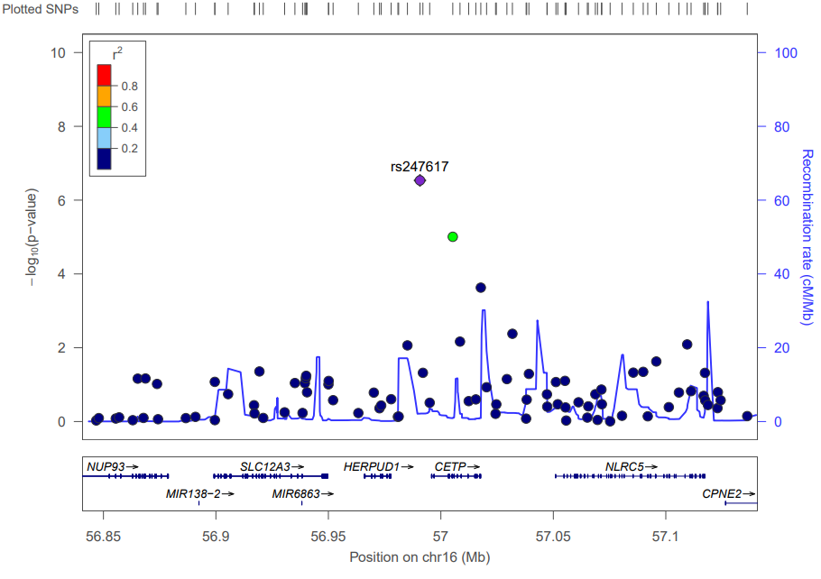

- How many genes are there in the top SNP ± 150kb regional plot? What conclusions can you draw from the regional association plot?
  - There are 8 genes in the regional plot.
  - The closest gene to the reference SNP has a LOD R^2 value between 0.4 and 0.6, located on the CETP gene.
  - Recombination appears at an increased rate among local areas in the +/- 150kB region around the reference SNP, suggesting that recombination is frequent in this area.

- After generating the QQ plot and Manhattan plot, describe the results. What is lambda and interpret possible underlying issue.
QQ-plot:
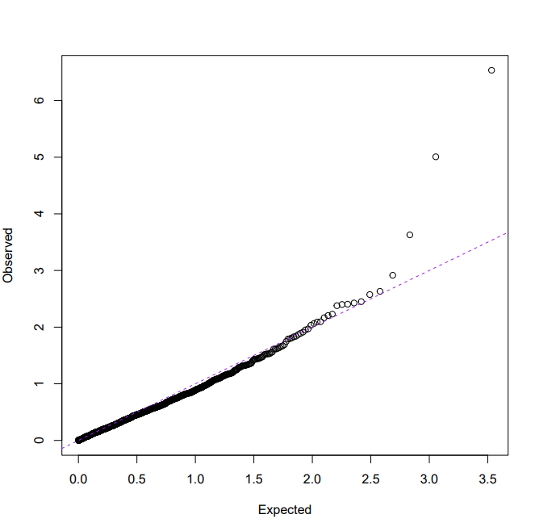
Manhattan plot:
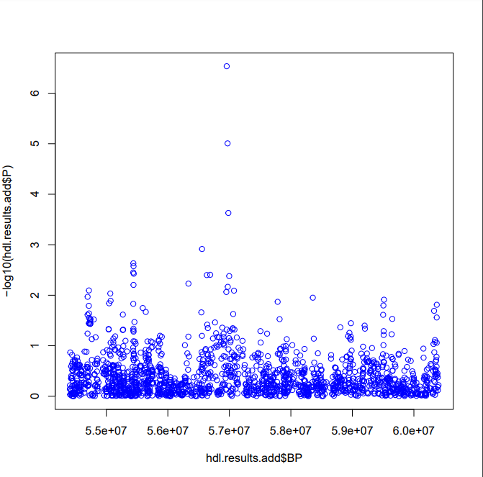
Discussion: The null hypothesis (the data are normally distributed) is maintained for many of the values shown on the QQ plot, apart from those shown on the very right of the plot. These deviations suggest the possible associations identified above. These are also characterized in the Manhattan plot, in the middle with values exceeding 3 on the y-axis. In this case, lambda is equal to 0.82182. A lambda value less than 1 suggests deflation of the test statistics, which could be due to issues like overcorrection for population stratification or overly stringent quality control. This situation indicates a conservative approach.
- After the meta-analysis, what is the top SNP? Is the effect stronger or weaker? Do you observe any heterogeneity between studies?
  - After meta-analysis, the top SNP is still rs247617.
  - The effect is stronger, because we use a duplicate data file for the METAL control file, instead of comparing between two studies.
  - There is no observed heterogeneity between studies because both study files are the same.
- After generating the QQ plot and Manhattan plot, describe the results. What is lambda and interpret possible underlying issues.

  - QQ-plot: Significant deviation from null hypotheses. In this case, the data are not normally distributed. The meta-analysis may be inflating or over-estimating the effect, possibly due to both METAL files containing the same data.
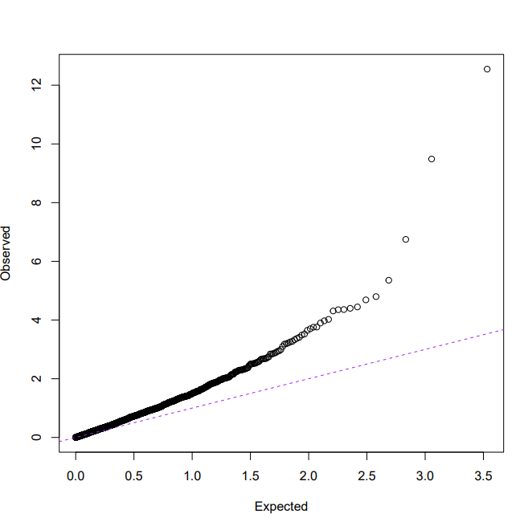
  - Manhattan plot: In comparison to the previous Manhattan plot, it appears that all values have a higher -log10 value, especially those previously determined to be significant. This also suggests that the meta-analysis is overestimating the effect.
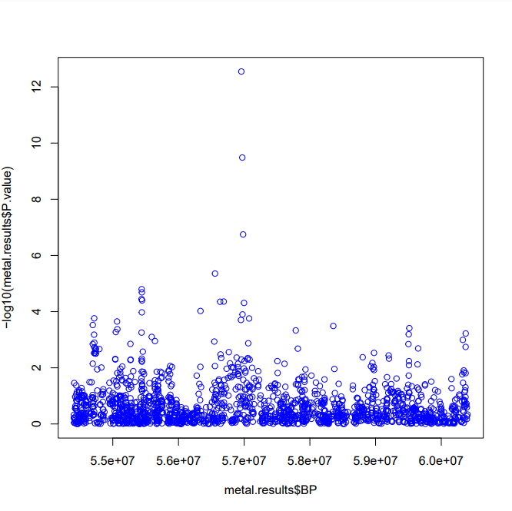
  - Lambda: 1.6453. A lambda value greater than 1 suggests inflation of the test statistics, which could be due to a variety of factors, including population stratification or genotyping error. Since this lambda is greater than 1.1 / 1.2, it is unlikely to be fully corrected with genomic controls. It may signal potential issues in the data or analysis that should be addressed. In this case, lambda of 1.6453 seems to suggest that using identical data sets causes significant inflation of the data. This situation indicates an anti-conservative approach.

