* Volley is a HTTP library that makes networking for android much easier and faster. 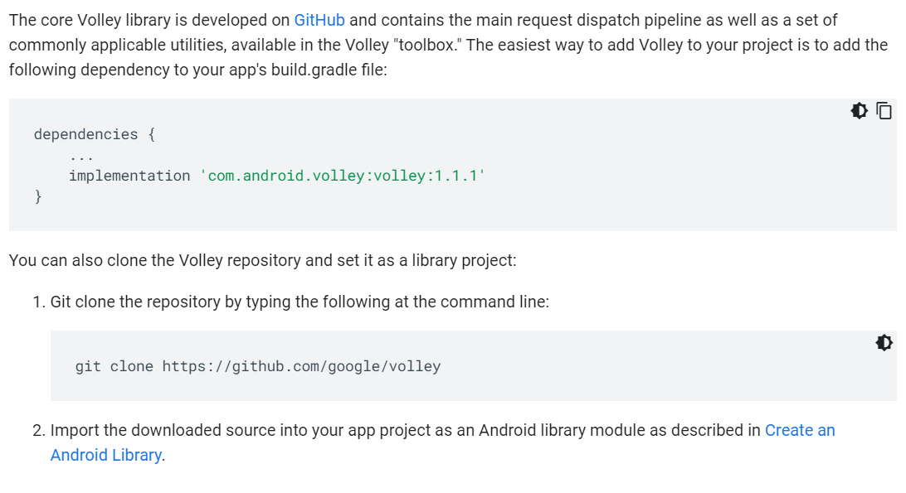
* Without adding the internet permission , volley cant function

